Important Information for Service Users

In hospital it is very important that we stop Coronavirus spreading

Evidence has shown that sometimes people may be carrying the virus but are not showing any symptoms.

We want to keep everyone safe and therefore the healthcare professionals who are looking after you on the ward will now wear Personal Protective Equipment (PPE) so that they do not spread the virus to you, and you do not spread the virus to them.

The type of equipment they will wear will consist of:

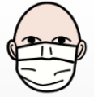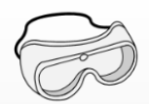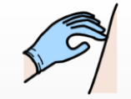

Facemask Glasses or Goggles Gloves Apron

Please do not be alarmed – this is being done to protect you and them

- If you would like to wear a facemask yourself, please ask a member of staff on the ward and they will provide you with one.

- Your facemask must be changed every time you have a drink or eat some food.

- You should continue to wash your hands regularly with soap for 20 seconds.

If you become unwell

If you develop a high temperature and have a persistent dry cough, you may be asked to have a test taken.
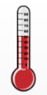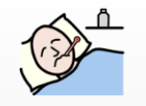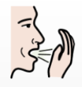

You will be asked to open your mouth and a swab will be taken from as far back in your mouth as possible. A second swab will be taken from up your nose.

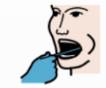

These swabs will then be taken away for testing and you will be made aware of the results by staff as soon as they come back.

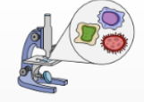

We are doing our best to help keep you and our staff protected. If you are concerned or worried about anything on this leaflet,
please let your keyworker know.

