Supporting someone with complex emotional needs

A self-help guide for friends, family and supporters of those who may have difficulties consistent with a ‘personality disorder’ diagnostic label.

About this booklet

Developed by carers, for carers.

This booklet is for friends, family and supporters of people with complex emotional needs who may or may not have received a diagnosis of ‘personality disorder’. We refer to friends, family and supporters as ‘carers’ in this booklet. As carers ourselves, we have developed this booklet with staff working in Leeds Personality Disorder Services, part of the Leeds and York Partnership NHS Foundation Trust (LYPFT).

Over the years we have met regularly to share our issues and get support from our peers and
professionals. However, many carers haven’t had this chance, so we wanted to share some of our experiences and tips for coping. We have also included information on where to get more support and ideas to improve your wellbeing.

We know everyone is unique and we cannot cover all eventualities. We will, however, address the most common themes, patterns and difficulties, with the aim of helping you to recognise and manage stressful situations earlier.

We have included quotes from interviews with carers.

The term ‘personality disorder’ is in inverted commas because not everyone agrees or connects with this diagnosis.

This booklet has been reviewed by people with lived experience of complex emotional needs but there may be aspects that could be hard for the person you care for to read. Reading about the impact of our actions on others can be distressing, regardless of whether we have complex emotional needs or not. Not everyone with ‘personality disorder’ reacts or responds in the same way. We encourage you to think about and discuss the contents with this in mind.

Contents

Contents 1
What do we mean by the term carer? 2
What is ‘personality disorder’? 3
How useful is this diagnosis? 3
How does ‘personality disorder’ develop? 4
Core needs and beliefs 5
Coping responses 6
Breaking the cycle 8
When things don’t go to plan 13
Looking after yourself 15
Words from carers 21
Extra support 21
Summary 23
Additional resources for carers 23
Feelings 25
Safety plan 26
Contact information and acknowledgements 27
References 28

What do we mean by the term carer?

Not everyone who is a carer would think of themselves as being a carer. In this booklet, ‘carer’ describes partners, family members, friends, or anyone who gives informal and often unpaid support to someone with a mental health condition, in this case ‘personality disorder’ or complex emotional needs.

Some common myths

Myth | Fact
Carers need to be in receipt of some sort of  financial benefit to be officially recognised | Many carers don’t receive financial benefits
Carers only provide practical support like  helping with washing, dressing, cleaning and  shopping | Carers provide practical and emotional support  such as long phone calls and encouraging self-care
Carers are paid workers, not family members | In 2021, 5 million people provided unpaid care  in England and Wales
You are only a carer if you live with the person  you care for | Anyone can be a carer. Some travel long  distances. Others support virtually by phone  calls, emails or video chats
Carers are ‘healthy’ themselves | Many carers have their own health problems  and say that caring has made them worse

According to NHS England “A carer is anyone, including children and adults, who looks after a family member, partner or friend who needs help because of their illness, frailty, disability, a mental health problem or an addiction and cannot cope without their support. The care they give is unpaid.”

Carers often don’t fully understand the diagnosis of the person they care for and struggle to access support for themselves.

“It’s been like a three-year apprenticeship and my knowledge has been broadened.”
“You’ve had no previous experience. You just gotta accept that you’re [in a] starting position.”

What is ‘personality disorder’?

The term ‘personality disorder’ is often used to describe a person who has complex emotional needs which can affect how they relate to themselves and others, and how they cope with intense and difficult feelings.

It is “the term used within mental health services to describe long standing difficulties in how an individual thinks and feels about themselves and others, and consequently how they behave in relation to other people.”

How useful is this diagnosis?

The diagnosis of a ‘personality disorder’ has faced negative and unfair, stigmatising reactions for years. It is often debated because:

- Even experts disagree on how to understand ‘personality disorders’
- The diagnosis doesn’t consider individual experiences
- The term itself is unhelpful as it labels a person’s personality and their sense of self as disordered in a medical context

For many people, the ways they cope with situations are reasonable, essential and lifesaving. They are responses to society’s pressures and to difficult or traumatic experiences they have been through. Labelling this as a ‘disorder’ or ‘illness’ is upsetting and distressing. It makes people feel like they are the problem.

For others, having a diagnosis helps them name and understand their experiences. It can also explain their actions and ways of coping. It can open doors to various care options that might not otherwise be available. From a carer’s perspective, a diagnosis can be helpful as it can ease some of the feelings of responsibility and guilt that they may experience.

Our understanding of mental health and the language we use is often changing so it’s important to talk to the person you care for about the terms they prefer. Respecting their wishes can help them feel heard, understood and empowered rather than ‘done to’, labelled and categorised. Ultimately, the person you care for is the same person, no matter how they identify or whether they are comfortable with a ‘personality disorder’ label or not.

“You’re sort of pleased that you know what it is because before that we’ve had 10 or 11 years of difficulties and to know that it is something and then to be able to better understand it is helpful.”
“But… it’s also a shock. Give yourself time to get an understanding and have people to talk to so that you’ve got time to process it.”
“Give yourself time to digest that information and not act on a knee jerk reaction.”
“The type of personality disorder actually isn’t particularly useful in terms of a label.”
“The people we care for already feel so much shame and guilt.”
“Therapy and services work for some people, but not everyone. It’s really important not to force the people we care for into something that may be scary or further damaging to them.”

Common difficulties related to ‘personality disorder’

It is important to highlight that everyone has different experiences, so it is impossible to cover them all. However, many people with complex emotional needs or a ‘personality disorder’ face certain common difficulties, including:

- Difficulties with identity and sense of self
- Difficulties developing and maintaining relationships
- Intense experience of emotions
- Impulsivity
- Difficulties coping day-to-day
- Difficulties with how they see and understand themselves, others and the world
“My partner thinks, “I have what I need in life and I should be happy with this, and still I’m having all these difficulties”.”

How does ‘personality disorder’ develop?

Personality is what makes you ‘you’! While some believe personality is something you’re born with, it’s more likely that it’s shaped by your experiences and interactions with the world.

There is no single cause of ‘personality disorder’. It can be influenced by biological, psychological and social factors:

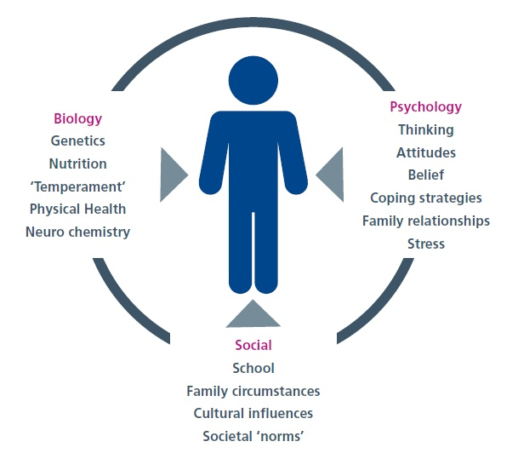
Biological – Genetics, brain structure and hormones are some of the biological influences on people’s development that may predispose them to a particular pathway in life.

Psychological – Early experiences in important relationships, as well as those that are traumatic or adverse, greatly influence adult personality.

Social – A person’s wider environment also shapes the way people understand their sense of self and how they see other people and the world.
“I think the people we care for often blame themselves, think they should be “doing better” and should be feeling all right. I know some will blame everyone else and never themselves, but a lot of the people we care for will still be blaming themselves even if it’s internalised and you don’t see it. It takes a lot of reassurance and telling them that it’s not their fault, and that it’s a case of what’s happened in their lives. I don’t just mean the environments of home, school, peers etc that we grow up in, I mean it on a political scale.”
“Society is really difficult to live in for a lot of people, and it’s not set up in a way that works, especially if you are already overwhelmed. A lot of people will say that the person has something wrong with them but to me it’s the environment that society has created doesn’t fit that person, and society’s response to that person is not helpful.”

Core needs and beliefs

As children we need certain things to help us grow and feel safe,including food, education and care. These are our core needs. They can be met by many sources like the government, schools, neighbours,
family, friends and others around us. When these needs are fulfilled, we feel valued. We can then form
healthy relationships.

We have core physical needs and core emotional needs. The core emotional needs are:
- Feeling secure, cared for and accepted by others
- Freedom to express emotions and ask for what we need
- A well-developed sense of who we are and confidence in making choices
- Opportunities to be spontaneous, playful and fun
- Having realistic limits and developing self-control

When these needs are not met, they can lead to some of the challenges talked about earlier.

There are many situations where a child’s needs cannot or might not be met such as:
- Lack of academic support at school, or high expectations so a child’s need for play is passed over
- The death of a close family member
- Being socially isolated leading to a child not feeling like they belong
- Growing up in poverty, limiting access to resources, education and healthcare
- A caregiver’s own health
- A lack of role models to show a range of emotions
- Growing up in a discriminatory society e.g. racist, sexist, homophobic
- Experiences of trauma

Whether our needs are met or not shapes our memories and emotions, which in turn creates our core beliefs and sense of self. A core belief is a deeply held foundation for how you view yourself, others and the world. It influences your feelings, thoughts and interactions. Core beliefs can be positive, such as “People care about me,” or negative, such as “People will hurt me.” They can be reinforced or challenged over time so may develop or change.

The films Inside Out (2015) and Inside Out 2 (2024) show another way to understand people’s core emotions, needs and responses.

People with complex emotional needs may hold beliefs from some or all of the five categories below:
- Abandonment/instability e.g. “People will always leave me.”
- Social isolation/alienation e.g. “I’m totally different to everyone around me.”
- Defectiveness/shame e.g. “I cannot understand how anyone could love me.”
- Emotional deprivation e.g. “People are not going to be there for me.”
- Mistrust/abuse e.g. “People will take advantage of me.”

Recognising and addressing these beliefs is essential in supporting the people we care for to form healthy relationships and self-worth.

Coping responses

We all cope with things in our own way. Our core beliefs and feelings about ourselves shape our ways of coping. Some can be seen as more helpful or safer than others.

Some ways of coping that can be considered helpful include, but are not limited to, going for a walk, taking a bath, writing in a journal or speaking to a friend.

Some people have ways of coping that start off as helpful and then can, over time, become less helpful, for example:

Going for a walk. Walking to the point of exhaustion

Taking a bath. Taking a bath with extremely hot water

Some people cope in ways that may appear to be unhelpful such as isolating or harming themselves.

It can be difficult to know where the boundary between helpful and unhelpful lies. Eating a nutritious meal can help after a bad day, but fixating on food and eating only salad every day would not. Going for a run can be a great way to cope, but running until exhaustion day after day might be less helpful and a way to avoid feelings or thoughts.

To determine this, we can think of coping responses in terms of these four categories:
- Good enough
- Avoid
- Surrender
- Overcompensate

To help explain this, there are examples for each of the categories below. We use the same scenario so that you can see the difference in each of the coping responses.

Scenario: Ashley has been felling lonely and different to other people

Coping response category | Coping response example
Avoid | Ashley decides to stay at home away from  others and avoids meeting friends or new  people.
Surrender | Ashley sees themself as different and accepts  that they will always be that way so doesn’t  make an effort to find people who have similar  interests or feelings.
Overcompensate | Ashley decides to go out and meet lots of  people. They get involved in a variety of  different groups. Everyone thinks Ashley is  really sociable and has life all figured out.
Good enough | Ashley calls a friend, Jessie, and has a chat  about dogs, something they both love talking  about.

As carers, we see the coping responses of the people we care for. We don’t always understand
them, especially when there is a repeated pattern that doesn’t appear to get the desired outcome. However, a repeated pattern is known and familiar which can be comforting. It can confirm someone’s beliefs about themselves or other people.

Using the example above, if someone feels lonely, they may believe they are different from others. They may overcompensate by trying to fit in with lots of people, but can never be themselves. This reinforces their belief that everyone else is different to them and their feelings of loneliness, so the cycle continues.

Self-harm can also fall into this cycle and is a way for people to cope. It is not “attention seeking.” Using the same scenario, someone may feel lonely and different and this could lead to self-harm. After they have self-harmed they may be filled with a lot of thoughts and feelings, one of which might be “Why do I do this? No one else I know hurts themselves.” This can confirm their belief that they are different and alone, and reinforces their feelings of loneliness.

The flow below shows how disconnecting beliefs and coping responses reinforce each other.

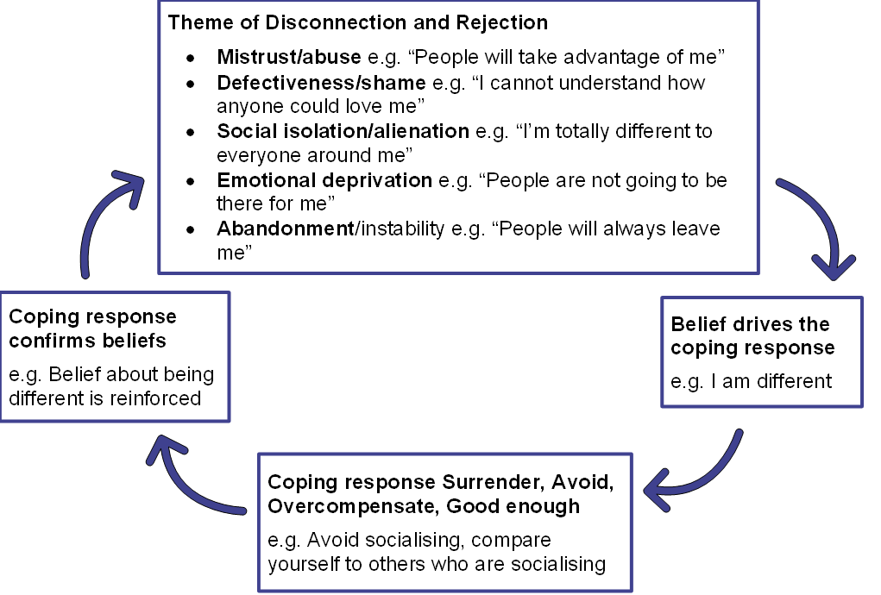

Breaking the cycle

There are many ways to help ourselves and the people we care for manage distress and difficult coping responses.

Recognising and managing triggers
A trigger is something that can cause a strong emotional or psychological response. It can be difficult to identify triggers for certain behaviour patterns and coping methods, but many of us have noticed some things that may contribute or make things worse. For example:
- Crowded places
- Tiredness, fatigue
- Missing meals, feeling hungry
- Change of routine, place, timetable
- Difference of opinion, inability to see another’s viewpoint
- Feeling overwhelmed, taking on too much
- Drugs, stimulants, alcohol
- Poor time management
- Feeling unwell, rejected or low in mood
- Being ignored
- Certain smells or sounds that connect to a memory of a traumatic event

Whilst some triggers can be anticipated, others are harder to manage without extra support.

It is sometimes possible to avoid going to crowded places or travelling at peak times, but this isn’t always possible for appointments or events. The person you care for may be able to overcome their anxieties in the short term, but may need time and space after an event to process feelings. This can help them to develop coping strategies for the future, but requires time and patience from both of you.

A difference of opinion can be tolerated or negotiated, but the person you care for may feel things are out of control, or that they’ve done something wrong. It’s important they know you have an opinion without letting it escalate into a conflict. Sometimes it’s best to agree to disagree.
“Like other relationships – you don’t have to agree about everything all the time!”
Those affected by drugs and substance misuse may need support from professionals. Further information for these services is at the end of this booklet.

To help with poor time management, set earlier meeting times than required. Use a shared calendar for things you need to both know.

Discuss taking on too much in personal life and work during a calm time, and agree on realistic expectations. Work issues should be discussed with their employer, who should make allowances for the difficulties of the person you care for. This can be addressed with HR, Occupational Health, or their manager.

Without being judgemental about the people we care for, all of the above can be emotionally and physically exhausting. You may experience increasing isolation, anxiety, stress and poor health. We’ll discuss looking after yourself in a later section.

Communication

Communication can be both verbal and non-verbal. We express ourselves in many ways using speech, gestures and body language. Often it is not just what we say but the way we say it that can make all the difference between good communication and something being misunderstood.

What we feel is a ‘normal’ response or gesture may be interpreted differently by someone else. For those with ‘personality disorder’ or complex emotional needs this can feel more intense. They might feel they have been judged, dismissed or disrespected. As carers this can be hard to understand.

Consequently, we may feel uncomfortable about communicating with the people we care for. We fear upsetting them by saying the ‘wrong thing’ or expressing ourselves in the ‘wrong way’. This can lead to long term difficulties which are hard to change and cause relationships to suffer.

Those with complex emotional needs or ‘personality disorder’ may struggle to communicate. For example, you may avoid certain topics if they are particularly difficult for the person you care for to discuss. They may walk away when someone brings up the topic, or take some time out in their own space and then return without acknowledging it.
Sometimes the person you care for may appear to act impulsively and not consider the consequences. They may find it difficult to understand what they did or why they coped in a certain way. If this happens often, you may feel scared, frustrated, stressed and possibly some resentment towards them. Therefore, it’s important to communicate in a way that works for both of you. It may involve a bit of trial and error but you can help if the person you care for is open to discussing ways to communicate so you both feel heard.

Here are some ideas to help you nurture better communication. It doesn’t happen overnight, and we all make mistakes and forget at times. If you do, don’t blame yourself. Consider it a learning exercise, think about what went wrong and how it could be improved next time.
Communication ideas

Make a plan
- Plan to talk about important subjects when you feel the time is right and not blurt them out in the spur of the moment. Choose a moment when you both feel relaxed, are not tired or stressed, and have enough time to talk things through without distractions. If either of you have had a bad day, wait for a better time.
- Don’t worry if you need to pause the conversation to give space to process information or prevent emotions from getting too high. Chasing after the person you care for when they need space can lead to unnecessary arguments. Suggest coming back to the topic later if it feels okay to do so.
“One of us often says something like, “I can’t process anything else. Can we stop this conversation now? We can try to come back to it tomorrow if we both feel able to, but no pressure and we can just see how we feel and rearrange if we need to.””
“Validation is extremely important, and allowing people to have space.”

Language
- Express and talk about your own emotions so that the person you care for can see they are not alone in feeling things. A feelings list can be helpful so that we use ‘real’ feelings such as “I feel sad/lonely/scared” to create connection rather than accuse others. You can find a feelings wheel at the end of this booklet.
- Language has changed over time and shortened common ways of expressing emotion. Rather than saying, “I feel sad when you don’t talk to me,” we may say, “I feel ignored.” Unintentionally, this suggests someone is ‘doing’ something to the other person. It shifts the responsibility onto someone else. This can come across as judgement or blame.
- Stick to facts when discussing important topics to avoid arguments.
- Avoid critical language such as “you never” or “you always.”
- Rephrase sentences to sound more constructive and less accusatory. For example, “Be honest with…” has a more positive tone than “Don’t lie to...”
- Non-verbal language such as shoulder shrugs and facial expressions to us may mean that we aren’t bothered either way about something. The person we care for may feel dismissed and interpret it as “No.”
- Body language can be easily misunderstood so try to be as transparent and clear as you can in conversations.
- Expressing anger through shouting, swearing, abruptness or silence is likely to stress the person you care for. You cannot expect them to respond respectfully if you are using this approach and language yourself.
- Hurtful words may be spoken by the person you care for in times of crisis but try not to take them to heart. They are lashing out and are rarely meant. That doesn’t make it okay and you may want to talk about it when it’s calmer to agree on more helpful ways to communicate with each other.
- Getting defensive rarely helps. We tend to get defensive when we react to criticism or perceived threats. This can make it difficult to have constructive conversations so we cannot address concerns.
- We may get defensive by arguing back, saying something like, “You never listen to me, so why should I?” or by playing the victim, “You blame me for everything. Why can’t I ever get a break?” More helpful responses may be along the lines of, “I didn’t realise I was doing that. I’ll try to be more attentive.” or “I can see why you feel that way. Let’s talk about what’s been happening.”
- We may also deny responsibility or make excuses such as “I didn’t do anything wrong,” or “I was too busy to do it.” Instead, we could say something like, “You’re right, I’ll make an effort not to do that again.”
- The person you care for may find it difficult when you disagree with something they say because it may feel that you’re saying how they feel isn’t right or important. This can come across as being dismissive. You can try saying something like, “I understand you feel this way. It makes sense. But my understanding of the situation was different and I’m happy to talk about this. We all interpret things differently.” You may need to find the opportunity to put your point across later and “bite your tongue” for a while, however hard this seems at the time.
“It’s not always easy to find the words to explain feelings, so we started using a traffic light system for how we were each day. Green for good, amber for could go either way or on edge and red for feeling low, distressed or anxious. We did it both ways, it wasn’t just for him. I would use it as well so he could understand how I was feeling. We had some sort of commonality to use and then worked from that; starting with having this traffic light system to then having a few words or a list of feelings, and then you can pick a feeling from it.”
“Don’t tell people to “calm down” as this often escalates and inflames the situation.”

Listening
- Listening is one of the hardest things to do especially in heated conversations. Many people are thinking about what they are going to say next whilst the other person is talking. However, hearing a person out until the end of what they’re saying is a valuable skill. It helps you see their perspective and respond more thoughtfully.
- We frequently do not listen enough to fully understand what is being said to us. We may think we understand a situation but we often only hear what we want to hear.
- Listening carefully can bring clarity.
- Reflect back what you’ve heard and ask questions.
- Ask the other person if they want you to hear, support or advise them. Only offer suggestions if they ask and try to solve something together.
- Avoid interrupting as it can disrupt a train of thought. It can be upsetting and lead to a breakdown of the conversation which you may not regain.
- If there is a disagreement in the conversation, wait until the person has finished speaking and then calmly suggest it’s your turn. You could say something like, “I’ve heard you and now I would like to share my thoughts.”
“We were talking about listening and I actually learned what listening means. It just means listening, not trying to fix the problem that my son is speaking about, but actually hearing him.”
“I would say listening is the most important thing. Listen to what they have to say.”

Take it somewhere else
- Changing the scene can help reconnect or ease communication. Some settings can bring out the worst in you, them or both of you. For example, asking someone a complex question when they are in a crowded place is more likely to get a short response as they are on edge.
- A walk or an outing for coffee, a picnic or a stroll round a garden centre, for example, may help to break the ice and open up what has been bothering you, them, or both of you.
- Doing something side by side e.g. walking or going for a drive can help conversations to feel less intense by minimising eye contact. Movement during talks can help relax both of you.
- Avoid serious discussions if either of you feels tired, unwell or not in the right mindset. It could lead to unwanted public confrontation, or ruin an event or holiday.

Assertiveness
- Take responsibility for how you are feeling and remember you don’t have to agree with the person you care for all the time. Although you are trying to accept that some people feel and think differently to you, you should still try to help them understand your feelings. If you are tired, say so; if you need a break then do so.
- You can explain, “I’m tired right now, but I’ll help after I’ve rested.” This is not to make them feel guilty but to ensure you’re at your best to support them.
- Be clear about decisions and ask them to repeat what’s been agreed to avoid misunderstandings.
- Don’t be afraid to say “no” sometimes, and give a reason if needed. It can be hard at first but gets easier with practice.
- You don’t have to “do it all.” Given the right time and support, the people we care for can do things themselves when possible. You can begin by doing things together and learning what the person you care for is able to manage by themselves. Doing too much for them prevents them from learning. You may start to feel resentful and less valued, and they may start to feel inadequate and useless.
- Walk away if you need a break, saying something like, “I’m not leaving you. I’m taking ten minutes to cool down.”
“Knowing your own boundaries and not accepting any violence or abusive behaviour. We shouldn’t have a bias because someone’s got a diagnosis either way. We shouldn’t condemn them because they’ve got a condition, nor should we have a lower threshold, or a lower level of expectations for them.”

Be calm
- Don’t get too upset if things don’t go as planned. Sometimes the person you care for might start projects with enthusiasm but then lose interest. This can lead to frustration and disappointment for you, but also for them when they aren’t able to follow things through.
- The disappointment could be an opportunity to think together. What makes these things hard? Is there anything that could make it easier, such as listening to music when cleaning?
- If their plans or projects seem unrealistic to you, you could avoid getting too involved or you could help them make smaller, more achievable goals that work towards their bigger goal. Either option is okay and you will know best what suits the person you care for and your style of support and care.
- Offer gentle encouragement by suggesting they cost things out and think things through. Time to reflect may help avoid arguments or lead to better ideas. They may also abandon the project.
- Don’t mention past failures. e.g. “Do you remember when you started so and so, look how that turned out!”
- If the project succeeds, give praise. If it doesn’t then be sympathetic. Ask what they have got or learned from it, turning it into a positive experience.

Responsibility
- It is useful to focus on responsibility rather than to blame each other. As carers we are as responsible for our words and actions as the people we care for.
- We should apologise if we upset someone, speak hurtfully etc. Admitting mistakes helps repair relationships. It also shows that it’s okay for others to make mistakes.
- Some of the people we care for apologise for things that are not their responsibility, often to avoid conflict and keep everyone happy. This can make it difficult for them to make their own choices and develop their self-identity. If they have done nothing wrong, tell them so. Encourage and give them space to be imperfect.
- If an argument occurs, try to let it go unless it’s really important. Having the last word might feel good, but it doesn’t help the relationship or to connect you with the other person. Disagreements are easier to handle when you focus on connecting rather than fighting with each other.
- Give each other space. After some time, you might be able to see each other’s points of view.
- Apologies can come in different forms, like a verbal “I’m sorry”, a small gift appearing e.g. a biscuit, or a task getting done.
- If the person you care for acts as though nothing has happened, accept it. You can bring up the issue later when things are calmer, if needed.

When things don’t go to plan
- Sometimes we don’t know what triggers the reactions of the person we care for. What seems like a small misunderstanding to us can feel much bigger to them, and we need to be mindful of this.
- Being clear when making plans is important.
- Writing things down, like in a text or email, may appear formal but can help confirm arrangements and avoid misunderstanding. It can also help you both remember what was discussed. The person you care for may have a lot going through their head so remembering information may be difficult for them.
- After an event or episode, you could send a brief message to help you feel less anxious and show you care without overwhelming them.
- Saying something in person or by message like, “Although we’ve had an argument and are annoyed with each other, I still love and care for you,” can help. The people we care for can sometimes feel that events like this are final and that the person may not like or love them anymore. It’s important for them to know that they can work through disagreements, difficult times and feelings.
- If the person you care for needs space, let them have it. We do not always find this easy, as we naturally want to comfort them. For many people, the last thing they need is someone following and questioning them. Give them time to themselves and do not feel guilty about doing this. Many carers have said that this has been the hardest thing to do but one of the best things for their relationships.
“Realise that they need space. And to be left alone. Because it only escalates the problem. And so that is a big tip, I would say. Or to leave. To let them be alone. It’s not easy to do, to walk away from an argument, or to try and not get to the bottom of what’s actually going on. That was the biggest stepping stone for us in moving things forward, I think.”
“A lot of the things for me are about taking a step back and leaving space for people to do their own thing.”

The more difficult situations
Sometimes the person you care for may react in a way that is beyond your ability to manage. If a situation escalates and becomes serious, it’s crucial to prioritise everyone’s safety. Intense reactions might require outside help which can be difficult to ask for. This could come from a friend, neighbour or outside agency. If you or the person you care for feel or are in danger, you can call 999 if you feel you have exhausted other ways of calming the situation down. Outside involvement can make a situation worse in the short term but they may give further support needed in the longer term.

Supporting someone who self-harms
Some of us care for people who self-harm. This can be overwhelming and lead to feelings of fear, sadness and even frustration.

There are many ways that people self-harm. For example, they may hurt themselves physically by pulling out their hair, hitting or biting themselves. They may overdose on medication. They may harm themselves emotionally with negative thoughts. Methods, reasons and frequency will vary between individuals.

It can be hard to know how to help. Rethink Mental Illness offers guidance on what to do and what to avoid when someone self-harms:

Do
Care
Support
Recognise it as a coping mechanism
Allow the individual to talk and be open about their feelings and what they are experiencing
Keep clean dressings in case to promote safe self-harm
Remain positive
Be honest and open
Let them know they are not alone
Seek medical advice if needed
Create a safety plan together
Recognise confidentiality
Get support for you
Research into self-harm with an objective mind
Encourage the individual to seek help
Try to look at underlying issues
Remember how things were before the individual was self-harming
Things you were doing before the self-harm
Be hopeful about finding other ways to cope
Talk about positive factors in their lives

Don’t
Accuse the person of attention seeking
Make your whole relationship about the fact that the person is self-harming
Ask to show scars or stare at them
Take all responsibility; they have responsibility
Panic or over-react
Judge
Punish or blackmail them
Abandon the person
Threaten hospitalisation
Hide away self-harm instruments
Promise to keep secrecy behind self-harm
Vent your frustrations towards the individual
Blame yourself or see it as a failing on your part
Force them to get help before they are ready
Lay blame
Ignore the feelings behind the action but also do not reward the behaviour
Ignore
Say things like “If you loved me, you wouldn’t do this”
Lie

Looking after yourself

Accessing help
Getting the right support often starts with your GP, both for the person you care for and for yourself as a carer. You can register as a carer with your GP and at the practice of the person you care for, with their permission. This can be useful in emergencies when you may need to speak on their behalf. The GP can also note other contacts for crises.

Anxiety can affect your memory. Write down your concerns before your GP appointment, and ask them to write down important information for you. If you struggle to see your GP, the practice nurse might help. You might also qualify for a Carer’s Assessment, which you can discuss with your GP, social services, or a local carers organisation.

Main signs of stress
Caring for someone with complex needs can lead to carers feeling stressed, overwhelmed and exhausted.

You might feel your relationship is going well when suddenly an unexpected change occurs, leaving you feeling like you’re back to square one. This may be an early sign of stress.

Some people cope with stress better than others. Some thrive on a busy lifestyle and nothing phases them, others cannot cope with anything out of the ordinary and many fall in between.

Some common signs of stress are:
- Trouble sleeping
- Worrying about things
- Impatience and irritability about small issues
- Difficulty concentrating
- Inability to make decisions
- Drinking or smoking more
- Loss of appetite, weight loss, weight gain
- Being unable to relax, feeling that you must be active all the time
- Feeling tense, ‘knotted stomach’, dry mouth, thumping heart

These symptoms often build up gradually, and carers may not notice until they become unwell. Others might point out changes in your behaviour at work or in relationships.

Carers are often shocked to realise they are stressed because they worry about who will care for the people they care for if they can’t. It’s crucial for carers to take care of themselves. You deserve it, and ultimately, who will look after you?

Resilience
Resilience is the ability to withstand or to recover from difficult situations. Carers need resilience to handle stress and “bounce back” from challenging interactions that may have left them feeling overwhelmed. We can’t change the difficulties the people we care for face but by building up our resilience we can minimise the impact of tough interactions on us as carers. So how do we do that?

Resilience is not a static trait within us. It is something that we can develop and strengthen over time.

Many people have explained resilience in different ways. One approach comes from a counsellor, Karl Gregory, who describes resilience in three parts:

1. Power
Understanding your strengths and recognising when and where they have come in use and when they have been unhelpful. This may involve acknowledging that you need help from others and this is not a sign of weakness. For example, persistence can be a strength unless you cannot recognise when you are wasting your time and then it becomes a weakness.

2. Purpose
Finding meaning in your experiences. It may be talking to others about our experiences, as sharing often helps us come to terms with things. It can also be about learning to accept that things are not the same as they were before, just different, and adapting to the difference is okay.

3. Pleasure
Enjoying a hobby or spending time with friends or family. Power and purpose bring us pleasure. We know ourselves and accept who we are. This lets us enjoy and practise “self-healing” to cope with life’s challenges.

Stress management
We cannot always control the difficult parts of our lives but managing stress is crucial.

How often do we hear carers say, “I don’t have time,” “I don’t have the energy,” or “I can’t afford to”? All the time!

You may feel that there is no time, but even five minutes of deep breathing or a hand massage can make a big difference. It can boost your self-esteem and help you relax.

Many carers start small by taking five minutes a day to themselves and gradually build up to include things such as yoga, pottery or salsa dancing. They realised they could spend more time when they built up the confidence in themselves and the person they care for.

Think about what “tools” you could use in your wellbeing. They don’t have to cost anything or take much time. You may already have some in place but not be using them to their full advantage.

- Do you access any other services or help organisations? There is a list of these at the end of the booklet.
- Do you have access to any Carer groups?
“You realise that when you join these groups that you aren’t alone, and people will share. I remember coming away from my first meeting and thinking, “Wow, that was a weight off my shoulders.””
- Friends and family - are they supportive? Time out with friends & family who can share fun times can be very therapeutic. Don’t isolate yourself from friends. Even those who don’t share similar circumstances matter. It can be good to get away from your everyday life and gain perspective.
- Hobbies – if you don’t have one would you like to learn something new? Learning boosts confidence and you can do it online or in person. It’s okay to enjoy things at the same time as going through a difficult situation; you don’t need to feel guilty.
- Exercise – physical activity can have positive effects on physical and mental health. Even if it’s only a five minute walk each day outdoors to start with, you will feel the benefits of getting out of your routine now and again. Connect with your community, join a dog walking group for example or a park run.
- Healthy eating – when we are stressed, we tend not to care much about what we eat. Try to get back to eating regular meals and planning your diet.
- Sleep – If you are exercising more and eating better hopefully you will be sleeping better. There are also relaxation techniques that can help such as yoga, meditation and aromatherapy.
- Can you talk to your GP? They may know your family already and understand your challenges.
- Remember that you, your needs, the person you care for and their needs change over time and that’s okay. You may have to build in change gradually as it can be unsettling.
- Avoid comparing yourself to other people and their circumstances. Your situation is unique.
“Develop a self-care plan like you would if you have an asthma plan or you have a set back with any long-term condition.”
“We’re human and sometimes we have to forgive ourselves and not beat ourselves up.”
“Don’t be too hard on yourself.”

Activity: Stress Bucket
Imagine you have a bucket. As you experience life’s difficulties and challenges, the bucket begins to fill up.

Everyone’s bucket is a different size, depending on past experiences and how sensitive they are to stress. The size of your bucket can change from day-to-day. For example, if you haven’t slept well the night before your bucket may feel smaller that day.

The point at which your bucket is full and begins to overflow represents the times where you feel overwhelmed, burned out, and exhausted.

Now, imagine a tap at the bottom of your bucket. Every time you do something which relieves a bit of stress, it’s like opening the tap. This lets the stress out so the bucket doesn’t overflow. Things like exercising, reading or spending time with a friend can help. As long as you can open the tap, you will feel more able to manage the incoming stress (water in the bucket) and it won’t overflow.

Think about what fills your bucket with stress, and what activities help you release it. Use the examples and template below to help you.
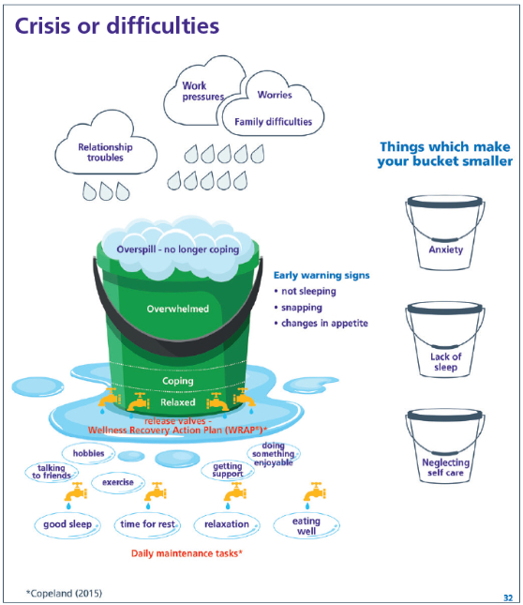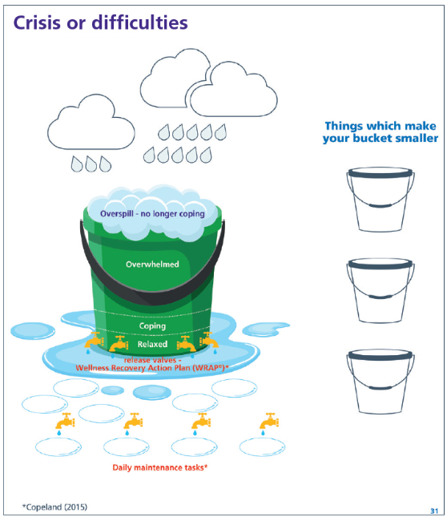

Examples of self-care activities

Making / Creating
Baking/Cooking
Crafting
Making Music
Crochet
Learn something new
Active
Walking
Dance
Letting off steam
Laughter/humour
Yoga/Pilates
Sport

Calming / Soul Soothing
Spiritual healing
Listening to music
Relaxation Techniques
Warm Bath
Aromatherapy
Meditation
Out and About
Cinema
Spend Time with Friends
Day Trips/Holiday
Board game events

Tech Activities
Coding
Podcasts
Online Gaming
Watch Youtube, TV, Film

Some relaxation exercises

Simple breathing exercise
When we are stressed or tense, we often breathe too fast or shallow, making things worse. We can end up with too much carbon dioxide in our lungs, which can make us feel dizzy and increase anxiety.

If you are feeling anxious, check that you are not breathing too fast or too shallow. Sit and put one hand on your stomach and the other on your chest. When you breathe in, your stomach should rise and when you breathe out, your stomach should fall. The hand on your chest should not move.

The following breathing exercise is a simple technique that will help slow and deepen your breathing. It’s a technique you can use at any time, in any place.

- Empty your lungs, then breathe in smoothly through your nose to the slow count of four and allow your stomach to swell.
- Then breathe out just as smoothly to the slow count of six.
- Try to get a rhythm going, counting to four on the in-breath and to six on the out breath.
- You may feel that you’re not getting enough air, but it is important to resist the urge to gulp. With regular practice this slower rate of breathing will feel more comfortable.

Body scan
Sit or lie down with your legs outstretched and your arms at your side. Feel the alignment of your body as a whole.

Feel the chair or floor support your body. Relax; try not to achieve anything.

Pay close attention with an open and receptive mind.

Notice sensations as precisely as you can, but remember you are not for or against whatever you feel.

There is no right or wrong thing to feel.

Focus your attention on the toes of your left foot.

Beware of the sensations; temperature, touch, moisture and air current. Let your attention rest there for about 30 seconds.

As you slowly inhale, move your attention to the bottom of your foot.

Again, rest your attention there for around 30 seconds; notice the sensations.

Then move to the top of your foot. Then the ankle and the lower leg all the way up to your left hip and then start again with the toes of your right foot.

Scan your whole body this way. If you do not feel any sensations, be comfortable with that and do not create any.

Sending thoughts away on clouds
Start by observing your breathing without trying to change it. Notice the sensations of breathing air in and out of your body. Try to focus all your attention on your breathing.

As you breathe, close your eyes and imagine that you are lying on soft grass, looking up at a clear, blue sky.

Let your mind become as clear and empty as a perfect blue sky

If any thoughts drift into your mind, imagine breathing them out so that each thought forms a cloud that you can send blowing across the clear blue sky.

Allow your thoughts to drift away from you, like clouds across the sky, until your mind becomes empty again – only filled by the image of a clear blue sky

Words from carers

Throughout this booklet, you will have noticed various quotes supporting some of the points. These are direct quotes from other carers who have helped us to develop this booklet.

Below, you will find more hints and tips from those who have faced similar challenges.

Tip 1: Be consistent:
“There are a lot of times where my partner found it hard because I’ve been inconsistent. I’ve said I’ll do one thing and then I do something else. If I say I’ll be home at 11:00 o’clock, I need to make sure I actually mean that. Because if I then get home at 11:30, that’s a massive inconsistency for him and he gets anxious or distressed and can’t trust what I’m saying.”

Tip 2: Don’t underestimate the power of empathy:
“That was the most powerful thing I saw… It sounds like common sense to say… Put yourself into the shoes of somebody who’s struggling with their mental health.”

Tip 3: Time and space for self-care are essential:
“Find something that’s just for you.”

Tip 4: It’s common to feel lonely
“Sometimes you think horrible things about the person you’re caring for and it doesn’t mean you don’t care for them and don’t love them, but you just think “Oh my God, I wish this wasn’t happening.” Other people feel that as well. And having someone else say that, it’s like, good. I’m glad I’m not the only one.”
“Even if it feels like it, you’re not to blame for everything.”
“Open up and talk about it with someone - a friend, colleague, your GP or a helpline. Be kind to yourself. Try to connect with others through activities such as volunteering or parkrun.”

Extra support
Everyone needs extra help at times. Friends and family can be well meaning and supportive but may lack experience. They may not know what it is like to care for someone with complex emotional needs on a daily basis. This is why it is good to meet up with people who do know what it is like and who “get it”.

It is a sign of strength to ask for support, whether you need it for yourself as a carer or to better understand the person you care for. Whatever the reason, there are many types of support that may suit you.

Peer support
Many people find it helpful to talk to others who understand their situation and get tips on how others have handled similar situations. You can do this face to face or online.
“Sometimes you’re like… ‘I am so angry with you right now’. And I really wish you weren’t here. And I really wish I didn’t have to deal with this… Having someone else to talk to about that, who gets that feeling… it’s like… I’m glad I’m not the only one.”

Carer groups
EMERGE Leeds, in partnership with Carers Leeds, runs two groups that friends, family and supporters of those with complex emotional needs or a ‘personality disorder’ diagnosis can access. The people they care for do not have to be using services.

Andromeda
A monthly peer support group that runs both online and in person. It offers carers the time to chat and share experiences with other carers, to get information and advice, and to focus on their wellbeing.

Cygnus
A five-week course. It offers advice and support on a variety of topics for carers.

Topics covered include:
- What does the diagnosis ‘personality disorder’ mean?
- What can be helpful for people who have complex emotional needs?
- Ways of offering support to someone with complex emotional needs.

For more information or to book your place, please email EMERGE carers.

You can also visit the Support for Carers page on the EMERGE Leeds website.

Talking therapy
Not everyone feels comfortable in groups of people so may be more comfortable with one-to-one support. You can access talking therapy through your local NHS services. Your GP is often able to signpost or refer you.
“If someone offers you any kind of opportunity to talk… take it!”

Registered therapists
Some websites to find registered therapists working privately include:
- The British Association for Counselling and Psychotherapy
- The British Association for Behavioural and Cognitive Psychotherapies
- The British Psychological Society

Summary
Carers support people struggling with a ‘personality disorder’, complex emotional needs, or whichever term they best identify with. Diagnosis can be a positive or negative experience for the person you care for, so it is important to use the terminology that they prefer.

Complex emotional needs affect how a person relates to themselves and others. Their ability to cope with emotions is also impacted. They may have long term difficulties with their sense of self and identity and developing and maintaining relationships. They can experience intense emotions and impulsivity.

Carers recommend being consistent and having empathy for the person they care for. They also recommend making time for self-care and taking steps to reduce their own loneliness. Connecting with other carers who understand your situation can be helpful. There are groups and resources available where you can do this, to help feel less alone and receive support and practical advice.

Additional resources for carers
Carers have recommended the following books and websites. Leeds Personality Disorder Services have not reviewed them.

Books
- Bon Dobbs (2015, 2nd Edition). When hope is not enough: a how-to guide for living with someone with borderline ‘Personality Disorder’
- Freda B. Friedman and Kimberlee Roth (2005). Surviving a Borderline Parent: How to Heal Your Childhood Wounds and Build Trust, Boundaries, and Self-Esteem
- Alan Fruzzetti (2006). High-conflict couple: a dialectical behaviour therapy guide to finding peace, intimacy and validation
- Randy Kreger and Paul Mason (2021, 3rd edition). Stop Walking on Eggshells: Taking Your Life Back When Someone You Care about Has Borderline ‘Personality Disorder’
- Randy Kreger (2008). The Essential Family Guide to Borderline ‘Personality Disorder’: New Tools and Techniques to Stop Walking on Eggshells
- Jerold Kreisman and Hal Straus (1991). I Hate You Don’t Leave Me: Understanding the Borderline Personality
- Shari Manning (2001). Loving Someone with Borderline ‘Personality Disorder’: How to Keep Out-of-Control Emotions from Destroying Your Relationship
- Valerie Porr (2011). Overcoming Borderline ‘Personality Disorder’: A Family Guide for Healing and Change

Useful websites for carers
- Carers UK
- Carers Trust
- Rethink Mental Illness - Our Services
- Carer's Allowance
- Carers Leeds

Information about ‘personality disorders’
- Mind
- Out of the Fog
- Mind - Personality Disorders

Mental health legislation
Government's Legislation website contains information about the Mental Health Act 1983 and amendments and information about the Mental Capacity Act 2005.

Wellbeing and self-care
- Wellness Recovery Action Plan
- Get Self Help

Medication
Choice and Medication website for Leeds and York Partnership NHS Foundation Trust

Talking treatments
- NHS Talking Therapies
- The Consortium of Therapeutic Communities
- British Association for Behavioural and Cognitive Psychotherapies - What is Cognitive Behavioral Therapy
- Understanding Schema Therapy
- The Royal College of Occupational Therapists
- Association for Cognitive Analytic Therapy
- Mentalization Based Therapy (MBT)

Self-harm
- National Self Harm Network
- Battle scars
- Life Signs - Self-Injury Guidance and Network Support

Substance use
- Talk to Frank
- Forward Leeds

Self-help
- Headspace - Mindfulness Meditation

Crisis
If there is immediate risk of harm, injury, or risk call 999.

Places to call
- Samaritans - Call: 116 123.
- Mindwell - Need Urgent Help.
- MindMate (support for under 18 year olds) – Urgent help.
- Leeds Survivor-led Crisis Service, which can also support deaf people using British Sign Language.
- Call NHS 111.
- Night Owls – overnight West Yorkshire and Barnsley Listening and Advice Service

Face-to-face help
- GP emergency appointment. Ask to talk to the first available GP.
- Here For You: out of hours support in a safe space.
- Dial House is a sanctuary offering emotional and practical support to people, aged 16 and above, in crisis.
- Dial House at Touchstone, for people from culturally diverse backgrounds.

Support by text of online chat
- Leeds Survivor-led Crisis Service
- Shout text service – Text SHOUT to 85258 (free) for 24-hour support.
- Signhealth Crisis Text Service for deaf people – Text DEAF to 85258 (free) for 24-hour support.
- NHS 111 online

Feelings

Emotion wheel
A six‑segment emotion wheel showing how core emotions: fear, anger, sadness, surprise, joy, and love, expand into more specific emotional states, designed to support emotional awareness, reflection, and communication.
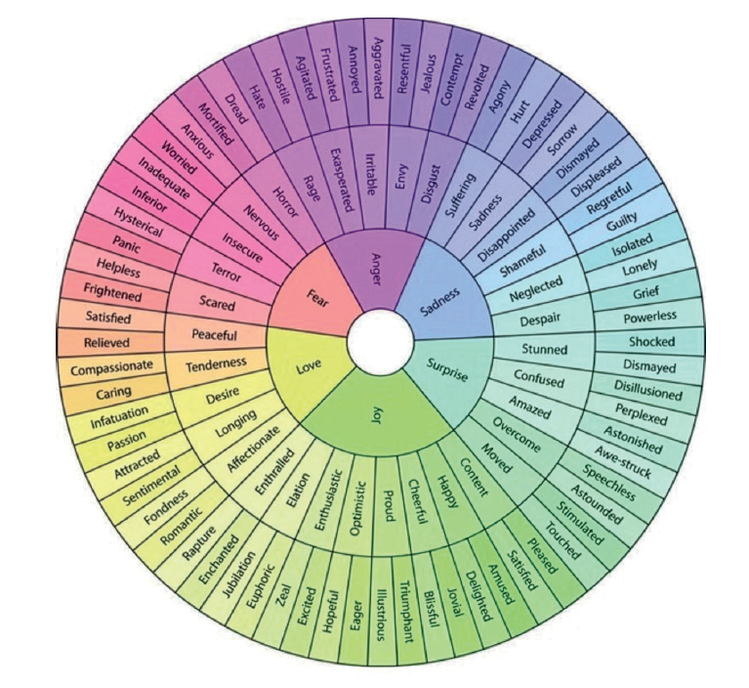
Examples of commonly used negative words that are shortcuts to feelings:
Abandoned
Forgotten
Suffocated
Attacked
Ignored
Taken for granted
Blamed
Insulted
Trapped
Criticised
Judged
Unappreciated
Disregarded
Stupid
Unheard

Safety plan

This safety plan has been adapted from templates used by Mersey Care NHS Foundation and Heads Above the Wave for people who self-harm. The person you care for may find it helpful to make their own, and you could try to do it together. It doesn’t all have to be filled in at once and can always be changed. Example answers have been included under each section.

What are the warning signs or feelings that I might self-harm?
I feel anxious
I feel overwhelmed
I try to do lots of tasks at once

Is there anything I can do right now to keep myself safe?
I could distract myself by going outside for a walk
I could tell someone I’m not feeling well

Is there anything anyone else could do to help keep me safe?
They could be in the same room as me but not interacting directly with me
They could be reading while I’m listening to music

Coping strategies I can try that help me feel better
Listening to music cheers me up
I like to move so I will try some gentle stretches
I will focus on my breathing

Things that make me feel worse
Being asked questions

Being told to stay positive

If my best friend was feeling like this, what would I say to them?
I would say: “This feels awful right now and that’s ok, but this feeling won’t last forever”

I’d tell them they’ve survived all their bad days so far and can get through this. I’d try to say this
to myself too

What is one thing that is important to me and worth living for right now?
My cat, my friends and going away next month

Who can I speak to and ask for help right now? Who can I call that will be able to
distract me?
Friend

Family member

Teacher

Helpline

Where is my self place I can go to in an EMERGEncy? How can I safely get there?
What do I need to take with me?
I can go to my partner’s house where it’s quiet and calm

I can cycle there or take a taxi

I need to take my phone, charger, headphones and medication with me

Contact information and acknowledgements

Contact
EMERGE Leeds: Complex Emotional Needs Service
Poplar House
St. Mary’s Hospital
Green Hill Road
Leeds
LS12 3QE
Call: 0113 855 7950
Email the EMERGE carers inbox
Visit the Support for Carers page.

Development Team
- Lorna Pankethman
- Alice Holland
- Anna MacRae
- Faye Cox
- Poppy Underwood
- Stephanie Smith
With special thanks to the six carers who gave up their time to be interviewed about their experiences of caring for someone with complex emotional needs. They shared tips and advice which have helped them along the way. Their insights have been essential for the development of this booklet.

References

- Southwark Carers (n.d.). 8 common misconceptions about being a carer. Accessed 22 August 2024. Available from: Southwark Carers – 8 common misconceptions about being a carer
- NHS England (2014). Commissioning for Carers: Principles and resources to support effective commissioning for adult and young carers. Available from: NHS England – Commissioning for Carers guidance
- Bolton, W., Lovell, K., Morgan, L., & Wood, H. (2014). Working effectively to support people with personality disorder in the community. Available from: Tavistock and Portman – Meeting the Challenge report
- World Health Organization (2019). International statistical classification of diseases and related health problems (11th ed.). Available from: WHO – ICD-11 online
- Mind (2020). About Personality Disorders. Accessed 22 August 2024. Available from: Mind – About personality disorders
- American Psychiatric Association (2022). Diagnostic and Statistical Manual of Mental Disorders (5th ed.). Available from: APA – DSM-5-TR online information
- Engel, G.L. (1977). The need for a new medical model: a challenge for biomedicine. Science, 196(4286), 129–136.
- MindWell Leeds (2023). What is self-harm? Accessed 23 October 2024. Available from: MindWell – What is self-harm?
- Rethink Mental Illness (2023). Self-harm – what you need to know. Accessed 30 August 2024. Available from: Rethink – Self-harm information
- British Thyroid Foundation (2022). Living with a thyroid condition: Looking after your psychological wellbeing. Available from: British Thyroid Foundation – Psychological wellbeing and thyroid conditions
- Brabban, A., & Turkington, D. (2002). The search for meaning: Detecting congruence between life events, underlying schema and psychotic symptoms. In A Casebook of Cognitive Therapy for Psychosis (pp. 59–75).
- South West Yorkshire Partnership NHS Foundation Trust (2021). My self-care plan. Available from: SWYPFT – My self-care plan
- MindWell Leeds (2024). Finding support in a mental health crisis. Accessed 22 August 2024. Available from: MindWell – Finding support in a mental health crisis
- David Hodder (2021). Emotion and feeling wheel. Accessed 12 September 2024. Available from: David Hodder – Emotion and feeling wheel
- Mersey Care NHS Foundation Trust (2017). Safety Planning Flashcard. Accessed 16 October 2024. Available from: Mersey Care – Person-centred safety planning
- Heads Above the Wave (n.d.). Self-harm Safety Plan. Accessed 16 October 2024. Available from: Heads Above the Wave – Self-harm safety plan (PDF)

