**Have Your Say Feedback April-June 2024**

‘Have Your Say’ is a way for people who access our service to have their voice heard and give feedback on their experience. The feedback questionnaire has questions produced jointly by service users, carers and staff asking about experience of care to gather anonymous patient feedback. Below are the feedback data received between April and June 2024, specifically for Leeds Gender Identity Service.

**Respondents were asked ‘Overall how was your experience of our service?’ with the response options Very Good, Good, OK, Bad, Very Bad and Don’t Know.**

Out of all the feedback given (n=216), 95.3% (n=205) was positive feedback, <1% (n=3) was negative feedback, 2.38% (n=5) was OK/Don’t know, and <2.32% (n=5) was comment only feedback.

**Distribution of responses each month with the categories Positive, Ok / Don’t know, and Negative.**

**Feedback**

**Positive comments**

*Good communication*

Good, positive communications. Previous goals were discussed and new positive one were set in place. Appointments with other members within the department were discussed and adjusted, new appointments were also discussed and set.

*Listened to*

Listened to my opinions and history and was kind and courteous. Ensured I was confident in myself and my identity and provided necessary information and support

*Helpful*

Excellent staff, understanding, helpful, set any anxieties about my care at ease. Always willing to explain in detail and if they don't know the answer, willing to say as much as find out for you from someone who does.

*Satisfaction*

The care I have received has made me feel so much better about myself, I don't feel ashamed of my body, I no longer try to cover up or hide away.

*No need to travel*

Good and easy to understand communication, don't have to travel to Leeds

*Medications*

Thoroughly explained the side effects and possible changes that taking hormones can cause, and was lovely to talk to during the session

*Understanding and helpful*

Named professionals have been very respectful and understanding, as well as explaining the options I have along with the processes that will come with those options.

*Transparent*

Very helpful, willing to listen and discuss what's best. Transparent about best options and risks/downsides. Understanding of complex life situations.

**Negative comments and suggestions**

Instead, or as well as the letter invitation to appointment, send an email with the link to video chat, sometimes the letter goes in a pile and I cannot find which link I should use as it differs for named professional or with the prescribing doctor, whereas if it was over email I could search it up a lot easier and quicker. and ecofriendly!

**Thank you for your suggestion.**

**Currently you can request appointment letters to be sent either by post or e mail and in addition we can send appointment text reminders.**

**We are also currently working on creating a video guide to our appointments, explaining about the different appointment links with different health professionals who make up the team.**

***In line with the above, please find below the instructions on how to access the consent form to receive emails and notifications from our service.***

1. ***Access the Gender Identity Service website***
2. ***Scroll down until “An important note about contacting us”***
3. ***Click on “service user communication consent form”***
4. ***Let us know if you just want post by email only.***
5. ***Complete the form and send it to the following email*** [***gid.lypft@nhs.net***](mailto:gid.lypft@nhs.net)***.***

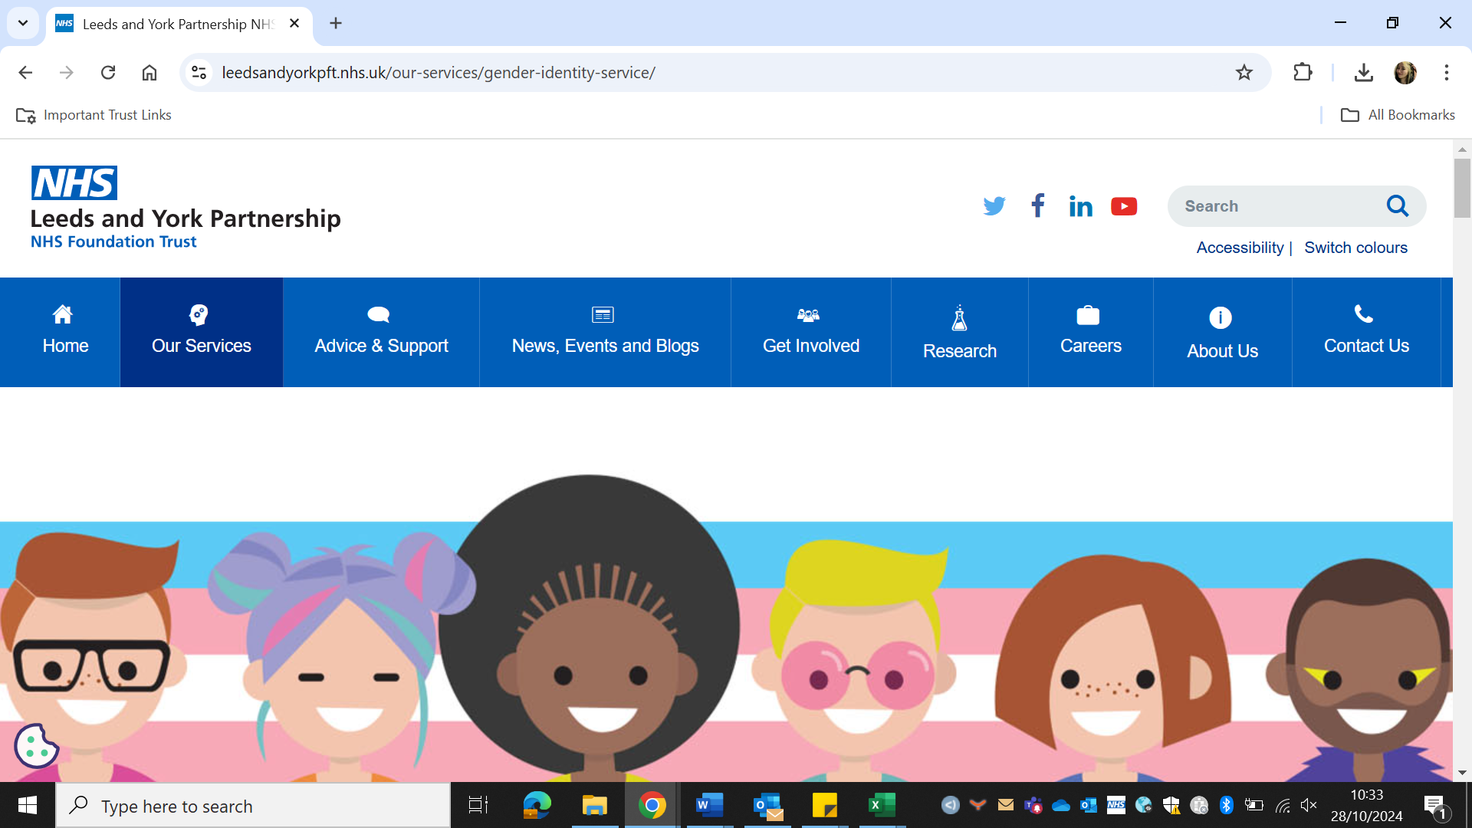

The huge wait times for everything on the GIS are just deadly, I'm not sure what the service could do to improve this without a large increase in capacity.

**We know the waiting times for our service are long, and we are really sorry that this is the current experience. Although we only have a set resource, we are working on ways to maximise the resource that we do have, for example working on how we can maximise attendance at appointments through ensuring that letters are sent out with notice, increasing use of text reminders and being clearer on our did not attend procedure. With the consent of people we are working with, we are also trying to reduce appointments where there feels to be little benefit to try to increase our capacity e.g. post referral for surgery, by introducing out Patient Initiated Follow up (PIFU) process.**