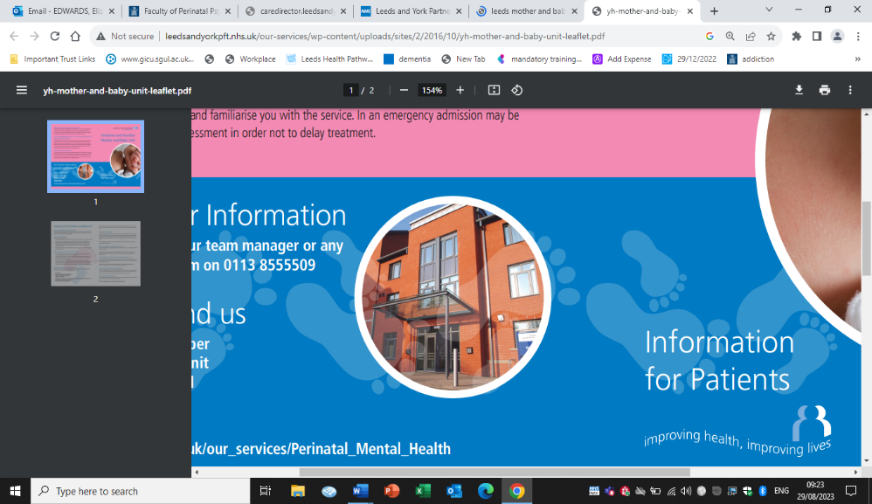

Yorkshire & Humber Mother & Baby Unit

Tips for completing MBU referral form.

1. **Supporting Documentation**

## Please send referrals with recent clinic letters, previous discharge summaries, and risk assessment



1. **Mental State Exam**

## Please include a detailed mental state examination including symptoms relating to infant and capacity to consent for admission.

## describe patient’s symptomatology in detail

**4. Parental Responsibility**

### Please document both parents under the parental responsibility (PR) section, and tick if partner has PR.

#### Partner must be consenting for baby to be admitted if they hold PR.



1. **Safeguarding & Child Protection**

## Please ensure any safeguarding or child protection issues are explained in detail including named social workers and contact details – this is to ensure admission is safe and appropriate.

## If there is an allocated social worker – please check, they have approved admission to MBU.



1. **Smoking**

## The trust has a strict no smoking policy, and leave cannot be granted for smoking.

## Please include details of smoking status and check patient is aware of policy and consenting.

