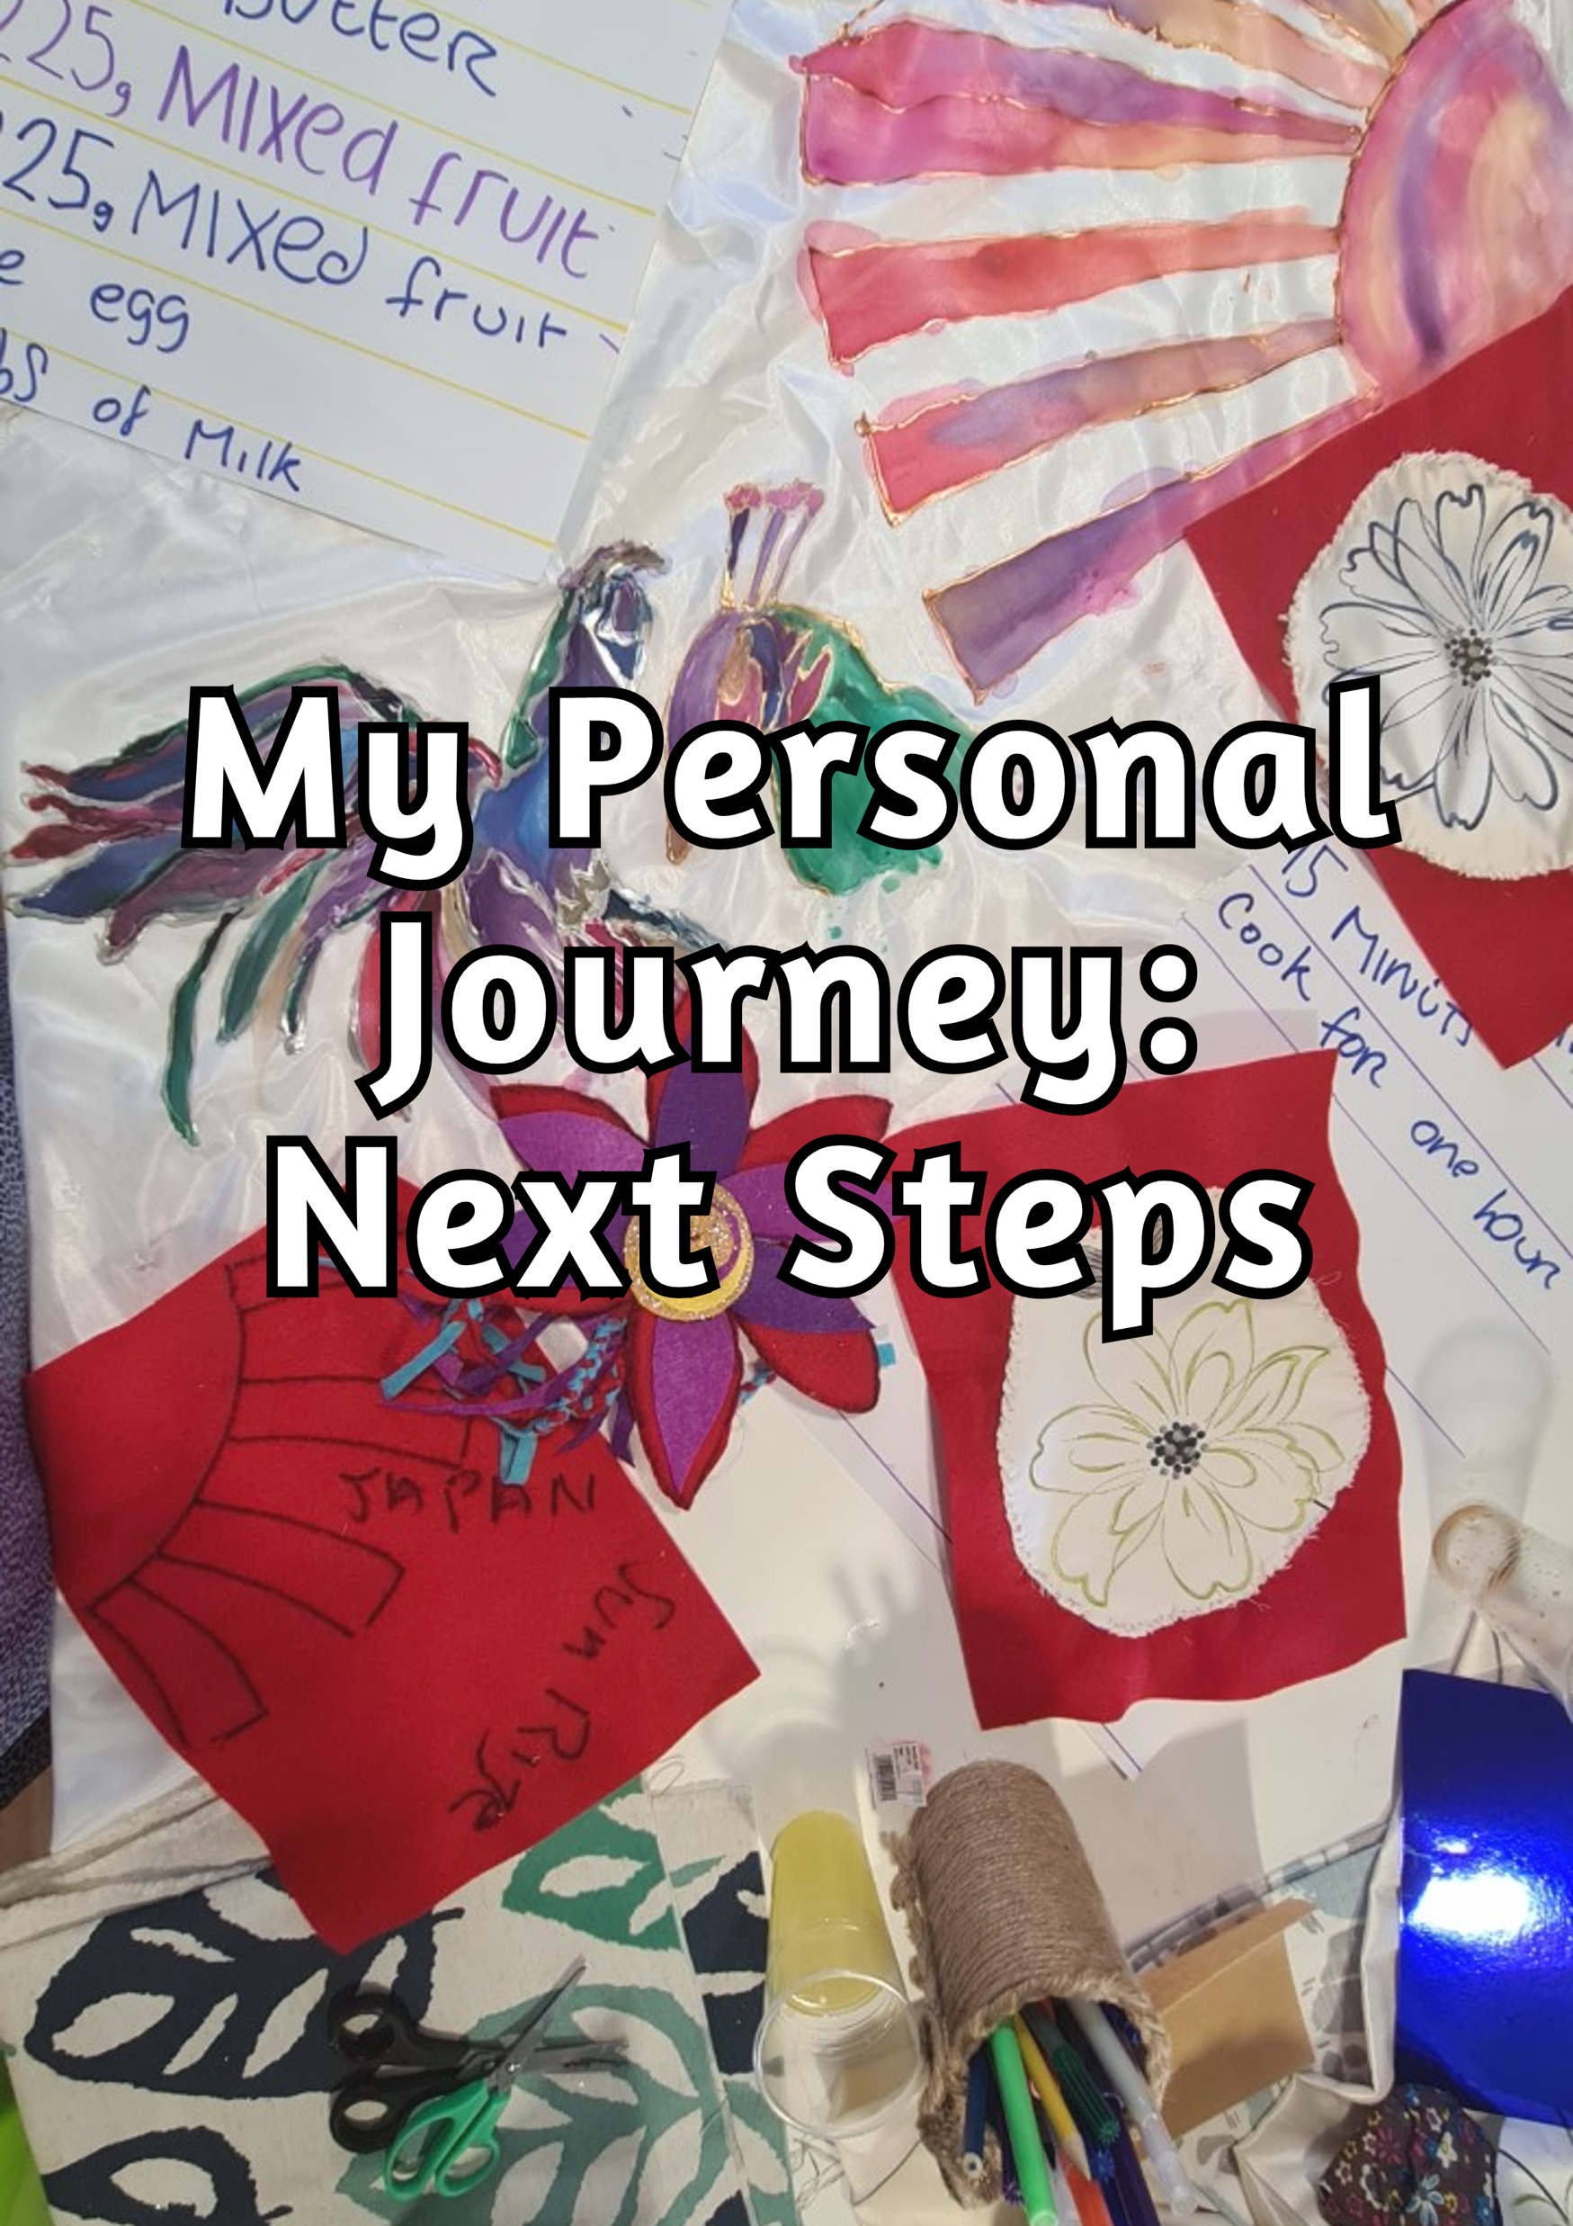

My Personal Journey: Next Steps has been written by the Peer Recovery Workers from CREST, with the help of patients from hospitals across Yorkshire. This means that everyone who has played a part in its creation has had their own experience of mental health challenges and getting mental health support, and so we hope that this will make My Personal Journey: Next Steps more relevant to you and your experiences and journey back to the community.
The booklet has been put together as a ‘working document’, which means that it will stay with you whilst you’re working with CREST, and it can keep changing and developing as you adapt and adjust to community life again. Remember – something that is right for you while you’re in hospital might not be right for you on your first day out of hospital, which might be different again a year down the line! Because of this, you can change your answers whenever you want to, so that My Personal Journey: Next Steps stays accurate no matter what happens.
The questions in My Personal Journey: Next Steps have been written with your rehab goals in mind. You might find that some of the questions aren’t relevant to you, and if that’s the case then that’s absolutely fine – just don’t answer those ones! But this booklet can help CREST to understand your strengths as well as what you might need some help with, and it will also help you recognise what you’re already good at, as well as identifying what we can help you with and set some goals for the future.
My Personal Journey: Next Steps is designed to be flexible to your own needs. It is also written for you, not for CREST staff. Because of this, if there is something in the booklet that you would like to change, please let us know and we will do our best to do this.
We hope that My Personal Journey: Next Steps will help you to move forwards from your time in hospital, as well as helping CREST to understand you; your likes and dislikes; your needs and goals; so that we can support you in a way which will work best for you.

Introducing: ________________________
A bit about myself, my likes, hobbies and interests:

Some hobbies I would like to learn/try are:

Things in my day-to-day life that are important:
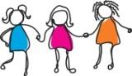  Family and/or friends | Staying in  contact with  people | 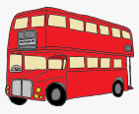  Having a  bus pass | Personal  hygiene
Clothing | 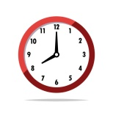  Having a  daily routine | 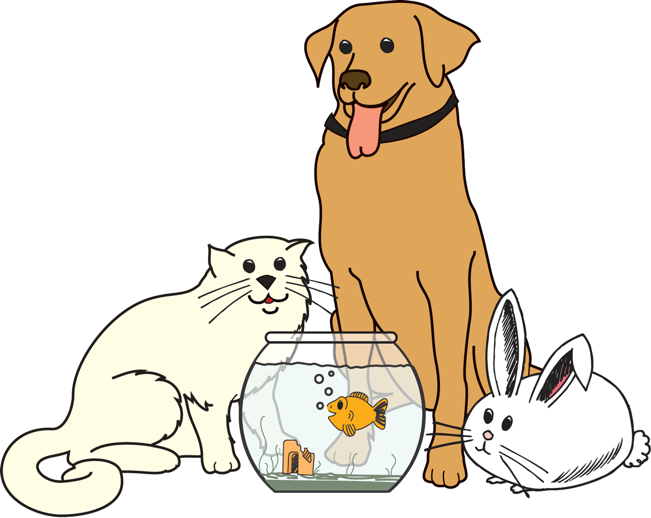  Pets | 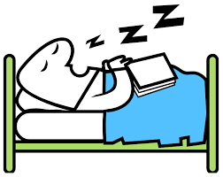  Getting a good night’s  sleep
Other:

Things in my day-to-day life that I might need help with:
Managing finances | 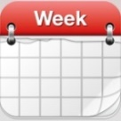  Planning  my week | 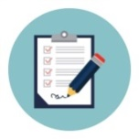  Filling in  Forms (e.g.  housing/  benefits) | Managing  letters
Accessing  my money  easily  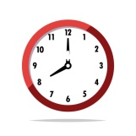 | Paying  bills | 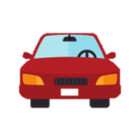  Getting  around | 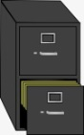  Storing  important  documents  safely
Having a  daily  routine | Personal  hygiene | Cooking | 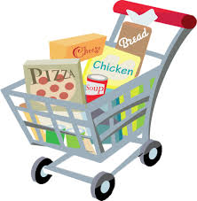  Shopping
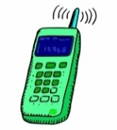  Making important  phone calls | 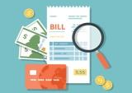  Understanding bills | Understanding letters | 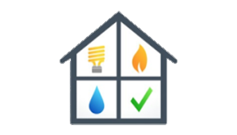  Contacting gas,  electric, and  water  companies
Going to  the Job  Centre | Using  self-service checkouts | Making sure that my benefits  are paid  correctly | 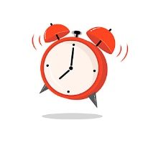  Being on  time for  visits
Other:

Places I like to go:
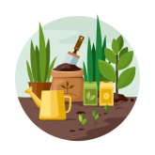  Allotments | Family and/  or friends’  homes | Supermarket | Nature  reserves
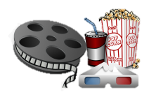  Cinema | 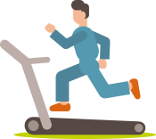  Gym | 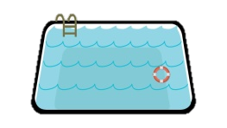  Leisure  centre | Parks
Clothing  shops | Hairdressers | Library | 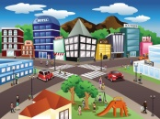  Town  centre
Other:

Are there any family and/or friends who support me?

Are there any people who I don’t want involved in my care?
Yes No
If yes, this is some information about them:

In the future, I would like to… (do I have any goals?):

Everyday life
Do I have any qualifications?

Are there any qualifications I would like to get?
Yes No
If yes, the qualification(s) I’d like to get are:

Would I like to do a basic skills course (For example, English and Maths)?
Yes No
If yes, the course(s) I’d like to do are:

If you would like to do a course or get a qualification but are not sure what you’d like to do one in, please let us know and we can get some information about courses to help you decide.

The IT skills I’m good at are:
Switching a  computer/  phone on  and off | Plugging in  the charger | 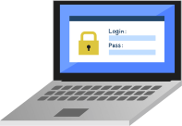  Logging in  and out
Connecting to  the internet | 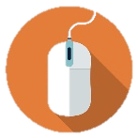  Using the  mouse/touch  screen | Using the  keyboard
Online  banking | Social  media | 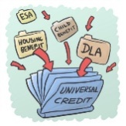  Applying for/  accessing  benefits
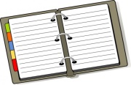  Booking  a GP  appointment | Online  Shopping | Using a  search  engine
Google  Maps | Ordering a  takeaway | Using a  calendar
Emailing | Antivirus  Software | Using video  chat software
Other:
The IT skills I’d like some help with are:
Switching a  computer/  phone on  and off | Plugging in  the charger | Logging in  and out
Connecting to  the internet | Using the  mouse/touch  screen | Using the  keyboard
Online  banking | Social  media | Applying for/  accessing  benefits
Booking  a GP  appointment | Online  Shopping | Using a  search  engine
Google  Maps | Ordering a  takeaway | Using a  calendar
Emailing | Antivirus  Software | Using video  chat software
Other:

What household tasks are achievable for me?
Food  shopping | 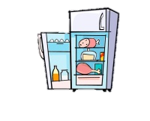  Food  storage | Cooking | 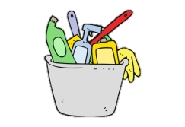  Cleaning  up after  cooking
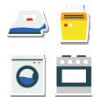  Maintaining appliances | 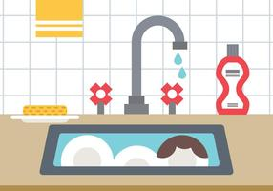  Washing  up | 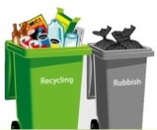  Taking  bins out | 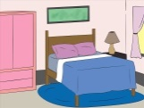  Tidying  living  spaces
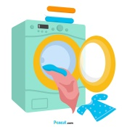  Laundry | 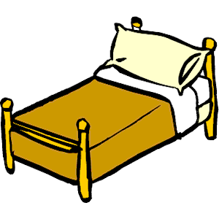  Changing  bedding | Cleaning bathrooms  and toilets | 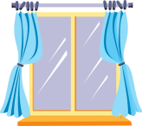  Cleaning  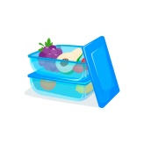  windows
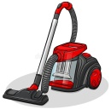  Hoovering | Dusting | Changing lightbulbs | Batch  cooking
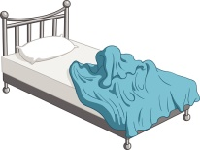  Making  the bed | 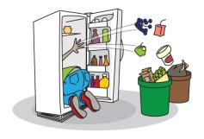  Cleaning  the fridge | 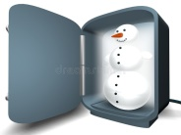  Defrosting  the freezer | Looking  after plants
Other:

What household tasks do I find challenging?
Food  shopping | Food  storage | Cooking | Cleaning  up after  cooking
Maintaining appliances | Washing  up | Taking  bins out | Tidying  living  spaces
Laundry | Changing  bedding | Cleaning bathrooms  and toilets | Cleaning  windows
Hoovering | Dusting | Changing lightbulbs | Batch  cooking
Making  the bed | Cleaning  the fridge | Defrosting  the freezer | Looking  after plants
Other:

Circle the answers which are correct for you:
How do I feel about using gas and electricity safely in my home? | Confident | Unconfident
How do I feel about finding information and support about fire safety? | Confident | Unconfident
How do I feel about budgeting my money? | Confident | Unconfident

Do I get benefits?
Yes No
The benefits I may be entitled to are:
Personal Independence Payment (PIP) | Employment Support Allowance (ESA) | Housing Benefit
Free Bus Pass | Universal Credit | Jobseeker’s Allowance
Warm Home Discount | Council tax reduction | Other:

Would I like support to apply for these?
Yes No

Is there anything I am interested in getting involved in (for example, gyms, classes, social groups)?

Would I like to get involved with volunteering?
Yes No

Looking after my body
Do I have any long-term illnesses?
Yes No
If yes, what are they?

Will these make it more challenging for me to get out and about?
Yes No Maybe
What would make it easier for me to be able to get out and about?

I like to get ____hours of sleep.

My dietary needs are:

I am allergic to:

How many covid jabs have I had?
0 1 2 3

Do I drink alcohol, take drugs, or smoke?
Yes No

If so, I can manage my cravings by:

I would like some support with these issues.
Yes No

Is there anything I would like to do to improve my health?

To help me look after myself, these are the things that I need some help with:
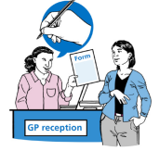  Registering  with a GP | 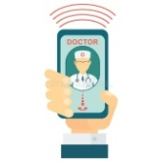  Contacting  the GP | Booking an  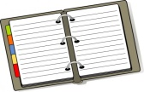  appointment | 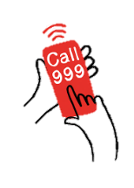  Contacting the emergency  services
Getting to and  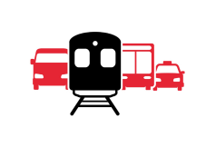  from appointments | 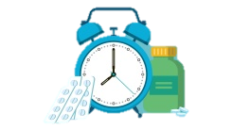  Taking my medication at the right times | 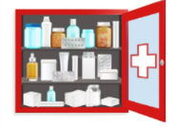  Storing my medication  safely | 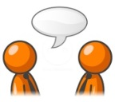  Understanding what professionals are saying to me
Other:

Looking after my mental health
A list of important contacts:
Name of person | Their job role | Contact information | When can I contact them?
Example: Fiona Smith | Care co-ordinator | 0113 200 0000 | Monday-Friday 9am-5pm

What helps me to manage day to day?

What makes me feel hopeful?

What has made my mental health worse in the past?

These are some things I feel and do when I’m becoming unwell:

These are some things I can do that help me to feel better:

My home
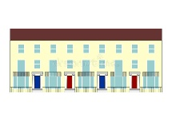
What type of home would I like to live in?
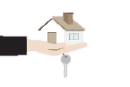  Supported  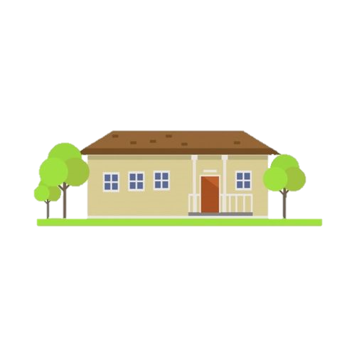  housing | Care  Home | 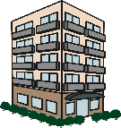  Flat | Terraced  House
Bungalow | 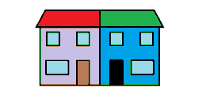  Semi-detached  house | Nursing  Home | 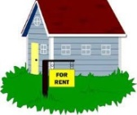  Private  tenancy
Housing association property  (council house) | 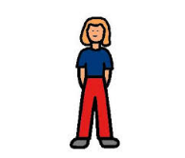  On my  own | 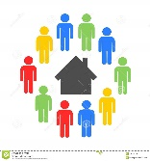  Shared  with  other  people | Other:

Areas that I would like to live in | Areas that I would not like to live in

What helps me to feel safe in my home?

How can people contact me if I need help? (Include phone contacts and how to access your home e.g. Key safe codes, key holders etc.)

Who is allowed to visit me and how often can they come?
Name of person | How often

It’s important to me that my home:
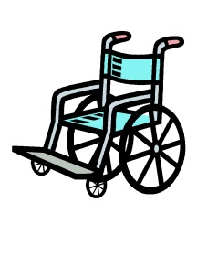  Is accessible for wheelchairs/  other  mobility  needs | Is in a  safe place | 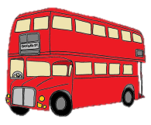  Is near good bus routes | 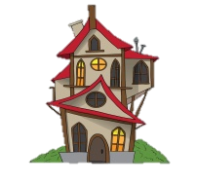  Is big enough that  I don’t  feel  cramped
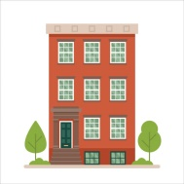  Is on the  _____ floor  of a block | Has access to  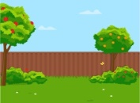  a garden/  outside  space | 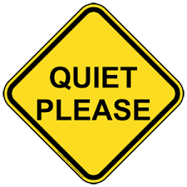  Is in a quiet  place | 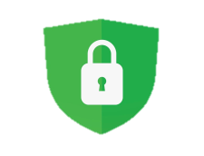  Has really good security
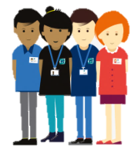  Has staff onsite  to support  me when  I need  them | Has a stable internet  connection | Lets in  plenty  of light | 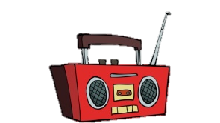  Is somewhere that I am allowed to play loud  music
Is near to parks  and/or  open  space | Has furniture  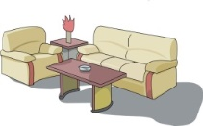  so that I don’t  need to  buy it | 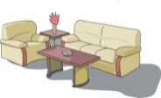  Has no furniture  so that I  can buy  my own | Is near  a shop
Other:
Which things do I need for my home that I don’t already have?

I would like some help to find these things.
Yes No

Getting around
Do I need some help with finding my way around the local area?
Yes No
What might be helpful?

Do I need help with travelling, for example using public transport?
Yes No

Do I get anxious when using public transport?
Yes No Sometimes
If yes, I can manage this by:

Some places which are important to me are:

The bus routes and times which will be most useful for me are:

Step by step instructions to get from _____________ to _________________

Step by step instructions to get from _____________ to _________________

Step by step instructions to get from _____________ to _________________

Step by step instructions to get from _____________ to _________________

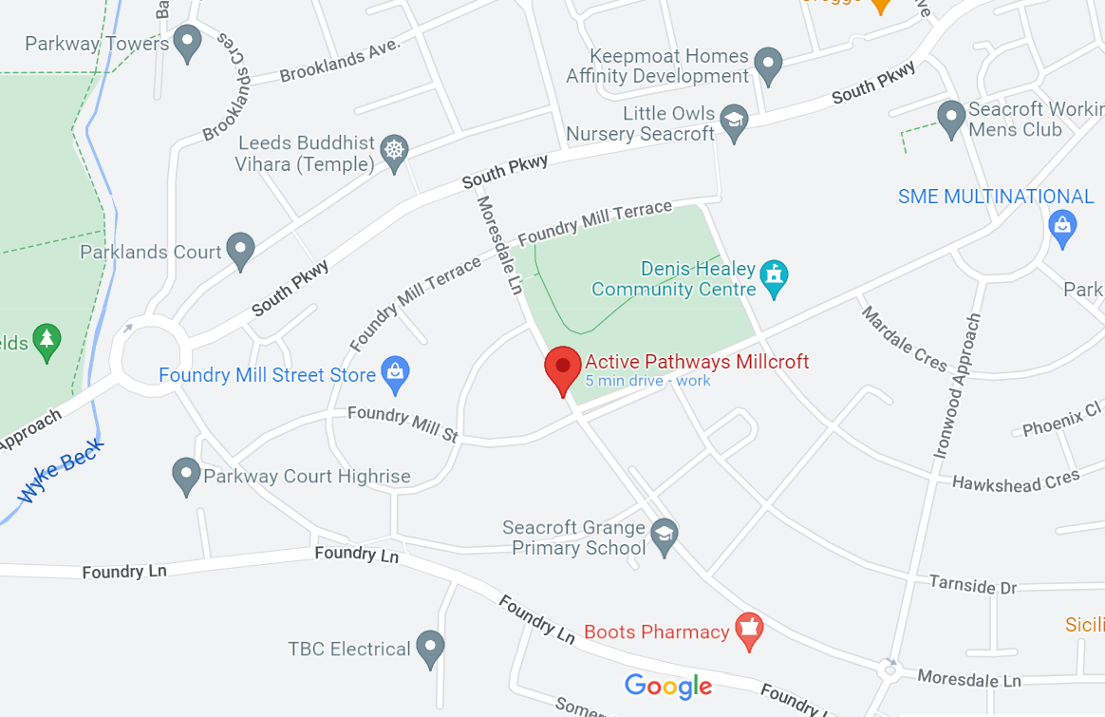
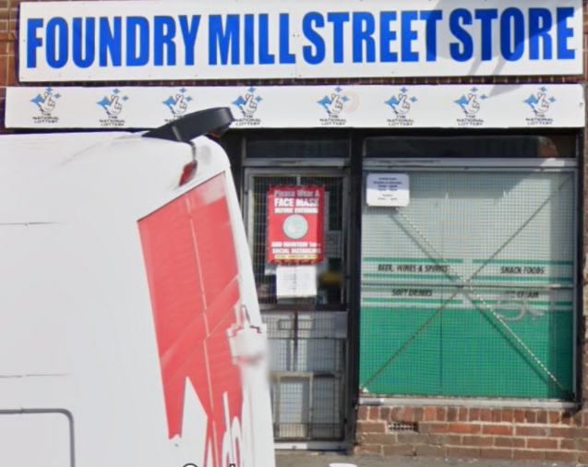
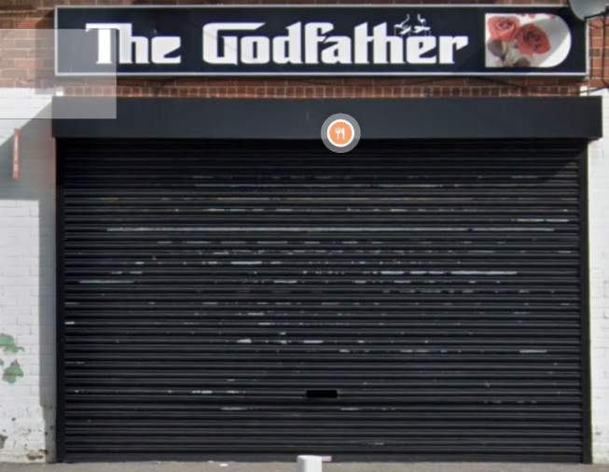
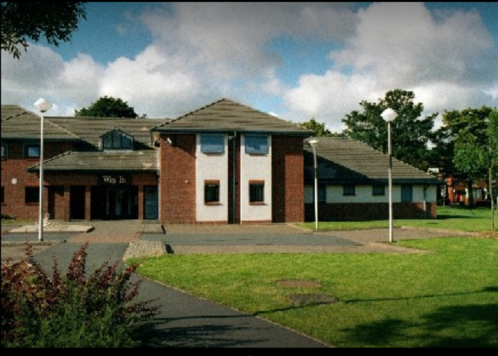
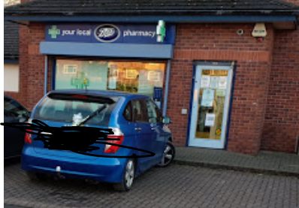
Temple
Doctor’s surgery
Park
Post Box
Shop
Take away
Bus stop

