YHPDP Annual Review 2021-2022

Contributors
Jo Ramsden, Consultant Clinical Psychologist, Co-author
Davina Patel, Senior Forensic Psychologist, Co-Author
Lizzie Finley, Assistant Psychologist, Co-Author

Max Ward, Principal Clinical Psychologist
Emma Palethorpe, Senior Forensic Psychologist
Lucy Siena, Clinical Psychologist
John Atkinson, Senior Forensic Psychologist
Leanne Myers, Senior Psychotherapist
Lisa Maltman, Senior Forensic Psychologist
Rebecca Triffitt, Senior Forensic Psychologist
Claire Cooper, National Probation Service North East Lead
Table of Contents
Contributors 1
Who/What is YHPDP? 3
Executive Summary 4
Core Offender Management Service (CORE-OM) 5
Re-setting and transitioning out of COVID-19 5
Personality Disorder Probation Officers (PDPOs) 7
HUB cover model 8
Joint Case Working Consultation 8
Activities data for the year 9
Intensive Integrated Risk Management Service (IIRMS) 11
Psychologically Informed Planned Environments (PIPES) 12
Humberside Enhanced Resettlement Service (HERS) 15
The Humberside Indeterminate Public Protection sentence Project (HIPPP) 17

Who/What is YHPDP?
Yorkshire/Humberside Personality Disorder Partnership (YHPDP) is a partnership organisation tasked with supporting the implementation of the national Offender Personality Disorder (OPD) Pathway in the Yorkshire/Humberside region.
YHPDP is the NHS (Leeds and York Partnership Foundation Trust) and the National Probation Service (NPS) working together to enhance the criminal justice management of high-risk offenders with characteristics we recognise to be consistent with ‘Personality Disorder’.
YHPDP is working to ensure that criminal justice risk management is “psychologically informed”. This means that those who are thinking about risk with an offender are more aware of how the offender is thinking and feeling and how they may act as a consequence.
YHPDP employs a range of professionals including Psychologists, Psychotherapists, Occupational Therapists, Probation Practitioners (PP’s), and Housing & re-settlement workers. We work to ensure risk management is psychologically informed through the following services, centred around co-production;
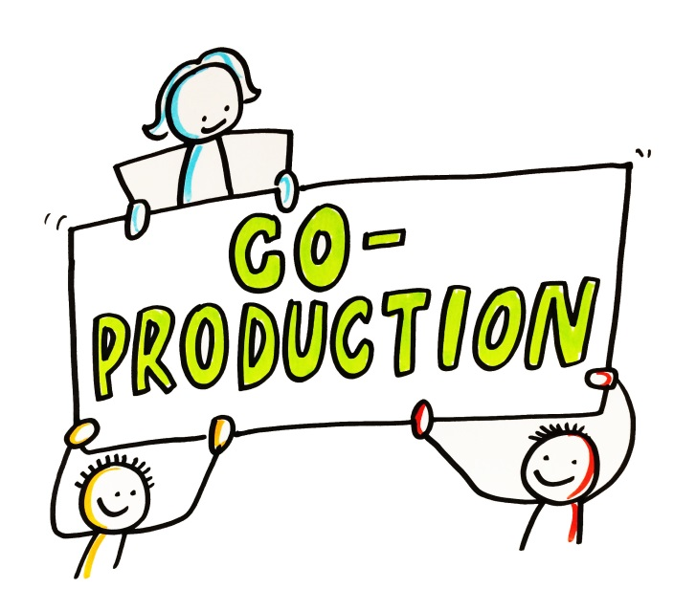
HIPPP (Humberside Indeterminate Public Protection Project)
We provide a bespoke service offering intensive support to PP’s and their management of offenders subject to Indeterminate sentences for Public Protection in Humberside. This can include consultation, formulation and joint working. HIPPP works to support psychological thinking within the whole system, to understand difficulties in pathway progression and learn about what works.
HERs (Humberside Enhanced Resettlement Service)
We provide appropriate accommodation and a wraparound support service to support their reintegration back into society in the Humberside area to PoP, who screen onto the OPD pathway, (and have had previous tenancy difficulties).

IIRMS (Intensive Integrative Risk Management services)
We provide a direct intervention service for both male and female offenders called Discovery. We work with offenders and their offender managers to support engagement and to think together about risk. We hope to support offenders’ therapeutic activities.

Psychologically Informed Planned Environments (PIPES)
We work in two specialist Approved Premises (AP) in York and Leeds. PIPES offer a range of activities to psychologically support therapeutic progress on the pathway.
CORE-OM
We provide a wraparound consultation service to PP’s, their teams, & their seniors to think about individual clients, to ‘formulate’ their difficulties and to plan for their pathways. We also work with Approved Premises (APs) probation hostels to plan for release and to ensure that the AP’s management of offenders is psychologically informed.

Executive Summary

This report summarises the work undertaken by YHPDP from April 2021-22, across our five main work streams. Although distinct, each work stream has an overlap this year, in that we have all been learning how to transition out of the changes that occurred during the COVID-19 pandemic. YHPDP has been thinking about the challenges as well as the opportunities that have arisen from this and we are keenly aware of how ‘transitions’ are closely held to the heart of the work we do in terms of trauma focussed and psychologically informed formulation. As such we have come together over the year for Team Development Days (TDDs) to hold this parallel in mind to support us in best transitioning, resetting, and re-energising our service for the future.
Resetting the service
Last year, April 2020 to 2021, there was a focus on adapting our practices in response to COVID-19. Although our overriding OPD Pathway CORE-OM task remained the same, our ways and means of doing the work were severely disrupted. One obvious difference being the switch to remote working from home. There were pros and cons to this in terms of efficiency and responsivity of our consultation work and for staff being, on the one hand, more present and available to provide support at home during a very difficult time whilst, on the other hand, finding themselves isolated from YHPDP colleagues and all the associated benefits of being part of a cohesive team.

This year, certainly in the later part as COVID-19 restrictions loosened, our attention turned to ‘resetting’. Resetting is the term we have adopted to describe the process of figuring out and operationalising what we want the service to look like in the future. Essentially, we think there are three parts to this. First, reflecting on and learning from the COVID-19 experience. Second, blending this learning during COVID-19 with how we worked previously (e.g. hybrid working). Third, supporting staff and the service generally to transition or move to this new position.

(Written by Dr Davina Patel, Forensic Psychologist, & Dr Max Ward, Lead Clinical Psychologist for CORE-OM)

Core Offender Management Service (CORE-OM)

Re-setting and transitioning out of COVID-19

Last year, April 2020 to 2021, there was a focus on adapting our practices in response to COVID-19. Although our overriding OPD Pathway CORE-OM task remained the same, our ways and means of doing the work were severely disrupted. This year, as pandemic restrictions loosened, our attention turned to ‘resetting’. Resetting is the term we have adopted to describe the process of figuring out and operationalising what we want the service to look like in the future.

Although positive and energised about this opportunity, it is important we continue to hold in mind just how challenging and impactful COVID-19 has been and that transitioning out of the experience will involve more upheaval and uncertainty, with energy levels and psychological capacity for change running low. As would be expected, this was and remains a feature in our wellbeing discussions and for our Team Development Days (TDD) in October and December 2021 and March 2022, which we were able to facilitate face to face.

In October, the main emphasis of the TDD was on supporting as many people as permitted at the time from across our workstreams and the partnership to come together in person. Understandably for many of us there was a mix of ‘positive’ and ‘not so positive’ feelings about being together face to face after such a long absence. Several staff who joined our services during COVID-19 were meeting colleagues in person for the first time. The morning session involved different ‘Geese Theatre Company’ exercises designed to help us engage or re-engage with each other. This ‘light touch’ approach enabled us to breakdown some of the inter-relational barriers that had been built up over the preceding two years in a way that felt purposeful and containing.

The December TDD again adopted a ‘light touch’, with this same primary overarching emphasis on ‘coming together’. The time was used to reflect on 1) ‘the story of us’ (we do this work because?), 2) ‘the story of now’ (what is going on now which influences our work and identities?), and 3) ‘call to action’ (what are our next steps and what do we think needs to change?). This exercise was designed to helped us reconnect with our service values and vision. The vision aspect being imagined differently, incorporating what we have learned from COVID-19. This was about “going back to basics” to help orientate us to how we want things to look in the future, shaped by what we have learnt from COVID-19.

We structured our discussions around the task of identifying:
- 3 key priorities (what do we need to do?)
- 3 innovations (how are we going to do it?)
- 3 risks (what are the main barriers?)
In doing this, we took into account:
- The ‘clinical’ task for each service area
- The re-setting task which we agreed is, essentially, about creating a sense of service identity, belonging and connectedness
- Related to the above, team engagement and staff wellbeing
- Our responsibility to address health inequalities

Building on this work, the TDD in March 2022 focused more exclusively on ‘action’, translating our values and vision into strategy and goals. In other words, the practicalities of re-setting e.g., ‘what is it that we need to do from a service provision point of view, how is it similar or different to pre-COVID-19 days, and then related to this, what will our individual job plans look like.’ There was a strong emphasis here on clearly operationalising the work we do and what will be different post COVID-19.

The feedback from the day was synthesized and written up for circulation. In summary, the three priorities that were identified across the YHPDP workstreams were:

1) review our operating procedures to reflect new post COVID-19 ways of working
2) clarify the needs/expectations for working on site
3) raise or reboot the work and profile of YHPDP across probation

All this will have prominence in our business aims and objectives and workforce development plan for the coming year.

There was a particular focus on having more closely integrated practices across the three workstreams with CORE-OM providing a more clearly operationalised wrap-around function. We agreed to set aside a subsequent TDD early in the new financial year to think and plan more precisely what this means. One idea that was already being worked on was CORE-OM and the core formulation playing a more active role in gate keeping all cases picked up by Discovery.

Perhaps brought into sharper focus during COVID-19, there was also renewed impetus for ensuring CORE-OM input regionally is consistent and equitable and that it operates within the national framework, whilst at the same time being responsive to local differences and needs. In essence 'what we offer' should be consistent' but 'how we offer this' in different areas or settings can be interpreted with some flexibility. And where there are local differences in provision, these should be agreed through consultation and in partnership and supported by a clear rationale; important for avoiding regional or demographic health inequalities. Our plans, as we move out of COVID-19, around re-contracting with PDUs will provide a forum for these developments to be discussed and agreed. What we learned from adapting our work during COVID-19 informed our thinking here.

The second priority, clarifying the need/expectations for working on site, is an issue that has been around throughout our COVID-19 resetting reflections. Discussing this openly within teams and individually with staff has felt important. By the time we met for the TDD in March, there was a strong collective desire to move from thinking to action i.e.: operationalising what we want hybrid working to look like for 1) team togetherness and cohesion and 2) individual job plans. The latter, for the CORE OM team, is partly about frequency of visits to PDUs and Approved Premises APs and partly about how we may want to use this time differently from pre-COVID-19 ways of working e.g.: more emphasis on combining team and individual consultation.
Particularly during the second six months to April 2022, there was an appetite for CORE-OM to come together as a team and with other YHPDP workstreams. This relates to the above points about team identity and cohesion and about having closer YHPDP integration and sense of shared purpose. Unfortunately, due to on-going COVID-19 restrictions, it remained difficult to use Poplar House as a venue for this. Being able to fully utilise Poplar House is something we can look forward to in the coming financial year.
Raising or rebooting the profile of YHPDP across Probation was our third priority.
Plans were discussed for a proactive push to remind people what CORE OM is about and how it can be accessed and utilised. This will form part of ‘re-contracting’ with PDUs in the new financial year, reacquainting SPO colleagues with our work, what we can expect from each other, and inviting feedback about the resetting changes we are proposing as we move out of COVID-19.

Roadshows, briefings and other workforce development and engagement initiatives can be used alongside these PDU re-contracting meetings. All this will be outlined in our CORE OM workforce development strategy for the coming year.

What else …?

The adaptations we made in response to COVID-19 two years ago and the more recent emphasis on ‘resetting’ services has not prevented us from introducing or further embedding non-COVID-19 related Service developments.

Personality Disorder Probation Officers (PDPOs)

In the last Annual Review, we presented some feedback about the introduction of the split PDPO role working into CORE-OM. Since then, we have continued to learn about the scope and benefits of the role and importantly how they can be best supported. Although the role is not defined by this task, they have played a big part in completing caseload reviews. Caseload reviews facilitate much better monitoring and oversight of all OPD Pathway screened in cases across the region. We feel confident that this process better enables PPs to keep abreast of the risks and needs of their OPD Pathway cases and to make balanced decisions about who would benefit from consultation and core formulation and those not requiring the Service.

Towards the end of this financial year two PPs, two clinicians, and two PDPOs were interviewed about their experiences of the caseload review process for an evaluation. We had received a lot of anecdotal feedback and wanted to anchor this is something more robust that could be used to fine tune the approach we take in the future, including how frequently we think caseload reviews should happen.

Overall, participants felt that it helped improve relationships between YHPDP and PPs. It was seen as particularly beneficial in engaging PPs who had limited or no prior involvement with the Pathway. At the very least, it provides some opportunity for contact and OPD Pathway caseload oversight that would be absent otherwise.

As is often the case when new ways of working are first introduced, it was time consuming and there were aspects such as “chasing PPs” that felt overly administrative and onerous. As the work embeds, and people become more familiar with the process, we expect this to improve. For PDPOs, who were relatively new to CORE-OM at the time, it helped orientate them to the work of CORE-OM quicker than may have been the case otherwise.

PDPOs have also helped our thinking around and response to ‘reunification’. Reunification was in July 2021 and involved the reintegration of Community Rehabilitation Companies (CRCs) back into the public sector National Probation Service (NPS). As a result, the NPS caseload increased significantly. In the months following, we were anticipating a corresponding sharp increase in ‘screened on’ cases and requests for consultations, possibly exceeding our capacity to pick up the work, but this did not materialise.

However, reunification has meant a significant influx of new probation staff, legacy CRC employees, many of whom had no knowledge of the OPD Pathway from prior to the Transforming Rehabilitation reforms split the organisation back in 2014. Again, our PDPOs were pivotal in planning and rolling out briefings to provide these staff with basic of the OPD Pathway to then access and take advantage of the routine consultation offer.

HUB cover model

Our Hub cover model, now well-established, was speedily re-introduced on more than one occasion during this period, we think illustrating the ability of CORE-OM to adapt and work flexibly in response to gaps in staffing across any area in the region. Although less reliant on it now COVID-19 redeployment is no longer an issue, it remains an important part of our contingency planning for, as far as possible, maintaining an accessible, responsive, and equitable service across the region. A focus group with PDPOs and clinicians is planned to gather some feedback about the utility of the model and ways in which it may be further improved.

Joint Case Working Consultation

After being put on hold during the first stages of COVID-19, our Joint Casework Consultation guidance was finished off and ratified through governance. Joint Casework Consultation is an important aspect of the clinician and PDPO consultation input, making up a significant proportion of the work. Essentially, it involves supporting PPs to take existing core formulations and apply them to the practicalities of offender management and pathway planning. It can include helping with OASys or PAROM reports, helping with MAPPA or IPP panel meetings, helping plan and maximise the benefits of supervision sessions, writing letters to a PoP or helping with referrals.

‘Mental health liaising’ is a form of Joint Casework Consultation we have been working on as part of our governance plan over this period. The aim here has been to develop better structures and processes for how CORE-OM consultation, referring to the core formulation, can be used to support relationships with and access to mental health services. We discussed this at a TDD & put together scoping brochures identifying mental health services in the different parts of the region, and are in the process of drawing up leaflets to 1) provide PPs with key information about liaising with mental health services and how CORE-OM can support this, and 2) provide mental health services with information about the OPD Pathway that may be important for them to be aware of, making discussions about supporting OPD Pathway cases a little easier from their perspective.

Following an appraisal of the data we routinely collect for CORE-OM, we decided through the Senior Leadership Team to do some work with an ethnicity and cultural diversity consultant. This involved all three YHPDP workstreams and the aim was to reflect on the accessibility and quality of our services in this regard. The continued progress on this work will be informed by the new appointment of a peer support worker with lived experience of the criminal justice system, as well as outcomes of research on BAME groups within CORE-OM in the North East. It will continue to be part of our YHPDP clinical governance plan for the coming financial year.

Activities data for the year

There is a governance plan to redo the national formulations quality audit. This has been undertaken twice previously, but not recently. The outcomes of this will sit alongside the data we routinely collect and review with our commissioners regarding levels and nature consultation activity.

As mentioned, we have required HUB cover for gaps in staffing on more than one occasion during this period. Also, we continue to get feedback from probation that COVID-19 related pressures are an ongoing concern and that it remains hard for them to find or prioritise time for CORE-OM involvement. On top of this, the absence of face to face contact over such an extend period is likely, we think, to have contributed to any difficulties with engagement. Despite this, our CORE-OM activities levels across the region remain consistent with previous years. See table below.

(Written by Dr Max Ward, Lead Clinical Psychologist for CORE-OM & Claire Cooper, Probation Service OPD Strategic Lead)

Cluster | Total NPS Cases | Total 'live' NPS cases that screen in | Male/Female screened | Screened in cases as % of total caseload | New qualifying cases for April - March | Consultations | Consultations offered | Formulations | Meetings e.g Mappa/IPP | File reviews | Joint working | AP Support | OM Support
Doncaster | 1728 | 244 | M - 230  F - 14 | 14% | 176 | 118 | 118 | 46 | 1 |  |  | 5 | 30
Sheffield | 2809 | 328 | M - 296  F - 32 | 12% | 257 | 108 | 111 | 46 |  |  |  | 12 | 27
Rotherham and Barnsley | 2547 | 322 | M - 284  F - 38 | 13% | 261 | 125 | 138 | 43 | 2 |  | 4 | 10 | 27
Wakefield | 1926 | 154 | M - 145  F - 9 | 8% | 195 | 64 | 66 | 47 | 1 |  | 1
Kirklees | 2290 | 249 | M – 238  F - 11 | 11% | 219 | 57 | 73 | 41 |  |  |  | 1
Leeds | 5112 | 735 | M - 660  F - 75 | 14% | 476 | 132 | 84 | 53 |  |  |  | 12 | 12
Bradford/ Halifax | 5448 | 518 | M - 489  F - 29 | 10% | 492 | 139 | 144 | 125 | 1 |  |  | 7 | 3
North Yorkshire | 1689 | 203 | M - 184  F - 19 | 12% | 176 | 52 | 54 | 22 | 3 |  |  | 5 | 5
York | 823 | 119 | M - 106  F - 13 | 15% | 63 | 36 | 42 | 18 | 1 | 7 | 1 | 2 | 1
Hull & East Riding | 3486 | 478 | M - 437  F - 41 | 14% | 433 | 161 | 219 | 48 | 1 |  | 2 | 2 | 15
North East Lincolnshire | 1750 | 245 | M – 222  F - 304 | 14% | 150 | 108 | 72 | 50 | 2 |  | 7 | 37 | 33
Totals 2021 - 2022 | 29608 | 3594 | M – 3291  F - 299 | 13% | 2898 | 1100 | 1121 | 539 | 12 | 7 | 15 | 93 | 153
Total 2019 – 2020 | 9368 | 4268 | M - 4972  F- 583 | 45.50% | 621 | 944 |  | 532 | 62 | 75 | 99

Intensive Integrated Risk Management Service (IIRMS)

Between April 2021 and April 2022, the YHPDP IIRMS, Discovery, provision continued to be impacted by the COVID-19 pandemic, albeit to a slightly lesser extent than the previous financial year. Whilst the previous year was characterised by re-deployment and adjusting to enable continuous working during the pandemic (including online meetings and doorstep visits to Service Users), this year the team moved towards transitioning out of the pandemic, re-setting and moving towards ‘living with’ coronavirus.

The easing of national restrictions permitted services to adjust local policies on keeping service-users and staff safe. This was positive for Discovery as intervention workers were able to meet with service-users in probation offices and at APs with a little more ease, and some third sector services opened their doors again. This meant that the team could be more flexible in where to meet service-users for appointments based on their preferences, risk, and need.

The Discovery team also began to meet in person for regular team development days once a month. These development days provided much needed opportunities to come together as a whole team and utilise the previously enjoyed support structure. The development days were focused on re-setting the service by giving the team the opportunity to review existing processes, such as the file review and referrals. The discussions from these development days were used to update Discovery’s information leaflets and the overall operating procedure.

As part of this transition and re-setting work, Mentalisation Based Therapy (which had been a pathway option in the OPD service pre-pandemic) became part of Discovery’s offer. Some occupational therapists, psychologists, and PPs who were interested in delivering MBT attended training and formed a working group to plan the re-introduction. A 12-month MBT group is now embedded into Discovery as one of the interventions on offer. The Discovery Team also attended Structured Clinical Management training with Anthony Bateman which is hoped to inform how the teamwork moving forwards.

This year also saw a service evaluation project undertaken by a Trainee Clinical Psychologist, which aimed to understand the benefits and challenges of Discovery’s team meeting in its remote format. With the project being conducted shortly prior to the review of the operating procedure, it helped to inform conversations regarding whether to transition back to face-to-face clinical team meetings or whether they might remain online. A key finding from the project interviews was that the important affective responses and interpersonal dynamics between team members felt more difficult to understand and use to inform the formulation in the remote team meetings. Shortly after the project, the Discovery clinical team meeting returned to in person in April 2022. The service evaluation project is currently being edited for publication in hope that it can help other services to consider the costs and benefits of each way of working.

The next year will give rise to a new pilot intervention ‘The Finish Line’ which, with the support of previous Discovery service users, involves engaging current service-users in group sports and activity. The year will also see the introduction of the exciting new peer support worker role whereby an individual will draw upon their own experiences to work within both the Discovery and Core-OM services. The hope is that this role will help to work with Service Users who might be finding it hard to engage, as well as support staff to think in alternative ways within meetings.

(Written by Lucy Sienna, Clinical Psychologist, Discovery Project).

Psychologically Informed Planned Environments (PIPES)

The PIPE AP’s Reset and Recovery: The messy reality of transitioning back to ‘normality’ after the pandemic.

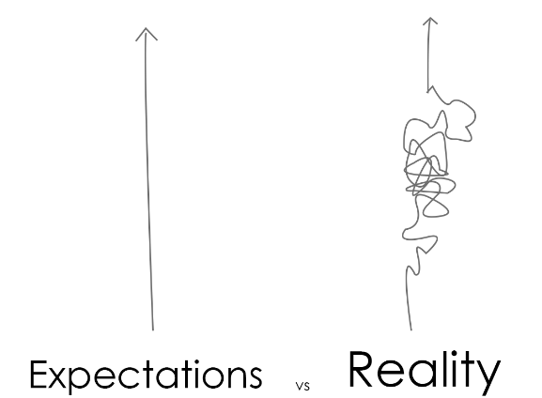

We have outlined some of the bumps in the road we experienced in our re-set and recovery journey.

COVID-19 outbreaks. Both staff teams coped with repeated COVID-19 outbreaks and self-isolation periods during 21-22, either within the staff or the resident group. Numerous shifts needed covering during these periods and this meant that there was a near constant service level ‘threat response’. At times covering the basics was a struggle and this meant that work to re-build had to be halted in order to attend to the ‘here and now’. This prompted the need for flexibility to mitigate the worst effects of staff shortages, and often required staff to cover one another’s commitments at the expense of their own job priorities or their own free time. Fortunately, such outbreaks were relatively short-lived in nature, so there were breaks between the chaotic periods, but they still placed additional burdens upon goodwill and energy levels.

Staff morale, resilience and readiness for the transition. By the end of March 2022, it seemed that staff at all levels within the PIPEs were required to ‘dig deep’ to remain committed to the challenge of running a PIPE setting. Difficult choices had to be made during the pandemic and these were not without personal cost. Many of the staff reflected on how it felt that they were choosing the service over their own health or wellbeing.

Many residents were struggling with adapting to life outside of prison, especially after they had enduring tough custodial lockdowns and social isolation, and they turned to the staff group to contain the emotional aftermath.

Tensions and challenges of homeworking versus on-site working had contributed to some splits within the teams, and the emotional needs of residents were making demands upon teams who were often themselves feeling psychologically depleted. As we started to return to being more physically present and connected there was some fear and reluctance. Disconnection had started to feel safer and new routines and patterns of being relational had been formed. Many preferred homeworking or staying behind the safety of the office door.

For a period of time the AP’s were operating to different rules and restrictions to the wider world around us. Although this was necessary to protect people, it felt confusing, unfair and isolating for both staff and residents. Residents felt punished and beliefs of own defectiveness and mistrust of others was inevitably triggered. Staff found implementing rules difficult and some felt like ‘jailers’. Many weighed up whether working in the AP PIPE’s was something they wanted for their future.

Constant relational flux. Southview saw some significant personnel changes during 20-22, in particular because it’s original Operational Lead, Petra Chapman-Gibbs, left after over seven years in post. This led to a gap in cover, and then another disruption when Petra’s replacement left the post after six months. The team coped with a further gap in Operational Lead cover until Sarah Mair joined at the end of the financial year. At this point the Clinical Lead, Lisa Maltman, had also announced her planned departure from the service. The end of the 21-22 period also saw the move-on of two Residential Workers from Southview PIPE, leaving relational gaps within the team and also creating additional challenges to cover shifts at a time of heightened staff sickness caused by COVID-19 infections.

At Holbeck House, several Residential Workers and one of our keyworkers moved on. For those leaving, it was a welcome move onto developmental roles and, in some ways, the movement in the team, facilitated change and progression. This was welcome after a long period of stasis during the stricter restrictions of the pandemic. New staff were then able to bring renewed energy to the PIPE and support us to move forwards.

To some extent it is inevitable that the pandemic would lead to personnel changes, as the unique circumstances of this period of history has prompted individual reflection and the opportunity for redirection and change. Personal growth is a core feature of the PIPE model, and a cause for celebration, however the timing and pace of some of the staff changes within both settings has been far from ideal and have the potential to destabilise already unsettled team dynamics.

Re-banding of AP Residential Workers (RW). This challenge was separate from the consequences of COVID-19 but still had a profound impact on the way in which our teams functioned, both practically and in terms of team dynamics. Essentially, those working at Residential Worker (RW) grade saw their roles upgraded to the same pay banding as Probation Service Officers (PSO). Although a welcome step for RW’s, the timing and length of the process (18 months) left many feeling mistrustful, fatigued and ‘burnt out’. For PSOs, however, it felt as if their roles were no longer seen as different, or of having added value to the organisation. This ‘levelling up’ has also led to a revisiting of the expectations of RWs, and the role that they play within PIPEs, at a time where roles had already been blurred by pandemic working.

Physical environment. Both services faced changes to the physical environment during 21-22.

The building issues at Southview came to a head during this period because the fabric of a Victorian building required significant upgrading. Communication about the problems with the private-sector contractors was often unsatisfactory and the buildings issues escalated to the point where some parts of the building were placed out of use, including resident bedrooms and some communal areas. The resident group became increasingly frustrated with leaking windows and ceilings, faulty showers, and other unacceptable living conditions, and the staff team bore the brunt of this dissatisfaction. In the absence of any resolution by the contractors we opted to address the situation in an enabling way i.e. to work with the resident group to bring wider attention to the state of the Southview building. We jointly drafted a letter about the building and how this was affecting the PIPE community both psychologically and relationally. We highlighted the unhealthy schemas being reinforced by being expected to live in such conditions and also the impact upon community cohesion and the motivation to engage in PIPE living. After this letter was widely circulated it gradually drew more focussed attention to the situation by those within the system with more influence, thus modelling how to resolve issues in a pro-social and assertive way. The downside to this successful move is that Southview has faced consideration disruption with contractors on site, and with more disruption to come, however this process is being framed as a progressive step for the service.

Holbeck House fortunately has a more stable physical environment. The site did, however, welcome a complete refurbishment. This has ultimately dramatically improved the environment, but the period of refurbishment has been very unsettling for residents. Due to different contracts, there have been numerous contractors in the building. This has left residents feeling on edge, hypervigilant and irritated by impact on their spaces, including the bedrooms.
Looking back at last year’s Annual Review for Southview and Holbeck House PIPEs it is interesting that we focussed primarily on the achievements made during that year as perhaps celebration and optimism felt essential after the unforgiving first year of restrictions, directives, stagnation, and systemic anxiety.

2021-22, however, saw an adjustment to a new rhythm of coping with the pandemic, and learning to adapt to a new pace and the relentless uncertainty attached to a second year of living with COVID-19.

The limiting of external visitors, including those professionals working with our residents, further enhanced the feeling of isolation and of being ‘cut off’ from the systems of support we ordinarily work with.

‘Pandemic fatigue’ also took its’ toll and we realised that the recovery of service provision would be far from straightforward. Personally and professionally, those working within both PIPEs began to draw upon their ebbing reserves of resilience and motivation in order to rebuild, reset, and revisit what it meant to be a more fully operational PIPE setting.

An overview of our transition and recovery plan:
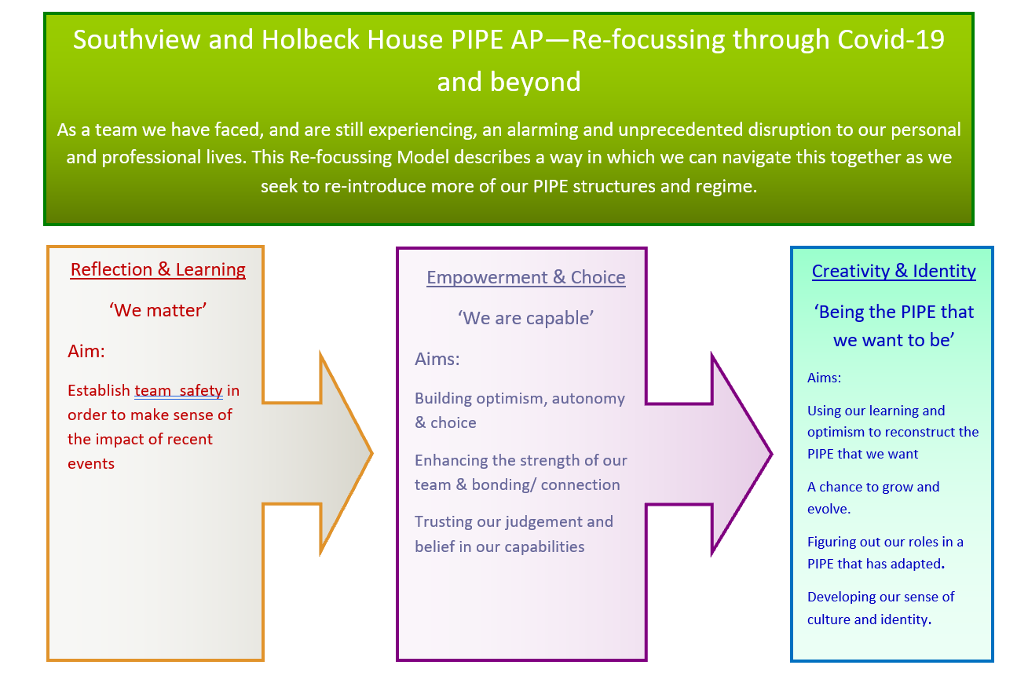
The transition back to ‘normality’ has, however, not been as linear and clear as we had hoped and wished for and our transition and recovery plan has had to adapt to a much longer than anticipated period of disconnectedness. Our expectations of a smooth transition were impacted by the reality of needing to, at points, return to more stringent COVID-19 restrictions. Through outbreaks, illnesses and staff shortages we had to try our best to navigate what was safe, fair and manageable for our staff and residents.

Written by Leanne Myers, Senior Psychotherapist and Clinical Lead at Holbeck House PIPE Approved Premise, and Lisa Maltman, Senior Forensic Psychologist and Clinical Lead at Southview PIPE Approved Premise.

Humberside Enhanced Resettlement Service (HERS)
HERS functions as a three-way partnership project between YHPDP, Hull Probation Delivery Unit and Humbercare (a third-party housing provider). The service was developed to provide people on probation (PoP), who screen onto the Offender Personality Disorder (OPD) pathway, (and have had previous tenancy difficulties), with appropriate accommodation and a wraparound support service to support their reintegration back into society in the Humberside area.

The HERS team commenced its second operational year by continuing to work through the difficulties associated with the pandemic. We navigated the national restrictions, managing to squeeze in two team away days and a couple of visits to Hull probation to meet as a team whilst guidelines allowed. This was extremely beneficial for team development and the enhancement of the service model. Humbercare staff faced more lenient restrictions, thus allowing them to continue face to face and doorstep visits with Service Users. This compensated greatly for the fact that probation staff were stopped from doing similar. Indeed, the preliminary findings of a qualitative review on HERS suggest that this increased monitoring and contact with Service Users has been one of the main benefits of the HERS working model. In addition, professionals from different agencies who work alongside HERS staff, also reported that the coming together of professionals ‘around the table’ (albeit usually on Teams) as an interdisciplinary team of sorts, helped with communication, responsive planning and reducing replication of work. All of this is felt to have benefitted PoP accessing the service.
As with the majority of OPD services, the restrictions of COVID-19 hindered the ideal delivery of HERS, and we have worked flexibly to try and overcome these difficulties. For example, whilst is was planned that PoP coming from APs should transition very gradually to their community accommodation, strict guidelines meant that this could not take place. On one occasion, a Service User had to be quickly placed in his community accommodation due to being unable to return to the AP. This was assisted by the keyworkers and Probation Service Officer (PSO) from HERS who skilfully negotiated entry to his property within a very tight timescale.
Staffing also had its challenges during the financial year. Whilst the PSO and Psychologist for HERS have remained consistent, there have been several keyworkers come and go from HERS since its inception, with one gap in this role from July 2021 which has only recently been filled in January 2022. Assistant Psychologist Abigail Plant departed in July to be replaced in September by Lizzie Finley , this has allowed the Psychologist to concentrate on the clinical leadership. During periods without full complement, the staff did thoroughly well to keep the ship afloat and provide as quality a service as possible.
The table below provides some information on the people HERS has worked with from April 2021 to end of March 2022. As outlined, there is an ongoing evaluation of the service, t a poster concerning this, will be presented at the BIGSPD conference in June of this year. Whilst the service will cease in October 2022 due to funding, the aim is to produce some further information and learning to assess the broader impact of HERS. There has been plenty of learning to disseminate to wider OPD teams, which will no doubt enhance our wider work, both locally and nationally. The below table includes some statistics on the PoP HERS has worked with during the reporting period:
Table 1: HERS Service User information April 2021 – March 2022.
Gender | N | Mean Age | Ethnicity |  | Time with HERS (days) | Status during time period (at 31.3.22)
 |  |  | Black | White British |  | Exit to community | Recalled/ reoffended | On service
Female | 3 | 49 |  | 3 | 366 | 1 |  | 2
Male | 11 | 46 | 1 | 10 | 225 |  | 5 | 6
Trans Female | 1 | 41 |  | 1 | 504 | 1
TOTAL | 15 | 47 | 1 | 14 | 272 | 2 | 5 | 8

(Written by John Atkinson, Senior Forensic Psychologist)

The Humberside Indeterminate Public Protection sentence Project (HIPPP)

Over the last 12 months we have continued to embed a more ‘active’ joint working model within HIPPP and have seen a further increase in PP engagement with the project. As it stands, there are currently 103 IPP sentenced Service Users within the Humberside area who screen into HIPPP and out of these, 63 have received input from a HIPPP clinician.
There have been some challenges over the last year in terms of pressures and changes in staffing within the Humberside area, which has meant that some planned work has been delayed or halted. Changes in PPs has also inevitably impacted upon Service Users’ levels of engagement, motivation and trust in professionals. There have also been challenges for Service Users in terms of accessing or receiving the full benefit of services whilst COVID-19 restrictions have been in place.
It is positive however, that whilst some consultations and joint working remains online, there have been increased opportunities to engage in more face-to-face joint working, owing to the easing of COVID-19 restrictions. This has included meetings in both custody and community sites, between the Service User, HIPPP Psychologist, PPs (custody and community) and other professionals, such as HMPPS Psychologists. This has enabled us to build relationships with PPs and other professionals and has added clinical value in terms of being able to meet Service Users face to face and to develop more informed understandings and formulations and a better therapeutic alliance.
In relation to current themes for HIPPP interventions; the main areas of input have included:
- Joint working sessions between PPs (custody and community based), the HIPPP Psychologist and Service Users (including a mixture of video and telephone conferences and face to face meetings).
- Consultations between PPs and HIPPP Psychologist.
- Formulations.
- Professional meetings and wider service consultations (for example with the IIRMS Service, Custody PPs/ Offender Supervisors/ HMPPS Psychologists, AP staff and Progression Units).
- Consultation at IPP Panels and MAPPA meetings.
- Psychologically informed letter writing.

In relation to the joint working session element, there remains a balance between the HIPPP Psychologist supporting PPs in consultancy/ reflection, planning/ overseeing therapeutic interventions, & more direct involvement in intervention delivery with Service Users themselves. The latter has included psycho-education, work around consolidating skills and learning and preparing for release/ relapse prevention work and more discussion/ reflection based work. The theme of this work is around relationship building/ repair, enhancing motivation and engagement, discussing issues around previous recall, developing Service Users’ understanding of themselves and their behaviour, exploring their goals and enhancing their self-management skills.
The main need for HIPPP intervention continues to be related to Service Users who appear ‘stuck’ in the prison system or in a cycle of release and recall, cases where relationships with PPs or other professionals have broken down or those individuals in the community who are struggling to maintain motivation and focus.

There continue to be good opportunities for more joined up, multi-agency working and consultation, including work into MAPPA, IPP panels and professionals’ meetings. We have also been working to build better links with the HOPE progression Unit at HMP Humber, by attending professionals’ meetings, case conferences, and more recently participating in a community afternoon on the unit; to provide information and invite questions regarding the realities of release, supervision and management and available OPD pathways.

We have recently submitted ethical approval for a HIPPP evaluation, which will commence imminently. This will involve an evaluation study looking at the ‘movement’ over a 2-year period of IPP sentenced Service Users (who screen onto the pathway) within the Humberside area. This will be compared to another demographically similar area, which does not have HIPPP involvement. It is hoped that with will provide some measure as to the impact of HIPPP.
(Written by Rebecca Triffitt, Senior Forensic Psychologist)

