Have Your Say Feedback January-March 2022

‘Have Your Say’ is a way for people who access our service to have their voice heard and give feedback on their experience. The feedback questionnaire has questions produced jointly by service users, carers and staff asking about experience of care to gather anonymous patient feedback. Below are the feedback data received between January and March, specifically for Leeds Gender Identity Service.

Respondents were asked ‘Overall how was your experience of our service?’ with the response options Very Good, Good, OK, Bad, Very Bad and Don’t Know.

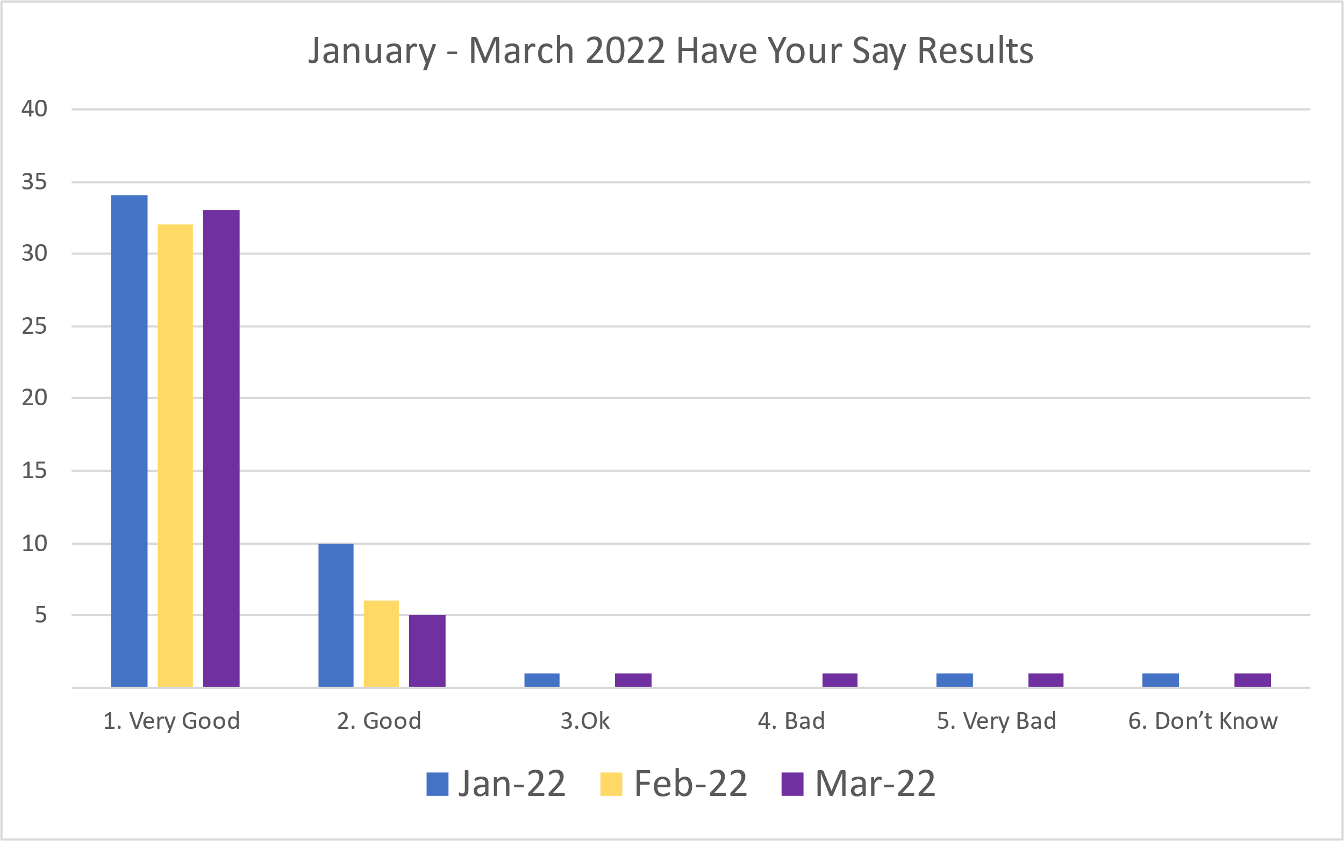

Out of all the feedback given (n= 103),78 % (n=81) was positive feedback,6 % (n=6) were suggestions and 15.5 % (n = 16) was negative feedback.

Below is the feedback analysis in a visual form.
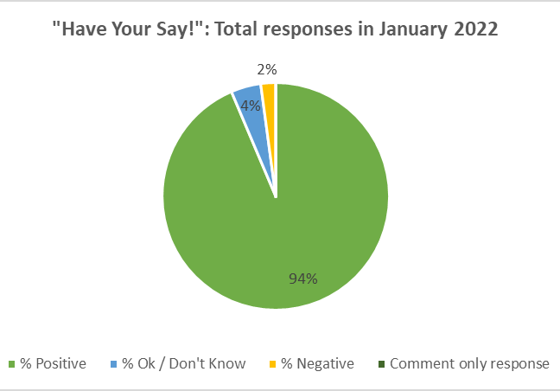
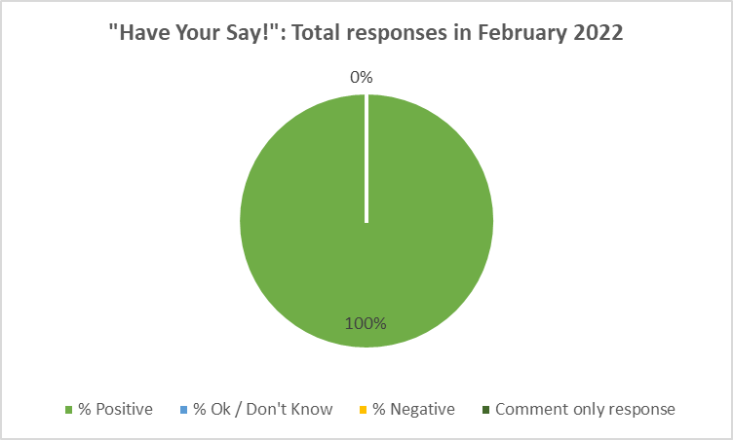

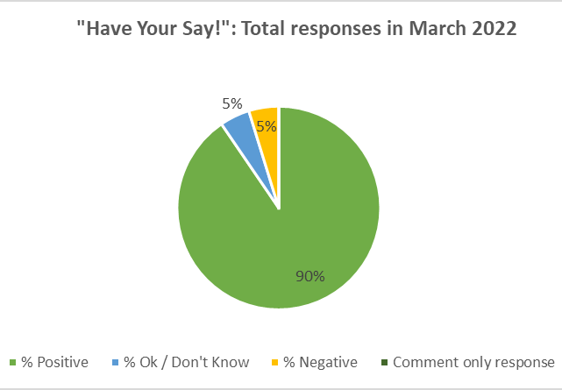
mmmmmm

From the feedback comments given, the main themes that were identified were:
- Approachability of staff
- Communication
- Team knowledge and skills
- Accessibility
- Digital accessibility/technical issues
- Waiting Lists
- Suggestions for improvement

These themes were identified throughout all the feedback given and were the most common. Below are some of the feedback comments positive, negative and suggestions.

January 2022

Positive

“…both of the professionals I spoke to so far have been amazing, they listened to me and understood what I was saying, and were keen to help me get the help I need” – Approachability of staff

“All questions answered, helpful support.” – Communication

“I felt like the questions were relevant, the people listened to me and it was productive.” – Approachability, Team knowledge and skills.

Negative

“Waiting times have been extortionate. We know it's not the fault of the practice but that is the biggest downfall of the service.” – Waiting lists

“Waited from 1:50pm for a 2pm appointment. No one answered. Just kept getting same message. They know you are waiting. Ended call at 2:45pm. Very annoyed” – appointment times/communication issues.

February 2022

Positive

“Very informative and professionally putting me at ease with my forthcoming surgery.” – Communication, Team knowledge and skills

“Very thorough, careful and respectful.” – Communication.

“Attentive Doctor, very good about checking the details of what I said and making sure she understood my needs and wants.” – Communication.

Negative

“I appreciate that Covid-19 has caused set backs, along with high demands on the service, however, it would be great to see waiting times reduced, to limit the anxiety brought on by gender dysphoria.” – Waiting times

“Sound on video call not always the best but not much you can do about that I’m sure.” – Technical issues

March 2022

Positive

“My next options, in terms of surgery, were explained to me in great detail, as well as emailed through to me for reference.” – Team knowledge and skills

“They were able to help with my issue and made me feel very happy with the solution.” -Team knowledge and skills.

“Very warm doctor and listened to me and understood what I was saying. Did not feel judged at all.” - Approachability of staff

Negative

“The connection was poor on both side.” – Technical issues

“I felt a few questions I were asked were off topic, but I'm no professional so I dont know.” – Team knowledge/skills.

The below comments are suggestions we have received through the feedback. These suggestions have been taken to a team meeting where we have discussed ways in which we can work to improve the service for users.

Suggestions

“The call waiting tune is mind shattering, a bit of silence goes a long way.” –

Thanks for your feedback. The Service aren’t able to change the call waiting ‘music’ but on review it looks as though there is a function which makes it possible to turn off the music. We are really sorry that this is affecting people accessing Attend Anywhere.

“As it was a video call, make it a rule/policy to ring the telephone number that they have for the patient if they do not see them in one of the rooms that they join. This is to ensure that if the patient is having any troubles connecting that they can tell them and assist in this. Especially as the patient cannot get in touch with the service if the appointment is after 2 p.m. like mine was.”

“The phone line closes at 2pm, but my meeting was at 3pm, so I couldn’t get in touch to find out what had gone wrong. The phone line needs to stay open to support this service.”

Thank you for your suggestion and we are sorry that you experiencing difficulties with accessing Attend Anywhere. Unfortunately, due to ensuring that we are able to maximise the work that the administrative team can complete across the whole service, we are not currently able to open the phone lines for additional hours. We will ensure that the Guide for Attend Anywhere is added to the appointment letters, and you can trial this prior to your appointment to ensure that it appears to be working for you. We will happily try to support you prior to your appointment to gain access if we can.

Once the administrative team is fully staffed, we will then complete a review the volume of calls and the overall workload to further consider this issue, as we recognise that this can be really frustrating, particularly if you have waited for this appointment for such a long period of time.

“Perhaps a log in where I can see upcoming appointments and medications I am taking etc. Could also include records and diagnoses which can be used when needed instead of contacting the clinic when there is anything I need.”

Thank you for your suggestion. There is some ongoing work in the Trust to explore the possibility of apps and although this isn’t an immediate solution, we will ensure that your comments are added to this review about what would be helpful.

