Have Your Say Feedback

“Have Your Say” is a new way for people accessing our service to give feedback on their experience. Formerly the Friends and Family Test, it has questions produced jointly by service users, carers and staff asking about experience of care to gather anonymous patient feedback. Below are the feedback data received between July and September, specifically for Leeds Gender Identity Service.

Respondents were asked ‘Overall how was your experience of our service?’ with the response options Very Good, Good, OK, Bad, Very Bad and Don’t Know.

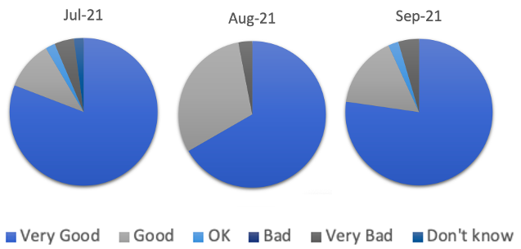
The comparison across July, August and September for these ratings are displayed below. The proportion of patients rating their experience of the service as Very Good is 81%, 67% and 77% respectively for July, August and September.

Out of all the feedback analysed (n=113), 73% of the data were compliments (n=83), 17% negative feedback (n=19) and 10% suggestions (n=11). Of the compliments received:

- 22% said that staff were friendly
- 24% said they felt heard/listened to or understood
- 27% said that it was clear or informative
- 20% said that staff were kind, caring or respectful
- 22% said staff were supportive or helpful

Themes were identified arising from the adjectives used to describe the service and/ or its staff members, and a visual representation of the significance and frequency of each adjective is displayed below in a word cloud.

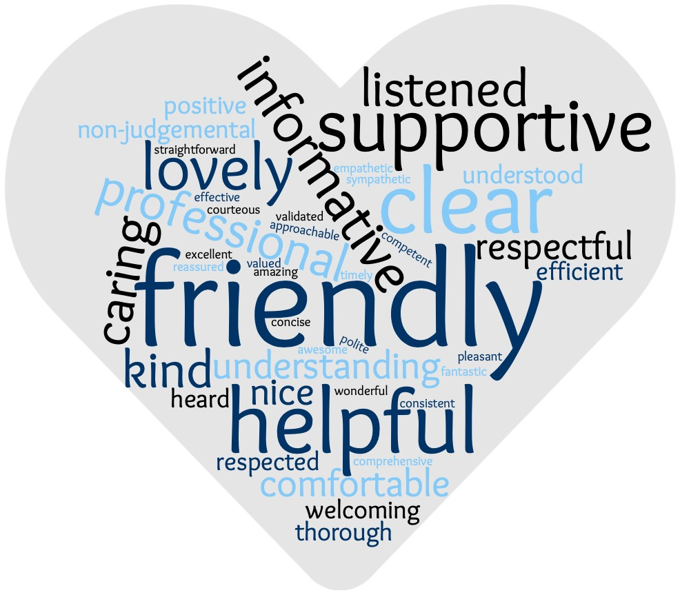

Please see below for some of the many positive comments received about the experience of using our service:

JULY 2021
“Overall the service so far has been friendly and professional. I have been regularly appraised an updated regarding appointments (and any changes).”

“The staff were wonderful, supportive and clear.”

“Very welcoming and made me feel very comfortable. Always made me aware of what is happening next”

“Supportive, friendly, and personable named professional. Made me feel at ease despite having to discuss difficult topics. I felt listened to and respected the whole way through which has not always been the case in other healthcare settings”

“While I was anxious at first, the doctor was very kind and respectful and I managed to feel very comfortable as the appointment progressed. She was very clear and explained well what the appointment was about, and that helped reassure me further.”

AUGUST 2021
“Named professional was very approachable and kind, found her to be well informed and overall a good experience”

“I've felt very validated with my gender and that my transition is being handled really well.”

“Very welcoming and informative, everything necessary was discussed and done in pretty good time.”

“Timely, friendly, informative and very helpful. I felt valued and understood and in the hands of knowledgeable caring professionals”

“The understanding and care shown by the staff has been excellent.”

SEPTEMBER 2021
“Really lovely and caring staff members. Always make me feel listened to and treat me with respect. A great service to use”

“I have felt very engaged and supported even though the waiting lists are fairly long for treatment - I also have been well informed on the process itself. My main contact has been incredibly supportive and helpful.”

“it has been very good because it was a face to face on the pc because I am autistic and felt that I could digest information better regarding my treatment and was able to write things down and ask questions”

“Friendly, full and comprehensive as always”

“Really friendly staff, very knowledgeable and respectful”

Please see below for some negative comments received about the experience of using the service.

JULY 2021
“The GIS is doing the best it can with a complete lack of funding. The wait times are appalling, but I know this is outside of the GIS control.”

“There is a lot of duplication of information. I've had to go over the same things multiple times. No joined up documentation. Also latest professional didn't have my full blood results even though I'd emailed them twice they just disappeared.”

AUGUST 2021
“the service itself has a serious problem with waiting times. I understand that the root causes of this aren't simple, but this is something that has to improve as it costs trans people’s lives every year.”

“The online platform had some technical issues, which included the entire program crashing at two instances.”

SEPTEMBER 2021
“Wait times are high, but not the fault of the staff team themselves”

“It’s really just about the waiting lists to be honest”

“The connection on the call was a bit unstable and at times it was difficult to hear what was being said”

We asked service-users how they think we can improve the service. See below for some of the suggestions and how we have implemented action to meet these improvements.

“Introduce name and pronouns as well at the same time. Not just for gender services but for all services you offer. I think it normalises the sharing of pronouns and makes people feel welcome and included in a setting that often is not.”

This has been discussed in a recent staff meeting that this is something that would help service users feel more comfortable if they are not already doing so. We will continue to promote this within the Service.

“Please find a way to give your staff a better wifi connection as in many of these appointments it is so laggy as to cause confusion over what was said.”
“The online platform had some technical issues which included the entire program crashing at two instances.”

We are aware of the difficulties that are occurring when using the online platform (Attend Anywhere) and recognise that at times this has posed a problem with connectivity. The Service has raised this with the Informatics department, and they are testing with different remote access methods e.g. phone, laptop, hospital and private connection methods to see if they can identify what the issues may be in order to reduce this from happening.

“The Doctor who didn’t say anything was a little off-putting. I think I’d have preferred her to be off screen even though I knew she was present.”

We have relayed this suggestion to our staff and have asked that they will ask the individual patient whether they would prefer their camera to be on/off, as we can understand how it may be off-putting. At times there may be someone else accessing your appointment. This may be a student or a new member of staff who is work shadowing to gain experience. We have asked that staff ensure that they discuss this with you at the start of the appointment, and the additional person only brought in with your permission. You can identify whether you would prefer them to have their camera on or off.

“Letters need to come out faster – 2 weeks notice for an appointment is pretty short, and the post appointment letters are taking a long time.”

As you may be aware, we have experienced some delays in our administrative processes which we have been working hard to address. We have changed the system of booking our named professional (nurse) appointment, so letters go out with at least four weeks’ notice (unless it is something arranged with you at short notice). We are also trying to consistently provide more notice for other types of appointments e.g. hormone appointments.

We would like to thank everyone for their feedback, as it provides invaluable insight from a patient perspective as to what we are doing well in the service, and ways in which we can improve it for its service-users. We will continue to feedback any information in this way, and any ongoing actions that we are taking based on your feedback to improve our service.

