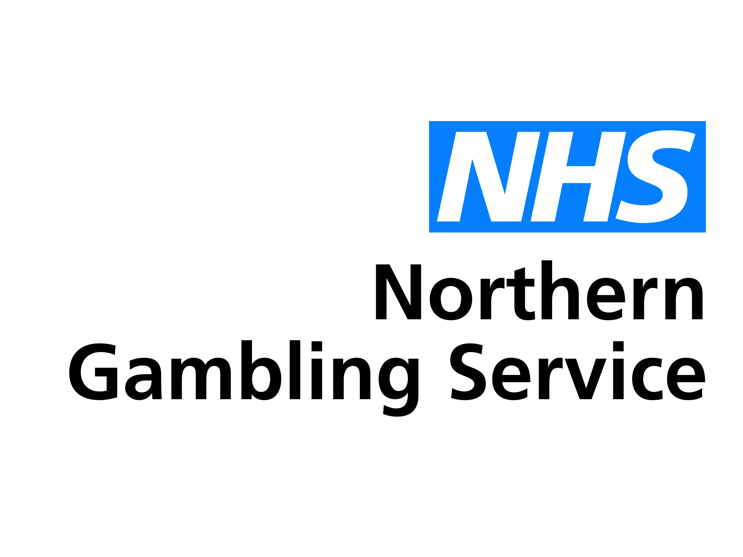
This form is for health and care professionals making referrals into the NHS Northern Gambling Service on behalf of people with gambling addiction problems.
Once completed, please email securely to referral.ngs@nhs.net
Alternatively, you can post it to us at: NHS Northern Gambling Service, Merrion House, Merrion Way, Leeds LS2 8PD
If you are a member of the public looking for support, please visit our website for more information at www.leedsandyorkpft.nhs.uk/our-services/northern-gambling-service

Version: 0.3
Last updated: 29 September 2020
Referral Form for Professionals
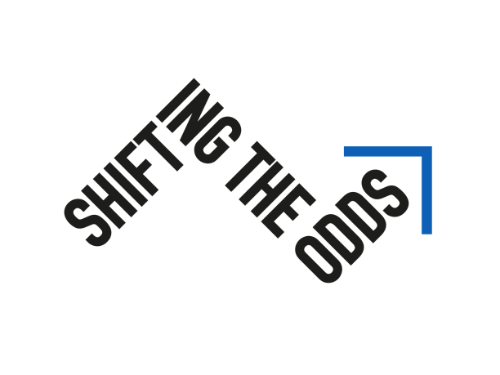

Problem Gambling Lie/Bet Questionnaire

- Have you ever had to lie to people important to you about how much you gambled?

- Have you ever felt the need to bet more and more money?

“Yes” response to one or both items: further assessment is needed.

If you would like to discuss the referral with us in more detail, please contact the NHS Northern Gambling Service on referral.ngs@nhs.net or 0300 300 1490.

