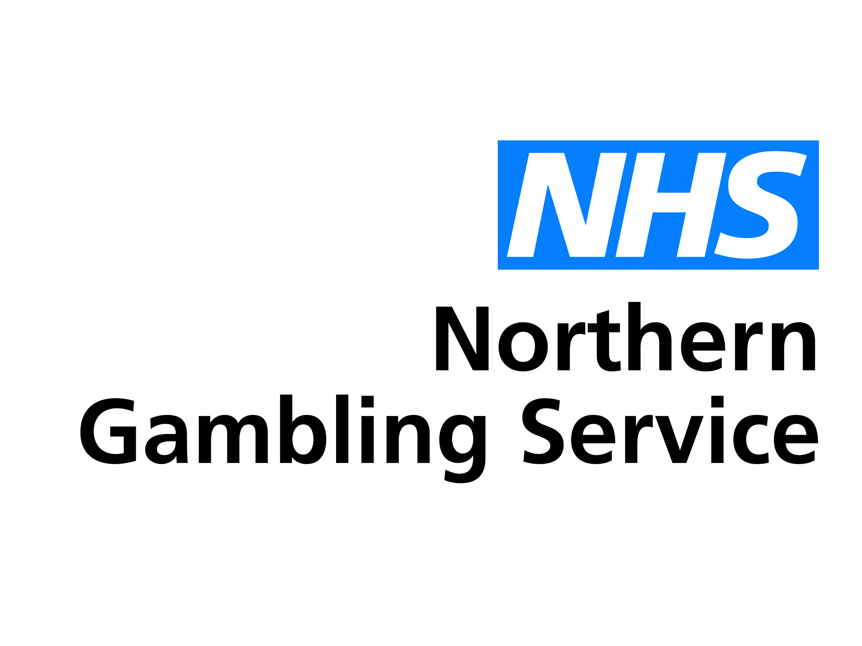

This form is for health and care professionals making referrals into the NHS Northern Gambling Service on behalf of people with gambling addiction problems.

Once completed, please email securely to [referral.ngs@nhs.net](mailto:referral.ngs@nhs.net)

Alternatively, you can post it to us at: NHS Northern Gambling Service, Merrion House, Merrion Way, Leeds LS2 8PD

If you are a member of the public looking for support, please visit our website for more information at [www.leedsandyorkpft.nhs.uk/our-services/northern-gambling-service](http://www.leedsandyorkpft.nhs.uk/our-services/northern-gambling-service)

Version: 0.3

Last updated: 29 September 2020

**Referral Form for Professionals**

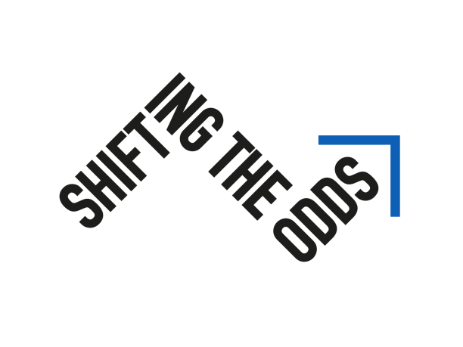

**Problem Gambling Severity Index**

This self-assessment is based on the Canadian Problem Gambling Index. It will give you a good idea of whether you need to take corrective action.

**Thinking about the last 12 months…**

Have you bet more than you could really afford to lose?

|  |  |  |
| --- | --- | --- |
|  |  | Your Score |
| 0 | Never |  |
| 1 | Sometimes |  |
| 2 | Most of the time |  |
| 3 | Almost always |  |

Still thinking about the last 12 months, have you needed to gamble with larger amounts of money to get the same feeling of excitement?

|  |  |  |
| --- | --- | --- |
|  |  | Your Score |
| 0 | Never |  |
| 1 | Sometimes |  |
| 2 | Most of the time |  |
| 3 | Almost always |  |

When you gambled, did you go back another day to try to win back the money you lost?

|  |  |  |
| --- | --- | --- |
|  |  | Your Score |
| 0 | Never |  |
| 1 | Sometimes |  |
| 2 | Most of the time |  |
| 3 | Almost always |  |

Have you borrowed money or sold anything to get money to gamble?

|  |  |  |
| --- | --- | --- |
|  |  | Your Score |
| 0 | Never |  |
| 1 | Sometimes |  |
| 2 | Most of the time |  |
| 3 | Almost always |  |

Have you felt that you might have a problem with gambling?

|  |  |  |
| --- | --- | --- |
|  |  | Your Score |
| 0 | Never |  |
| 1 | Sometimes |  |
| 2 | Most of the time |  |
| 3 | Almost always |  |

Has gambling caused you any health problems, including stress or anxiety?

|  |  |  |
| --- | --- | --- |
|  |  | Your Score |
| 0 | Never |  |
| 1 | Sometimes |  |
| 2 | Most of the time |  |
| 3 | Almost always |  |

Have people criticized your betting or told you that you had a gambling problem, regardless of whether or not you thought it was true?

|  |  |  |
| --- | --- | --- |
|  |  | Your Score |
| 0 | Never |  |
| 1 | Sometimes |  |
| 2 | Most of the time |  |
| 3 | Almost always |  |

Has your gambling caused any financial problems for you or your household?

|  |  |  |
| --- | --- | --- |
|  |  | Your Score |
| 0 | Never |  |
| 1 | Sometimes |  |
| 2 | Most of the time |  |
| 3 | Almost always |  |

Have you felt guilty about the way you gamble or what happens when you gamble?

|  |  |  |
| --- | --- | --- |
|  |  | Your Score |
| 0 | Never |  |
| 1 | Sometimes |  |
| 2 | Most of the time |  |
| 3 | Almost always |  |

**TOTAL SCORE**

|  |
| --- |
|  |

Total your score. The higher your score, the greater the risk that your gambling is a problem.

Score of 0 = Non-problem gambling.

Score of 1 or 2 = Low level of problems with few or no identified negative consequences.

Score of 3 to 7 = Moderate level of problems leading to some negative consequences.

Score of 8 or more = Problem gambling with negative consequences and a possible loss of control.

Thank you for completing this form.

Please email it from a secure account to [referral.ngs@nhs.net](mailto:referral.ngs@nhs.net)

If you are having problems with this form or you would like to discuss the referral with us in more detail, please contact the NHS Northern Gambling Service on [referral.ngs@nhs.net](mailto:referral.ngs@nhs.net) or phone 0300 300 1490.