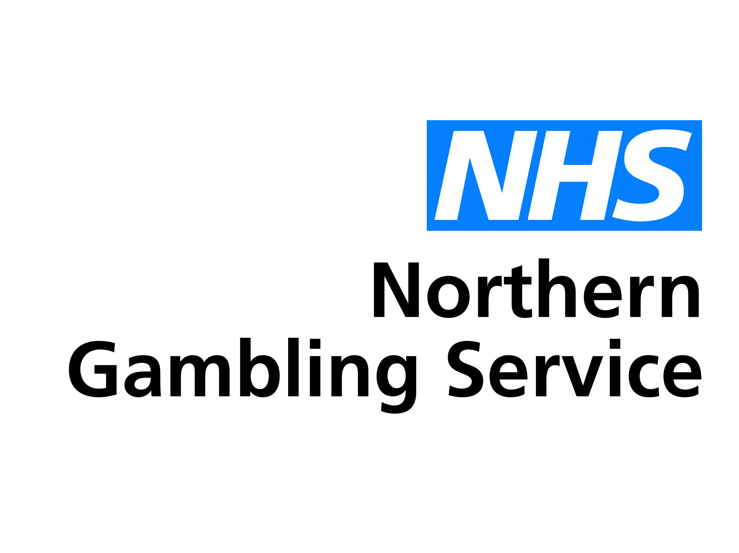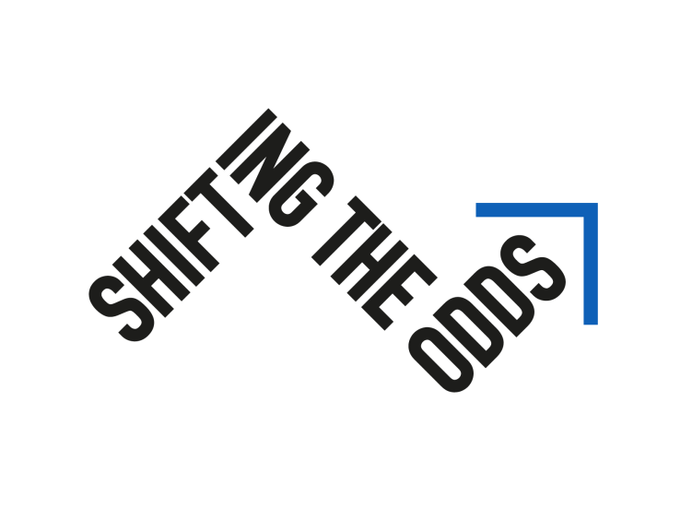
Only 3% of people suffering from harmful gambling either seek or are referred for treatment
Shifting the Odds on harmful gambling

This means millions of men and women, young and old, are suffering in silence - or not so silently causing harm to their loved ones, friends and colleagues. Many of them may be your patients.
We know how precious time is with a patient, either at screening or during in-surgery visits and telephone consultations and we also know how hard it is to recognise the signs of gambling addiction.
We want you to help us shift the odds for your patients.
Our Shifting the Odds campaign brings together a range of resources for you and your clinical teams; it provides the knowledge and confidence to start the conversation about harmful gambling and how you can refer to the NHS Northern Gambling Service.
Visit [website] for more information - as Covid restrictions drive more extreme gambling behaviour, now is the time to shift the odds.
Northern Gambling Service referral hotline: 0300 300 1490 or referral.ngs@nhs.net

