**Standard Operating Procedures**

**Cleaning COVID-19**

|  |  |  |
| --- | --- | --- |
| **Contents** |  | Pages |
| SOP Cleaning Wards and Bedrooms |  | 2 - 4 |
| SOP Cleaning Non-Clinical Areas |  | 5 |
| Infectious Waste | Action Card (A) | 6 - 9 |
| Personal Protective Equipment (PPE) | Action Card (B) | 10 - 13 |
| Hand-Hygiene | Action Card (C) | 14 |
| Cleaning Chemicals | Action Card (D) | 15 - 17 |
| Cleaning COVID-19 Infected Bedrooms | Action Card (E) | 18 |
| Social Distancing | Action Card (F) | 19– 21 |
| Consulting with our Partners |  | 22 |
| Bagging of Linen |  | 23 |

**Standard Operating Procedure**

**COVID – 19**

**Ward & Bedroom cleaning**

**What is this procedural document about?**

This procedural document highlights the procedure that must be read by all Domestic Assistants responsible for cleaning wards and bedrooms. It includes PPE requirements, the management of infectious waste and the cleaning chemicals which must be used because they offer the ability to kill COVID-19 infection.

**Am I able to deviate from the procedure?**

No, the procedure is written for the wellbeing of you and your colleagues so it MUST be followed in full.

**When must it be read?**

The procedure must be read immediately and where possible with your line manager.

**Where do I get PPE for my team?**

The clinical team on the wards have been asked to provide PPE to your Domestic Assistants. The infection control team are available to provide advice to Domestic Assistants on the correct way for the donning and doffing of single use disposable PPE.

**What if I have any further questions?**

If you have questions, please contact your line manager who will then collate the questions and seek answers from the Infection Control Team.

**Contract Cleaning**

The Trust provides a cleaning service which is delivered by Trust staff and/or contract cleaning services provided by Interserve. The view of the Trust is that the relationship with Interserve is a ‘one team approach’ and therefore this SOP is shared equally. To prevent complications in ownership responsibilities, it is the responsibility of the Commercial Manager and the Interserve Account Manager, to circulate the SOP document to sub-contractors that are working directly for them to provide essential services. If an extra clean is needed for a bedroom, please request in advance and preferably by 12 noon.

**Introduction**

This Safe Operating Procedure (SOP) provides the Domestic team with the information they need to ensure the areas of occupation are kept hygienically clean for service user’s comfort and safety. This Procedure highlights the safety measures and resources which the Trust has put in place to enable you to achieve this goal.

**Purpose/Scope**

This SOP outlines the procedure for cleaning wards and bedrooms during this time of COVID-19. The most recent national guidance requires all wards to be classified as COVID-19 infected wards, regardless if the virus is present or not. This means a higher level of personal protection equipment for the team and enhanced cleaning of the wards.

**PPE**

Personal protective equipment is available for all Domestic Assistants to wear and this level of provision is also extended to contractors. For more information, please refer Action Card (B) of this document.

**Hand-Hygiene**

Hand hygiene is essential to reduce the transmission of infection. All Domestic Assistants should decontaminate their hands with alcohol based hand rub when entering and leaving the ward environment. Remember the government advice to wash hands for at least 20 seconds. Please remember to follow the hand hygiene rules which as required by the clinical team members. For more information, please refer to Action Card (C) of this document.

**Social Distancing**

Please follow the rule of social distancing (2m apart) from each other.

**Cleaning Chemicals (Chlorinated)**

Cleaning chemicals (**chlorinated**) are provided to you for cleaning surfaces, fixtures and fittings. The list here provides the chemicals which must only be used. For more information, please refer to Action Card (D) of this document.

* GV Health – SoChlor Disinfectant surface wipes (or equivalent)
* GV Health - ScoChlor Disinfectant water soluble tablets (or equivalent)

**Frequency of Cleaning**

The frequency of cleaning of the ward environment must be done twice per day. This means a morning clean and an afternoon clean and the gap between the 1st and 2nd clean must be as wide as possible. Please note that cutlery and crockery must be placed in the dishwasher and not thrown away. The dishwasher must reach a water temperature of no less than 60c.

**Entry into the bedroom (non - isolated rooms)**

The bedroom should be empty before entering into a service user’s bedroom. The cleaning of the rooms that takes place should include, as a minimum, all access points within reaching distance, fixtures, fittings, bed/rail, floor and skirting boards, door and handles, cupboards and anything else which your line manager will require. Please do not forget to use the list of chlorinated cleaning products, which has already been highlighted in this SOP. Always remember to open the windows (if possible) to ventilate the room before and during the cleaning session. The Domestic team do not have authorisation to clean the service user’s personal items.

**Process for cleaning the COVID-19 isolated bedrooms**

It has already been made clear that the ward must be treated as COVID-19 and where a service user has been tested as COVID-19 positive, that individual will remain isolated within their bedroom (until and unless that individual is transferred out of the ward to another location) and will therefore not be allowed to use any of the shared kitchens, dining rooms or toilet facilities, however for their own comfort and wellbeing they will be provided with a commode and vanity unit within their own bedroom. A member of the clinical team will be present when the room is being cleaned and the door is kept closed with the service user also present.

It is recognised that some rooms are small and the 2m distance rule can be difficult when multiple individuals are present however please understand that the PPE offers protection.

**Process for cleaning wards**

Due to the current climate, enhanced cleaning involves cleaning the wards twice daily. As a **minimum** the following should be included in the list of items to be cleaned. Please also include any fixtures and fitting which would normally be done as part of the daily cleaning service;

|  |  |  |  |  |  |
| --- | --- | --- | --- | --- | --- |
|  | Door edges |  | TV |  | Computer keyboard |
|  | Door handles |  | TV remote |  | Mouse |
|  | Door push plates |  | CD player |  | Computer monitor on/off button |
|  | Chairs |  | Radio |  | Computer on/off button |
|  | Table surfaces |  | Telephones |  |  |

|  |  |  |  |  |  |
| --- | --- | --- | --- | --- | --- |
|  | Light switches |  | Toilet handles |  | Kitchen cupboard handles |
|  | Light pull cords |  | Taps |  | Kitchen work surfaces |
|  | Toilet seat |  | Toilet door locks |  | Kettle touch points |

|  |  |  |  |  |  |
| --- | --- | --- | --- | --- | --- |
|  | Shower heads |  | Shower taps |  | Room temperature adjustment wall touch points |
|  | Shower screens |  | Bin lids |  | Wall mounted power socket on/off touch switches |
|  | Bath taps/bath |  | Window door  handles |  |  |

If there are access problems to any areas because of local circumstances then please, where possible concentrate on the RED zoned areas of the ward (refer to Action Card F) and if a part of the ward still cannot be cleaned by the time the shift is finished then inform your line manager.

**Disposal of PPE and Waste**

Please refer to Action Card (A) and Action Card (B) which accompanies this SOP document.

**Standard Operating Procedure COVID – 19**

**Cleaning Non-Clinical Areas**

**Introduction**

This Safe Operating Procedure (SOP) provides the Domestic Assistants with the information they need to ensure the non – clinical areas are kept clean and hygienic for the comfort and welfare of the service users.

**Purpose/Scope**

This SOP outlines the procedure for cleaning non-clinical areas which include all areas shared exclusively by staff. This refers to the facilities that include shared rest areas, kitchens, toilets and corridors.

**PPE**

Personal protective equipment is available for all Domestic Assistants to wear and this level of provision is also extended to contractors. For more information, please refer Action Card (B) of this document

**Hand hygiene**

Hand hygiene is essential to reduce the transmission of infection. All Domestic Assistants should decontaminate their hands with alcohol based hand rub when entering and leaving the ward environment. Remember the government advice to wash hands for at least 20 seconds. Please remember to follow the hand hygiene rules which as required by the clinical team members. For more information, please refer to Action Card (C) of this document.

**Social Distancing**

Please follow the rule of social distancing (2m apart) from each other.

If there are access problems to any areas because of local circumstances then please, where possible concentrate on the RED zoned areas (refer to Action Card F) and inform your line manager where cleaning cannot take place by the time your shift is finished.

**Frequency of cleaning**

To ensure a level of comfort and safety, please ensure the areas are cleaned daily.

As a **minimum** the following should be included in the list of items to be cleaned. Please also include any fixtures and fitting which would normally be done as part of the daily cleaning service;

|  |  |  |  |  |  |  |
| --- | --- | --- | --- | --- | --- | --- |
|  | Door edges |  | TV |  |  |  |
|  | Door handles |  | TV remote |  |  |  |
|  | Door push plates |  | CD player |  |  |  |
|  | Chairs |  | Radio |  |  |  |
|  | Table surfaces |  | Telephones |  |  |  |

|  |  |  |  |  |  |
| --- | --- | --- | --- | --- | --- |
|  | Light switches |  | Toilet handles |  | Kitchen cupboard handles |
|  | Light pull cords |  | Taps |  | Kitchen work surfaces |
|  | Toilet seat/handle |  | Toilet door locks |  | Kettle handle /window ledges |

|  |  |  |  |  |  |
| --- | --- | --- | --- | --- | --- |
|  |  |  |  |  |  |
|  |  |  | Bin lids |  | Wall socket on/off switches |
|  |  |  | Window door handles |  | Microwave door handle/switches |

**Disposal of PPE and Waste**

Please refer to Action Card (A) and Action Card (B) which accompanies this SOP document.

**Reference Action Card (A)**

**COVID – 19**

**Infectious Waste**

**Introduction**

This card provides Domestic Assistants with the information they need to ensure that infectious waste is correctly segregated, contained, identified, handled and transported to ensure its safe management and disposal.

**Purpose/Scope**

This card outlines the procedure for the safe management of infectious waste. The most recent national guidance is the wards are now classified has COVID-19 infected wards, regardless if the virus is present or not. This means all waste must be classified as infectious and disposed in line with this Action Card.

**PPE**

Personal protective equipment is available for all Domestic Assistants to wear and this level of provision is also extended to contractors. For more information, please refer Action Card (B) of this document

**Infectious Waste Segregation**

Any items that have come into direct contact with a service user who is either confirmed or suspected to have COVID-19 must be treated as infectious waste. This includes but is not limited to the following:

* Tissues and Paper Towels
* Disposable Cutlery and Cups
* Food Wrappers
* Dressings & Swabs
* Incontinence Pads
* Used PPE
* Other disposable items generated by either the service user or Clinician during their treatment / care.

In the interest of reducing the volume of infectious waste please ensure that all outer packagingis removed and recycled before an item is taken onto any ward or clinical area. *If this is taken into an isolation or higher risk area, then it is likely to become contaminated and therefore must be disposed as infectious clinical waste*.

In addition:

• All **food waste** must still be disposed of in black bags.

• All **confidential waste** must be put into confidential bins.

• Where **medicines** are prepared in a clean area, pharmaceutical waste must be separated into the blue containers as normal

• All **sharps waste** must be put into the relevant receptacle with an appropriately coloured lid (Orange or Yellow) as per HTM07-01, and these do not need placing in an orange bag <https://www.gov.uk/government/publications/guidance-on-the-safe-management-of-healthcare-waste>

Infectious waste must be segregated in the relevantly labelled internal bin designated specifically for infectious waste. Do not mix Infectious waste with non-infectious waste items.

Examples of infectious waste internal bin label and internal bin used by the Trust

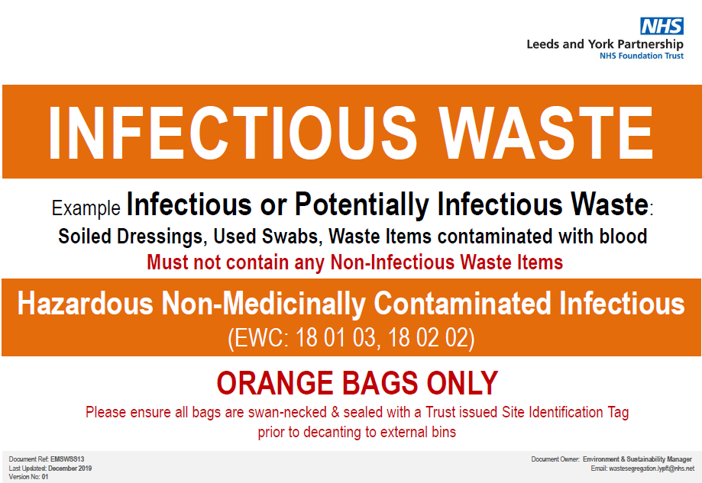

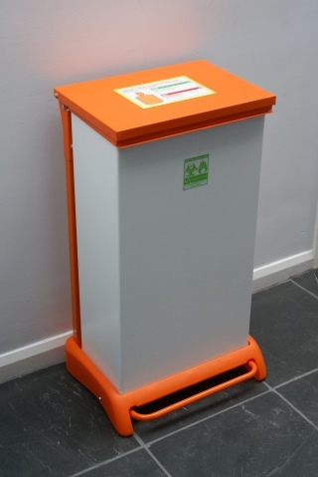

Additional internal bins are available for essential distribution and can be ordered along with additional bin labels by emailing: [wastesegregation.lypft@nhs.net](mailto:wastesegregation.lypft@nhs.net)

*Due to limited supply we will be allowing the use of Tiger-Striped (Offensive waste) bins to be repurposed, appropriately labelled and lined with orange bags for the internal disposal of infectious waste only.

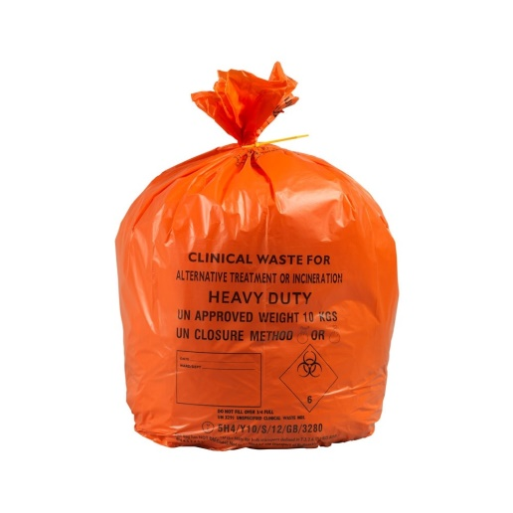

**Double Bagging of Infectious Waste**

All internal infectious waste bins must be pre-lined with two UN3291 approved orange bags (where stock levels permit) as an added precautionary measure of double bagging infectious waste. A stock of approved orange bags should be kept at each site/ward and ordered by Clinicians via NHS Supply Chain as per usual. If an area/site is running low and cannot get a timely delivery through NHS Supply Chain then LYPFT stores do have a limited contingency stock available for essential distribution.

The **supply chain order numbers for Orange Bags** are:

– MVN493 (5M available per month): Orange – 711 x 980mm (28 x 38.5 inch) 40

micron, pillow seal, 80L heavy duty – £1.60 ex VAT roll of 25.

– MVN849 (10M available per month): Orange – 711 x 965xmm (28 x 38 inch) 45

micron, pillow seal, 80L heavy duty – carriage in bulk – £2.80 ex VAT roll of 25

**Sealing Infectious Waste Bags**

Bags should only be filled up to the filling line (two thirds full) then closed using the below “Swan Neck” method and sealed using a Trust issued, orange infectious waste identification bag-tie. Once sealed the Clinician must write on the date and ward number/location on the bag with a permanent marker pen.

All sites should have a stock of bag-ties for both Infectious (orange) and offensive (yellow & Black) waste bags. Additional bag-ties can be ordered by emailing: [wastesegregation.lypft@nhs.net](mailto:wastesegregation.lypft@nhs.net)



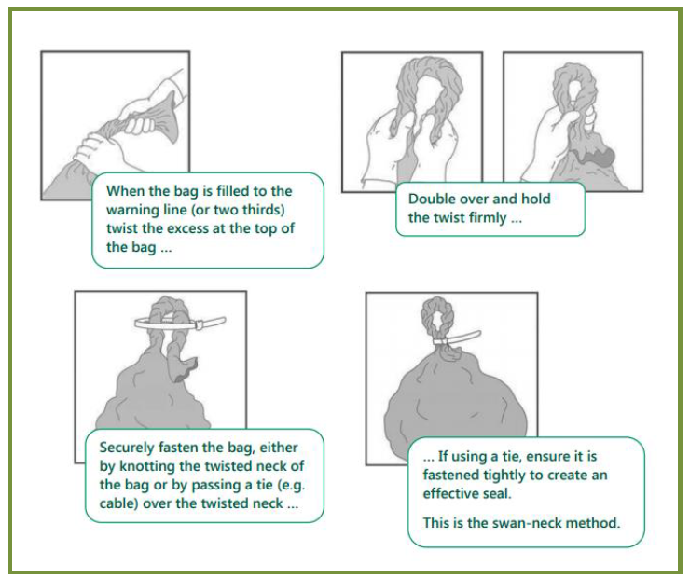

**Storing of Sealed Infectious Waste Bags Whilst Awaiting Decant Into External Bins**

If resources allow then it is preferable that any sealed bagged infectious waste is removed to the external bins immediately, however temporary storage is permitted for short periods of time. Under no circumstances should bagged infectious waste be temporarily stored for longer than 8 hours.

Sealed bagged infectious waste can be temporarily stored if it is clearly segregated from other bagged wastes in an appropriate container (either a wheeled or non-wheeled bin or wheeled cage used solely for infectious waste). The storage location must be secure and agreed locally between Clinicians and Trust Porters or IFM.

**External Storage of Infectious Waste Bags**

Bagged Infectious waste must be segregated in the relevantly labelled, UN approved external bin designated specifically for infectious waste. Do not mix Infectious waste bags with non-infectious waste bags. External bins must be kept locked at all times and stored in a secure location whilst awaiting collection and disposal by the Waste Contractor.

**Illustration (1) Infectious waste external bin label**

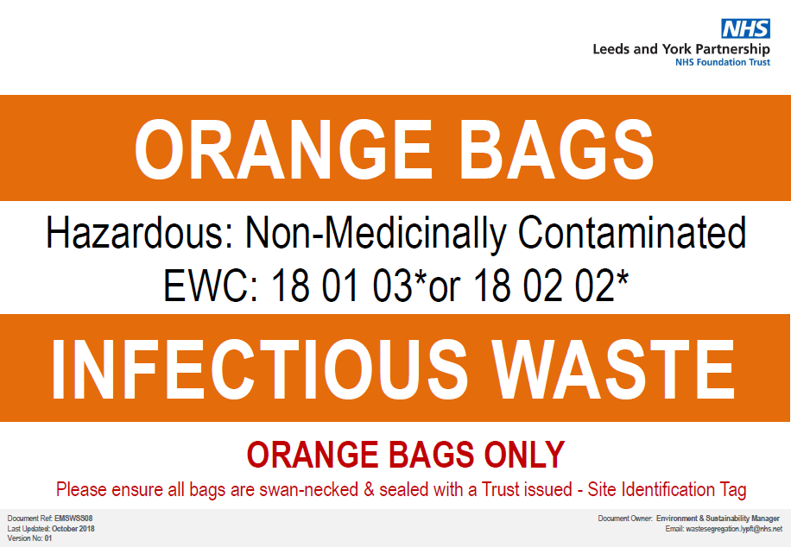

The responsibility for decanting bagged infectious waste into external bins should be locally agreed but generally speaking for PFI sites this is performed by IFM Domestic Assistants and for owned and leased sites this is performed by either Trust Clinicians or Trust Porters.

Due to the anticipated increase in Infectious waste during this time we ask that you monitor external bin levels and communicate any concerns to your line Manager who will relate them back to the Waste and Sustainability Manager for action. We will increase bin capacity and/or amend collection frequencies as required to assist with the safe management of Infectious waste.

**Community Teams / clinical Domestic Assistants working in people’s homes**

Clinical Domestic Assistants working in people’s homes should follow the same segregation and bagging guidance as above.

Bagged infectious waste including used PPE can be brought back to base in a single use orange lidded transportation container and decanted into the appropriate external bin for collection.

Any sharps waste back to their base in a closed off sharps container which is then placed inside the reusable, red transportation container provided. The sharps container should then be decanted into the appropriate external bin for collection at their main work base.

**Action Card (B)**

**COVID-19 Personal Protective Equipment (PPE)**

**Introduction**

This Action Card provides Domestic Assistants with the information they need to ensure that they understand the right type of PPE that must be worn. There are three items of PPE that you must wear and each has its own benefits for offering protection. The PPE supplied to the Trust is in line with national public health guidance and meets standards of approval of quality and assurance.

**Purpose/Scope**

This card outlines the requirements for the correct selection, donning, doffing and disposal of PPE. The most recent national guidance is the wards are now classified has COVID-19 infected wards, regardless if the virus is present or not.

**PPE**

Personal protective equipment is available for all Domestic Assistants to wear. This level of provision is also extended to contractors. The PPE supplied will include the following;

**Gloves and Apron**

* Change your gloves and apron when moving from one area to another i.e. activity room to lounge area

**Face Masks**

* Masks should be changed following breaks, eating and drinking. It is important to take regular drinks breaks when wearing masks as wearing a mask all the time can increase the risk of dehydration.
* Please ensure you wash your arms as well as your hands thoroughly in line with best practice. This is in case you have any spillage droplets on your arm whilst working bare bellow the elbows.

**Safety Spectacles/Goggles/Visors**

* Safety Spectacles/Goggles must be worn to protect you. If you wear prescription spectacles which are not compatible with the safety spectacles / goggles, you must use a visor over the top of them.
* Safety Spectacles/Goggles and Visors must only be used up-to and including 4 sessions (e.g. PPE strip down after each individual session), and then disposed-off in the clinical waste stream (refer to Action Card (A) in this document.
* Each member of staff must be allocated their own visor, named with a permanent marker and stored away from contamination when off duty

**How do I clean the visors/goggles/spectacles?**

Step 1 - Clean using a Clinicell Disposable Universal (Green) wipe.

Step 2 – Headband first with one wipe of the plastic (foam/elastic cannot be cleaned.

Step 3 - Using a second wipe clean the inside surface in an ‘S’ shaped motion from top to bottom. Remember to keep contact onto the screen for 60 seconds – leave to air dry.

Step 4 – use a third wipe, clean the outside surface in an ‘S’ shaped motion from top to bottom as above for 60 seconds – leave to air dry.

If at any time the visor becomes cracked, damaged or impaired in anyway e.g. plastic become brittle, opaque etc. dispose of in the clinical waste stream (Action Card A) and seek a replacement.

Don’t forget to avoid contaminating yourself by removing gloves (if worn) first and performing hand hygiene. A separate new pair of gloves should be worn for cleaning activities.

**Changing Areas for putting on and taking of the PPE**

Putting on the PPE must take place before entering the ward area (in a blue area) and the removing of the PPE must take place before leaving the ward (red area). For more information, please refer to Action Card (F) of this document. All the PPE is single use items which means they must be replaced at the end of the shift pattern and or when moving from a COVID-19 infected bedroom into other areas e.g. ward and non-clinical areas.

**Facial Hair**

The presence of facial hair for men mean that the reliability of the face mask is significantly compromised because it will no longer provide a tight fit around the contour of the face. For your own safety and wellbeing all male Domestic Assistants must be clean shaven.

**Infectious Waste**

When disposing of PPE, please refer to Action Card (A) of this document.

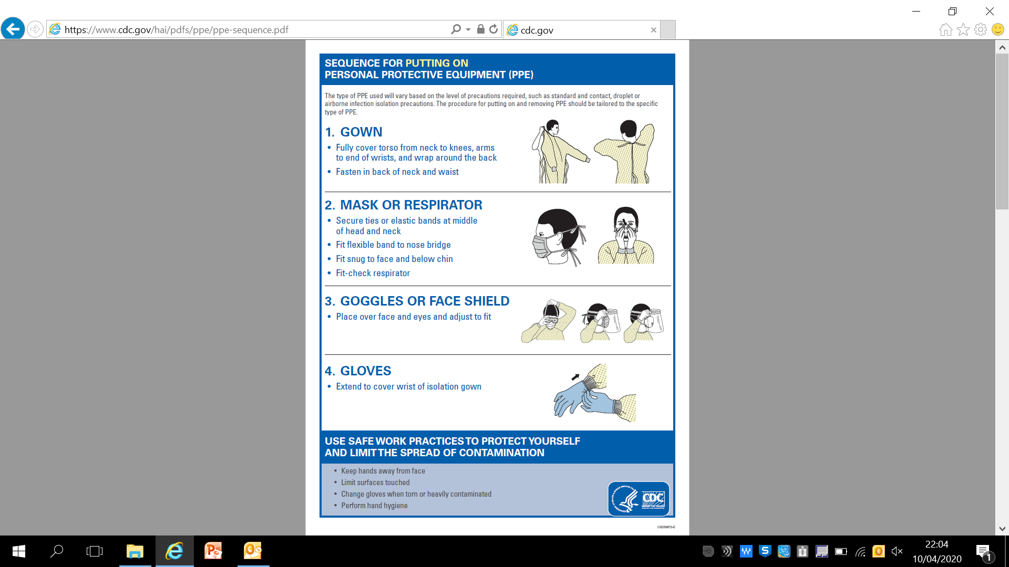

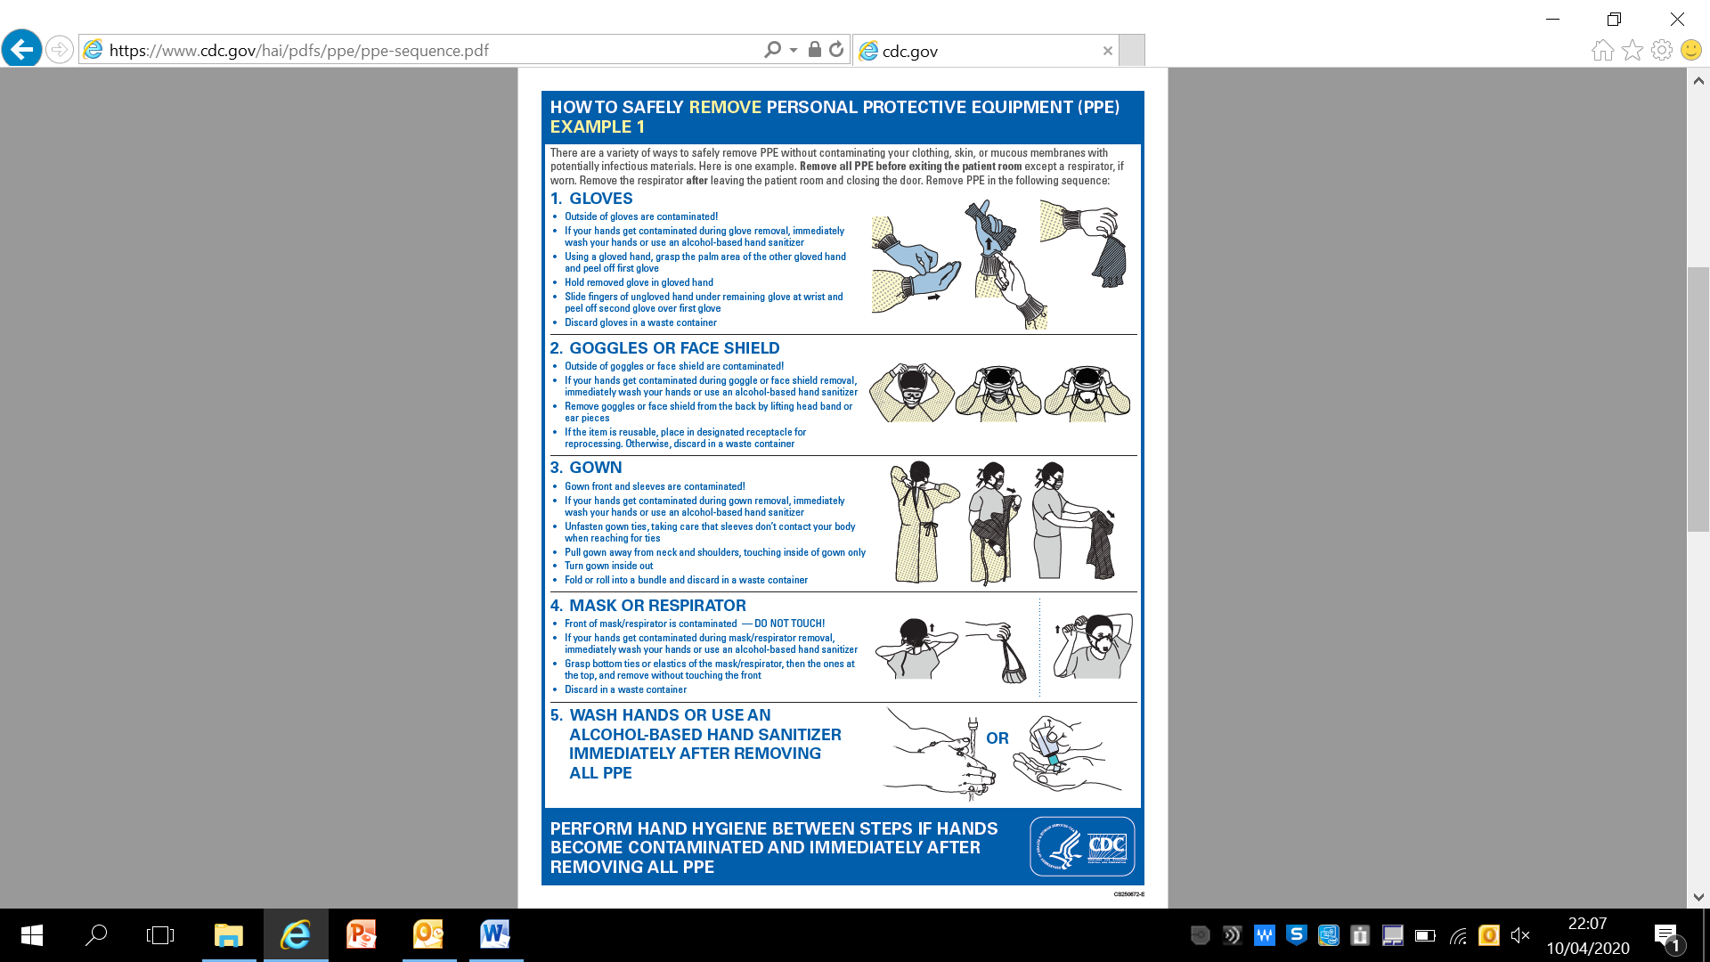

**Action Card (C)**

**Hand-Hygiene**



**Action Card (D)**

**Essential Chlorine Chemicals**

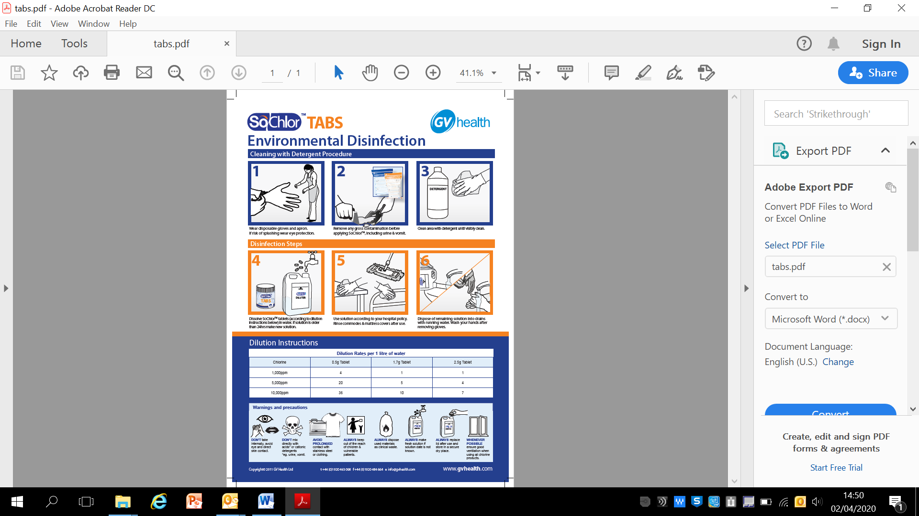

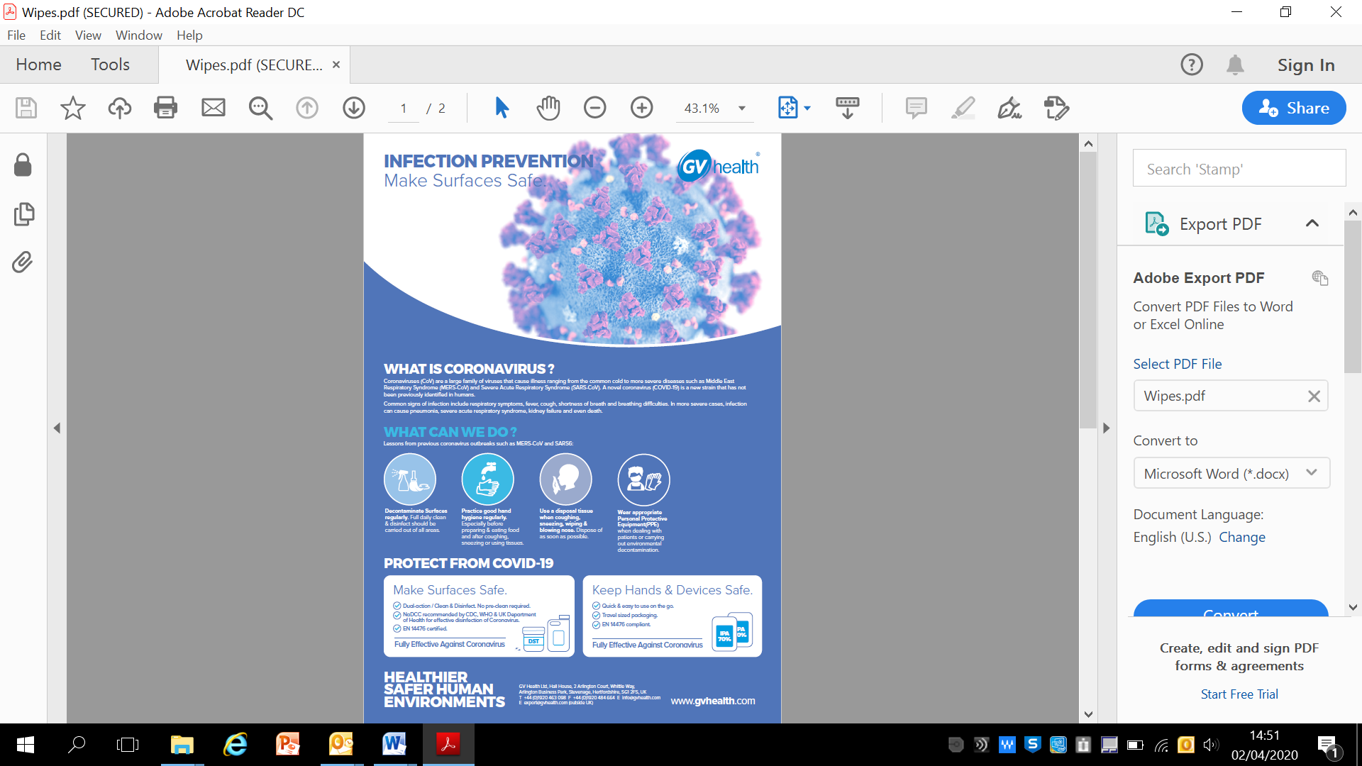

.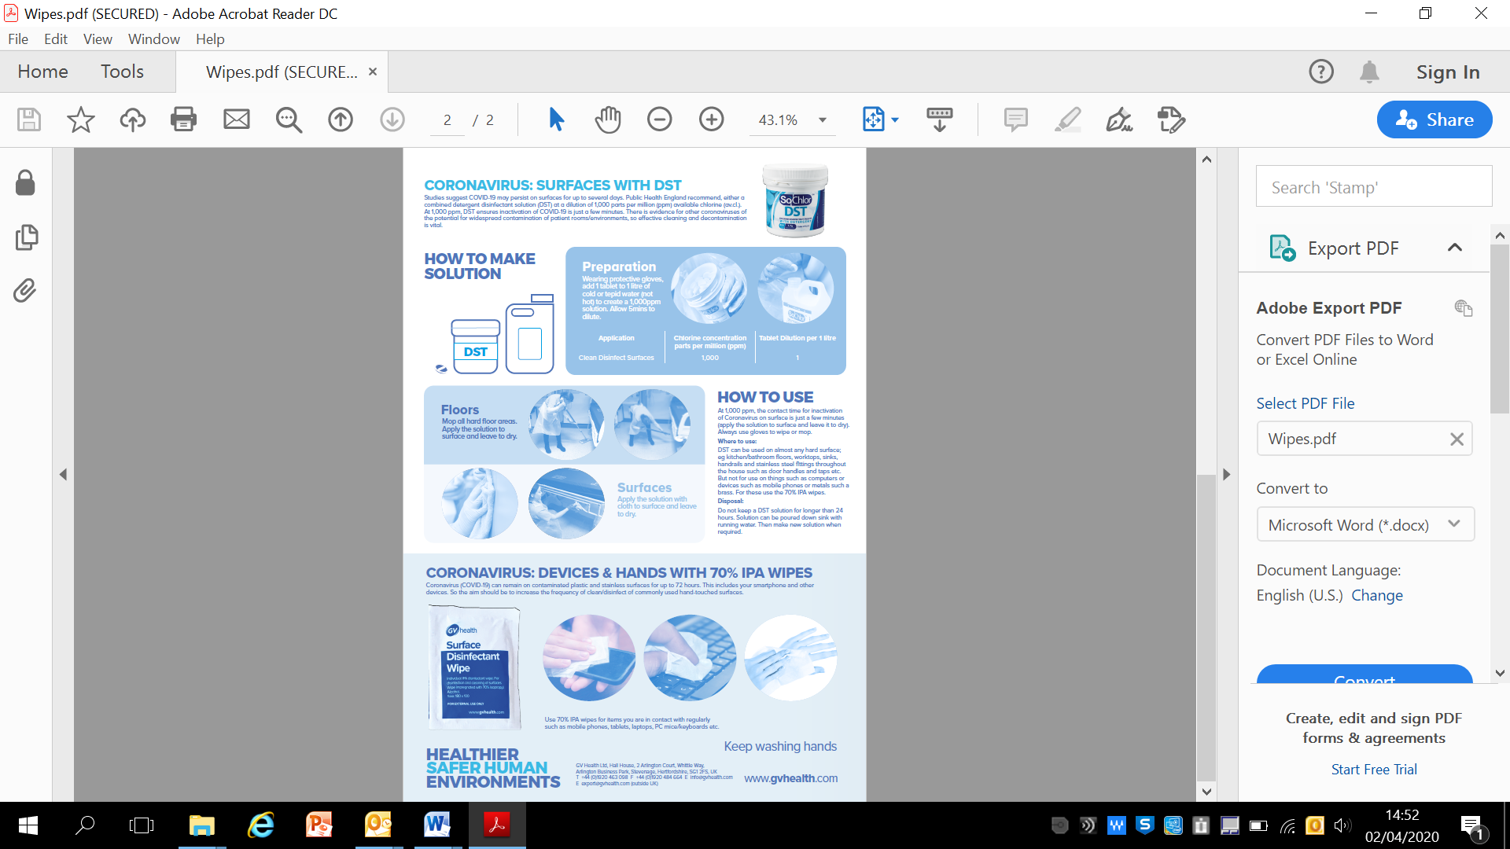

**Action Card (E)**

**Cleaning of a COVID-19 infected bedroom**

The windows must be opened (if possible) and the air conditioning switched off until it has been cleaned with the cleaning chemicals. Once this process has been completed, the room can be put back into use.

**Preparation**

* Collect all cleaning equipment and clinical waste bags before entering the room.
* Any cloths and mop heads used must be disposed of as single use items.

**PPE**

* Before entering the room, perform hand hygiene then put on a single use disposable apron, single use disposable gloves and disposable face mask within a clean area (blue zone), refer to Action Card (F).

**On entering the bedroom**

* Please keep the door closed with windows open (if possible) to improve airflow and ventilation whilst

cleaning.

* Bag all items that have been used, and the contents of the waste bin and any consumables that

cannot be cleaned with the chlorine chemicals. Please refer to Action Card (A) for more information about infectious waste.

* Remove any fabric curtains or screens and bag as infectious linen.Please refer to Action Card

(A) for more information within this document.

**Cleaning process**

All fixtures and fittings, floor, doors and windows must be cleaned and this includes all touch points including;

1. Light switches.
2. Wall power socket switches.
3. Floor surfaces.
4. Door handles.
5. Radio.
6. Light pull cords.
7. Cupboard doors and handles.
8. Window handles and ledges.
9. (If supplied in the room; water taps, bath, shower heads, screens, toilet handles, seat)
10. Chairs
11. Bed frame

**Action Card (F)**

**COVID - 19 The colour coding here indiciates social distancing rules that must be followed**

|  |
| --- |
| **WHEN YOU ARE INSIDE THE WARDS**  **YOU ARE LIKELY TO COME**  **WITHIN 2M OF SERVICE USERS.**  **PLEASE WEAR PPE** |

|  |
| --- |
| **WHEN YOU ARE OUTSIDE OF THE WARDS**  **PLEASE FOLLOW THE (2m) RULE**  **BETWEEN YOU AND OTHERS** |

|  |  |
| --- | --- |
| |  | | --- | | **THE SERVICE USERS ARE NOT**  **ALLOWED OUTSIDE OF THE WARD** | |

**Consulting with our Partners**

The Board recognises the valuable contribution our partners make for providing a clean environment for our staff and service users and the view of the Board is a ‘one-team approach’ with Interserve.

We ask you to have a conversation with LYPFT & Interserve domestic staff of any new COVID-19 confirmed cases before they begin clening the ward and this must happen daily.

**Bagging of Linen**

* A member of the Trust staff will strip the bed of all linen and place it firstly into a red bag as with all soiled linen and then into a laundry bag
* The double bagged linen then needs removing from the bedroom by the Trust member of staff and placed in the sluice room.
* Once in the sluice room the bags of linen will be collected by an Interserve member of staff and transferred to the external skips ready for collection by the laundry contractor.