Prescribing and Monitoring Oxygen On Electronic Prescribing System
- Print off oxygen monitoring chart from the electronic prescribing system by clicking on “reference viewer” then “observation sheets” then “observation charts” then “24hourly oxygen monitoring chart”. Complete relevant sections of the chart and keep with patient’s MEWS sheets n the ward
- Prescribe oxygen on the patient’s electronic drug chart by either:

- When in the patient’s drug chart on medchart click on “protocol” then “oxygen” then click which oxygen saturation level you require then click “add” at the bottom right of the page then follow the prompts to prescribe on the drug chart (see example on page 2). Once prescribed you can click on the drug oxygen and then in the qualifier you can state the mask and the flow rate as well as putting it on the oxygen monitoring chart.

- When in the patient’s drug chart on medchart click on “prescribe” then type “oxygen” then click on “oxygen via appropriate device” then chose which oxygen saturation level you want and then prescribe like any other drug. In the qualifier you can state the mask and the flow rate as well as putting it on the monitoring chart. (see example on page 3)

*please note the examples below were done on the electronic prescribing training system

Method A
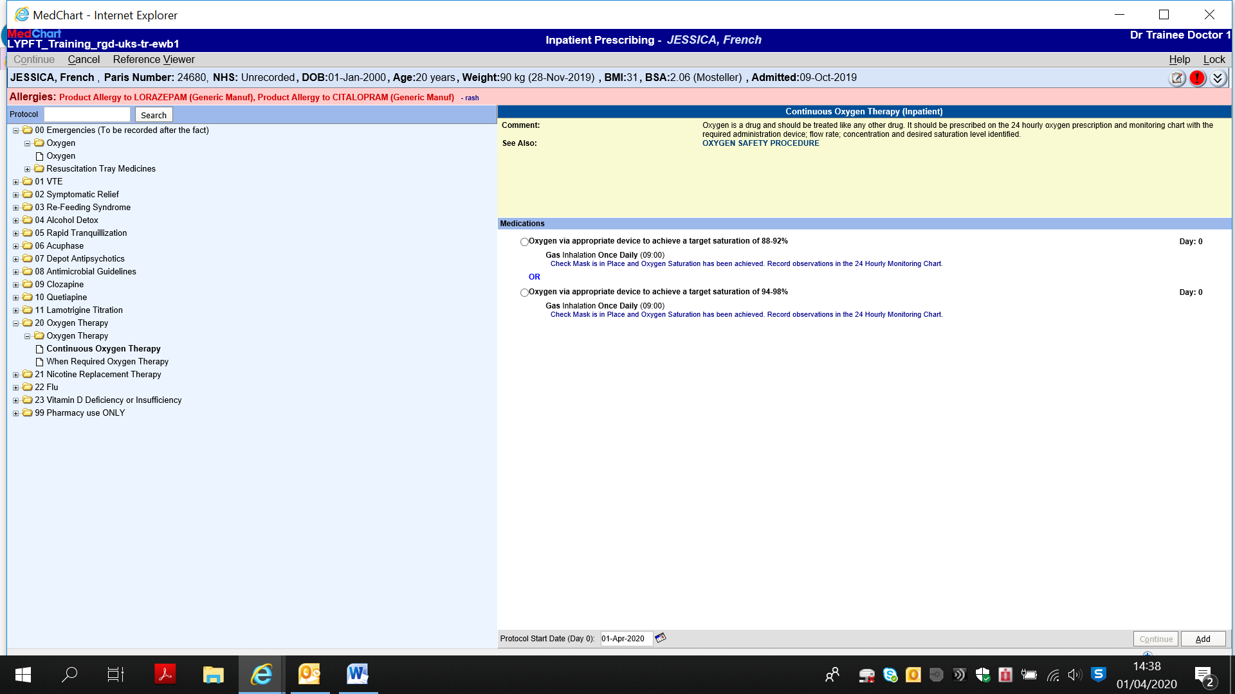

Method B
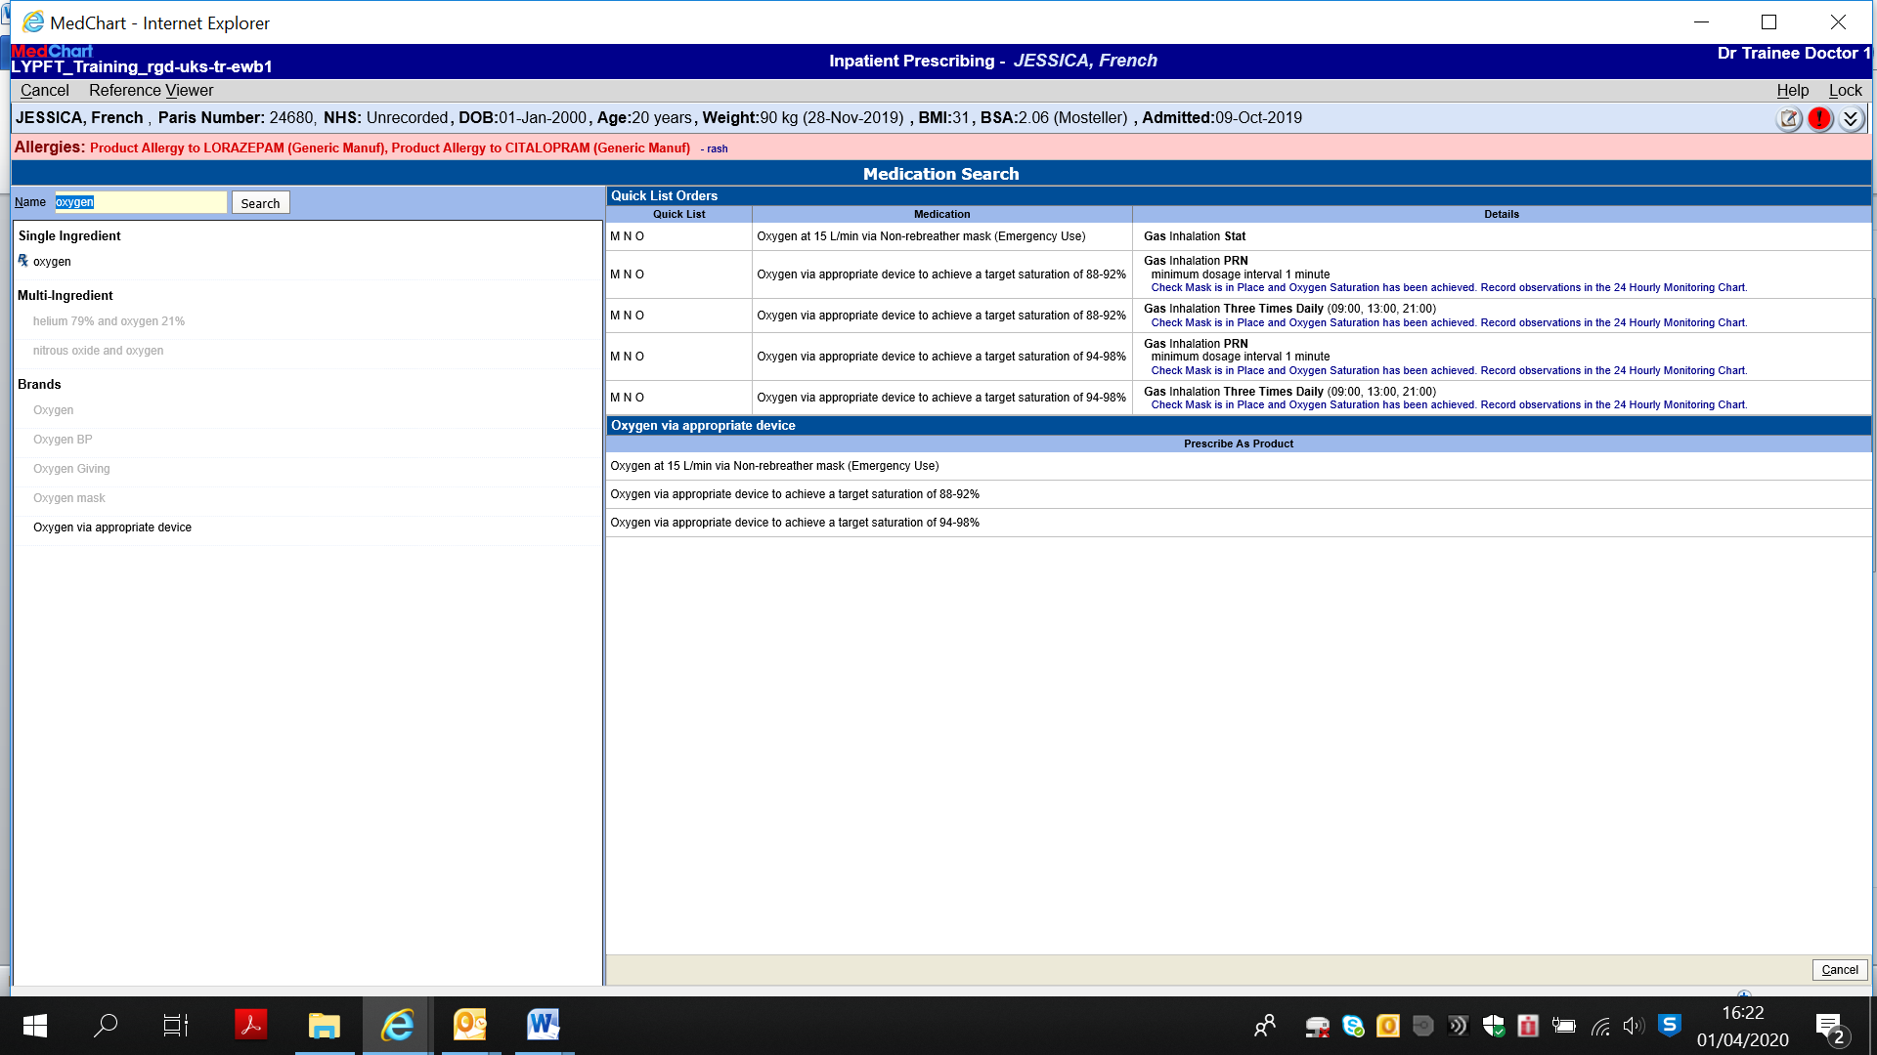
Michael Dixon, Lead Pharmacist for Medicines Information, 1.4.20

