Letters to Loved Ones
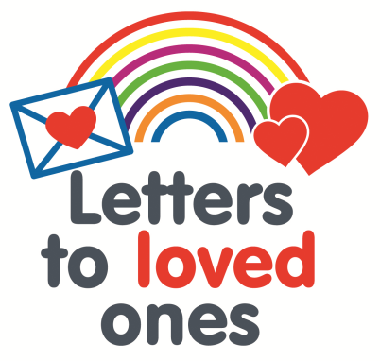
We recognise that it is a very difficult for our patients and their families whilst visiting is suspended. Not being able to talk to loved ones during this time is very distressing. In addition to the use of web platforms such as zoom, we have set up an email address, for families and friends to send messages to their loved ones whilst they are in our care.
Emails can be sent to letterstolovedones.lypft@nhs.net where our team will print them, pop them in an envelope and deliver them for you. To make sure we deliver to the correct person please include the patients full name, date of birth or address, the site they are on e.g. The Mount, and the ward (if known) and any other special requirements (e.g. large print / letter to be read out).
Letters to loved ones will be delivered by the next working day.
Please note we are only able to offer this service Monday-Friday, any letters sent after 2pm on Friday will be delivered on the following Monday.
If you do not have access to an email our PALS team would be happy to write your message down on a card and we will print and deliver this in the same way. PALS can be contacted on Tel: 0800 0525 790.

