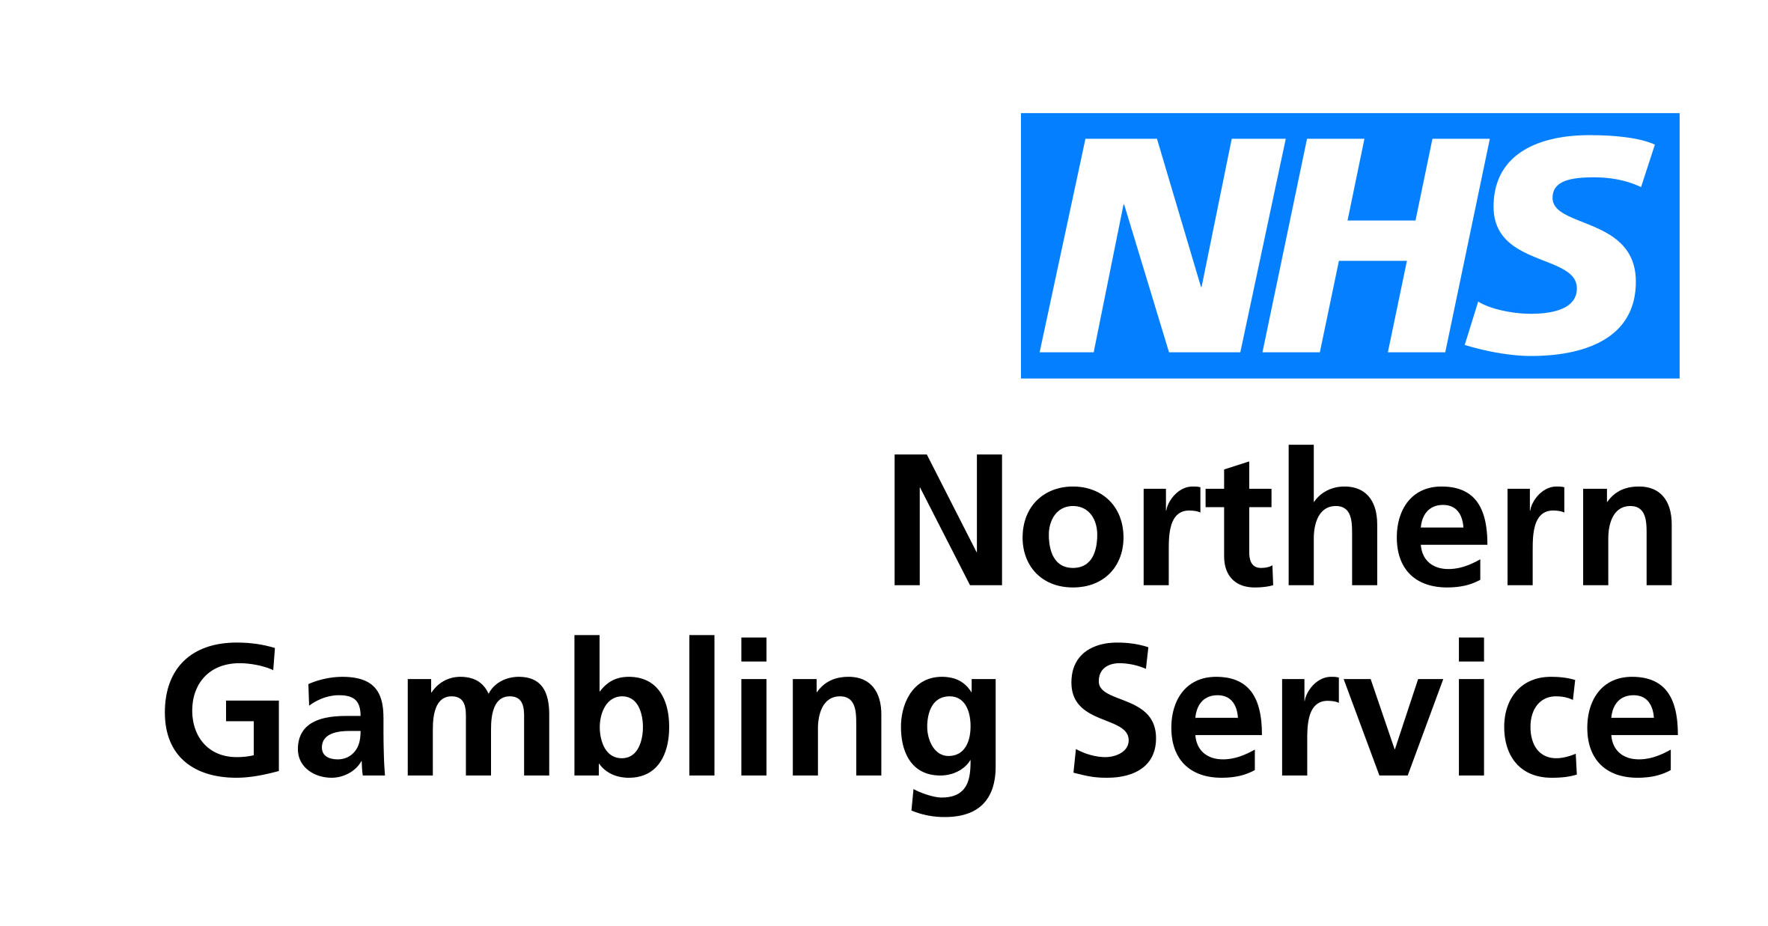
NHS Northern Gambling Service
Hard copy materials ordering form
A4 poster
Product | Quantity required | Contact name | Contact number for delivery driver | Organisation name | Delivery / receiving address

A5 leaflet
Product | Quantity required | Contact name | Contact number for delivery driver | Organisation name | Delivery / receiving address

Return to: Northern Gambling Service, Leeds and York Partnership NHS Foundation Trust at: referral.ngs@nhs.net
Any issues please contact LYPFT’s Communications Team on 0113 855 5989 or email communications.lypft@nhs.net

