Leeds Adult ADHD Service Referral Pack

Contents

Page 2 - Section 1 to be completed by referrers
Page 5 - Section 2 to be completed by service user
Page 7 - Minimum data set information form – to be completed by service user
Page 9 - Self-rated scales to be completed by service user.

Further copies of the referral forms and scales can be found at www.leedsandyorkpft.nhs.uk/our-services/services-list/adult-adhd-service/

Please send completed referral to: referral.lypft@nhs.net

If you need any advice or guidance please contact the ADHD Service on
0113 85 59341
Leeds Adult ADHD Service Referral Form

Section 1 to be completed by referrer:
SERVICE USER DETAILS
SURNAME |  | ADDRESS INC TOWN, COUNTY & POSTCODE
FORENAME |  | TELEPHONE NUMBER
TITLE |  | NHS NUMBER
SEX | ☐Male  ☐Female  ☐Other | LANGUAGE PREFERRED
DATE OF BIRTH |  | IS AN INTERPRETER REQUIRED? | ☐ Yes  ☐ No
EMAIL ADDRESS |  | CONSENT | Does the service user fully consent to the referral?  ☐ Yes ☐ No (If no, please obtain consent - referrals are not accepted into the service if full consent is not given)
Does the service user want someone to contact us on their behalf (e.g. partner, parent) when arranging an initial appointment? |  | If YES, please provide name and contact details…
What is the service user’s preferred method of contact? |  | ☐Telephone  ☐Email  ☐Letter
GP DETAILS
NAME |  | ADDRESS INC TOWN, COUNTY & POSTCODE
EMAIL |  | TELEPHONE NUMBER
REFERRER DETAILS  (If different from GP details above) | Name:  Address:  Contact Number/Email:
Please outline the reason for your referral including description of any areas of impaired functioning:

Please provide information about any current or previous physical and mental health difficulties (including sleep) and details of current medication (or attach GP summary care record)
Is the service user at serious risk of harming themselves or others?
☐ Yes – please give details….
☐ No

If you feel that the service user is currently acutely unwell or at significant risk to themselves or others then please refer to appropriate services e.g Crisis service, CMHT, Police.

Any further information you wish to provide?

Leeds Adult ADHD Service Referral Form

Section 2 to be completed by service user and returned to referrer:

Name: Date of Birth:

REFERRAL DETAILS: all information listed below is required for the service to assess the appropriateness of the referral.
a) Please outline the reasons why you wish to be assessed for ADHD.
b) Have you been diagnosed with ADHD before?

☐ Yes☐ No

If you have a past ADHD diagnosis, please provide details of when the diagnosis was made; if you received previous treatment; your response to treatment; and if you are still taking treatment. If you are no longer taking treatment please state the reasons for stopping and when the medication was stopped.

Please forward past correspondence evidencing diagnosis of ADHD and any treatment. If this is not available please state the reasons.

c) Please provide examples of any inattention symptoms in childhood. Also any current inattentive symptoms, occurring often or very often, and impacting on their current functioning. E.g. difficulties with concentration, distractibility, organisation, forgetfulness. Please state NONE if there are no symptoms.
Childhood:

Current:

d) Please provide examples of any hyperactive symptoms in childhood. Also any current hyperactive symptoms, occurring often or very often, and impacting on their current functioning. E.g. fidgeting, physical and/or mental restlessness, over talkative, loud speech. Please state NONE if there are no symptoms.
Childhood:

Current:

e) Please provide any examples of any impulsive symptoms in childhood. Also any current impulsive symptoms, occurring often or very often, and impacting on their current functioning. E.g. impatient waiting for turn; completing other people’s sentences; or impulsive (and possibly risky) decision making. Please state NONE if there are no symptoms.
Childhood:

Current:

f) Can you explain in your own words how you feel that any of the symptoms you have identified above may impact on areas of your life (for example, Home life, relationships, work, education, finances)?
g) Do you have any difficulties with unstable moods e.g. rapid mood changes, low tolerance to frustration?
h) Do you struggle with your mind often wandering and/or find it difficult to “switch off”?
i) Can you provide written information available from childhood to help support your assessment? E.g. school reports, workplace assessments, mental health reports etc.
☐ Yes
☐ No

If yes, what is available?

Please note that as part of the assessment process we need to obtain collateral information. This is usually from one person who can provide a childhood developmental history and a second person who knows you well currently who can provide their observations of your current difficulties and behaviour. We can proceed without obtaining a collateral developmental history, but please be aware that sometimes we are unable to make a final decision regarding ADHD diagnosis.
Please also complete the minimum data set form along with the self-rated scales that should have been provided to you by the referrer.

Minimum Data Set Information
Patient name: _____________________________________ Telephone No: _________________________________________

We would be grateful if you could please provide us with the following information. By doing this you are helping us to monitor the uptake of or services and aid the planning process to ensure that a culturally competent service is provided to outpatient.
Personal data about you is not shared with anybody not directly involved in your care. If you have received this letter in the post we would be grateful if you would complete and bring to your next appointment. If you need any help to complete this form please ask a member of staff.

ETHNICITY:
Asian – Bangladeshi |  | Black – Caribbean |  | Mixed-White/Black African
Asian – Indian |  | Black – Other |  | Mixed-White/Black Caribbean
Asian – Kashmiri |  | White – Other |  | Other ethnic group
Asian – Other |  | Chinese |  | White – British
Asian Pakistani |  | Mixed – Other |  | White – Irish
Black – African |  | Mixed-White & Asian

RELIGION:
Baha’I |  | Jain |  | Pagan
Buddhist |  | Jewish |  | Sikh
Christian |  | Muslim |  | Zoroastrian
Hindu |  | None |  | Other

MARITAL STATUS:
Divorced |  | Separated |  | Surviving partner / widowed
Married/ civil partner |  | Single

LIVING STATUS:
Lives alone |  | Lives with parent/ guardian |  | Residential care
Lives with family |  | Lives with partner/ spouse |  | Supported living
Lives with other |  | No fixed abode

ACCOMMODATION STATUS:
Bail/Probation Hostel |  | Other mainstream Housing |  | Sheltered Housing
Non M/H reg. Care Home |  | Owner Occupier |  | Squatting
Older persons nursing home |  | Settled Mainstream (Live with family/friend) |  | Staying with family/friends
Other – Homeless |  | Shared Ownership Scheme |  | Supported lodging

EMPLOYMENT STATUS:
Employed |  | Unemployed – Seeking work |  | Student
Looking after Family/ Home |  | Unemployed – Not seeking work |  | Other
Retired |  | Unemployed – Sick/ Disabled |  | Unpaid/Voluntary

SMOKING STATUS:
Do you smoke? | YES |  | NO
If yes, have you been offered help via smoking cessation? | YES |  | NO
If help was offered, did you accept this help? | YES |  | NO
Could you provide us with a date when this was offered?

NEXT-OF-KIN INFORMATION:
NAME: |  | ADDRESS:
CONTACT INFORMATION: |  | Landline: |  | Mobile:
NEXT-OF-KIN RELATIONSHIP TYPE | Husband/Wife | Son/Daughter | Father/ Mother |  | Brother/ Sister
 | Grandparents | Grandchild | Uncle/Aunt |  | Nephew/Niece
 | Common-Law spouse | Civil partnership | Other

CARER INFORMATION:
Do you have a Carer? | YES |  | NO
Name of Carer: |  | Address of Carer:
Contact number of carer: |  | Relationship to service user:

SEXUALITY:
Which of the following best describes how you think of yourself? (please tick)
Heterosexual or Straight | Gay or Lesbian | Bisexual | Other sexual orientation not listed | Not known (not recorded)
Person asked and does not know or is not sure |  |  | Not stated (person asked but declined to provide a response)

Wender Utah Rating Scale for the Attention Deficit Hyperactivity Disorder

Please circle the most appropriate response from 0-4 for all the questions below.

 | As a child I was (or had): | not at all or very slightly | mildly | moder-ately | quite a bit | very much
1 | active restless always on the go | 0 | 1 | 2 | 3 | 4
2 | afraid of things | 0 | 1 | 2 | 3 | 4
3 | concentration problems easily distracted | 0 | 1 | 2 | 3 | 4
4 | anxious worrying | 0 | 1 | 2 | 3 | 4
5 | nervous fidgety | 0 | 1 | 2 | 3 | 4
6 | inattentive daydreaming | 0 | 1 | 2 | 3 | 4
7 | hot- or short-tempered low boiling point | 0 | 1 | 2 | 3 | 4
8 | shy sensitive | 0 | 1 | 2 | 3 | 4
9 | temper outbursts tantrums | 0 | 1 | 2 | 3 | 4
10 | trouble with stick-to-it-tiveness not following through. failing to finish things started | 0 | 1 | 2 | 3 | 4
11 | stubborn strong-willed | 0 | 1 | 2 | 3 | 4
12 | sad or blue depressed unhappy | 0 | 1 | 2 | 3 | 4
13 | incautious. dare-devilish involved in pranks | 0 | 1 | 2 | 3 | 4
14 | not getting a kick out of things dissatisfied with life | 0 | 1 | 2 | 3 | 4
15 | disobedient with parents rebellious sassy | 0 | 1 | 2 | 3 | 4
16 | low opinion of myself | 0 | 1 | 2 | 3 | 4
17 | irritable | 0 | 1 | 2 | 3 | 4
18 | outgoing friendly enjoyed company of people | 0 | 1 | 2 | 3 | 4
19 | sloppy disorganized | 0 | 1 | 2 | 3 | 4
20 | moody ups and downs | 0 | 1 | 2 | 3 | 4
21 | angry | 0 | 1 | 2 | 3 | 4
22 | friends popular | 0 | 1 | 2 | 3 | 4
23 | well-organized tidy neat | 0 | 1 | 2 | 3 | 4
24 | acting without thinking impulsive | 0 | 1 | 2 | 3 | 4
25 | tendency to be immature | 0 | 1 | 2 | 3 | 4
26 | guilty feelings regretful | 0 | 1 | 2 | 3 | 4
27 | losing control of myself | 0 | 1 | 2 | 3 | 4
28 | tendency to be or act irrational | 0 | 1 | 2 | 3 | 4
29 | unpopular with other children didn't keep friends for long didn't get along with other children | 0 | 1 | 2 | 3 | 4
30 | poorly coordinated did not participate in sports | 0 | 1 | 2 | 3 | 4
 | As a child I was (or had): | not at all or very slightly | mildly | moder-ately | quite a bit | very much
31 | afraid of losing control of self | 0 | 1 | 2 | 3 | 4
32 | well-coordinated picked first in games | 0 | 1 | 2 | 3 | 4
33 | tomboyish (for women only) | 0 | 1 | 2 | 3 | 4
34 | running away from home | 0 | 1 | 2 | 3 | 4
35 | getting into fights | 0 | 1 | 2 | 3 | 4
36 | teasing other children | 0 | 1 | 2 | 3 | 4
37 | leader bossy | 0 | 1 | 2 | 3 | 4
38 | difficulty getting awake | 0 | 1 | 2 | 3 | 4
39 | follower led around too much | 0 | 1 | 2 | 3 | 4
40 | trouble seeing things from someone else's point of view | 0 | 1 | 2 | 3 | 4
41 | trouble with authorities trouble with school visits to principal's office | 0 | 1 | 2 | 3 | 4
42 | trouble with police booked convicted | 0 | 1 | 2 | 3 | 4
 | Medical problems as a child | not at all or very slightly | mildly | moder-ately | quite a bit | very much
43 | headaches | 0 | 1 | 2 | 3 | 4
44 | stomachaches | 0 | 1 | 2 | 3 | 4
45 | constipation | 0 | 1 | 2 | 3 | 4
46 | diarrhea | 0 | 1 | 2 | 3 | 4
47 | food allergies | 0 | 1 | 2 | 3 | 4
48 | other allergies | 0 | 1 | 2 | 3 | 4
49 | bedwetting | 0 | 1 | 2 | 3 | 4
 | As a child in school I was (or had) | not at all or very slightly | mildly | moder-ately | quite a bit | very much
50 | overall a good student fast | 0 | 1 | 2 | 3 | 4
51 | overall a poor student slow learner | 0 | 1 | 2 | 3 | 4
52 | slow in learning to read | 0 | 1 | 2 | 3 | 4
53 | slow reader | 0 | 1 | 2 | 3 | 4
54 | trouble reversing letters | 0 | 1 | 2 | 3 | 4
55 | problems with spelling | 0 | 1 | 2 | 3 | 4
56 | trouble with mathematics or numbers | 0 | 1 | 2 | 3 | 4
57 | bad handwriting | 0 | 1 | 2 | 3 | 4
58 | able to read pretty well but never really enjoyed reading | 0 | 1 | 2 | 3 | 4
59 | not achieving up to potential | 0 | 1 | 2 | 3 | 4
60 | repeating grades | 0 | 1 | 2 | 3 | 4
61 | suspended or expelled | 0 | 1 | 2 | 3 | 4

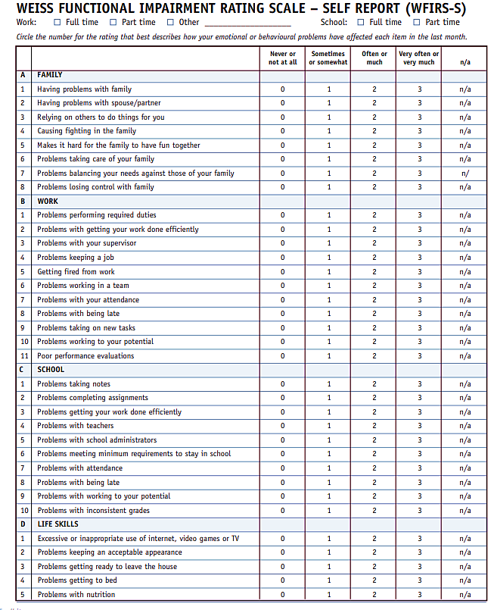

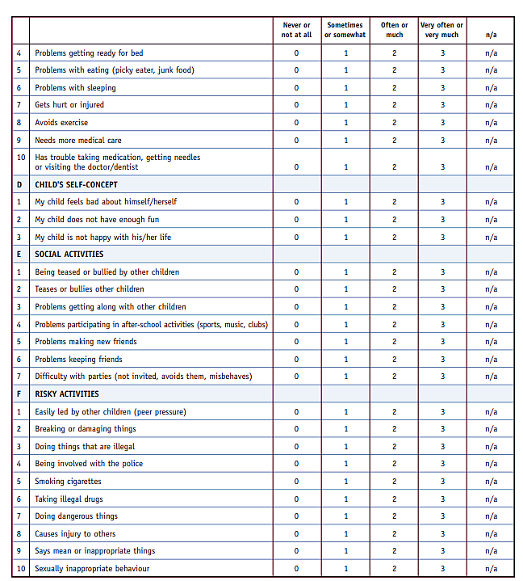

Adult ADHD Self-Report Scale Symptom Checklist (ASRS-v1.1)
Please answer the questions below, rating yourself on each of the criteria shown using the scale on the right side of the page. As you answer each question, place an X in the box that best describes how you have felt and conducted yourself over the past 6 months | Never | Rarely | Sometimes | Often | Very often
1. How often do you have trouble wrapping up the final details of a project, once the challenging parts have been done?
2. How often do you have difficulty getting things in order when you have to do a task that requires organisation?
3. How often do you have problems remembering appointments or obligations?
4. When you have a task that requires a lot of thought, how often do you avoid or delay getting started?
5. How often do you fidget or squirm with your hands or feet when you have to sit down for a long time?
6. How often do you feel overly active and compelled to do things, like you were driven by a motor?

Thank you for completing the referral.

Please return your referral form, minimum data set information and rating scales to the referrer.

You will receive an acknowledgement from our service if you are accepted on to the waiting list.

