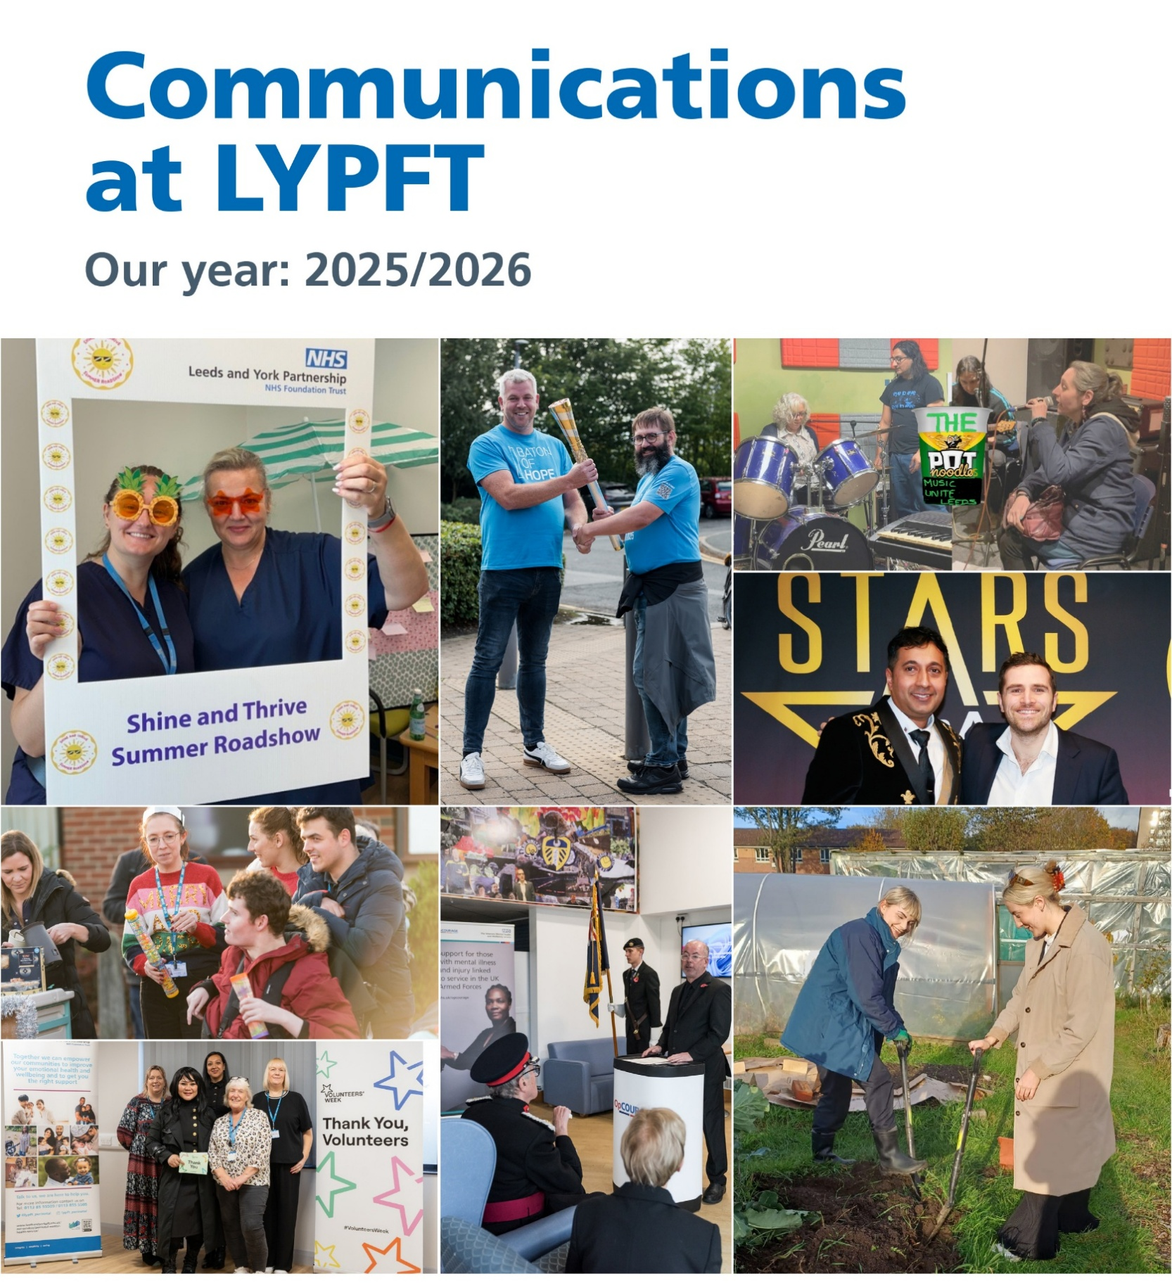

Contents

Foreword

Highlights of 2025/6

Our 10 strategic priorities – how we did in 2025/6

Forward look: “The future ain’t what it used to be.”

Some links contained within this report point to our intranet, Staffnet 365. This is only accessible to staff with an nhs.net email account assigned to the Trust. To request versions of any content that is not accessible, please email the comms team at communications.lypft@nhs.net.

Foreword

Comms teams are often criticised for not doing their own PR – shining a light on themselves for a change rather than the people they serve or represent. So, this is an attempt to do just that.

Some might say writing your own annual report sounds a bit of a dull and dry way of doing your own PR. Whilst that depends on how you write it, I would also say the journey is as important as the destination!

In other words, the process to get the end product is a great exercise for the whole team to contribute to. Because let’s face it, we’ve all slept a few times during and since 2025/6, so its brilliant to be reminded of all the hard work and success stories of the year. It's shocking how much of my own work I’d forgotten about.

One very pleasing phrase I hear from colleagues, especially from the longer serving veterans within the team, is that “things are so much better now because . . .” followed by an example of how we’ve made improvements to the way the team works, the quality of the work we do, and the impact we have supporting the Trust.

I like to think one of the reasons for this is the fact that we have a strategy in place. Whilst they can be cumbersome documents, strategies give you clarity on what’s important and where to put your time and energy. They also give you permission to say things like “sorry that’s not one of our strategic priorities”, or “here’s the guide on how you can do this yourself”.

Our strategy has five aims. They are:

- We provide an outstanding communications service to the Trust that improves the health and lives of the communities we serve.
- We tell great stories.
- We promote and protect our brand in line with our values of integrity, caring and keeping it simple.
- We support and enable all our people to be great communicators through advice, guidance, consultancy and training.
- We warn and inform – leading on communications that saves lives and prevents harm before, during and after serious incidents.

How we operationally deliver on those aims is set out in our 10 strategic objectives – and you can read more on how we did on them during 2025/6 in Section 3 of this report.

I remember once hearing (from a wiser comms pro than I) that the purpose of strategy is to be “intentional”, rather than being constantly reactive to other people’s demands or just responding chaotically to stuff that happens around you. We’ve probably all worked in teams like that at some point.

I would go on to say that any comms strategy can only be as good as the organisation’s strategy. In other words, you’ve got to know what’s important to your top team, figure out how your team can apply themselves to best support them, and then create the conditions for success.

In our team, we’ve done a lot of work behind the scenes to create those conditions – whether it be developing procedures, improving workflow and project allocation, running comms planning sessions, creating training guides etc etc.

But we did it. And by doing it, we’ve made space and time to do some great stuff – the evidence you’ll hopefully see for yourselves here.



Oliver Tipper
Head of Communications

Highlights of 2025/6

Celebrating our work and our people
Here is just a small selection of some of our favourite stories that we’ve worked between April 2025 and March 2026.

Carrying the message of hope
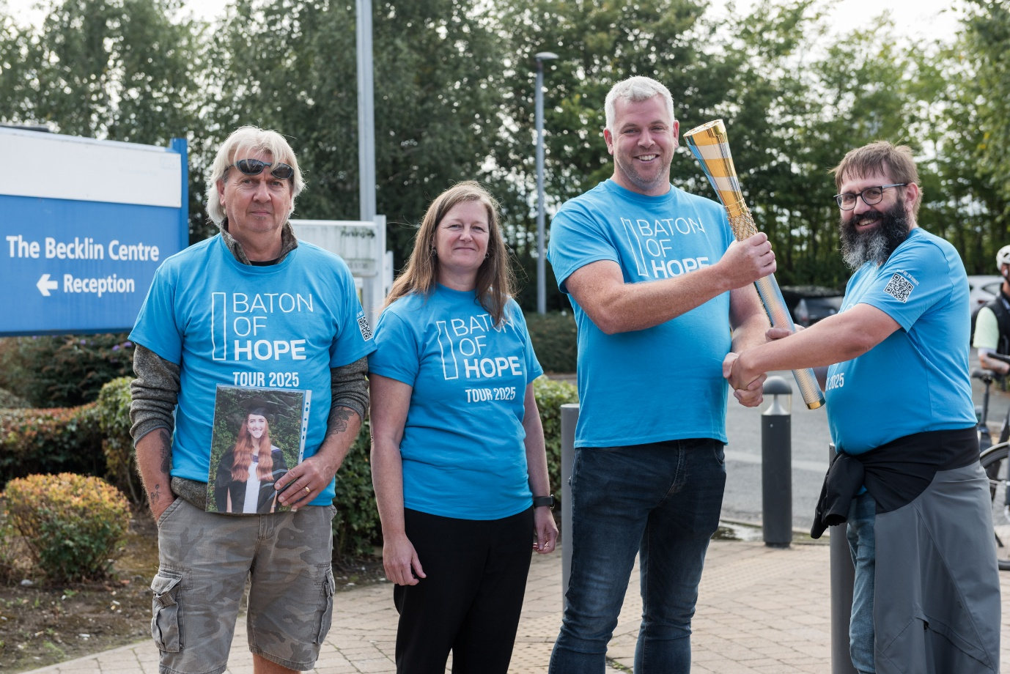
We will only ever win the battle against suicide if people can reach out before reaching that breaking point. That was the message from Steve Taylor (pictured second from the right) - who works in our Digital Data and Technology Team - when he opened up to us about losing a colleague to suicide.

Marking World Suicide Prevention Day in September 2025, he carried the Baton of Hope through the streets of Leeds as it toured the country spreading a message of hope and awareness. The day's events were expertly captured on video by our Trust's videography team alongside interviews with Steve, our CEO Sara Munro and our People Wellbeing Lead Judith Barnes.

Read more and watch a video featuring Steve on our website.

An MBE for our campaigning doc


Dr Matt Gaskell, Clinical Lead and Consultant Psychologist at the NHS Northern Gambling Service was made a Member of the Order of the British Empire (MBE) for ‘Services to People Experiencing Gambling Harm’ in this year’s King’s Birthday Honours.

We had to work closely with the Cabinet Office, which tightly controls the awarding of the King’s Honours and how they are announced, to ensure our story was consistent with theirs, and the timing was right. Can you imagine if, like with certain budgetary reports, we pressed the button too soon!?

Matt was typically magnanimous in his acceptance, dedicating it “to all those affected by preventable gambling-related harm, to the brilliant people who advocate for new gambling legislation, and to many amazing colleagues with whom I have worked over the years treating addictive behaviour.”

Read the full story on our website.

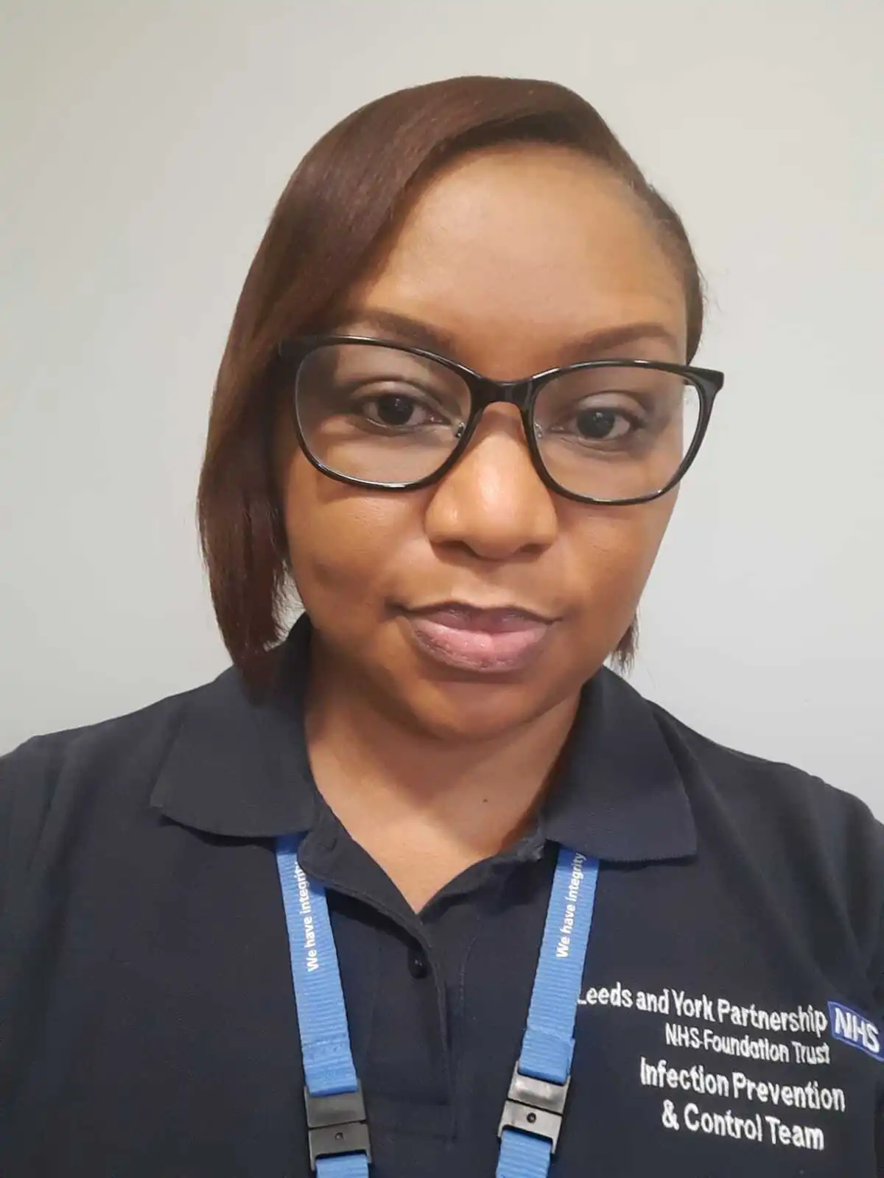
Turning an annual report into a great showcase
When the Infection Prevention and Control Team’s annual report landed on our desk, it would have been easy to overlook it.

But we found a great story inside it, and we worked it up into an in-person interview with lead nurse Gugu Ncube (pictured), also featuring a case study from Older People’s Infection Control Link Champion Colleen Liddon.

Read the interview in full on Staffnet News.

Wishing a long serving colleague well into retirement

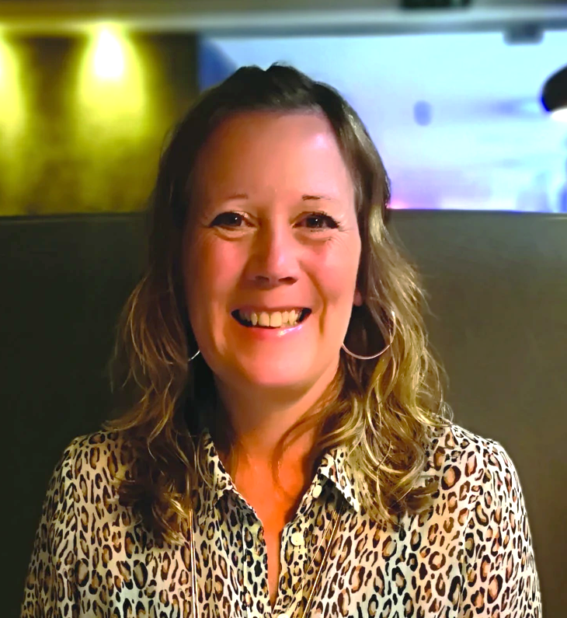
It feels great to be part of a very personal tribute – especially a surprise one. Which is why we’ve included this story marking the retirement of Debbie Thrush from Community & Wellbeing Services.

It was written on the QT with contributions from her close colleagues – and then sprung on her as (hopefully) a pleasant surprise.

The biggest challenge we faced was finding a nice picture of her – which we eventually did although it does look like she’s out enjoying a cheeky Nando’s.

Read the full tribute on Staffnet News.

Celebrating improvement in services not often in the spotlight

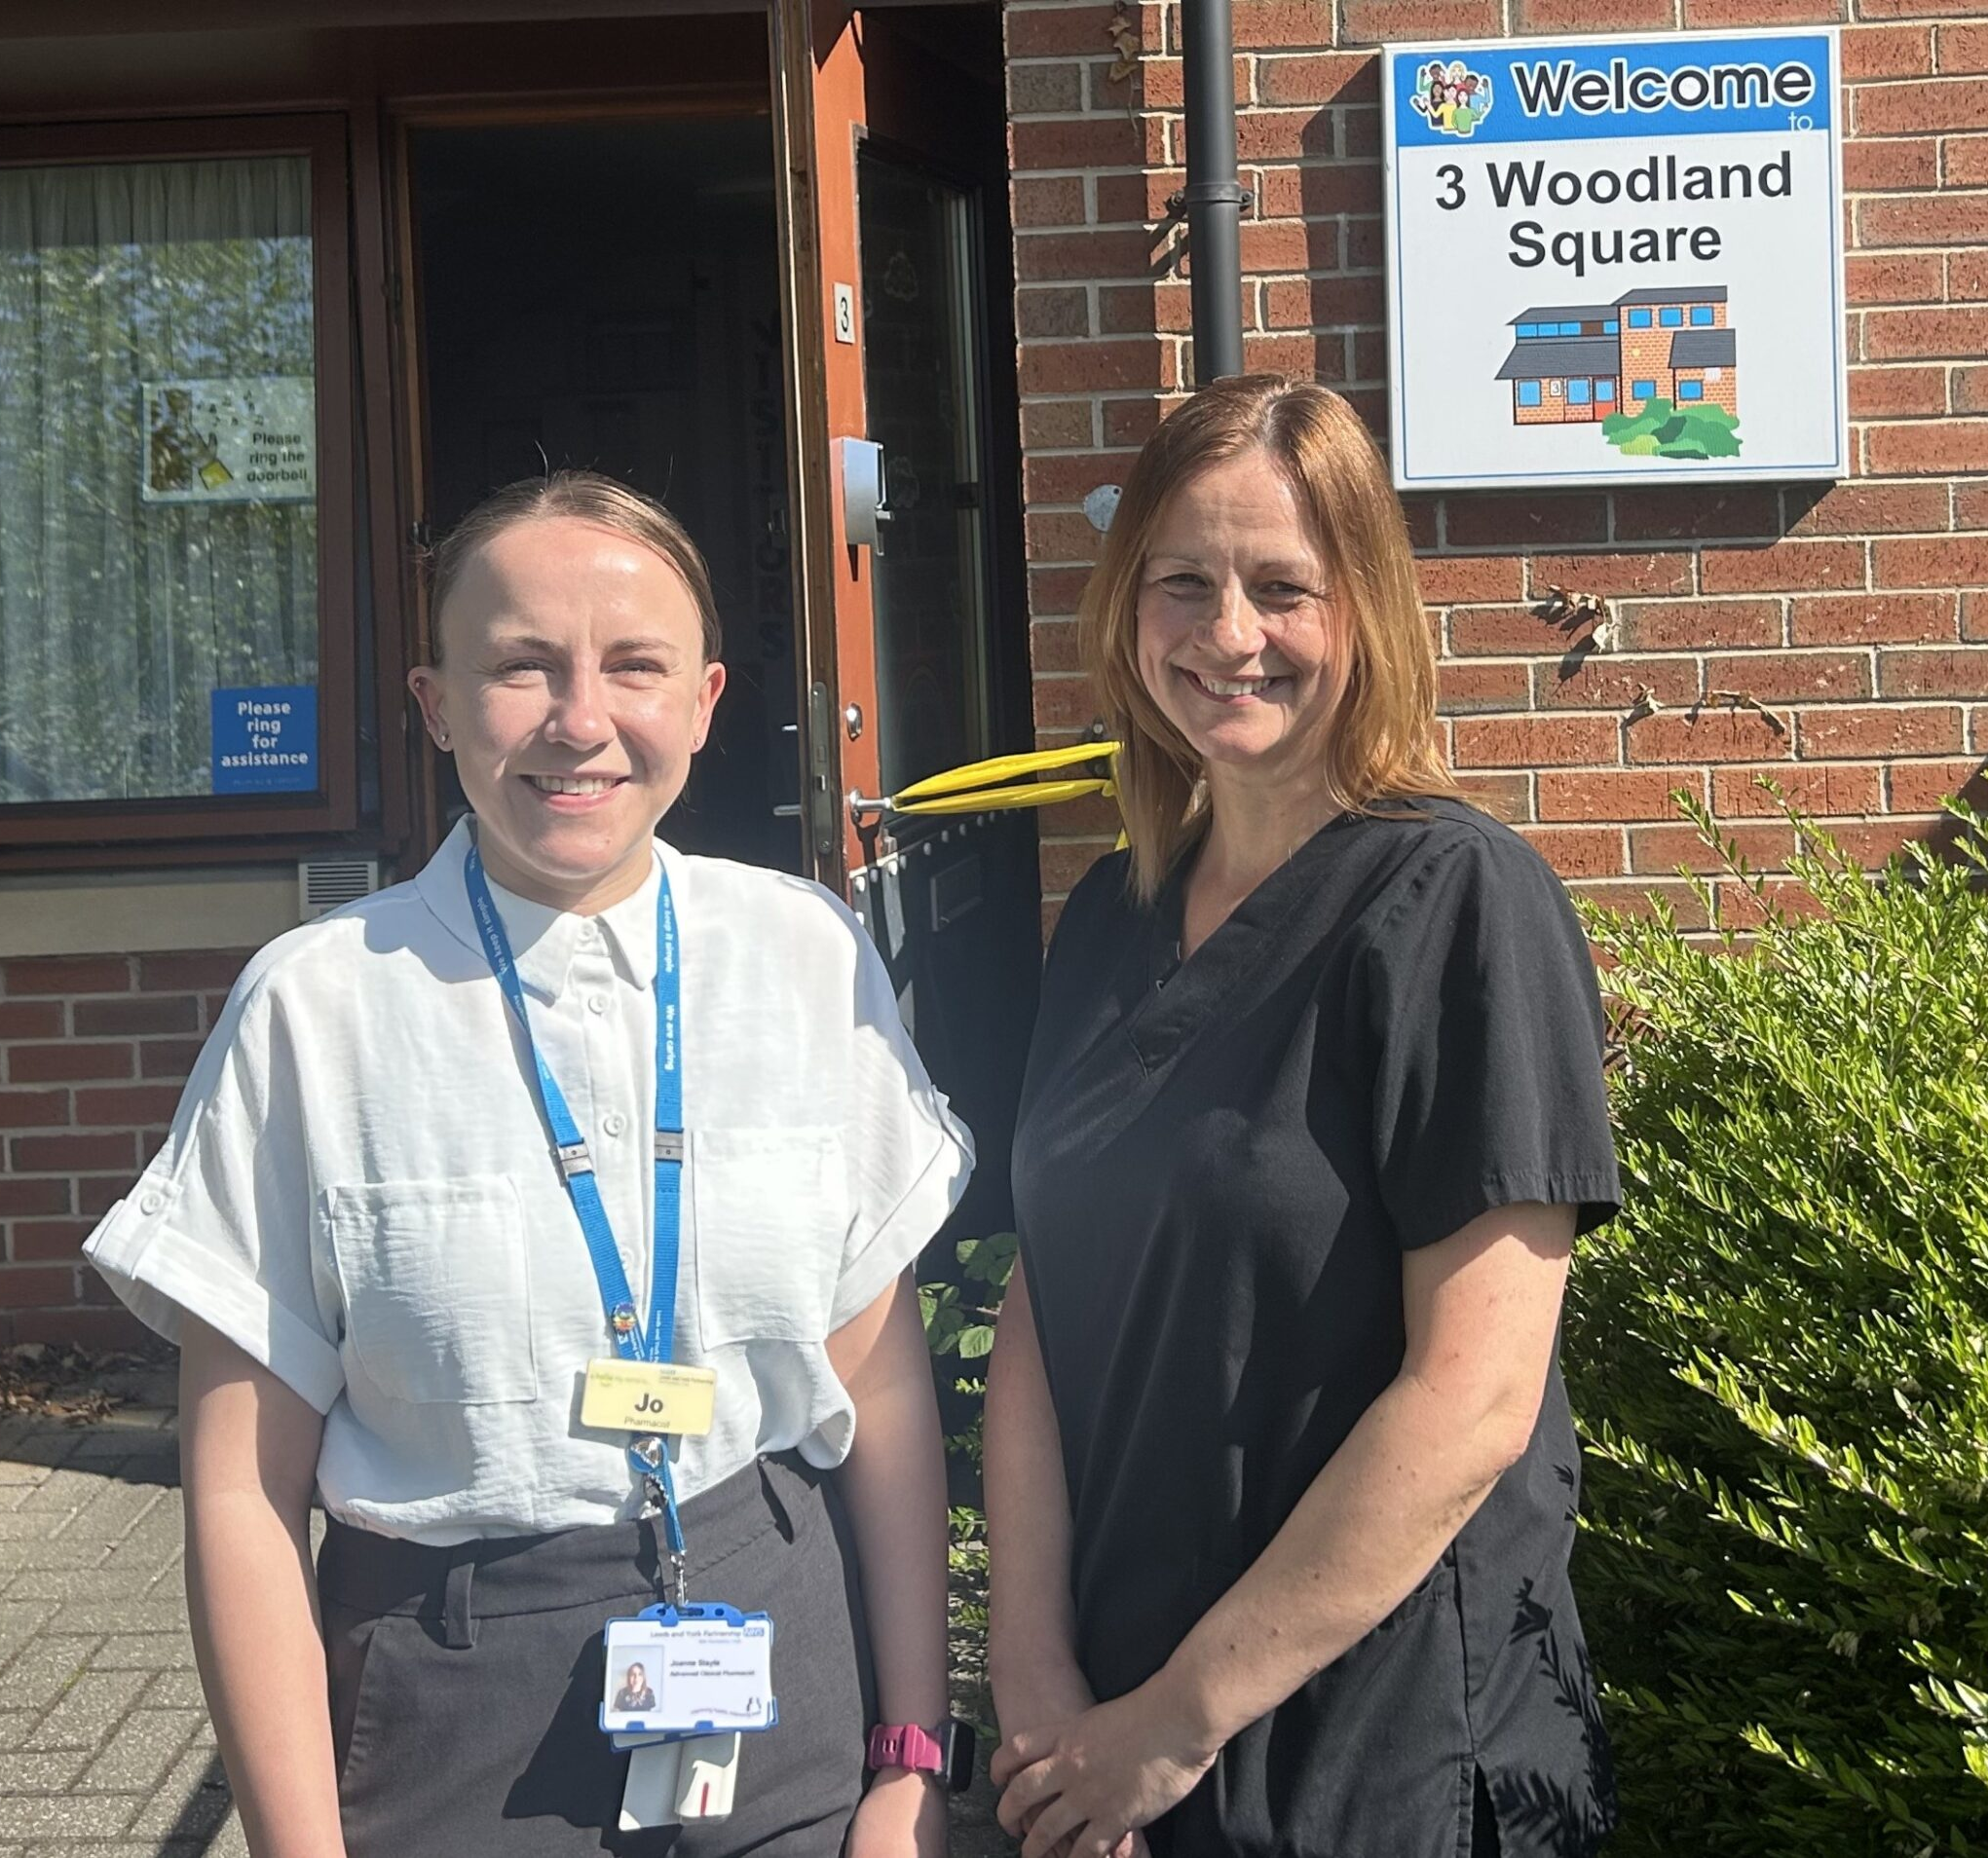
Our Learning Disability and Pharmacy teams don’t get a light shone on them as often as others. Which is why it was rewarding to work on this story about medicines management for people with profound learning and physical disabilities.

It describes how the Trust’s Pharmacy Team improved support our Learning Disability Respite Service at Woodland Square thanks to a collaboration with a local GP. It features Jo Stayte (Advanced Clinical Pharmacist pictured left) and Emma Barlow (Pharmacy Technician pictured right).

Read it on our website.

Turning our annual general meeting into a hot ticket

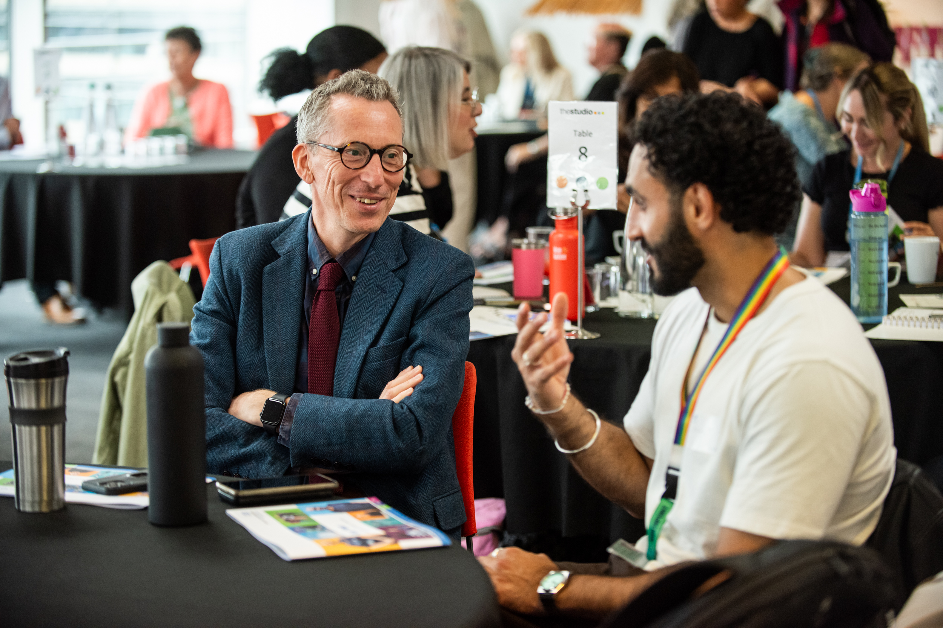
Every year the Trust is required to host its Annual General Meeting in public as part of its constitution as a Foundation Trust, fulfilling its accountability obligations to the Council of Governors and Foundation Trust members.

It would be easy to tick the box and simply run a standard hour-long AGM. The Communications Team works with the Trust’s Corporate Governance and Patient Experience Teams to go further. We use it as an opportunity to invite staff to share the things that have made them proud over the year – involving people with lived experience of our services too.

Around 70 people attend our latest one on Tuesday 29 July 2025 where we heard about how we’re making our sites more accessible, how we’re using artificial intelligence in our practice, cultural competency and group therapy work in the community, and the importance of nutrition and patient mealtimes.

Review the day on our website.

Industry awards – highlights from the year
We love supporting our staff and teams when they get nominated for an industry award. This includes sharing expertise on how to enter right through to amplifying their success stories.

Over 20 award nominations and shortlists were supported during the year, across programmes including the Positive Practice in Mental Health Awards, National Diversity Awards, National BAME Health & Care Awards, Nursing Times Workforce Awards, Skills for Health, National Learning Disability Awards, and West Yorkshire Adversity, Trauma and Resilience Awards.


Here’s a few of our success stories:

Nasser Mohammed (pictured), Accessible Information Designer with our Easy on the I Service, won Apprentice of the Year at the Our Health Heroes Awards 2025, and picked up a highly commended in the Spark of Innovation Award, Stars of Learning Disabilities and Autism Awards.

Our Pathway Development Service was highly commended in the Positive Practice in Mental Health Awards.

Our Service User Network (SUN) and Patient and Carer Experience Team (PCET) were shortlisted for the West Yorkshire Adversity, Trauma and Resilience (ATR) Awards, recognising contributions to connection, belonging and co-production.

Bringing you the big news

As trusted advisors to our senior leaders, we have the unique privilege of working on some of the most consequential announcements the Trust makes. We keep confidences, work behind the scenes and create content that sensitively communicates difficult issues. Here are a few highlights on how we’ve done that from last year.

Our merger with Leeds Community Healthcare
This was undoubtedly the biggest news of the year – that our Trust was planning to merge with its physical health counterpart Leeds Community Healthcare NHS Trust.

We had to work with senior leaders across the Leeds health system under strict confidentiality and put a range of comms and engagement plans in place, so the announcement landed well in November 2025.

Since then, we’ve been busy making sure staff, service users and stakeholders are kept in the loop about the merger, and the who, what, when, where and why of it all.

Supreme Court ruling on definition of sex
One of the most controversial events of the year was the UK Supreme Court’s ruling in April 2025 that people’s sex is defined by biological sex under equalities law. It marked the culmination of a long-running legal battle which had, and still has, major implications for how sex-based rights apply across the country, and specifically for public sector bodies including the NHS.

The announcement was a shock to many, and polarised communities across the country. As a Trust that celebrates diversity and champions inclusion, we were asked to support a response statement. That response can still be found on our website here.

We were one of only a few public service organisations that chose to speak publicly about the ruling. And we’ve experienced some backlash for it since. The NHS and other public bodies are still grappling with the implications of the ruling.

Launch of the National Oversight Framework (NOF)
Communicating clearly about data can be hard. Especially when that data is politically charged, critical and competitive. And so it was with the new National Oversight Framework which effectively put NHS trusts into a league table of performance based on a small set of metrics.

The NOF was launched in September 2025 to ministerial fanfare lauding it as a new way for patients and the public to judge the quality of services they were receiving from their local NHS trusts.

This put pressure on the Trust’s senior leadership, so it was important we supported communications in a proportionate and sensible way. Patients and the public will have to judge for themselves on whether it helps them hold the Trust to account for performance.


Temporary closure of Crisis House

The Leeds Oasis Crisis House (pictured) provides care for people who don't need a hospital stay. Following refurbishment, residents are enjoying a new garden summerhouse, our staff have additional workspace, and there's even an extra bedroom.

But Oasis had to be closed while the work was carried out, which meant working up a plan with our crisis service and partners at Leeds Survivor-Led Crisis Service to communicate with those affected. With service users and partners informed of alternative arrangements, the works went smoothly and Oasis reopened in October 2025.

A local response to the national review of Gender Services
Rightly or wrongly, the profile of gender identity clinics in England is very high. Therefore, when a national review was published in December 2025, it was important that we supported our own Gender Identity Service with a compassionate response that spoke to the concerns of its service users and those on its (very long) waiting list.

By staying in touch with our national colleagues who were leading the review and its comms plan, we were able to prepare for the publication of the report. We prepared key messages that spoke to what we knew would be the main concerns of our service users, namely hormone prescribing and waiting times.

We also provided a method by which service users could field questions to us, to try and take some pressure off the very much under pressure Leeds Gender Identity Service.

Supporting the Mutually Agreed Resignation Scheme
The Trust, like many others, faced significant financial challenges to achieve national NHS efficiency requirements – needing to achieve an £18.5m cost improvement programme in 2025/26 to achieve our statutory duty to break even.

To help achieve this, the Trust ran a Mutually Agreed Resignation Scheme. Our challenge in comms was to position this news as a positive opportunity for staff to exit the organisation and ensure equitable communication across the entire organisation, so nobody felt excluded from the opportunity.

We worked closely with our People and Organisational Development colleagues on a big announcement piece, a presentation, recorded webinars which we shared using YouTube, managers’ briefings and many frequently asked questions. The content on Staffnet alone has been viewed 2,800 times by around 1,300 individual staff.

When inspectors call, we tell our story
The Care Quality Commission (CQC) is the public authority charged with assessing the quality of NHS services and then reporting that to the public.

Therefore, it's important that we work professionally with them and the services they inspect to ensure the public receives the right messages about that service.

Happily, we were able to report some good news about our young people’s mental health inpatient units in Leeds and York (pictured below) – which were rated as “good” following inspections in October 2025. They reported that “young people were positive about the service, and they thought staff were kind and helpful and that they could speak to them when they needed to.”

Read the full story on our website.

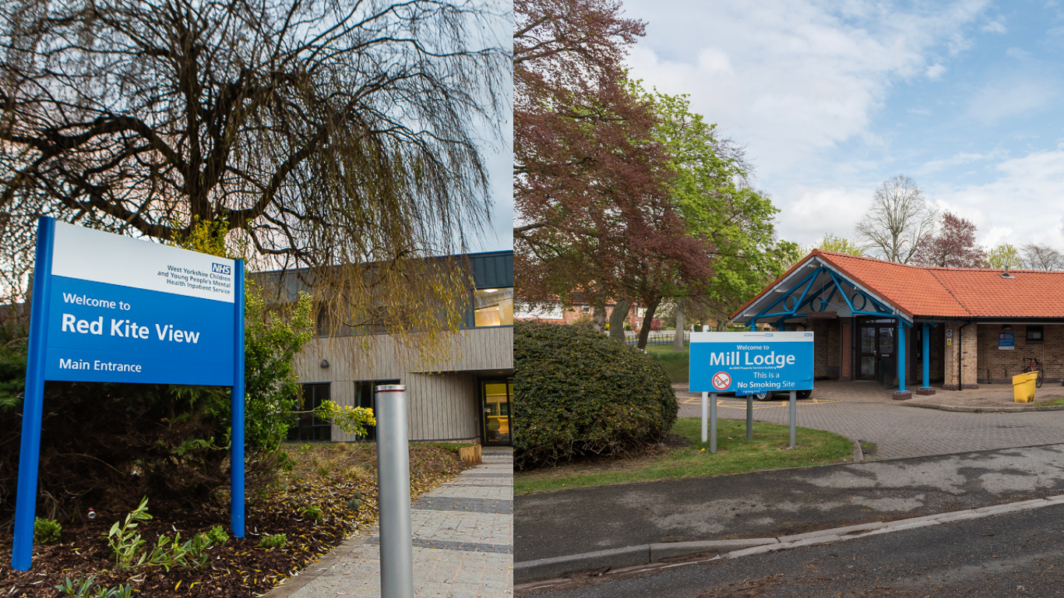

Campaigns with clout
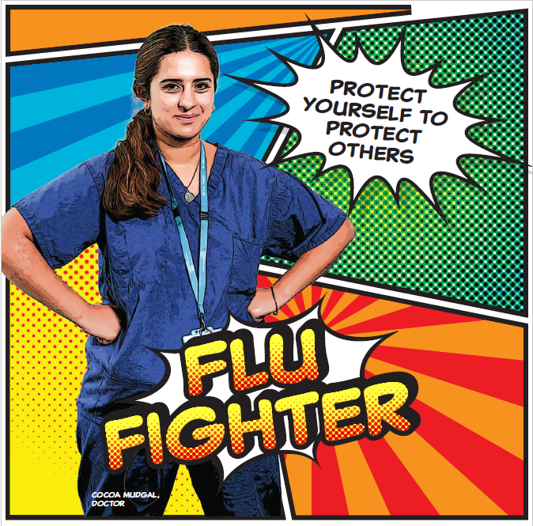
Winter vaccinations - Kapow!

Our fun superhero themed flu campaign took our vaccinations programme to new heights over winter, ensuring getting protected was simple, easy, safe and effective.

An eye-catching poster campaign, powered by our graphic design service, alongside a steady stream of engaging staff communications, motivated 38% of colleagues to have their jab, smashing our target and setting the bar high for next year.

Read about it on Staffnet

National Apprenticeship Week 2026

National Apprenticeship Week 2026 activity showcased apprenticeships at LYPFT as an accessible and valuable route into NHS careers, highlighting career progression, learning opportunities and the experiences of current staff and apprentices. Communications focused on people-led storytelling, aligned with the wider recruitment and retention approach.

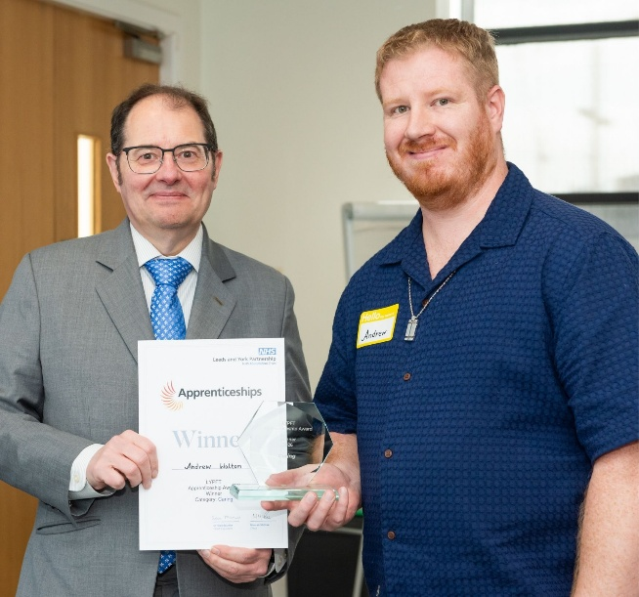
Key results highlights
- Content achieved over 15,700 impressions and reached nearly 10,000 people across social media during the week.
- LinkedIn and Instagram delivered the strongest engagement rates, particularly for short-form video and staff-led content.
- The best-performing posts featured apprentice stories, reinforcing the effectiveness of authentic, real-life experiences in promoting apprenticeships.

Insights from National Apprenticeship Week 2026 will inform future workforce campaigns, with continued focus on staff stories, short-form video and clear career-progression messaging to support apprenticeship recruitment and engagement throughout the year.

Volunteers’ Week 2025

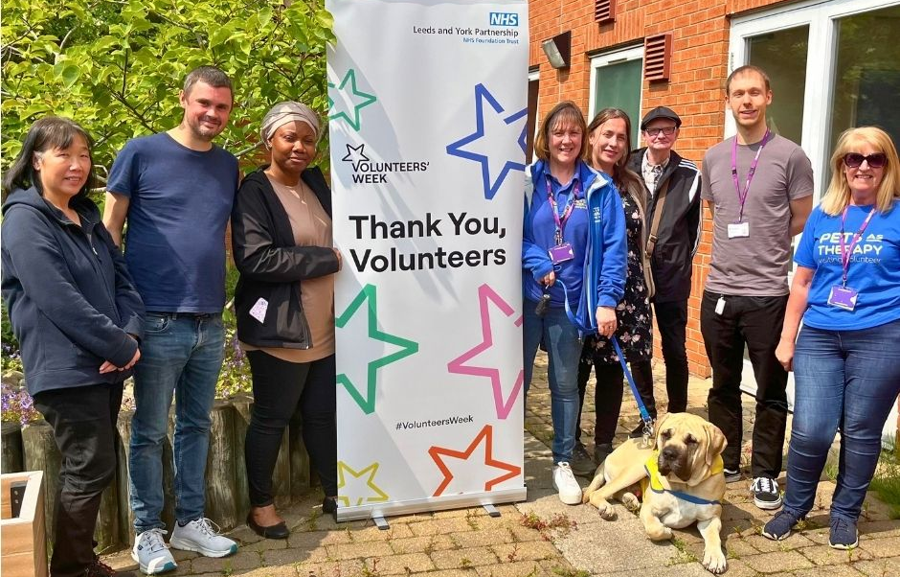

Volunteers’ Week 2025 activity focused on celebrating and thanking the Trust’s volunteers, while raising awareness of the vital role volunteering plays across LYPFT. Content centred on lived experience, inclusion and real volunteer stories, supported through social media, the Trust website and internal communications, including Sara’s All Staff Huddle.

Key results highlights
- Social media activity generated strong reach and engagement across platforms, with over 16,000 impressions across Facebook, LinkedIn and Instagram during the week, driven primarily by people-led stories.
- Instagram Reels performed particularly well, achieving engagement rates of up to 3.8%, demonstrating strong interest in short-form, volunteer-led video content.
- Facebook posts achieved the highest overall reach, with individual posts reaching 3,600+ people, while LinkedIn content supported professional and recruitment-focused visibility.
- Content highlighted the contribution of 133 active volunteers, including long-serving volunteers and the increasing involvement of Lived Experience Partners in services and recruitment.

Looking ahead, we will continue to build on this approach by sharing more volunteer stories across digital and internal channels, using insight from social performance to shape content, and supporting both volunteer recognition and future volunteering recruitment across the Trust.

The (staff) survey comes but once a year

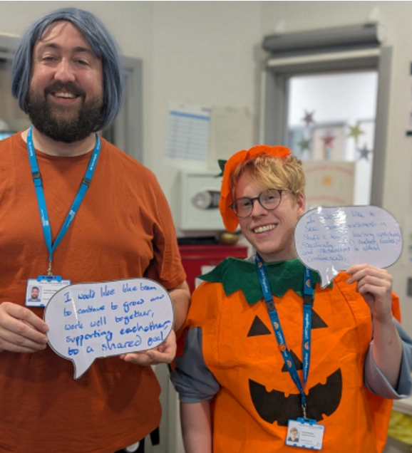
Being able to take part in one of the world's largest workforce surveys is a special thing. In 2025's National Staff Survey campaign, we wanted our colleagues to understand that their voice counts and, crucially, makes a difference to what it's like to work at LYPFT.

Our colleagues' insights, experiences, and ideas are the foundation of a healthier, happier workplace - so with that in mind, we focussed on sharing what our people had to say about improvements in their services. That helped inspire others to take part and complete the survey so teams can help turn insight into action.

Our People Engagement Team provide a range of support to colleagues to complete the survey - including myth-busting, accessible formats, and addressing concerns - keeping that support visible to teams across our communication channels was key.

Pictured: Dr Martin Vaughan and Dan Ramsden, Assistant Psychologist (and occasional pumpkin impersonator!), shared their hopes for the future at Red Kite View whilst embracing the Halloween spirit.

Read about it on Staffnet

Social media impact helps recruit health equity partners

The Health Equity Team works to put equity at the heart of everything we do at the Trust, helping address inequalities in health outcomes across our communities. We supported their mission to recruit 14 lived experience advisors by using our social media and design skills to reach suitable candidates.

We created website content, designed a poster campaign for inpatient areas, and produced graphics to share via WhatsApp groups with community organisations and third sector partners.

Our social media posts received more than 150 likes, 16 comments and 54 shares/reposts across Facebook and LinkedIn. The campaign generated 50 enquiries and led to more than 20 people attending a community information session.

Making work fun with the People Engagement Team
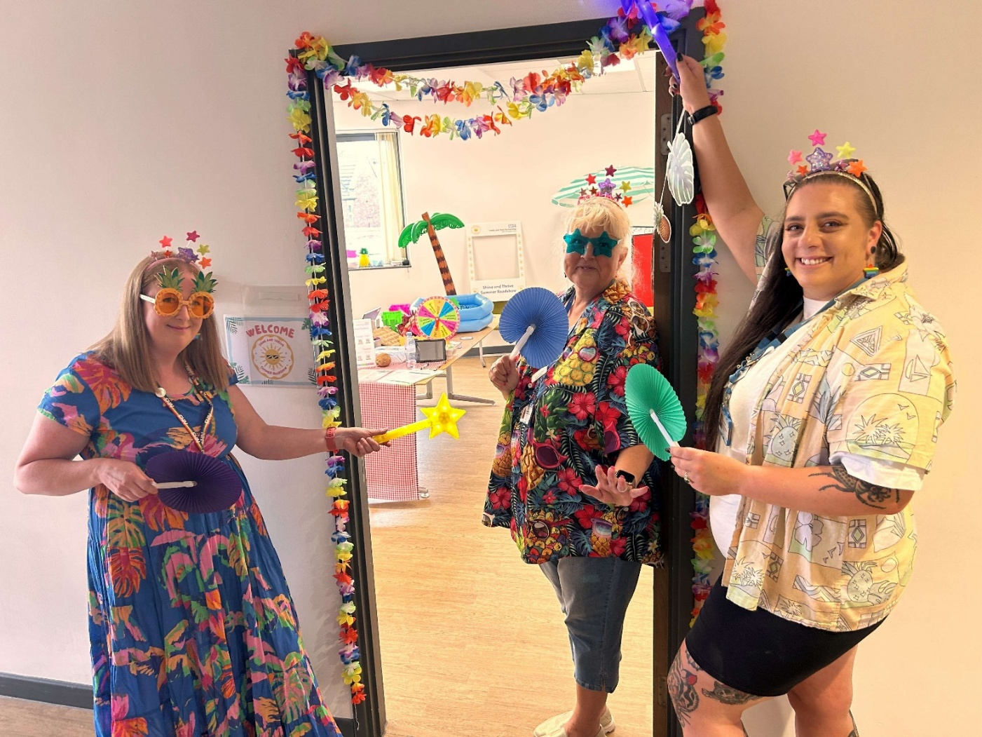
The Shine and Thrive Roadshow communications activity supported a Trust-wide programme focused on staff recognition, wellbeing and engagement. Communications played a key role in promoting the roadshow before, during and after events, using a mix of social media, intranet news, and virtual event support to amplify positive staff stories and encourage participation.

Key results and highlights
- High staff engagement: Over 480 colleagues engaged across 13 sites and a virtual stop, with more than 300 gratitude wall comments reinforcing a strong culture of appreciation.
- Strong social media performance: Posts featuring authentic staff stories and gratitude themes performed best, achieving high reach and engagement across Facebook, Instagram and LinkedIn, with image-led content consistently outperforming video.
- Effective virtual delivery: The Teams webinar attracted 71 attendees, with good average watch time and active chat interaction, supported by communications setup, moderation and video production.

Overall, the Shine and Thrive Roadshow demonstrated the impact of authentic, people-focused communications in driving engagement and wellbeing messages. We look forward to building on this success in future campaigns, strengthening live and post-event coverage, and continuing to showcase the voices and experiences of our staff across all channels.

Strategic engagement

One of the fundamental roles of any in house communications team is to translate the strategy of the organisation into something that motivates and inspires its staff to strive towards it.

Big strategy documents are rarely accessible or inspiring, so we need to find a way of breaking them down into content that connects with the range of diverse services and teams across the Trust.

For those who are interested, we published our ‘big strategy’ and strategic plans on our website in what are hopefully accessible formats. Communications played a leading role in writing and designing the Trust’s five-year strategy document ‘Improving the health and lives of the communities we serve: from 2025 to 2030’.

We bring this to life for staff and stakeholders in ways such as:

- Our Chief Exec’s monthly All Staff Huddle which includes updates on strategic priorities but also examples of how we’re delivering on them.

- In 2025, we launched a new programme of executive-level engagement with leadership teams across the Trust, presenting on the Trust’s priorities and listening to feedback. The programme went down well, and we’ve been asked to run it again.

- Through storytelling and showcasing how we are delivering on our strategic priorities, including quarterly updates and case studies (featured earlier in this report).

- For external stakeholders, partners and other interested parties, we publish a bimonthly leadership blog from the Chief Exec via LinkedIn and on our website. The LinkedIn newsletter performs very well.

Our 10 strategic objectives – how we did in 2025/6

Our 10 strategic objectives within our comms strategy are:

- Launch and embed a clear strategic narrative, brand proposition and visual identity,
- Improve our strategic relationships and forward planning,
- Create a consultancy approach: Investing in our people to be great communicators,
- Improving our operating procedures, workflow management and reporting,
- Review and enhance our corporate comms channels,
- Tell better stories more effectively,
- Measure what we treasure: using data in communications,
- Improve our approach to service user information,
- Attracting and retaining great people,
- Emergency Planning: warning and informing to save lives and prevent harm.

This section of the report gives a brief summary of how we performed against them in 2025/6.

Launch and embed a clear strategic narrative, brand proposition and visual identity.

We unveiled a new brand identity for the Trust in May 2024. During 2025/6 we’ve been working to incorporate it across the organisation. This has included:
- How we design our strategy and strategic plans,
- New look ID badges,
- In our patient and corporate publications.

We’ve included a few examples of our patient information which have been professionally designed in our vibrant brand style.

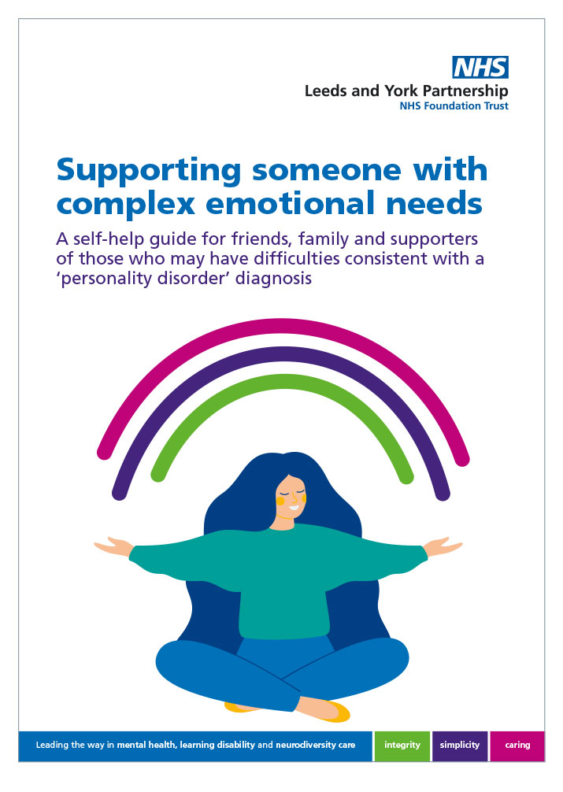 | 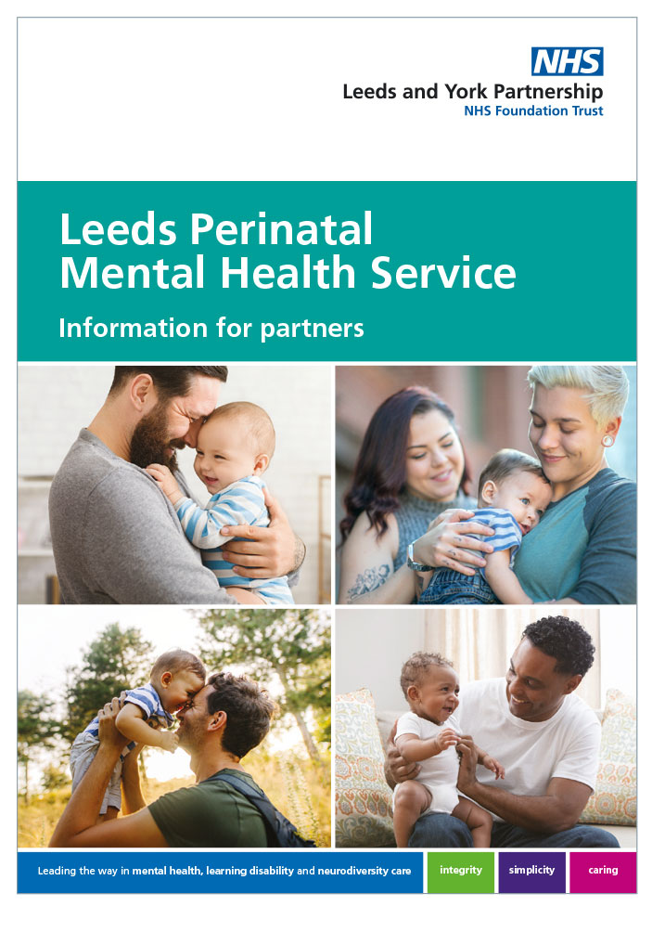

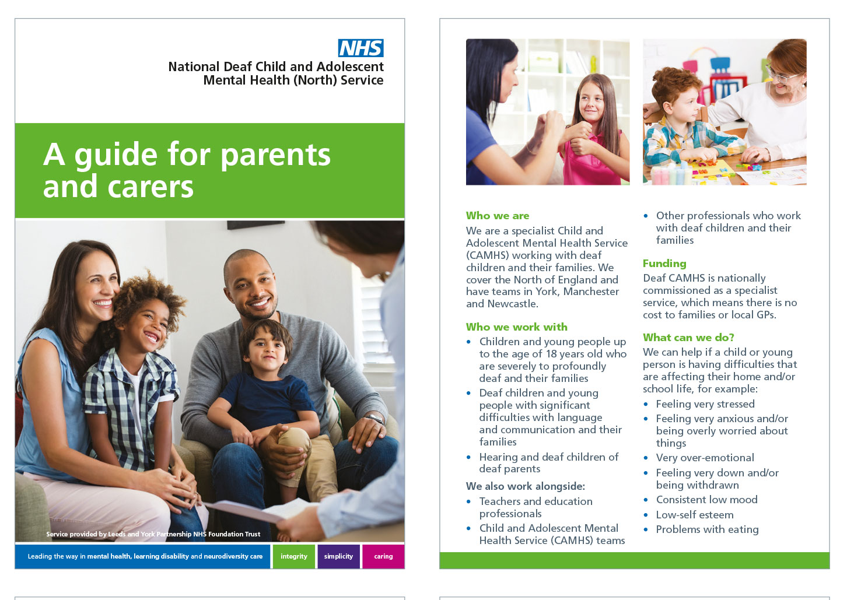
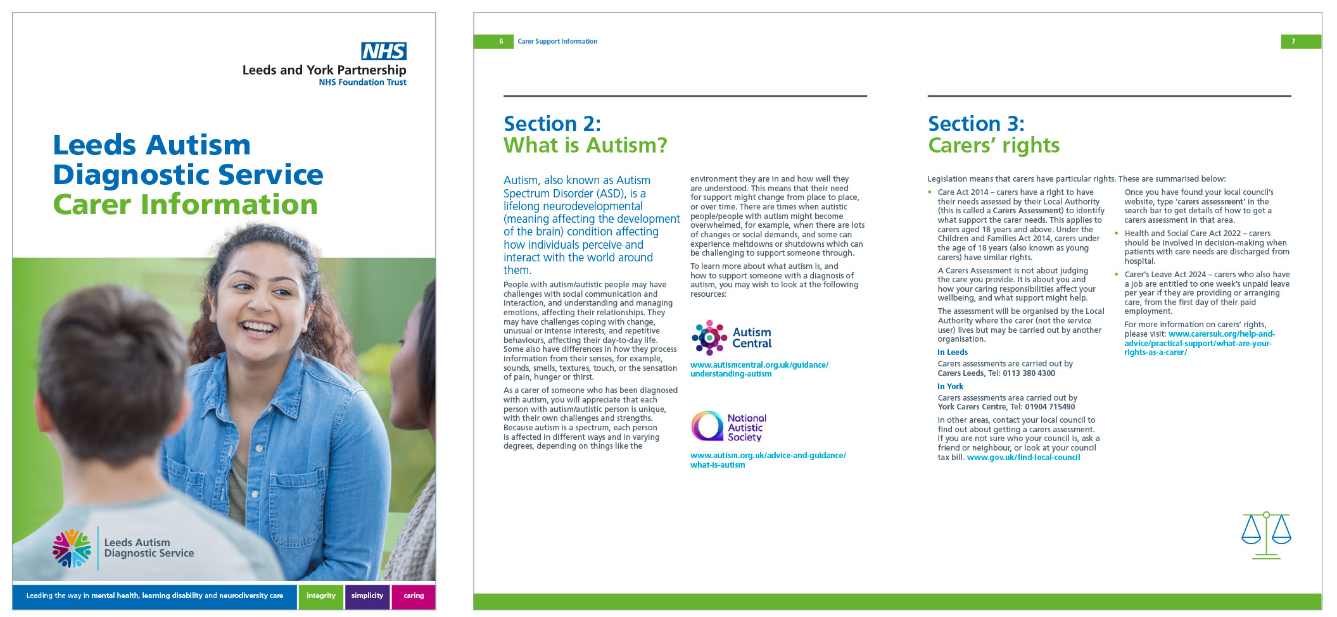

In November 2025 the Trust announced its intention to merge with Leeds Community Healthcare NHS Trust. At this point, the work to embed the new brand was stood down.

Improve our strategic relationships and forward planning

On this objective we’ve made progress in:

- Prioritising attending high value internal and external meetings and networking opportunities to build relationships and improve intelligence gathering and horizon scanning (for example Trust Board, Care Services Development and Delivery Group, Strategic Estates Group etc.),
- Deprioritising attendance at meetings where our input and value are limited,
- Leading communications planning workshops with key internal clients to improve outcomes for priority projects – such as inpatient quality transformation, community redesign, and health equity.

The Head of Communications and the Communications & Marketing Manager completed a 360 review which examined their performance in these and several other areas. Both have been addressing areas for improvement.

We convened a network of communications professionals from NHS, local authority and voluntary sector organisations to help shape the identity of partnership-delivered community mental health services across the city.

Create a consultancy approach: Investing in our people to be great communicators

As well as leading more communications planning workshops as referenced in objective 2, we’ve invested in ourselves and in turn our colleagues and clients to support them to be great communicators. This has included:
- Developing a refreshed policy and procedure on the use of social media by staff. There was intense engagement in the development phase from a wide range of colleagues and internal experts, and the final version has been highly valued internally and shared externally as good practice.
- Leading a brand identity exercise for the new neighbourhood mental health teams as part of the system-wide Community Transformation programme.
- Developing comprehensive guidance on how to produce a video and how to get support from our in-house videography team - in line with demand from colleagues,
- Growing and investing in our community of Staffnet 365 Super Users to support the creation of high‑quality intranet content, with the network now comprising 202 Super Users in total, including over 25 new Super Users added during the last financial year.
- Improvements to our image library on Staffnet – so colleagues have better access to a range of imagery featuring Trust staff.
- Leading a media training session for executive team members on how to communicate in a crisis. This used a lot of the best practice already available on our media relations page.
- Sharing the learning on how to run a great webinar – using our experience of managing the Chief Executive’s monthly All Staff Huddle.
- Shared best practice on how to write a great news story by telling the TRUTH!

Improving our operating procedures, workflow management and reporting

This is a forever objective. In the last year we have:
- Led a refresh of the Trust’s Media Policy.
- Led a refresh of the Trust’s Emergency Communications and Media Management Policy Procedure.
- Increased oversight of our workflow management tool to ensure new work requests are responded to quickly and appropriately, and we celebrate completion in team meetings.
- Stepped up and promoted our ‘quick call with comms’ approach to responding to new work requests from internal clients. This has been championed by our Communications Assistant who has received a lot of positive feedback for her responsive approach. This has improved our efficiency and effectiveness – as both parties are more likely to get a better outcome more quickly.

Review and enhance our corporate comms channels

Website project including homepage refresh
We began adopting an HTML‑first approach, aligning with best practice for accessibility and government standards. We worked with services to audit and update content to ensure it is accurate, user‑friendly and accessible. Key examples include the:
- Community Pharmacy Mental Health Service,
- Complex Psychosis Pathway,
- Emerge Leeds,
- Leeds Autism Diagnostic Service,
- Pathway Development Service, and
- Rough Sleepers Service.

Working with our agency HMA, we improved page templates to allow greater flexibility, enhanced search functionality and refreshed key pages such as Volunteers and Multi-faith Chaplaincy Service. As an indicative measure, our Silktide accessibility score improved from 77% to 81%, moving from 151st to 77th among NHS trusts.

Improving our intranet - Staffnet 365
We improved Staffnet 365 usability and resilience by working with our agency Intelligent Decisioning to refresh the homepage, introducing a colleague‑led “Tip of the day” and reducing the space in the header.

With super users and content owners, we updated key sites including infection, prevention and control, patient experience, and the on‑call site. When changes disrupted the document centre (DocCentrum), we overcame repeated missed service level agreements by working proactively with Intelligent Decisioning to rebuild the automation and restore DocCentrum.

Making our image libraries more accessible
Over the past year, we have made targeted improvements to our image libraries to make them easier, faster and more intuitive for staff to use.

A key change involved simplifying the search experience by removing unnecessary filters. This has made it quicker for staff to find images using commonly searched words, reducing frustration and improving efficiency when sourcing visuals for communications, presentations and projects.

We also reviewed how staff access the image library and addressed delays that were affecting usability. Clearer guidance has now been introduced, with updated access information available on the Communications Staffnet page. This ensures staff know exactly how to access the image library quickly and without unnecessary barriers.

Shifting social media towards storytelling gets “high quality” feedback from Facebook
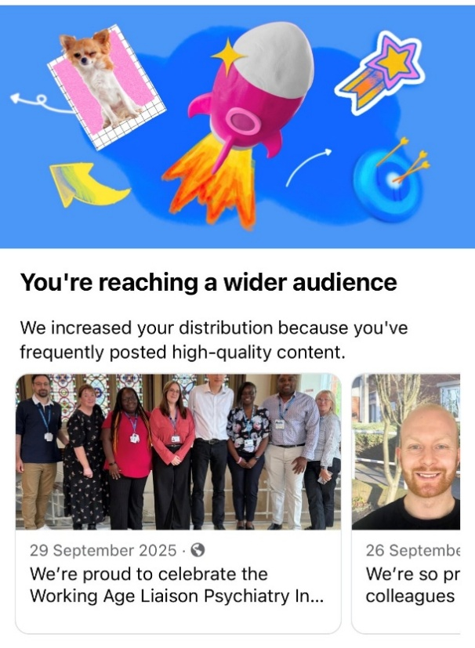
Social media performance improved significantly, reflecting more effective use of our corporate communications channels.

A shift towards storytelling and video increased reach and positive sentiment, particularly on Facebook and LinkedIn. Over 55 per cent of inbox messages were positive, meeting our sentiment objective. Facebook reach increased from 104,815 to over 642,000, while Instagram video views rose from 585 to 6,663. LinkedIn remained our strongest platform, with top posts averaging 6.5 per cent engagement, exceeding the healthcare benchmark.

Recruitment campaigns, including Rough Sleepers and Healthcare Support Worker recruitment, delivered strong engagement and supported application uplift through people‑centred, case‑study content.

To back up our claims, we got the message (right) from Facebook a few months after we made the shift to a more storytelling-led approach.

Thought leadership on LinkedIn
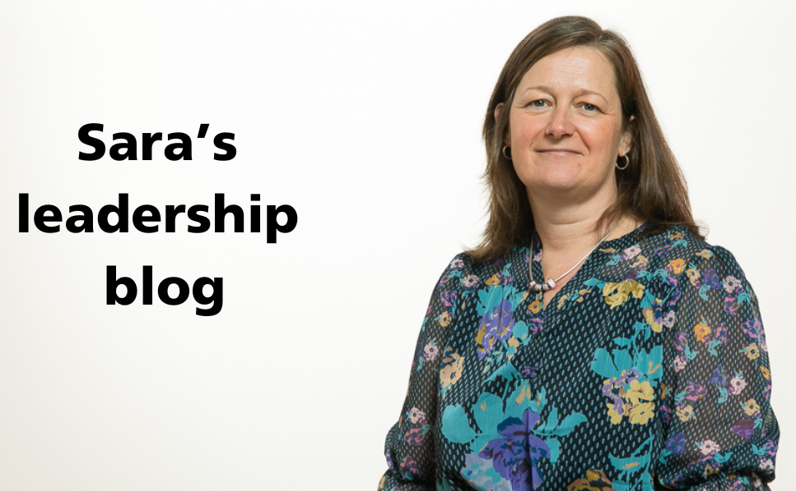
We’ve improved the reach of our Chief Executive’s bimonthly leadership blog by getting more out of our presence on LinkedIn – using their newsletter feature.

A LinkedIn newsletter is a recurring series of long-form articles published on the platform, allowing creators to share in-depth content regularly. Subscribers receive automated notifications and emails for each new edition, ensuring higher visibility compared to standard posts. It is a powerful tool for building professional authority and growing a dedicated audience.

Here are a few stats for Sara’s bimonthly leadership blogs on LinkedIn for 2025/26:

# | Data description
12,119 | Total number of times the blogs were viewed.
5,581 | Total number of new subscribers to the newsletter during the year.
11,057 | Impressions - total number of times articles were shown on a LinkedIn news feed.
187 | Engagements – total number of reactions to the article or posts about e.g. likes, comments and reposts.

Partnerships, trials in A&E and a culture of care - this was the last leadership blog of 2025/6 which achieved the following performance:
# | Data description
1,855 | Article views
2,774 | Email sends - the number of subscribers that have received an email for this article
40% | The percentage of subscribers that have opened the email sent for this article.

“Nobody reads Trustwide” . . . or do they?

This was the often-repeated trope about our weekly staff bulletin Trustwide. So, we led a project to find out exactly what the score was with readership, and how we could make the bulletin better.

The findings we got from some excellent data capturing changed everything. We could proudly share what the communications team knew all along - over two thirds of colleagues read our internal newsletter, many people like it, and some even love it! We also found there was room for improvement. Readers wanted Trustwide to be shorter, less repetitive, and to include more stories celebrating our successes. That's what they've been getting!

Over the past 12 months, we’ve stuck to those commitments while also rebuilding Trustwide through Staffnet after a few IT hiccups forced us to rethink how we produced it. Trustwide has gone from strength to strength, with the 24 June 2025 edition reaching a whopping 3,600 reads.

Telling better stories more effectively
We set our selves the goal of improving the impact and performance of our good news stories.

Here are a few examples of some of our top performing social media posts throughout the year – click them and it will take you to the post.

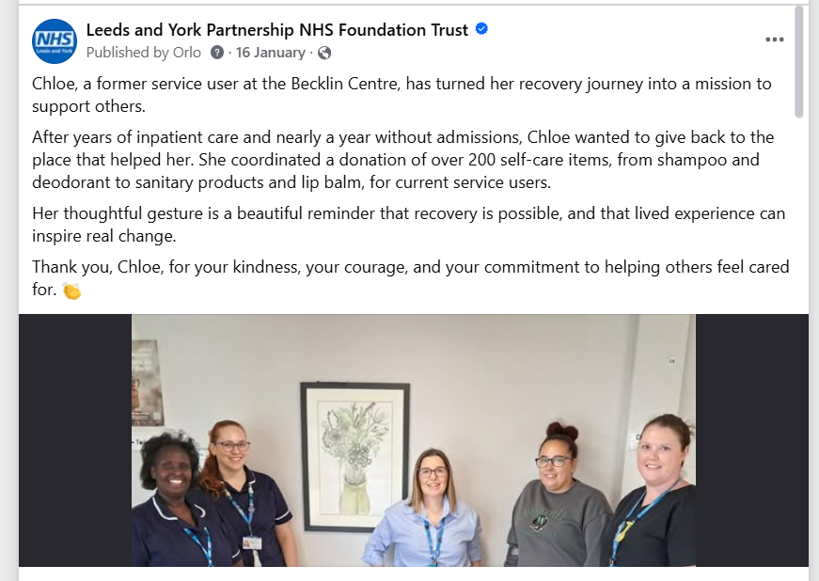

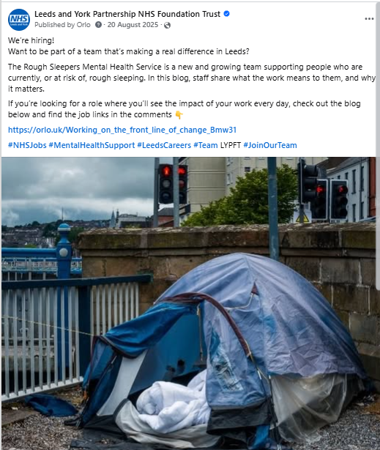 | 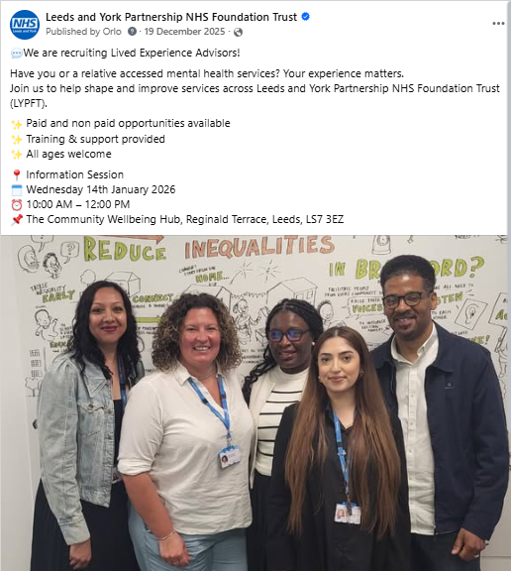
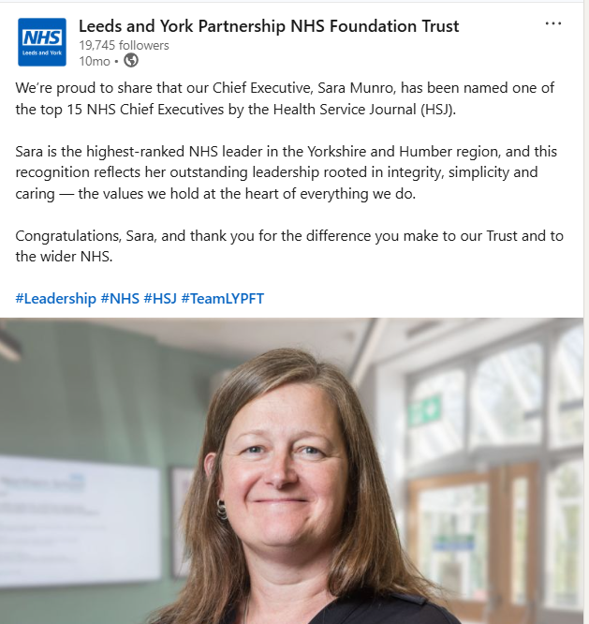 | 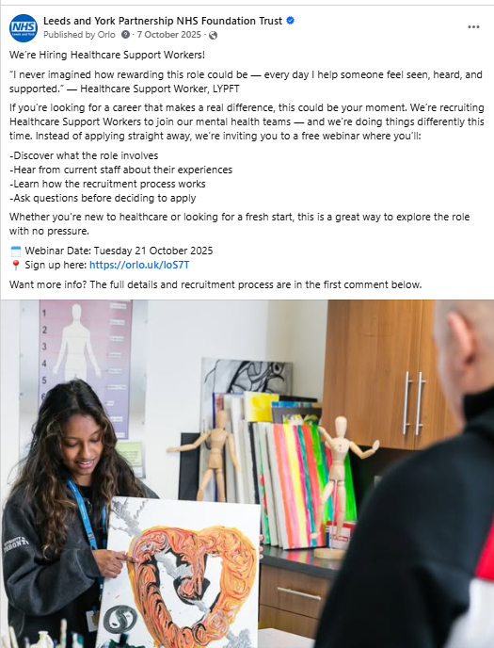

News and blogs on our website
In 2025/6 our news and blog posts were viewed over 13,000 times by over 11,000 individual people.
Our stories achieved an engagement rate of 37% - this is Google’s measure of active user interaction and is the percentage of user sessions that lasted longer than 10 seconds, included a conversion event (clicking a link or opening a document), or featured two or more page/screen views.

Google suggests that a good engagement rate for corporate websites generally falls between 50% and 70% - with a good engagement rate for informational / blog posts falling between 45% and 60%.

The best performing website stories of 2025/6 were:
How to apply for a job in the NHS – this continues to be our highest performing news or blog post despite it being published in October 2024 based on highest number of views, engaged sessions and event count.
Working on the front line of change: Life in the Rough Sleepers Mental Health Service - based on highest number of individual viewers.
Response to Supreme Court ruling on the Equality Act – was the next highest performing post based on multiple metrics.

According to Google Analytics, most people found our stories by searching and finding for it themselves (organic search).

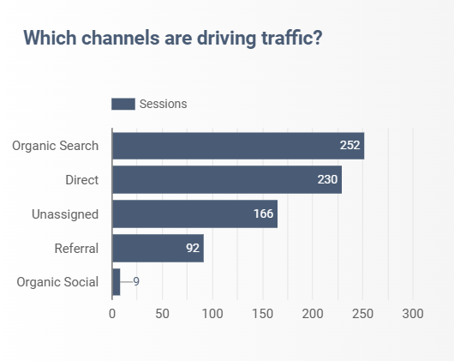

News and blogs on Staffnet
Top three stories on Staffnet 365 in the last 12 months are:
- Update on demonstrations in Leeds: Supporting the Emergency, Planning, Preparedness and Resilience Team ensuring colleagues have up to date disruption information. 1,024 views by 566 users.
- Mutually Agreed Resignation Scheme (MARS): 555 views by 352 users.
- Formal alignment of Leeds NHS Trusts: 408 views by 290 users.

Working with our video team to elevate our stories
Video content is king and our inhouse videography team can really bring a story to life. Here’s a great example from the Baton of Hope event (referenced earlier).

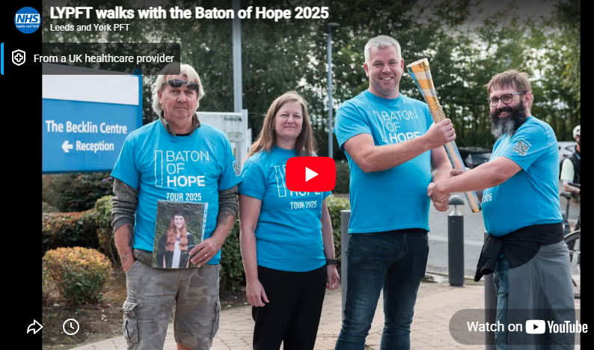
Coverage of the Baton of Hope tour combined emotional and hopeful interviews, event footage and personal reflections to create a compelling message about hope, stigma and the importance of talking openly about suicide.

Measure what we treasure: using data in communications to get better outcomes

Social media analytics from 2025/6

- Positive sentiment: Over 55% of inbox messages were positive, meeting the agreed objective.
- Reach and visibility: Facebook reach increased from 104,815 to 642,143, indicating stronger content resonance.
- Engagement quality: LinkedIn top eight posts averaged 6.5% engagement, exceeding the healthcare benchmark of 3.3%.
- Video effectiveness: Instagram video views increased from 585 to 6,663, supporting wider reach and storytelling.
- Recruitment impact: Narrative‑led recruitment campaigns, including Rough Sleepers and Healthcare Support Worker roles, generated high engagement and supported application uplift.

Recruitment campaigns
The two recruitment campaigns detailed below were our most high-profile workforce initiatives of the year, using targeted, engagement-led communications to support hard-to-fill roles and deliver measurable improvements in application quality and recruitment outcomes.

Rough Sleepers Services
We supported the recruitment of two hard-to-fill roles within the new Rough Sleepers Mental Health Service. A targeted approach using social media, video content and blog promotion aimed to raise awareness of the roles, showcase the service, and reach a wider and more relevant candidate audience than previous recruitment rounds.

Key results and highlights
- Improved recruitment outcomes: The Band 6 Mental Health Practitioner role attracted 28 applications, almost double a previous campaign without communications support, while the Band 8a Senior role received 15 applications for a post that typically attracts very low interest.
- Strong digital reach and engagement: The recruitment blog and video content performed particularly well on Facebook and LinkedIn, with the blog post reaching over 84,000 people on Facebook and generating strong engagement across channels.
- Positive service feedback: The Clinical Team Manager confirmed that the social media and video content directly supported recruitment, highlighting the value of dedicated communications input.

Healthcare Support Worker Recruitment
We supported the recruitment campaign for Healthcare Support Workers across inpatient mental health services. The campaign trialled a refreshed, webinar-first approach designed to attract better-informed candidates, reduce unsuitable applications and support services experiencing high vacancy levels. Activity focused on targeted promotion across Facebook, LinkedIn and the Trust website, encouraging potential applicants to attend a free information webinar before applying.

Key results and highlights
- Strong interest and reach: The campaign generated 211 webinar registrations, exceeding the original target, supported by high reach on Facebook (27,000+ users) and strong engagement rates on LinkedIn.
- Improved recruitment quality: Of the webinar attendees, 16 applications were submitted, resulting in three successful appointments, with hiring managers reporting improved candidate calibre and reduced shortlisting time compared to traditional recruitment.
- High website engagement: The recruitment page showed a 27% engagement rate, indicating that users landing on the page were highly interested and actively engaging with the content.

Improving our approach to service user information

Accessible Information Standard project
We kicked off a project to assess and strengthen our compliance with the Accessible Information Standard, to ensure that everyone who uses our services can access, understand and engage with our information in a way that meets their individual needs.

As an NHS trust, we have a duty not only to meet our statutory responsibilities, but to remove barriers that can prevent disabled people and people with impairments or sensory loss from receiving safe, effective and person-centred care. By reviewing our current practices and improving how we identify, record, flag, share, meet, and review communication needs, we are directly supporting our strategic objective of improving our approach to service user information. This work helps promote equity and inclusion, and ensures that people are better informed, more involved in their care, and supported to access our services with confidence.

Refreshing the procedure for producing information for service users, carers and the public
This has been an important step in improving our approach to service user information. Its emphasis on quality and accessibility serves as a reminder to all colleagues of the standards we should uphold when producing information for those who need us.

While retaining many of the original core principles, this revision aimed to simplify and clarify processes for staff, making it easier to apply in practice. Input from both staff and service user representatives helped shape the revisions, ensuring it reflects lived experience and supports the production of clear, accessible, and inclusive information for all audiences.

Improved website content and accessibility in line with best practice – HTML first approach
Improving website content through an HTML‑first approach strengthened how we provide service user information. By working directly with services to audit and update content, we improved clarity, accuracy and consistency across key service pages. Prioritising page‑first, structured content also improved internal search results, making it quicker and easier for service users to find the information they need. This approach put service users’ needs at the centre of our content, supporting clearer pathways to support and more inclusive access.

Attracting and retaining great people
Ask any member of staff in a clinical service what you can do to help them, and it won’t be long before you hear the response: “We need more staff.” Which is why attracting and retaining great people is one of our strategic objectives.

We do this by promoting LYPFT as a rewarding, inclusive and supportive place to work. Activity combined targeted recruitment campaigns with improvements to the Trust’s careers webpages, ensuring content was accessible, up to date and aligned with government accessibility standards, while showcasing real career opportunities and staff experiences where available.

Key results highlights
- High visibility and engagement across digital channels, with targeted recruitment campaigns supporting hard-to-fill and priority roles. Campaigns such as Rough Sleepers Mental Health Services and Specialised Supported Living Services contributed to strong application volumes, interviews and successful appointments.
- Strong careers webpage performance, with over 73,000 page views and 60,000 sessions to careers content between April 2025 and March 2026. The ‘Latest jobs’ page was the most visited, accounting for almost 50,000 views, demonstrating the website’s central role in converting interest into applications.
- Improved quality and accessibility of careers content, including the removal of outdated information and updates to meet government accessibility standards. While case study content remained limited, blogs promoting Rough Sleepers services and apprenticeships helped maintain people-led storytelling and support recruitment messaging.

Looking ahead, we will continue to build on these foundations by strengthening links between campaigns and careers pages, increasing staff case studies and blogs, and using web analytics to further refine how we attract, inform and retain people across the organisation.

Reasons to Be Proud
The Reasons to Be Proud campaign formed a core strand of the Trust’s reward and recognition communications across 2025/6, celebrating staff achievements, team success and research impact. Delivered across Facebook, LinkedIn and Instagram, the campaign focused on authentic, person-centred storytelling aligned with the Trust’s social media strategy and values, helping to strengthen staff morale and public confidence.

Key results and highlights
- Consistent, high-impact good news: Over 30 staff recognition and case study stories were shared across the year, far exceeding monthly good-news targets and maintaining a steady flow of positive content.
- Strong reach and engagement: The campaign generated 212k+ impressions with a 2% engagement rate, with Reward and Recognition posts consistently outperforming other content types and several LinkedIn posts meeting or exceeding the 3.3% engagement benchmark.
- Clear strategic alignment: Stories showcased excellence in care, inclusive and trauma-informed practice, staff leadership and research impact, directly supporting objectives around sentiment, reputation and confidence in services.

Overall, Reasons to Be Proud made a significant contribution to improving sentiment toward the Trust and highlighting the people behind our services. We look forward to building on this success, continuing to champion staff achievements and share impactful, values-driven stories that demonstrate the difference our colleagues make every day.

Emergency Planning: warning and informing to save lives and prevent harm.

Being ready to respond rapidly to incidents and events is crucial in an effective comms team. Thankfully the Trust did not experience any major or critical incidents during the year, but we had our fair share of issues to respond to.

Industrial action by our resident doctors
With resident doctors in dispute with the BMA over pay and conditions for over 3 years, it's a been a priority of ours to keep our colleagues and the communities we serve in-the-know to help minimise disruption for staff and service users and protect patient safety. 2025/26 saw resident doctors walk out on three occasions, requiring our team to form a key part of the Trust's Strategic Coordination Group each time.

Throughout, we've worked closely with emergency planning colleagues, coordinated and cascaded public health messaging from NHS England, and wrote staff messages from our Chief Operating Officer, to ensure staff, service users, carers and the public were aware of disruption and what to do during the strikes. We've also briefed colleagues on the progress we've made towards NHSE's 10 Point Plan to improve resident doctors' working lives.

Keeping staff informed and supported during a time of community protests
Our approach to keeping staff informed during the recent period of protests has been focused on timely, transparent communication alongside creating space for dialogue and support. We shared regular updates through internal channels, including alerts about local demonstrations in Leeds in partnership with West Yorkshire Police, ensuring colleagues had clear guidance on safety and awareness.

Alongside this, senior leadership, including our Chief Executive, reinforced messages through blogs and team communications, recognising the wider impact of rising tension and uncertainty on both staff and service users. Importantly, we listened and adapted our approach based on staff feedback. Colleagues told us they valued opportunities to talk openly rather than only receiving information, which led to the introduction of dedicated listening sessions led by our Head of Equality, Diversity and Inclusion. These sessions, alongside enhanced signposting to wellbeing and support services, helped create safe, compassionate spaces for reflection, connection, and mutual support.

This adaptive approach reflects our commitment to living our values of Integrity, Simplicity and Caring, ensuring that communication is not only informative but responsive, supportive and grounded in what our staff need during challenging times.

Damp disrupts young people’s inpatient unit
In October 2025, our young people’s mental health inpatient unit, known as Red Kite View, declared a business continuity incident when serious damp was discovered within its psychiatric intensive care unit. We quickly joined an Incident Response Team and started what was to be a six-month programme of regular briefings and updates for staff, service users and families, and system partners as the Trust worked with various architects and contractors to firstly find out what was causing it and then fix it.

Training our execs to be media spokespeople
Every NHS trust is required to meet national standards on its readiness for responding to incidents. One of those is having well trained spokespeople who can communicate with patients and the public in a crisis.

Working with our EPRR lead, the Communications Team developed a short crash course on giving media interviews. In two hours, we ran through some basic theory, gave examples of how (and how not) to do it, and put all six executives through their paces in both live in-person on camera interviews and “down the line” style interviews using MS Teams.

Thankfully none of the execs had to put this training into practice during the year.

Planning for emergencies
When disaster strikes, preparation is key. That's why, when our Emergency Communication and Media Management Policy came up for review, we made important changes to keep it up to date, working closely with our EPRR colleagues.

Our policy is to have a clear and managed communication strategy in situations where the Trust, or the wider community, is facing an emergency situation - that could be anything from disruption to services (like the Red Kite View damp problem described above!), to a fire in one of our buildings, to a city-wide mass-casualty event.

Our policy is now clearer on how we'll warn and inform, work with our partners, and manage the media in a crisis.

Forward look: “The future ain’t what it used to be.”

As has been alluded to within this report, our Trust is set to merge with Leeds Community Healthcare NHS Trust by 1 April 2027 (this is not some elaborate April fool!). So, this is effectively the final year of LYPFT as an organisation as are energies are focused on developing and launching a new organisation.

As campaign projects go, this is a biggie!

Here are three things on the action card for comms:

- Run a huge team development programme to bring our two communications team together and be working in harmonious tandem by 1 April 2027.

- Create a new brand for the new organisation – including running a consultation on deciding what our new name should be

- Develop a single solution for a new website, intranet and range of comms channels including social media.

The strapline for the merger process is “best of both” – meaning we are learning from each other and taking the best of what each Trust does into the new organisation – whatever we decide to call it.

That is going to require us to be open minded and ready to compromise. It might be that we need to let go of that particular channel or product we’ve spent years honing into the well-oiled machine that it is today. But that’s okay, because everything has a natural lifecycle.

The important thing is to share knowledge and expertise willingly and without prejudice for the benefit of the new bigger team.

Because, if the team wins, we all win.

