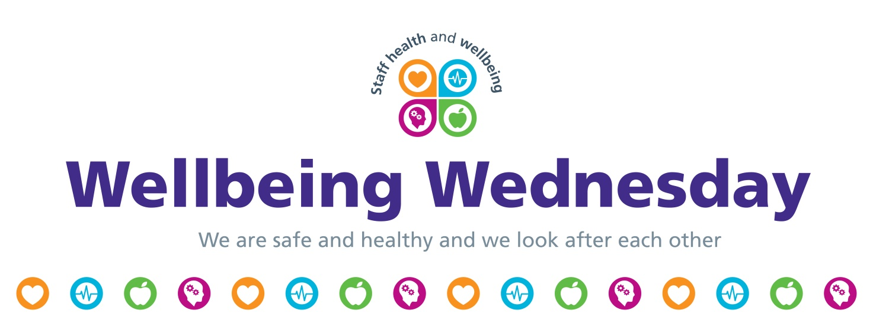

Challenges and fundraisers

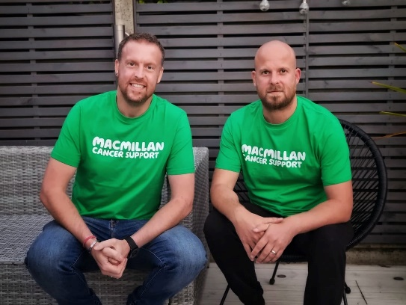
Ben’s fundraiser for Macmillan Cancer
Team Green Machine
Ben Green worked for the Trust as a nurse managing a team in the Gender Identity Service before being medically retired in 2020.
Ben and his family were told that his oesophageal cancer was treatable but incurable and in March 2020 he was given 12 months to live. He tried to live a healthy lifestyle but through sheer luck he has managed to outlive his prognosis. Through this difficult period Macmillan have been very present in Ben's and his family's life and now the Greenies want to give back.
Being a charity Macmillan rely entirely on donations from their generous fundraisers. During the pandemic these donations fell dramatically and Macmillan really struggled to support people diagnosed with cancer. Without our help Macmillan can’t support everyone who needs them.
Ben and his brother are walking 300 miles in 3 months during Ben’s chemo in support of Macmillan Cancer Support because he and his family want to give something back.
You can donate to Ben’s fundraiser for Macmillan Cancer - text GREEN300 to 70550 to donate £5 or visit his JustGiving page.
You can also follow Ben on Twitter @CancerandQuiff.

Be inspired by…

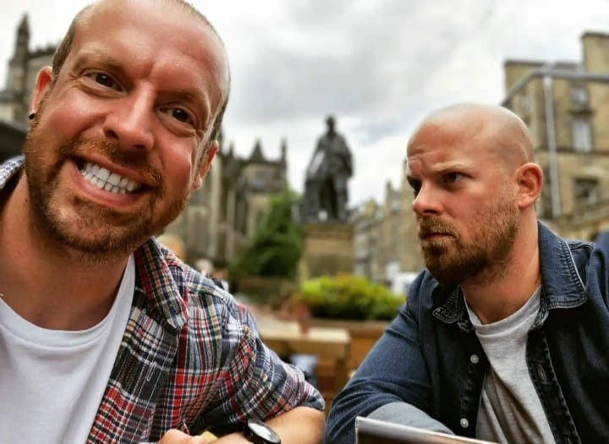
Cancer and Quiff - Ben’s blog on living with cancer
‘It’s the little things that matter’
Ben Green worked for LYPFT as a staff nurse, Clinical Lead and Ward Manager of Bluebell ward at Clifton House, York and as Clinical Team Manager of the Gender ID service at The Newsam Centre, Leeds. We’ve been chatting to him about a recent article in the Yorkshire Evening Post about his experience of living with cancer.

“So, I've been asked to write something for Wellbeing Wednesday. It feels very foreign to be writing something like this and pushes me out of my comfort zone... but that's what we're told to do, right? Do something every day that pushes us out of our comfort zone. So here goes.
“I suppose I should start with introducing myself and giving a bit of background to why I've been asked to write something like this. For those of you who I didn't get the opportunity to meet whilst I worked within Leeds and York PCT, I'm Ben... for those who I did meet, I'm still Ben!!
“My career as a nurse started in 2003 when I worked with older people, a job I loved and learnt so much. Not just about being a nurse but about people, compassion, kindness and the power of making very vulnerable people feel safe again. I then moved into forensic mental health, an area I felt so passionate about that I stayed there for 13 years, starting as a Band 5 nurse and eventually managing the female forensic ward in Clifton House, York. I worked with lots of amazing people, some of which I'm lucky enough to call my friends now. My career then moved to Leeds, Newsam Centre where I managed The Gender ID service with a great team of people.
“It was when I worked at The Newsam Centre that I was given some life changing and horrendous news that shook my world and turned everything I knew upside down. I'd gone to my GP as I was having issues swallowing food and drink, he sent me for an endoscopy and there, whilst still sitting on the procedure bed I was told I had cancer of the oesophagus. Despite it not really sinking in I felt like I'd been hit by a bus. To cut a long cancer story short I was told it was curable with surgery but whilst going through pre-surgery chemo the cancer had other ideas and it spread. This meant that I now had an incurable, terminal cancer and in March 2020 I was told I had 12 months to live. All I could think was how do I tell my friends and family that one day in the not too distant future I'm just not going to be there? What about all these plans I had? What about my family?
“The lead up to March 2021 was weird but March came and went and despite the cancer spreading a little throughout my lymph nodes and to a rib I was still here despite the doctor's one year prognosis. I often think about why I'm still here and I think most of this is to do with sheer luck but I believe 100% that a lot of it is to do with having a positive outlook and a positive mental attitude. Cancer may have changed my life but it certainly wasn't going to change me!
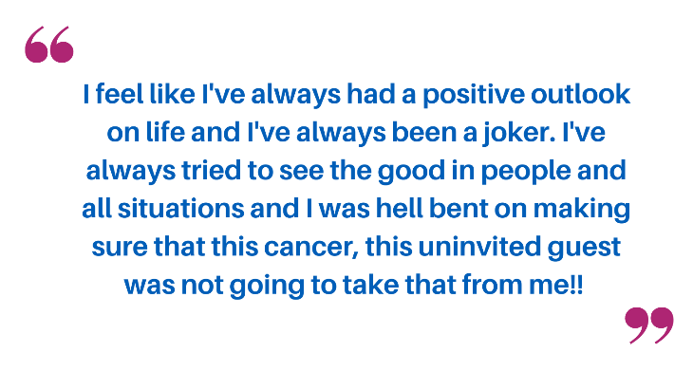
I'd previously written a blog and talked about terminal cancer being a thief as it takes so many things from you - your plans, your career, your physical and mental health, even your hair. But I made a decision and a personal promise to myself that I am not going to be paralysed by the things that have been stolen from me, I am not going to be a slave to any prognosis and I am going to empower myself to live a positive life despite what was going on with my physical health. Instead of thinking 'Why me?!' or being angry or battling negative thoughts I am going to recognise the positives in my life by being grateful for all the amazing things I have and all the wonderful people that surround me. I am going to practice mindfulness and where possible live in the moment by not dwelling on regrets from the past and not worrying about things that could happen in the future. Today is today and in the grand scheme of things that's all that matters.
“I've always loved a cheesy, life affirming meme and I'd seen one that said "We can't always choose the music life plays for us, but we can choose how we dance to it"... It fit so perfectly into my own ethos that I decided that this was the way I was going to live the rest of my life, no matter how long or short it was going to be. So now I say yes to that slice of cake and order a takeaway if I fancy it. I lay in bed for that extra 10 minutes. I buy the fancy coffee and pay a little extra for the nicer bottle of wine. I take long walks around my village and surrounding fields and recognise the beauty that we often miss when rushing through life. I say yes to any invite I get and spend as much time as possible with my friends and family. And I wear my favourite aftershave every day rather than saving it for special occasions. Some of these may only seem like little things but it's the little things that matter, make us grateful and make your day that little bit fuller and happier. I may not have been given a 'full life' but I am going to live my life fully.”
Thanks so much for sharing your story Ben it is so inspiring and moving to read what you have to say and how you are coping with your diagnosis. All your LYPFT colleagues are sending you positive vibes!

