PALS (Patient Advice Liaison Service) and Complaints Management Procedure

The key messages the reader should note about this document are:
- We welcome all feedback and resolve concerns early wherever possible, investigating complaints fairly, compassionately and transparently to drive improvement.
- We follow the NHS Complaint Standards and the Model Complaint Handling Procedure and comply with the Local Authority Social Services and NHS Complaints (England) Regulations 2009.
- Complaints are acknowledged within 3 working days and managed to a timescale of 60 working days from consent. Regular progress updates are provided (at least every 14 days unless otherwise agreed).
- We ensure accessibility, including compliance with the Accessible Information Standard (AIS) and access to independent NHS complaints advocacy.
- Learning from complaints is captured, acted on, evidenced, and reported through governance to drive improvement.
- Trauma-informed thinking has been embedded throughout this document.

This policy/procedure may refer to staff as qualified/registered/professional or other such term to describe their role. These terms have traditionally referred to individuals in a clinical role at band 5 or above. Please note that the use of these terms may or may not include nursing associates or associate practitioners (band 4). For clarification on whether a nursing associate or associate practitioner is an appropriate person to take on the identified roles or tasks in this policy/procedure please refer to the job description and job plan for the individual, or local risk assessment.

DOCUMENT SUMMARY SHEET
ALL sections of this form must be completed.

Document title | PALS and Complaints Management Procedure
Document Reference Number | PE-0001
Key searchable words | Complaints, PALS, Concerns, Compliments, Feedback
Executive Team member responsible (title) | Director of Nursing and Professions
Document author (title) | Lucy Walton, PALS and Complaints Lead
Approved by (Committee/Group) | Nursing and Professions Council
Date approved | 2 April 2026
Ratified by | Policies and Procedures Group
Date ratified | 28 April 2026
Review date | 28 April 2028
Frequency of review | At least every two years

Amendment detail
Version | Amendment | Reason
7.0 | Updated procedure | Revised templates and updated to reflect changes in Complaints handling process.
7.0 | Review deadline extended from 30  November 2017 to 30  November 2018 | Agreed Policy and Procedure Group meeting held 30 October 2017.
7.0 | Review deadline extended from 30  November 2018 to 28  February 2019 | Extension agreed on 28/11/2018. Provided by Kerry McMann and reported back to the Policy and Procedures Group.
7.1 | Job Title Amendment | PALS, Complaints & Claims Manager  amended to Legal Services & Complaints Lead

7.2 | Job Title Amendments | Associate Director changed to Head of Operations  Legal Services & Complaints Lead changed to Quality & Patient Safety Lead  Minor changes approved at the PPG meeting on 27 October 2021.
7.3 | Updated procedure | Updated wording to improve readability. Added clearer information to the procedure regarding allocation of complaints and timescales.
7.4 | Job Title Amendments | Director of Nursing, Professions & Quality changed to Director of Nursing & Professions.
7.5 | Five-month extension request | Review date extended from 23/11/2025 to 31/03/2026 on 18/11/2025 by the Policy and Procedures Group.
8.0 | Substantive update | Review replaces the previous (PALS) Procedure (PE-0002) and Complaints Management Procedure (PE-0001) into a single, coherent framework for the management of patient advice, liaison and complaints. It reinforces the Trust’s commitment to openness, responsiveness and learning from feedback, ensuring that concerns are resolved promptly, compassionately and fairly.  The procedure reflects full adherence to the Parliamentary and Health Service Ombudsman (PHSO) Complaint Standards and confirms compliance with the NHS Complaints Regulations. It clarifies roles, responsibilities and timescales, strengthens support for complainants, and promotes a consistent, person centred approach to managing concerns and complaints across the organisation. Learning from complaints is embedded as a core principle to support continuous quality improvement and service development.

CONTENTS
Section | Description |  | Page
1 | The content of the procedural document
 | 1.1 | Flow chart of procedure (if relevant) | 5
 | 1.2 | Description of procedure/process | 6
 | 1.3 | Definitions | 7
 | 1.4 | Principles and Approach | 8
 | 1.5 | Feedback | 9
 | 1.6 | Confidentiality, Consent and Capacity | 10
 | 1.7 | PALS and Early Resolution | 11
 | 1.8 | Formal Complaints Process | 14
 | 1.9 | Complaints and other procedures | 17
 | 1.10 | Dissemination and Implementation | 27
 | 1.11 | Compliance and Monitoring | 28
2 | Appendices included as relevant (include Appendices or a link to the relevant documents on staffnet)
 | A | Roles and responsibilities | 30
 | B | Investigator Toolkit | 33
 | C | Guidance for the handling of habitual or unreasonable complainants (special management) | 38
 | D | Consent Form | 41
 | E | Complaint Satisfaction Questionnaire | 44
 | F | Equality Gathering Form | 46
 | G | Process for managing MP feedback | 50
 | H | Reactivated Complaints | 51
 | I | CQC Complaints Process | 52
 | J | Common Principles for a Child Friendly Complaints Process | 53
 | K | Monitoring Form | 54
3 | Identification of Stakeholders |  | 55
4 | References, evidence base |  | 56
5 | Associated Documentation |  | 56
6 | Equality Impact |  | 56

SECTION 1. THE PROCEDURE

  - Flow chart of procedure

A process flow diagram is as below:
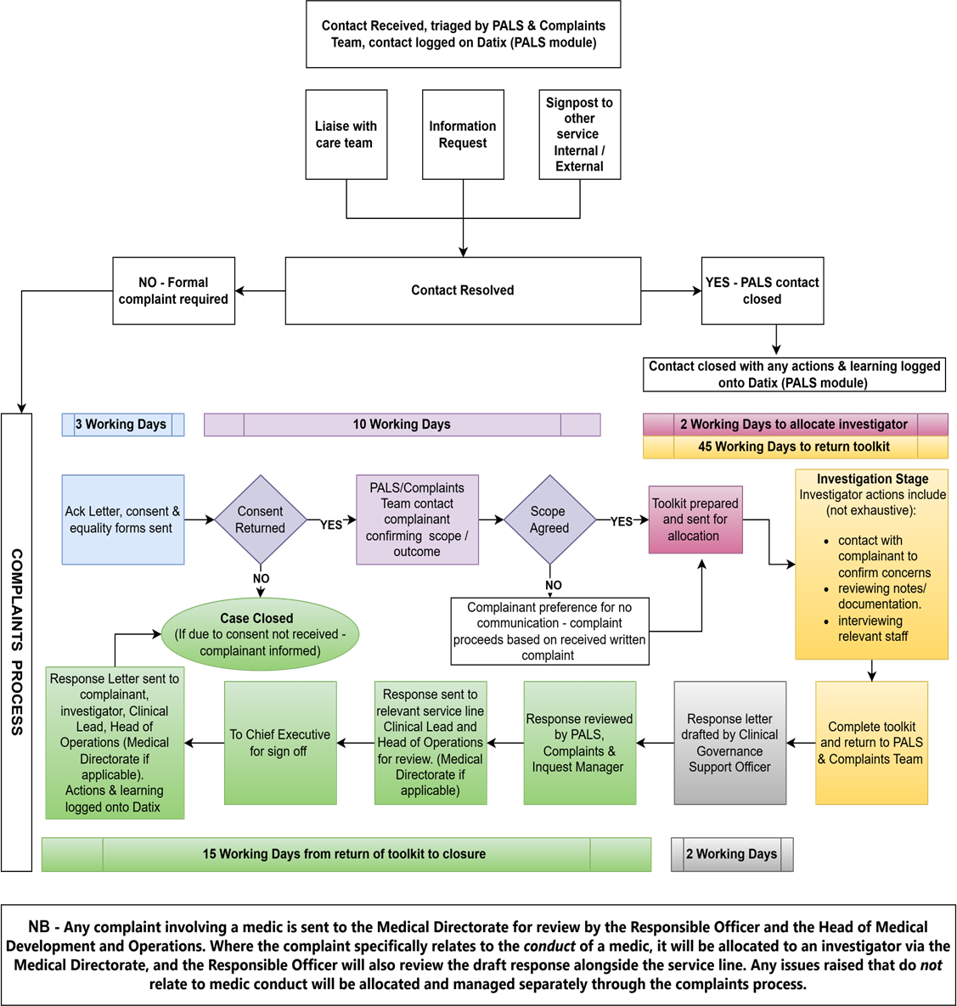

Description of Procedure/Process

The Trust provides an accessible, fair and effective process for concerns and complaints. We encourage early resolution at the point of service and, where a formal complaint is required, we agree a person-centred plan (issues, outcomes sought, communication preferences and update schedule) and investigate proportionately. We adopt a restorative, trauma-informed approach that focuses on listening, understanding impact, putting things right and learning to improve services.
This policy sets out the framework for the receipt and management of feedback received by the Trust through the Patient Advice and Liaison Service (PALS) and Complaints Team, for reader ease the team will be referred to as PaCT for the remainder of this document. Feedback may be submitted via a range of methods designed to ensure accessibility and convenience.

Quick Reference – First response to concerns/complaints:

1) Listen & acknowledge | Thank the person, avoid defensiveness, acknowledge any power imbalances that may impact on the person throughout this process,  validate distress, apologise where appropriate.
2) Early resolution | If you can resolve by end of next working day, do  so and record the outcome; otherwise refer to PaCT.
3) Refer to PaCT | Forward details the same day to PaCT:  email lypft.pals@nhs.net / Tel 0800 052 5790.
4) Immediate risk | Examples include (but are not limited to) where someone contacts PaCT and is expressing suicidal thoughts with intent or a plan, threats made towards identifiable individuals (family, staff, public) or a vulnerable adult is at risk of exploitation, abuse, or neglect. Escalation should be made immediately to the relevant Clinical Lead/Head of Operations and follow safeguarding/patient safety  procedures.

Trust staff are empowered to utilise a variety of approaches to respond to feedback and resolve concerns and complaints at the earliest appropriate opportunity. Staff are supported through training and guidance to respond to feedback with confidence and professionalism, and to take prompt and appropriate action where required.

Definitions
For the purposes of this procedure, feedback is defined across four categories, compliments, comments, concerns and complaints. These are based on definitions outlined in the NHS Complaint Standards:
Compliment: Positive feedback received regarding care, generally from service users, their relatives and/or carers. Compliments are also sometimes received from other healthcare professionals, services or external partners.
Comments (service issues/enquiries): A comment is a matter that is not about an individual’s care and treatment. It is something that is a cause for concern to the complainant, e.g., they may be unhappy with parking arrangements at the service, or someone is leaving lights on when a building is empty.
Concerns: A concern is a matter which an individual wishes to be considered on an informal basis. This can be done by the complainant directly with the service and should be resolved to the individual’s satisfaction within two working days. All staff are expected, on a routine and daily basis, to deal with patient concerns as presented to them. Wherever possible, staff are encouraged to achieve speedy resolution of the concern by either resolving it personally or establishing a dialogue between the complainant and the relevant personnel within operational/clinical areas, allowing for timely and informal resolution of the concern.
Complaints: An expression of dissatisfaction with care, services or facilities provided by the Trust, where any of the following apply:
    - Action or activity by the Trust or someone working for the Trust has detrimentally affected the experience of the service user or carer.
    - The complainant believes that a mistake or error occurred and that this has detrimentally affected them.
    - The complainant brings to the attention of the Trust an issue about a Trust service which could detrimentally affect them or someone else which they expect the Trust to put right.

Other forms of feedback
A range of approaches are in place across the Trust to obtain feedback from people who use our services, which, taken together, provide a framework for gathering insight into service user experience.
The framework includes real time feedback, Have Your Say (friends and family test), surveys, focus groups, workshops and events, and participation in National Patient Surveys as prescribed by the Care Quality Commission (CQC). These are not considered as part of this policy.

Principles and Approach
Overall responsibility for how we handle complaints sits with our organisation’s Responsible Person, as defined in the 2009 Complaints Regulations. In our organisation, this is our Chief Executive.
We follow the NHS Complaint Standards and the Model Complaint Handling Procedure to make sure we adhere to the standards of:
- Be fair
- Be open and accountable
- Put things right
- Act fairly and proportionately
- Seek continuous improvement
We ensure that we adhere to the CQC Regulation 16 which describes how the Trust should ensure that users of our services are able to make a complaint about their care and treatment.
Additionally, we aspire towards the following widely understood guiding principles around trauma-informed care (taken from NHS England guidance):

The 4 R’s of trauma-informed care are:
- Realise: all people at all levels have a basic realisation about trauma, and how it can affect individuals, families and communities.
- Recognise: people within organisations can recognise trauma, and how it can affect individuals, families and communities.
- Respond: organisations respond by practising a trauma-informed approach.
- Resist re-traumatisation: organisational practises may compound trauma. Trauma-informed organisations avoid this.
Within the context of this procedure, this means:
- We realise that complainants may have experienced trauma; and that this may include later iatrogenic harm from workers, services and systems.
- We recognise the signs of trauma in complainants; the ways in which trauma experiences may have contributed to a complaint being made; and the ways in which the complaints process itself may activate or trigger trauma responses.
- We respond by utilising trauma-informed thinking throughout this process; always responding to complainants through a trauma-informed lens. We remain aware that these power dynamics may echo or trigger past trauma, and we approach all interactions with sensitivity and care.
- We resist re-traumatisation by doing all the above; and by understanding the potential for harm to be caused through a lack of trauma-informed thinking within the complaints process.

We ensure that the Responsible Person and services regularly review what we learn from complaints, alongside other feedback such as incidents, compliments, and

patient experience data. This helps us spot themes, understand what matters most to people using our services, and identify where change is needed. This is further described in the procedure under heading ‘Learning and improving as a result of feedback’.
When learning is identified, Head of Operations and Clinical Lead for the relevant service/s make sure clear actions are agreed, monitored, and completed via tier 3 governance forums. They also make sure that the changes we make lead to real improvements in the quality, safety, and experience of our care.
This approach supports the expectations set out in the Model Complaint Handling Procedure, which emphasises coordinated oversight, meaningful learning, and demonstrating how complaints lead to service improvement.
Our Complaints Manager (as defined by the 2009 Regulation) is the Complaints, PALS & Inquests Manager. They are responsible for managing this procedure and for overseeing the handling and consideration of any complaints we receive.
The 2009 Regulations allow us to delegate the relevant functions of the Responsible Person and Complaints Manager to our staff where appropriate. We do this to ensure we can provide an efficient and responsive service.
The roles and responsibilities of staff within our organisation, when dealing with complaints, are set out in appendix A. Regulations 4(2) and 4(3) of the 2009 Regulations allow us to delegate any complaint handling function to relevant staff where appropriate.

Feedback
Who can give feedback?
Any individual can give feedback to any Trust employee, including to the PaCT. Feedback is most commonly received from service users, those affected by service provision, those acting as a representative of a service user, carer, relative, member of parliament, councillors, independent advocates and Healthwatch. All complaints involving children will be managed reflecting the guidance published by the Children’s Commissioner for England Common Principles for a Child Friendly Complaints Process. See appendix J.
A PALS & Complaints information leaflet is available on the Trust internet and intranet page; this includes an easy read version. This leaflet can be provided to support people to give feedback on the services they have received. We ensure accessibility including compliance with the Accessible Information Standards (AIS) and access to independent NHS complaints advocacy.

Confidentiality, Consent and Capacity Duty of confidentiality
Care must be always taken throughout the PALS & Complaints Procedure to ensure that any information shared is confined to that which is relevant to the PALS contact or investigation of the complaint. Information should only be disclosed to those people who have a demonstrable need to know for the purpose of responding to the PALS contact, investigating the complaint, or for ensuring that the complaints procedure is followed. It is good practice to obtain written consent from the person making contact, informing them that information from their contact will need to be disclosed to staff involved in managing, investigating and responding to the contact. If the person objects to this, then the effect on the response will be explained.

Consent and information sharing for formal complaints
Where the service user has capacity, their explicit consent will be sought before accessing personal or clinical records for the purposes of complaint investigation, in accordance with the Data Protection Act and Caldicott Principles. Responsibility for seeking and recording consent rests with the PaCT. A copy of the complainant’s identification is required at this point to verify the identity of the complainant to ensure that information is not shared inappropriately and in line with best practice. This can be in the form of passport, driving license, birth certificate, utility bill and can be provided either electronically or in person. If the service user is an inpatient at a Trust site, then identification is not required.
Where a complaint is made by a relative, friend, carer or advocate, the service user’s consent must be obtained before a complaint investigation can begin in order to allow the complaint investigator to access records and share clinical information with the complainant. Before any response can be provided, we will require consent from the complainant (where this is not the service user) in order to allow us to store the complaint information. Where a complaint is submitted by a Member of Parliament or Councillor on behalf of a service user, separate consent is not required as they will directly request this, however the complaints team should ensure that we receive a copy of this before proceeding with a complaint investigation. In some cases, it may be appropriate to obtain consent from a child (over the age of 12), if that child can understand the situation and can give informed consent. For younger patients, decisions to allow self-consent will be based on Gillick/Fraser competencies via discussions with the relevant clinical team.
For service users who lack capacity, decisions will be made in accordance with the Mental Capacity Act 2005. The Complaints Team, in collaboration with the clinical team and with advice from the Mental Health Legislation Team where required, will determine whether an individual is a suitable representative and ensure the complaint is handled in the service user’s best interests.
Where a representative holds a Lasting Power of Attorney for Health and Welfare or is a court appointed deputy, this authority must be verified before information is shared.

In relation to third party complaints, if the service user has capacity and declines to provide consent or in the absence of any other lawful authority, the Trust may investigate the complaint via discussions with the involved clinical team; however, any response provided will be appropriately limited and will not include personal or clinical information.
Explicit consent must be obtained where investigation of a complaint involves sharing information with another Trust or external organisation.
In cases where consent is not returned within 10 working days, the complaint will be closed with notification sent to the complainant to advise. Complainants may contact the PaCT within 6 months from the date of closure to request reopening of their complaint, subject to review. If there are patient safety or safeguarding concerns, these may still be investigated by the relevant service line, but response would not be provided to the complainant.
The PaCT should be mindful of trauma-informed practice whilst navigating issues around consent and the sharing of personal information, recognising that complainants may have experienced harm and a lack of control and safety in these areas. Investigators should make allowance for these factors; and ensure discussions are handled sensitively and with compassion.

Data and complaints information
All records relating to complaints investigation are confidential and must be kept by the Trust in a secure environment for 10 years. No other files relating to complaints should be held by the organisation and complaints correspondence should not be part of the clinical record.

PALS and Early Resolution Patient Advice & Liaison Service
The Patient Advice and Liaison Service (PALS) support people who use Trust services, and their relatives, carers, friends or advocates, by providing an accessible and trauma-informed mechanism for raising comments, concerns, requests for information, compliments or complaints. The Trust encourages people to raise concerns at the earliest opportunity, as many issues can be resolved quickly and informally without the need to progress to a formal complaint. We comply with the Accessible Information Standard (AIS) and signpost to independent NHS complaints advocacy

Role and Core Functions of PALS
The core functions of the PALS service is to provide an accessible, responsive and supportive service for service users, carers, staff and members of the public. PALS acts as the first point of contact for comments, concerns, complaints or compliments and aims to resolve concerns promptly and locally wherever possible.

Accessibility and Contact Arrangements
The PALS service operates Monday to Friday, 8am to 4pm. Where staff are unable to respond immediately, an answerphone service may be used during office hours. Calls made outside office hours will be advised to call back during office hours. PALS may be contacted by telephone, email, letter, or by arranging a face-to-face appointment.

Managing Feedback, Concerns and Complaints
Feedback may include expressions of dissatisfaction or compliments and does not require the use of the term 'complaint'. The Trust will use the language chosen by the service user or their representative. PALS will discuss the issues raised and agree with the individual how the matter will be handled.

Resolution and Escalation
Where appropriate, PALS will seek to resolve concerns through liaison with the individual’s care team, involved service or relevant staff. Where resolution cannot be achieved, and with consent, concerns may be progressed through the Trust’s formal complaints process.

Recording, Monitoring and Learning
All PALS contacts are recorded on the DATIX system. Outcomes and lessons learned are identified and shared through Trust governance structures to support service improvement.

Making sure people know how to complain, where to get support
We want all patients, service users, their family members and carers to have a positive experience when using our services. If someone feels that the service received has not met our standards, we encourage them to raise their concerns with staff involved in their care and/or to contact the PaCT so that issues can be addressed promptly.
We publish clear information about our PALS and complaints process and how people can get advice and support with their complaint through their local independent NHS Complaints Advocacy service. In our area this is Leeds Independent Health Complaints Advocacy (LIHCA) and other specialist independent advice services that operate nationally.
We will make sure that everybody who uses (or is impacted by) our services (and those that support them) knows how they can make a complaint by having our complaints procedure and/or materials that promote our procedure visible in public areas, including in all clinical areas and on our website. We will provide a range of ways to do this so that people can do this easily in a way that suits them. This includes providing access to our complaints process online.
We will make sure that our service users’ ongoing or future care and treatment will not be affected because they have made a complaint.

In line with The Local Authority Social Services and National Health Service Complaints (England) Regulations 2009, where a complaint is made verbally (either in person or via telephone) and is resolved to the complainant’s satisfaction by the end of the next working day, it is not required to proceed through the remainder of this procedure. In such cases, confirmation will be sought that the complainant is satisfied with the outcome. Where resolution is not possible within this timescale, the complaint will be managed in accordance with the full complaints procedure.
All staff who have contact with patients, service users, or those supporting them are expected to respond to concerns and complaints in a sensitive, empathetic, compassionate and professional manner. Staff should ensure that individuals feel listened to, that responses are provided as promptly as possible, and that any learning identified is appropriately captured and acted upon.
Staff will:
- listen carefully to understand the issue(s) raised
- seek to understand the impact on the individual, keeping in mind the possible interplay with past experiences of trauma
- ask what outcome the individual is seeking
- take action to resolve the issue directly where they are able to do so, with appropriate support if required
- explain clearly where resolution is not possible, including the reasons and available options
- identify and share learning to support service improvement
This may include providing an explanation or apology directly, or involving a colleague better placed to respond. Wherever appropriate, resolution will be sought through face-to-face or telephone discussion.

If we can resolve concerns
Frontline staff frequently manage concerns and complaints that can be resolved at the point they are raised, or very shortly afterwards. The Trust actively encourages early and local resolution wherever possible, as this supports timely outcomes for those raising concerns and learning for services.
Where staff consider that early resolution is achievable, they are authorised to take appropriate action to address the issues raised and put matters right. If the person raising the concern is satisfied that this resolves the issues, our staff have the authority to provide a response on our behalf. This will often be done in person, over the telephone, or in writing (by email or letter) in line with the individual circumstances.
A monitoring form should be completed to capture a summary of the concerns and how they resolved them and can be shared with the person raising the concern. The

completion of the monitoring form will ensure we build up a detailed picture of how each of the services we provide is doing and what people experience when they use these services. The completed monitoring form should be shared with the PaCT to ensure these contacts are logged to support any future contacts from the service user or their representative. A copy of the monitoring form is available at Appendix K.

If we are not able to resolve concerns
If we are unable to find an appropriate way to resolve the concern to the satisfaction of the person making it, we will look at whether we need to take a closer look into the issues.
Not every concern can be resolved quickly and sometimes we will require a longer period of time to take a closer look into the issues and carry out an investigation. In these cases, we will make sure that a formal complaint is logged and allocated to an appropriate member of staff (or Complaint Investigator), who will take a closer look into the issues raised. This will always involve taking a detailed and fair review of the issues to determine what happened and what should have happened.
We will make sure staff involved in carrying out a formal complaint investigation are trained to do so. We will also make sure they have:
- the appropriate level of authority and autonomy and trauma-informed understanding to carry out a fair investigation.
- the right resources, support, and time in place to carry out the investigation, according to the work involved in each case.
Where possible, complaints will be looked at by someone who was not directly involved in the matters complained about. If this is not possible, we will explain to the person making the complaint the reasons why it was assigned to that person. This should address any perceived conflict of interest.

Formal Complaints Process When people want to make a complaint
We understand that we cannot always resolve concerns straight away, and that
sometimes people may choose to make a complaint. The NHS Complaint Standards define a complaint as any expression of dissatisfaction, spoken or written, that requires a response. A complaint may be about:
    - something we have done, not done, or a decision we have made.
    - the quality or standard of the care or service we have provided.
We take all complaints seriously and will respond in a fair and timely way. The Trust is fully committed to ensuring that any future care received will not be negatively impacted as a result of a complaint being made. Issues which cannot be dealt with under this procedure are:-

    - A complaint made by an employee of the Trust about any matter relating to their employment.
    - A complaint made by an NHS or Local Authority Social Care body which relates to the exercise of its functions by another NHS or Local Authority Social Care body.
    - A complaint which has previously been investigated under these or previous Regulations.
    - A complaint which is made orally and resolved to the complainant’s satisfaction no later than the next working day.
    - A complaint that has been or is being investigated under the previous complaints regulations, or by the Parliamentary Health Service Ombudsman.
    - A complaint arising out of the Trust’s alleged failure to comply with a Subject Access Request under the Data Protection Act (2018) or a request for information under the Freedom of Information Act (2000).

Feedback and complaints
Complaints can be made to us:

In person
By telephone to the PALS team on 0800 052 5790

In writing to
PALS & Complaints Team Main House, St Marys House St Marys Road
Leeds LS7 3JX
By email to lypft.pals@nhs.net
We want to make sure that everyone can make a complaint in a way that works for them. We will consider any accessibility needs or reasonable adjustments a person may require, such as support with communication or using an alternative method to share their concerns. We will record any reasonable adjustments we agree to.
If someone makes a complaint verbally, our PaCT will write down the details and provide the person with a summary to check that we have understood their concerns correctly.
Sometimes we may receive anonymous complaints or general concerns that do not meet the usual criteria for who can make a complaint. When this happens, we will still look into the issues raised where possible, to see whether there is learning or improvement for our organisation, unless there is a clear reason not to do so.

Acknowledging complaints
We will acknowledge every complaint within three working days of receiving it. This acknowledgement may be provided in writing, electronically or verbally, depending on the person’s preference and needs. We will also discuss with the person making the complaint how we plan to respond to the complaint.

Who Can Make a Complaint and Consent Requirements
Under the NHS complaints regulations, anyone can make a complaint to the Trust if they:
    - have received care or services from us,
    - are currently receiving care or services, or
    - are likely to receive care or services from us in the future.
A complaint can also be made by anyone who has been, or may be, affected by something we have done, not done, or decided.

Making a complaint on someone else’s behalf
A complaint may be made:
    - by the person directly affected, or
    - by someone acting as their representative.
There is no limit on who can act as a representative, but we must be satisfied that they have the person’s consent or the authority to act for them and receive information about the complaint.

Situations where someone can complain for another person
A representative may make a complaint when the person affected:
    - is a child,
    - has died, or
    - cannot make the complaint themselves because of physical or mental incapacity.
In these cases, we will still need to be satisfied that sharing information with the representative is appropriate and in the best interests of the person affected. If we need to limit the information we can share, such as for confidentiality or safeguarding reasons, we will explain this at the beginning.

When the Trust may refuse or stop considering a complaint
If we believe that a representative is not acting in the best interests of the person affected, we may decide to stop looking into the complaint. If this happens, we will:
    - explain our reasons in writing, and
    - advise the representative that they can take the matter to the Parliamentary and Health Service Ombudsman.

Timescale for making a complaint
Complaints must be made to us within 12 months of the date the incident being complained about happened or the date the person raising the complaint found out about it, whichever is the later date.
If a complaint is made to us after that 12 month deadline, we will consider it if:
    - we believe there were good reasons for not making the complaint before the deadline (e.g., if the person did not feel psychologically safe enough to do so), and
    - It is still possible to consider the complaint.
If we do not see a good reason for the delay or we think it is not possible to properly consider the complaint (or any part of it) we will write to the person making the complaint to explain this. We will also explain that, if they are dissatisfied with that decision, they can complain to the Parliamentary and Health Service Ombudsman.

Complaints and other procedures
We make sure staff who deal with complaints are properly supported and trained to identify when it may not be possible to achieve a relevant outcome through the complaint process on its own. When this happens, the staff member dealing with the complaint will inform the person making the complaint and give them information about any other process that may help address the issues and has the potential to provide the outcomes sought. There is guidance within the investigator toolkit for instances where other processes are required to investigate concerns and includes information on how to escalate.
This can happen at any stage in the complaint handling process and may include identifying issues that could or should:
    - trigger a patient safety investigation
    - trigger our safeguarding procedure
    - involve a coroner investigation or inquest
    - trigger a relevant regulatory process, such as fitness to practice investigations or referrals
    - involve a relevant legal issue that requires specialist advice or guidance.

When another process may be better suited to cover other potential outcomes, our staff will seek advice and provide clear information to the individual raising the complaint. We will make sure the individual understands why this is relevant and the options available. We will also signpost the individual to sources of specialist independent advice.
This will not prevent us from continuing to investigate the complaint. We will make sure that the person raising the complaint gets a complete and holistic response to all the issues raised. This includes any relevant outcomes where appropriate. The staff member dealing with the complaint will engage with other staff or organisations who can provide advice and support on the best way to do this.
If an individual is already taking part or chooses to take part in another process but wishes to continue with their complaint as well, this will not affect the investigation and response to the complaint. The only exceptions to this are if:
    - the individual requests or agrees to a delay
    - there is a formal request for a pause in the complaint process from the police, a coroner, or a judge.
In such cases the complaint investigation will be put on hold until those processes conclude. A responsible body is not required to consider a complaint if doing so would prejudice an investigation.

If we consider that a staff member should be subject to remedial or disciplinary procedures or referral to a health professional regulator, we will advise the person raising the complaint. We will share as much information with them as we can while complying with data protection legislation. If the person raising the complaint chooses to refer the matter to a health professional regulator themselves, or if they subsequently choose to, it will not affect the way that their complaint is investigated and responded to. We will also signpost to sources of independent advice on raising health professional fitness to practise concerns.

Safeguarding Concerns Identified During a Complaint

If, at any point, the staff member handling a complaint becomes aware that anyone involved may have experienced harm, abuse, or may be at risk, they will immediately discuss this with the appropriate colleagues and follow our safeguarding procedures. The PaCT must also be informed so that the complaints process can support any
safeguarding actions and ensure that the person’s safety and wellbeing remain the priority.

Confidentiality of complaints
We will maintain confidentiality and protect privacy throughout the complaints process in accordance with UK General Protection Data Regulation and Data Protection Act

2018. We will only collect and disclose information to those staff who are involved in the consideration of the complaint. Documents relating to a complaint investigation are securely stored and kept separately from medical records or other patient records. They are only accessible to staff involved in the consideration of the complaint.
Complaint outcomes may be anonymised and shared within our organisation and may be published on our website to promote service improvement.

Clarifying the complaint and explaining the process
The staff member (or Complaint Investigator) dealing with the complaint and using trauma-informed principles, will:
- engage with the person raising the complaint (either via video call, telephone call, or face to face meeting) to make sure they fully understand and agree:
  - the key issues to be looked at
  - how the person has been affected
  - the outcomes they seek
- signpost the person to support and advice services, including independent advocacy services, at an early stage

- agree how they will keep the person (and any staff specifically complained about) regularly informed and engaged throughout
- explain how they will carry out a closer look into the complaint, including:
  - what evidence they will seek out and consider
  - who they will speak to
  - how they will decide if something has gone wrong or not
  - who will be responsible for the final response
  - how the response will be communicated.

Carrying out the investigation
Staff who carry out investigations will give a clear and balanced explanation of what happened and what should have happened. They will reference relevant legislation, standards, policies, procedures, and guidance (including trauma-informed guidance around the ‘4 R’s at Page 7) to clearly identify if something has gone wrong.
They will make sure the investigation clearly addresses all the issues raised. This includes obtaining evidence from the person raising the complaint and from any staff involved or specifically complained about.
If the complaint raises clinical issues, they will obtain a clinical view from someone who is suitably qualified. Ideally, they should not have been directly involved in providing the care or service that has been complained about.

If the complainant is a survivor of trauma, efforts will be made to ensure that they feel as safe and in control as far as is possible. This is especially crucial for people who have experienced e.g., childhood sexual abuse, where issues around power, control, consent and safety are paramount; and where there is a risk of re-traumatisation through these issues not being held in mind.
We will aim to complete our investigation within 60 working days from the time consent is received, and this target date will be shared and agreed with the person making the complaint at the start of the investigation. In instances that investigations exceed agreed timescales, the complainant will be kept informed and provided with revised timescales in line with the NHS Complaints Regulations. A rationale for an extension to timescale must be agreed with the relevant Head of Operations and the Clinical Lead with the PALS & Complaint Team informed.

Providing a remedy
Following the investigation, if the person investigating the complaint identifies that something has gone wrong, they will seek to establish what impact the failing has had on the individual concerned. Where possible they will put that right for the individual and any other people who have been similarly affected. If it is not possible to put the matter right, they will decide, in discussion with the individual concerned and relevant staff, what action can be taken to remedy the impact.
In order to put things right, the following remedies may be appropriate:
- an acknowledgement, explanation and a meaningful apology for the error
- reconsideration of a previous decision
- expediting an action
- changing policies and procedures to prevent the same mistake(s) happening again and to improve our service for others.
The above may be especially important for survivors of trauma, for whom a restorative process and response may have significant therapeutic value.

The final written response
During the investigation, the person carrying out the investigation will complete the investigator toolkit and return this to the PaCT who will insert all the relevant information into the response letter template. The draft letter will be shared with the complaint investigator to ensure they are happy with the content. The investigator must also provide the PaCT with a complete copy of all documentation relating to the complaint investigation, for secure storage within the official complaint file.
No complaint documentation should be filed within the service user’s medical record or retained by the person carrying out the investigation.

Once the draft response is complete, and agreed with the complaint investigator, this will be sent to the Clinical Lead and Head of Operations for the relevant service for approval, if more than one service line is responding to the complaint it will be sent to all. Approval from both parties within the service line, Head of Operations and Clinical Lead, will be required before progressing to sign off. Where the complaint involves the conduct of a medic and has been investigated by a medic, this will be sent to the Responsible Officer within the Medical Directorate for final clinical approval before progressing for sign off. The Responsible Officer will also receive a copy of the final complaint response once signed off.
All complaint responses are signed by our Responsible Person, Chief Executive (or their delegate). The PaCT will send this signed final letter to the person raising the complaint and any other interested parties. The response will include:
- a reminder of the issues investigated and the outcome sought
- an explanation of how we investigated the complaint
- the relevant evidence we considered
- what the outcome is
- an explanation of whether or not something went wrong that sets out what happened compared to what should have happened, with reference to relevant legislation, standards, policies, procedures, and guidance
- if something went wrong, an explanation of the impact it had
- an explanation of how that impact will be remedied for the individual
- a meaningful apology for any failings
- an explanation of any wider learning we have acted on/will act on to improve our service for other users
- an explanation of how we will keep the person raising the complaint involved and updated on how we are taking forward all systemic learning or improvements relevant to their complaint
- confirm that we have reached the end of our complaint procedure
- details of how to contact the Parliamentary and Health Service Ombudsman if the individual is not satisfied with our final response
- a reminder of where to obtain independent advice or advocacy. Once the complaint response has been signed off, it will be issued to:
- the complainant
- any relevant third party or external organisation, where appropriate and subject to consent (e.g. advocacy services, the Care Quality Commission, or a Member of Parliament)
- the Complaint Investigator
- the relevant Clinical Lead (s)
- the relevant Head of Operations (s)
- the Responsible Officer, where applicable

Support for staff
As part of our commitment to trauma-informed care, we take staff wellbeing seriously. We will make sure all staff who look at complaints have the appropriate: training, resources, support, and time to investigate and respond to complaints effectively. This includes how to manage challenging conversations and behavior in a trauma-informed manner.

We will make sure staff specifically complained about are made aware of the complaint and we will give them advice on how they can get support from within our organisation, and externally if required.
We will make sure staff who are named in a complaint are informed at the earliest opportunity by the Head of Operations, Clinical Lead or nominated person. They will have the opportunity to give their views on the events and respond to emerging information. Our staff will act openly and transparently and with empathy when discussing these issues.
The person conducting the investigation will keep any staff complained about updated. These staff will also have an opportunity to see how their comments are used before the final response is issued. Where appropriate, the relevant ward or service team will also be informed of the complaint to support learning and service improvement, in line with confidentiality requirements.

Referral to the Ombudsman
In our response on every complaint, we will clearly inform the person raising the complaint that if they are not happy with the outcome of our investigation, they can take their complaint to the Parliamentary and Health Service Ombudsman.
If the complaint is about detention under the Mental Health Act, or a Community Treatment Order or Guardianship we will inform the person making the complaint that if they are not happy with the outcome, they can take their complaint to the Care Quality Commission.

Referral to the Information Commissioner’s Office (ICO)
Where complaints relate to Data Protection Rights issues (including, but not limited to the right of Subject Access, right of rectification or right of erasure), or requests made under the Freedom of Information Act (2000), these will first be escalated to the Head of Information Governance / Data Protection Officer, and if the complainant remains dissatisfied they will be directed to refer their complaint to the Information Commissioner’s Office (ICO).

Complaints involving multiple organisations
If we receive a complaint that involves other organisation(s) (including cases that cover health and social care issues) we will make sure that we investigate in collaboration

with those organisations. The people managing the complaint for each organisation will agree who will be the ‘lead organisation’ responsible for overseeing and coordinating consideration of the complaint.
The person investigating the complaint for the lead organisation will be responsible for making sure the person who raised the complaint is kept involved and updated throughout. They will also make sure that the individual receives a single, joint response. The duty to fulfil this is a requirement of Regulation 9: “All responsible bodies must cooperate to ensure a single coordinated response where a complaint spans multiple organisations”.

Care Quality Commission (CQC)
Complaints to the Care Quality Commission (CQC)
People who are, or who have been, detained under the Mental Health Act have the right to complain to the CQC about use of the Mental Health Act. The CQC will usually ask that the complaint is initially submitted to the hospital managers.
The Mental Health Act Code of Practice (2015) requires that information on how to complain to the CQC is readily available on all wards that are registered to support people detained under the Act. The Trust has a duty to ensure this information is available and displayed on its wards, with consideration given to the accessible information standard in how this information is shared.
When the CQC raises a complaint or concern on behalf of a service user, it is considered good practice to ensure the service user is fully informed. This includes explaining the nature of the information the CQC is requesting and how their personal data will be accessed and used, including any sharing with individuals or teams not directly involved in their care. Given the sensitivity of the information involved, formal consent must be obtained from the service user before any details can be shared with a third-party complainant.
Only information that is directly relevant to the concern or complaint should be disclosed. Disclosures must be limited to what is necessary to respond appropriately, in line with data protection and confidentiality requirements.

Consent not received (CQC complaints)
If consent is not received within 10 days, a response will be sent to the CQC to address the concerns raised by the complainant (see appendix I).

Members of Parliament (MPs)
Complaints made by Members of Parliament (MPs) on behalf of constituents

When a Member of Parliament (MP) raises a complaint or concern on behalf of a constituent - either following a direct request during an MP surgery or through written correspondence - it is considered good practice to ensure the constituent is fully informed. This includes explaining the nature of the information the MP’s office is requesting and how their personal data will be accessed and used, including any sharing with individuals or teams not directly involved in their care. Given the sensitivity of the information involved, formal consent must be obtained from the service user before any details are shared. See appendix G.
Only information that is directly relevant to the concern or complaint should be disclosed. Disclosures must be limited to what is necessary to respond appropriately, in line with data protection and confidentiality requirements.

Third-party complaints made by MPs
In situations where an MP is representing a constituent who is themselves acting on behalf of a service user, explicit consent from the service user is required before any personal information can be disclosed. If the MP advises they have obtained this consent, they must provide documented evidence.
Once the consent form is received, it is essential to verify the preferred method and recipient address for the response, as indicated in the consent documentation.

Consent not received (MP complaints)
If consent is not received within 10 days, the complaint will be closed, and a general response will be sent to the MP. This response will outline the organisation’s process in relation to the concern raised and explain why a detailed reply could not be provided due to the absence of valid consent.

Reopened complaint responses
The outcome of the investigation and any actions agreed will be reported to the complainant in writing, signed by the Chief Executive or, in their absence, by their deputy. The response will cover all aspects of the complaint, offer appropriate redress, and advise the complainant of their right to make a complaint to the Parliamentary and Health Service Ombudsman (PHSO) – see appendix H. If the complainant is not satisfied with the response, or indicates on receipt of the response, that they have points that they require clarification, the complaint will be reopened/reactivated.
The points for clarification cannot constitute a new complaint and must not raise issues not already addressed within the initial complaint.
If clinical services and the complaint investigator consider that all reasonable steps have been taken to resolve the complaint in the original response, then the

complainant will be informed that local resolution has been completed, and they will be advised to contact the PHSO.
There are no set response time frames for a secondary response. However, the response should be within a reasonable time determined by the PaCT based on the circumstances of the individual secondary investigation.

Habitual or unreasonable complainants (Special Management)
A small minority of people will take up a disproportionate amount of staff time and resources dealing with an individual’s perceived problem even when explanations have been given and all reasonable attempts have been made to resolve their concerns. We recognise that these cases can cause undue stress to all involved including the complainant and staff.
It’s important to note that some habitual and/or unreasonable complaints may have their roots in unresolved trauma issues and non-trauma-informed responses from workers and services, including previous invalidating responses to complaints. Guidance around this is included in Appendix C.

Situations where complainant’s mental health is perceived to be root cause of complaint
Where, following an initial review, it appears that a complainant’s mental health may be contributing to the nature, frequency or presentation of the complaint, the Trust will manage the complaint in a compassionate, proportionate, trauma-informed and person-centred manner, in line with its duties under the Mental Capacity Act 2005, Equality Act 2010 and the NHS Complaints Regulations.
The presence of mental health needs does not invalidate a complaint and will not, in itself, prevent a complaint from being investigated.
The following steps should be taken:

Respectful Assessment of the Complaint
The complaint should be considered on its merits, without assumptions about motivation or intent. Staff must avoid making diagnostic judgments and should focus on the issues raised and the complainant’s expressed desired outcome.

Consideration of Capacity and Communication Needs
Where there are concerns about the complainant’s ability to engage effectively with the complaints process, consideration should be given to whether they currently have capacity to consent to the complaint investigation and be involved in the process. If they are not able to proceed, the complaint may be placed on hold, in agreement with the clinical team until they are well enough to participate. This decision must be clearly documented in the complaint file and should be reviewed on a regular basis.

Sensitive and Supportive Engagement
Communication with the complainant should be clear, empathetic and
non-confrontational. Where appropriate, discussions may be held to clarify the issues raised, manage expectations, and agree an appropriate way forward.
Where this is not possible, the involved clinical team should be contacted for advice and support in the best way to proceed.

Consideration of Advocacy or Representation
The complainant should be advised of their right to access advocacy support, including Independent Advocacy Services, to assist them in raising and progressing their concerns.

Clinical Liaison Where Appropriate
Where the complainant is currently receiving care from the Trust, and there are concerns regarding risk, distress or deterioration in mental health, it may be appropriate to inform the relevant clinical team, acting at all times in the individual’s best interests.

Managing Repeated or Persistent Complaints
Where a pattern of repeated or persistent complaints is identified, the Trust may apply its policy for managing such cases, ensuring that actions taken are proportionate, reasonable, and clearly explained. Trauma-informed thinking may be particularly relevant here. Decisions must be documented and approved through appropriate governance arrangements. Where the nature of the complaint relates to Data Protection or Freedom of Information law, the relevant statutory provisions will apply.

Safeguarding and Risk Considerations
If there are concerns that the complainant may be at risk of harm to themselves or others, safeguarding procedures must be followed in line with Trust policy, and appropriate support pathways activated.

Clear Documentation and Governance Oversight
All decisions, communications, and agreed actions must be fully documented. Any decision to limit contact, modify the process, or apply alternative arrangements must be clearly justified and subject to managerial oversight.

Learning and improving as a result of feedback
The complaint investigator is responsible for defining the actions that must be taken in response to a complaint. Actions should be documented on the Action Plan section of the Complaint Investigator Toolkit and sent to PaCT. This facilitates thematic analysis and the sharing of learning across the Trust. Actions should always be specific, measurable, achievable, relevant and time bound (SMART).
Any actions identified through a complaint investigation must be agreed with the service line including the relevant Head of Operations and Clinical Lead prior to the complaint being finalised by the complaint investigator. This includes agreeing the action wording, the lead for the action and the timescale for completion.
The PaCT will ensure that actions arising from complaint investigations are logged on the DATIX system and monitored to confirm completion within the agreed timescales.

Completion of actions must be evidenced, for example through updated standard operating procedures, training records or other appropriate documentation.
Themes from complaints and feedback are collated by PaCT and reported monthly to the Oversight and Improvement Group. This group reports annually to the Quality Committee.
Service Line Tier 3 Clinical and Operational Governance groups are responsible for aligning themes and learning from complaints within their own quality improvement and service improvement programmes, this includes escalation of issues or good practice to Unified Clinical Governance Group (UCGG). This learning should be triangulated with other forms of feedback on care and service delivery so that improvements are made to services.
Trauma-informed practice involves a meaningful commitment to ongoing learning and reflection within services and systems; and we expect this to form part of our process. The willingness to reflect on; and to learn from, complaints, supports the development of a trauma-informed working culture.

Dissemination and Implementation Dissemination
This policy will be disseminated to all Trust staff via publication on the Trust intranet. Awareness of the policy will also be supported through team meetings, management briefings, and induction processes for new staff.
Key staff with responsibilities under this policy, including managers and staff involved in handling complaints, and PALS enquiries, will be notified by the relevant corporate team and provided with additional guidance where required.
Managers are responsible for ensuring that staff within their areas are aware of and understand the requirements of this policy.

Implementation
This policy will take effect from the date of ratification. All Trust staff are required to comply with the arrangements set out in this policy as part of their professional and contractual responsibilities.

The Trust’s PaCT will support implementation through:
- Providing advice and guidance to staff and managers
- Supporting the handling of complaints, and PALS enquiries
- Delivering training and awareness sessions as required
- Ensuring processes are applied consistently and in line with national guidance

- Compliance with this policy will be monitored through regular reporting, review of complaints and PALS activity, and governance oversight arrangements.

Findings will be used to support learning, service improvement, and assurance to the Trust.

Compliance and Monitoring

Compliance will be monitored by the Trust’s PaCT through routine monitoring of complaints and PALS activity, including response times, outcomes, themes and trends. This information will be reviewed to identify areas of good practice, learning and opportunities for service improvement.

A weekly complaint tracker will be circulated to directors and senior leaders showing the status of all open complaints. A quarterly complaint actions tracker will be circulated to Directors, Heads of Operations, Clinical Directors, Clinical Leads and other staff as appropriate to show new and completed actions each quarter.

Monitoring information will be reported through the Trust’s governance structure to provide oversight and assurance.

Complaints presenting significant risk, repeated delay or systemic concern will be escalated through the Trust’s governance structure in line with the escalation framework.
We maintain a record of:

    - each complaint we receive
    - the subject matter
    - the outcome
    - whether we sent our final written response to the person who raised the complaint within the timescale agreed at the beginning of our investigation.

To measure our overall timescales for completing consideration of all complaints and our delivery of the NHS Complaint Standards, we seek feedback on our service from:

    - people who have made a complaint and any representatives they may have via a satisfaction survey
    - staff who have been specifically complained about on a random sample of 20% of relevant complaints within each financial year via a survey.
    - staff who carried out the investigation on a random sample of 20% of complaints within each financial year via a survey.

In keeping with the 2009 Regulations section 18, as soon as practical after the end of each financial year, we will produce and publish an annual report on our complaint handling. This will include how complaints have led to a change and improvement in our services, policies or procedures.

A monthly service line specific complaints performance report will be shared with all Clinical Leads and Head of Ops for dissemination through tier 3 clinical governance, enabling services to have oversight of performance in relation to complaints and support escalation of non-compliance through the Trusts governance structures (i.e. breaches in key performance indicators to Unified Clinical Governance).
The following Key Performance Indicators will be used to support transparency, accountability, and service learning across the organisation:
    - Volume & Type: Number of complaints received, categorised by service area and issue type.
    - Timeliness: Acknowledgement within 3 working days; resolution within 10 (PALS contact) or 60 working days (formal investigation).
    - Outcomes: Percentage of complaints upheld, partially upheld, or not upheld.
    - Satisfaction: Complainant feedback and number of reopened cases.
    - Escalation: Cases referred to the Parliamentary and Health Service Ombudsman (PHSO) and outcomes.
    - Learning: Complaints leading to policy changes, staff training, or service improvements.
    - Reporting: Regular internal reporting schedule and inclusion in public reports (i.e. Annual Report and Quality Report).

SECTION 2 Appendices
Appendix A - Roles and responsibilities
The following sets out the responsibilities of staff involved in complaint handling within the Trust. These responsibilities align with the NHS Complaint Standards, the Local Authority Social Services and NHS Complaints (England) Regulations 2009, and the processes described within this procedure.
In line with agreed principles within the Leeds Community Mental Health Transformation, trauma-informed practice ‘is everyone’s business’, so all named below should hold the ‘4 R’s’ in mind whilst carrying out their responsibilities.

Role | Responsibility
Chief Executive | The Chief Executive holds overall accountability for the Trust’s compliance with the NHS Complaints Regulations and this procedure. They are responsible for ensuring lessons from complaints are acted upon and for signing final complaint  responses (unless delegated to an authorised deputy).
Director of Nursing & Professions | The Director provides senior oversight of complaints handling, organisational learning, and implementation of actions to  prevent recurrence. They may also deputise for the Chief Executive in accordance with delegated authority.
Medical Director | Acts as an escalation point for complaints involving professional medical issues and supports clinical scrutiny where needed.
Head of Operations | The Head of Operations is responsible for operational oversight of complaints within their service. This includes:  - reviewing complaints relating to their area  - identifying and addressing immediate operational risks  - ensuring investigations and responses are completed within agreed timescales  - approving complaint responses and associated actions  - monitoring completion of actions and evidencing improvements  - escalating delays or risks through governance pathways  They work collaboratively with the Clinical Lead and PALS & Complaints Team to ensure learning is embedded.
Clinical Leads | Clinical Leads ensure the accuracy, quality, and clinical integrity of complaint handling within their service area. Their  responsibilities include:

- reviewing and understanding clinical issues within complaints
- identifying and escalating immediate clinical risks
- approving clinical components of complaint responses
- ensuring actions are completed and evidenced
- disseminating learning through clinical governance
- contributing to improvements informed by complaint themes
They play a pivotal role in promoting safety and learning from feedback.
Head of Patient Experience, Complaints & Legal Services | Provides senior oversight of the Complaints Procedure and ensures:  - investigations and responses meet regulatory standards  - performance reporting is accurate and timely  - actions and learning are monitored and embedded  - the complaints process is delivered consistently and appropriately.
PALS,  Complaints & Inquest Manager | Is responsible for overall day-to-day management and oversight of procedures for handling complaints and the teams that deliver those services (described in “PALS & Complaints Team” function).  Responsible for producing performance reports and monitoring implementation of actions to improve service delivery.  Responsible for the management and oversight of the PALS & Complaints team and may also act as a complaint handler/investigator as required.
PALS &  Complaints Team | The team delivers core operational functions and is responsible for:  - receiving, logging, and triaging complaints  - identifying and sharing immediate risks with operational/clinical leaders  - coordinating the investigation process  - preparing and issuing responses for Chief Executive sign-off  - uploading final documentation to Datix  - circulating final responses to relevant staff  - monitoring actions, KPIs, and compliance

- auditing sample cases and reporting learning into governance
They ensure a high-quality, compassionate, and efficient complaints journey.
Complaint Investigator | Manages the investigation of assigned complaints, ensuring:  - a fair, comprehensive, and evidence-based review  - engagement with the complainant to clarify issues, outcomes sought, and preferred communication  - timely collection of statements, records, and clinical views when needed  - clear conclusions comparing “what happened” to “what should have happened”  - identification of learning and required actions  They coordinate with the Complaints Team to ensure a high-quality final response.
All staff | All Trust staff are expected to:  - respond to concerns sensitively, professionally, and promptly  - support early and local resolution whenever possible  - signpost individuals to advocacy and support services  - cooperate with complaint investigations and provide factual, honest information  - take part in learning and improvement arising from complaints  Staff must ensure people feel heard, respected, and reassured that raising concerns will not impact their care.

Appendix B – Investigator Toolkit

🧰 Complaint Investigation Toolkit
Complaint Reference: COMPLAXXX

“Investigate once, investigate well” PHSO

Complainant Details

Complainant Name:
Relationship to service user if third party
complaint:
Service User Name: (if different to
complainant)
Received direct or via third party i.e. CQC or
Advocate
Consent received date:
ID provided to confirm identity:
Investigator contact agreed:
Preferred contact details:
Reasonable Adjustments required –
consider:
- communication preferences (such as written responses only, large print)
- support from an advocate
- specific needs, including a preference for the gender of the person handling the complaint
- trauma-informed considerations e.g. any risk of re-traumatisation through the experience of the complaints process; and any mitigations required to offset
this

📋 Case Overview

Date complaint received:
Service Line(s):
Relevant Head of Operation(s):
Relevant Clinical Lead(s):

Team(s)/Ward(s):
Point of contact for relevant team:
Staff Named within Complaint:
NB – staff will be notified of the complaint by the Head of Ops/Clinical Lead or delegated staff as appropriate.
Lead Investigator:
Items of note (e.g. safeguarding concerns,
recent complaints/PALS history):
Deadline for Completion:
NB: If the complaint spans multiple service lines all relevant Heads of Ops/Clinical
Leads will be informed, including multiple service line review and sign off.

Investigation Guidance

Follow the PHSO Standards to carry out your investigation:
y)​S Carrying out the investigation – Parliamentary and Health Service Ombudsman (PHSO): https://www.ombudsman.org.uk/organisations-we-investigate/complaint-standards/nhs-complaint-standards/good-complaint-handling-guides/carrying-out-investigation
Your report must include:
  - ⬛✓ What should have happened vs. what did happen
  - ⬛» Lessons learned and actions taken
  - ★ What went well

Additional expectations:
    - V: ˆ Interview key staff and retain witness statements or notes
    - 🗣 Use clear, jargon-free language
    - ●^" ⬛ ⬛ Include full names and job titles (avoid naming staff in final responses)
    - ⬛_]¸ ª Provide a timeline with key dates and assessments
    - ( Do not make any entries in relation to the complaint on Care Director
    - Always use trauma-informed thinking, in line with guidance within the PALS & Complaint Procedure

Investigation Points

The following points have been agreed with the complainant by the PALS & Complaints Team on XXXX and confirmed via email/letter to them on XXXX.
IMPORTANT INFORMATION - Please note contact with the PALS & Complaints Team does not replace your direct contact with the complainant. It should be used as a reference to inform your conversations. The complainant may have additional points to raise. Please also ensure you review the original complaint in full as part of your investigation.
Please respond to all elements of the points including lessons learned and actions to improve. Please note that the answers to these points will be placed in the letter response template so please ensure they are worded with the reader in mind.

Q1: [Insert question] Response:
Q2: [Insert question] Response:
Q3: [Insert question] Response:

Complainant Contact

Please complete the table below to detail all your contact with the complainant during the investigation:

Date | Method (phone, email, F2F) | Notes

Staff Interview Summary

Please complete the table below to detail any staff interviews:

Staff Interviewed |  | Role | Date of  Interview | Notes

Document Summary

Please list all documents reviewed or accessed to inform the investigation:

Information Accessed (policy/procedure/care record etc)

Investigation Outcome

In your view is the outcome of the complaint:
- Upheld - All aspects of the complaint were found to be valid and supported by evidence.
- Partially upheld - Some elements of the complaint were valid, but not all.
- Not upheld - No evidence was found to support the complaint.
Add any comments here (i.e. if partially upheld – which elements):

 Learning Points

ACTION PLAN
The table below should be used to record all actions arising from the complaint, including those that have already been completed.

All actions must be discussed and agreed with the relevant Clinical Lead, Head of Operations, and/or Team to ensure they are SMART (see end of toolkit), have an identified lead, and include an agreed completion date.
Please note that these actions are not for you, as the complaint reviewer, to complete or lead on. Responsibility for delivering the actions lies with the relevant team.

 | Action | Lead | Target date / date completed
1
2

Please ensure the toolkit is fully completed before returning to: lypft.complaints@nhs.net.

SMART Action Checklist
Use this checklist to ensure every action arising from a complaint meets SMART standards and is agreed with the appropriate Clinical Lead, Head of Operations, or Team.
✓⬛ S — Specific
  - ☐ Is the action clear, detailed, and unambiguous?
  - ☐ Does it state exactly what needs to be done?
  - ☐ Does it identify who will carry out the action?
  - ☐ Does it describe where or in which process/team the action applies?
⬛✓ M — Measurable
  - ☐ Is there a clear way to check whether the action has been completed?
  - ☐ Are success measures or outcomes defined (e.g., audit, updated document, training completed)?
  - ☐ Is the evidence required for completion specified?
⬛✓ A — Achievable
  - ☐ Can the action be realistically completed with the resources and capacity available?
  - ☐ Has the relevant team agreed to the action?
  - ☐ Does the action fall within the team’s control or influence?
⬛✓ R — Relevant
  - ☐ Does the action directly address the issues raised in the complaint?
  - ☐ Will it improve safety, quality, experience, or compliance?
  - ☐ Is it aligned with team/service priorities or operational needs?
⬛✓ T — Time-Bound
  - ☐ Is there a clear completion date (not “ASAP”)?
  - ☐ Is the timescale realistic and agreed by the responsible team?
  - ☐ If the action is long-term, are review checkpoints included

Appendix C – Guidance for the handling of habitual or unreasonable complainants (special management)
Staff are expected to respond with sympathy, compassion and patience to the needs of all complainants. However, there will unfortunately be cases where it is felt that there is nothing more which can reasonably be done to assist complainants or rectify a real or perceived problem. There may also be occasions where a complainant (or other involved party, e.g. the service user) conducts themselves in a way that limits the ability to carry out a fair investigation. In these instances, the complaint may be deemed as abusive, persistent or vexatious and the ‘Special Management’ process may be invoked.

It is recognised that referring to a complaint/complainant as “persistent” or “vexatious” may not be conducive to improving the relationship with the complainant, hence the use of the generic term ‘Special Management’. The Special Management process may, for example, involve an agreement that all future correspondence should be in writing to avoid the risk of abusive telephone exchanges with staff.
It is important to ensure that the complaints procedure has been correctly implemented so far as is possible and that no material element of a complaint has been overlooked or inadequately addressed. It should be recognised that this procedure will only be implemented in rare circumstances and only as a last resort after all reasonable measures have been taken in an attempt to resolve the issues raised by the complainant.

Trauma-informed considerations
It’s important to note that a lack of trauma-informed thinking across workers, services and systems can result in traumatised service-users feeling invalidated, dismissed and misunderstood in ways which are psychologically harmful. Issues can inadvertently be escalated through poor practice; and this may include issues that have led to a complaint being made in the first place; and/or from a poorly handled complaints process. Anger, which is a very understandable aspect of some survivors’ presentations, may be exacerbated in this context.

Additionally, labelling traumatised service-users as ‘abusive’ – particularly those who have experienced profound violations such as childhood sexual abuse – can lead to psychological harm, as it both feeds into a sense of their own abuse being minimised; and, if their abuse involved being coerced to harm others, can play into complex and harmful dynamics.

Consideration should be given to whether an abusive, persistent or vexatious complaint is motivated by unresolved past trauma and/or an absence of trauma-informed thinking, including whether some degree of responsibility for this lies within services. Service-user ‘behaviour’ should always be examined through a trauma-informed lens prior to any judgement being reached. Thinking along these lines demonstrates a commitment to embedding trauma-informed practice; and mitigates

against possible stigmatisation and re-traumatisation being caused to survivors of trauma.

Definition of an abusive, persistent or vexatious complaint:

Complainants (and/or anyone acting on their behalf) may be deemed as persistent or vexatious where previous contact with them shows that they meet one or more of the following criteria. The list is not exhaustive, nor does one single feature on its own necessarily imply that the complaint/complainant will be considered as being in this category.

Criteria:-
- Persists in a complaint after the NHS Complaints Procedure has been fully implemented and exhausted.
- Changes the substance of a complaint, continually raises new issues or seeks to prolong contact by raising further concerns or questions upon receipt of a response to the original complaint. Please note that care must be taken not to discard new issues which may be significantly different from the original complaint and might need to be addressed as separate complaints or accounted for as part of the investigation.
- Makes the same complaint repeatedly, perhaps with minor differences, after the complaints procedure has been concluded, and insists that the minor differences make these 'new' complaints which should be put through the full complaints procedure.
- Is unwilling to accept documented evidence of treatment given as being factual
e.g. drug records or nursing and medical notes.
- Refuses to accept the outcome of the complaint process after its conclusion, repeatedly arguing the point, complaining about the outcome, and/or denying that an adequate response has been given.
- Refuses to accept that it may be difficult to verify facts if a long period of time has elapsed since the event(s) in question took place.
- Does not clearly identify the precise issues they would like to be investigated despite offers of assistance.
- Refuses to co-operate with the complaints investigation process while still wishing their complaint to be resolved.
- Threatens or uses physical violence towards staff, their families or associates.
- Harasses, verbally abuses or seeks to intimidate a member of staff investigating the complaint, usually on more than one occasion.
- Makes an unreasonable number of contacts with us (by any means) in relation to a specific complaint or complaints, or persistently approaches the Trust about the same issue through different routes.
- Makes persistent and unreasonable demands or expectations of staff and/or the complaints process after the unreasonableness has been explained to the complainant (an example of this could be a complainant who insists on immediate responses to numerous, frequent and/or complex letters, faxes, telephone calls or emails).

- Is known to have recorded meetings or conversations without the prior knowledge or consent of the other parties involved.
- Denies statements he or she made at an earlier stage in the complaint process.
- Adopts an excessively ‘scattergun’ approach, for instance, pursuing a complaint or complaints not only with the Trust, but at the same time with a Member of Parliament, the council, advocacy services, the Parliamentary and Health Service Ombudsman or the Care Quality Commission.
- Persists in seeking an outcome which we have explained is unrealistic for legal or policy (or other valid) reasons.
Where the PALS & Complaints Team has identified a complainant as being abusive, persistent or vexatious in accordance with one of the criteria outlined above, the Director of Nursing & Professions (or their deputy) will be informed and asked to make a decision on what action should be taken. It may be necessary to obtain advice from others (such as the Trust’s legal advisors) before a decision is made.

The complainant will be informed in writing that their complaint may be taken under Special Management and what is expected of them in order to avoid this situation.
If the complainant does not change their behaviour in future dealings with the Trust, the Director of Nursing & Professions (or their deputy), may decide to draw up a signed ‘Special Management’ agreement between the complainant and the Trust, which sets out a code of behaviour for both parties if the Trust is to continue to process the complaint. This may include requiring the complainant to communicate in a particular way e.g. in writing only, or to have telephone contact only with a designated member of staff.

If it has been decided that all practical possibilities of resolution have been exhausted, the Director of Nursing & Professions (or their deputy) will notify the complainant in writing of the reasons why the Special Management process has been invoked and the action that will be taken. The complainant will be notified of the ways in which his or her behaviour is unacceptable. This notification may be copied for the information of others already involved in the complaint, e.g. Trust staff, Leeds Mental Health Advocacy Group or a MP acting on behalf of their constituent. A record should be kept of the reasons why a complainant has been classified as being abusive, persistent or vexatious.

After the Special Management has been invoked, if the complainant subsequently demonstrates a more reasonable approach or submits a new complaint raising other issues, their status as an abusive, persistent or vexatious complainant may need to be reviewed and withdrawn. Where this appears to be the case, the approval of the Director of Nursing & Professions or their deputy is required. Normal contact with the complainant will be resumed and the application of the NHS complaints procedures will again apply.

Appendix D – Consent form

Complaint/Concern Consent Form

Complaint Reference: COMPLA
Leeds and York Partnership NHS Foundation Trust is committed to protecting patient confidentiality; therefore, we must receive consent before accessing your patient information.
We request that you sign and return this form so we can commence the investigation into your concerns. Please complete all sections below. We also need a copy of one proof of your ID; without this we will not be able to proceed. Please note that until we receive consent, we will be unable to progress, if after 30 working days we have not received your consent, the complaint will be closed.
PATIENT/SERVICE USER’S DETAILS (to whom does this complaint relate)
Name:
Address/Email Address:
Date of Birth:
Patient’s NHS No:
Copy of ID Provided (passport, driving license, birth certificate, utility bill):

COMPLAINANT DETAILS (who is making the complaint? If different from above):

Name:

Contact telephone number: Address/Email address:
REPRESENTATION DETAILS (if the patient is unable to provide consent themselves):
If you are completing this form on behalf of the patient/service user, please indicate your relationship and provide supporting documentation (e.g., Power of Attorney, Guardianship Order).

Representative Name: Relationship to Patient:
Supporting Documentation Provided:

I GIVE MY CONSENT for Leeds and York Partnership NHS Foundation Trust to access my clinical notes and any other relevant information, where necessary, in order to conduct a full investigation into the concerns I have raised. If my concerns also relate to other health and social care organisations, I give my consent for Leeds and York Partnership NHS Foundation Trust to contact/correspond with them as part of the investigation into this complaint. I understand that my personal details and relevant clinical information may be accessed and shared across those organisations, to enable the complaint to be addressed.
I understand that any information that may be accessed will be limited to that which is relevant to the investigation of the complaint.

Patient signature:
Date:

Complainant signature (if different to above):
Date:

Representatives signature (if applicable):
Date:

How to submit this form
Once completed, please send this form to our complaints team:

Complaints Department
Leeds and York Partnership NHS Foundation Trust Main House - St Mary's House
St Mary's Road Leeds
LS7 3JX

Help and further information
If you have any queries, please contact our complaints team on 0113 855 5955 or alternatively you can email lypft.complaints@nhs.net.

You can also find general information about the complaints process on our website. Please visit
www.leedsandyorkpft.nhs.uk and search for ‘Complaints’.

LYPFT Complaints & Claims – Data Protection Privacy Notice
The Complaints and Claims Team are part of Leeds and York Partnership NHS Foundation Trust (“the Trust”). Leeds and York Partnership NHS Foundation Trust are the accountable Data Controller for data processed by the Complaints and Claims team.
Contact addresses are as follows:-

Head Office Data Protection Officer

Main House - St Mary's House St Marys House, North Wing St Mary's Road St Martins View
Leeds LS7 3JX Leeds LS7 3LA

The Complaints and Claims team are based at the Trust Head Office.

The Complaints and Claims team will collect, store and process information relating to the management of your complaint or claim. Your signing of the attached consent form will be the legal basis for this data processing, with the processing of your data and access to appropriate records essential to the management of your complaint or claim.
Other than discussions with those appropriate to progressing the complaint or claim, we will not share your information unless required to do so by law.
We will not process your personal data outside the European Economic Area.

We will retain and subsequently securely dispose of your information in accordance with the requirements of the Records Management Code of Practice for Health & Social Care. Aligned to the Code, we are required to keep all records relating to your complaint or claim for a period of 10 years after the case is closed.
You have a right to request a copy of any and all the records the Complaints and Claims team holds that are about you, which we will provide to you within 30 days of receiving your written request.
We will correct any factual errors within your records.

You have a statutory right to raise a complaint with the Information Commissioner’s Office if you feel we have failed to honour your rights under Data Protection legislation

ACCESSIBILITY OPTIONS:
If you require this form in an alternative format (e.g., Easy Read, large print, audio, or another language), please contact our complaints team on 0113 855 5955 or email lypft.complaints@nhs.net.

COMPLAINT CLOSURE AND REOPENING:
If we do not receive your signed consent form within 10 working days, we will close the complaint. However, you may contact us within 6 months from the date of closure to request reopening of your complaint, subject to review.

Appendix E – Complaint Satisfaction Questionnaire

Complaint Satisfaction Questionnaire
As part of our commitment to continually improving our services, we are always keen to hear what people think. This questionnaire can be used to tell us about your experience of making a complaint, to help us understand what worked well and where we can learn lessons.

If you are not sure about the answer to any of the questions, please leave them blank. Details on how to submit the form are provided at the end.

1. How easy was it for you to find out how to make a complaint? |  |  | 2. How well were you kept informed during the  process? |  |  | 3. Was the response you received easy to understand?
Very easy |  |  | Very well informed |  |  | Very easy
Easy |  |  | Well informed |  |  | Easy
Difficult |  |  | Not well  informed |  |  | Difficult
Very difficult |  |  | Not informed at all |  |  | Very difficult

4. Do you feel confident that we will learn from your complaint? |  |  | 5. Overall, how well do you think your complaint was handled?
Very confident |  |  | Very well
Quite confident |  |  | Quite well
Not very confident |  |  | Poorly
Not confident at all |  |  | Very poorly

6. Are there any other comments you would like to make?
Your feedback is important to us and can help us improve our processes. Unfortunately, we are unable to provide a formal response to comments made in this section. If you would like a formal response, please contact the Complaints Department directly.

How to submit this form

In writing:
Please send the completed form to our Complaints Department:
Complaints Department
Leeds and York Partnership NHS Foundation Trust Main House - St Mary's House
St Mary's Road Leeds
LS7 3JX

By email:
Once you have saved this form and attached it to an email, please send it to our Complaints Department:
complaints.lypft@nhs.net

Help and further information
You can find further information about the complaints process on our website at www.leedsandyorkpft.nhs.uk (please search for ‘Complaints’) or you can phone our Complaints Department on 0113 855 5955.

Appendix F – Equality gathering form

Equality Information
We understand that the questions in this form are personal. Please be assured that any information you provide will be kept strictly confidential. Your answers are confidential and used only to monitor and improve equality, accessibility and inclusion across our services.
We collect this data to help the Trust ensure that our services are accessible, fair, and inclusive for all communities. Your responses will only be used for monitoring and improving equality and will not be used for any other purpose.
Instructions for completion: Providing this information is voluntary. If you prefer not to answer a question, please choose ‘Prefer not to say’.

1. Ethnicity (tick one):
White – British
White – Irish
White – Any other White background
Mixed – White and Black Caribbean
Mixed – White and Black African
Mixed – White and Asian
Mixed – Any other mixed background
Asian or Asian British – Indian
Asian or Asian British – Pakistani
Asian or Asian British – Bangladeshi
Asian or Asian British – Any other Asian backgroun
Black or Black British – Caribbean
Black or Black British – African
Black or Black British – Any other Black backgroun
Other ethnic groups – Chinese
Other ethnic groups – Any other ethnic group
Prefer not to say

2. Language
What is your preferred spoken language:
Do you need an interpreter?

3. Communication support needs: (select all th
apply):
Easy Read materials
British Sign Language (BSL) interpreter
Lip speaker

Large print
Braille
Audio format
Email rather than printed letters
Text/SMS rather than phone calls
Other (please tell us):

4. Sex as registered at birth (tick one):
Female
Male
Indeterminate
Not known
Prefer not to say

5. Gender Identity (tick one):
Man
Woman
Non-binary
Other
Prefer not to say
Is your gender identity the same as the sex register  at birth? | - Yes ☐ No ☐ Prefer not to say

6. Age (tick one):
Under 18
18-24
25-34
35-44
45-54
55-64
65 and over
Prefer not to say

7. Disability
Do you consider yourself to be a disabled person? | - Yes ☐ No ☐ Prefer not to say
If yes what type(s) of impairment do you have? (select all that apply):
Physical
Sensory
Learning disability
Mental health

Cognitive
Long-standing illness or condition
Other
Prefer not to say

8. Sexual orientation (tick one):
Heterosexual/straight
Gay or lesbian
Bisexual
Other sexual orientation (please state)
Prefer not to say

9. Religion/belief (tick one):
No religion
Christian (including Church of England, Catholic,
Protestant and all other Christian denominations)
Buddhist
Muslim
Jewish
Sikh
Hindu
Agnostic
Atheist
Other (please state)
Prefer not to say

10. Caring responsibilities
Do you look after a relative, neighbour or friend  who is ill, disabled, frail or needs emotional support? | - Yes ☐ No ☐ Prefer not to say
If yes, are you registered with your GP as a carer?

11. Marital Status (tick one):
Single
Married/civil partnership
Widowed/surviving civil partner
Separated
Divorced/civil partnership dissolved
Prefer not to say

12. Please let us know if you have any specific communication preferences or other needs that the Trust should be aware of, so we can make reasonable adjustments to support you. For example, you might find it easier to read information when it’s printed on coloured paper, or you may prefer verbal communication over
written formats.

Thank you!

Appendix G – Process for managing MP feedback

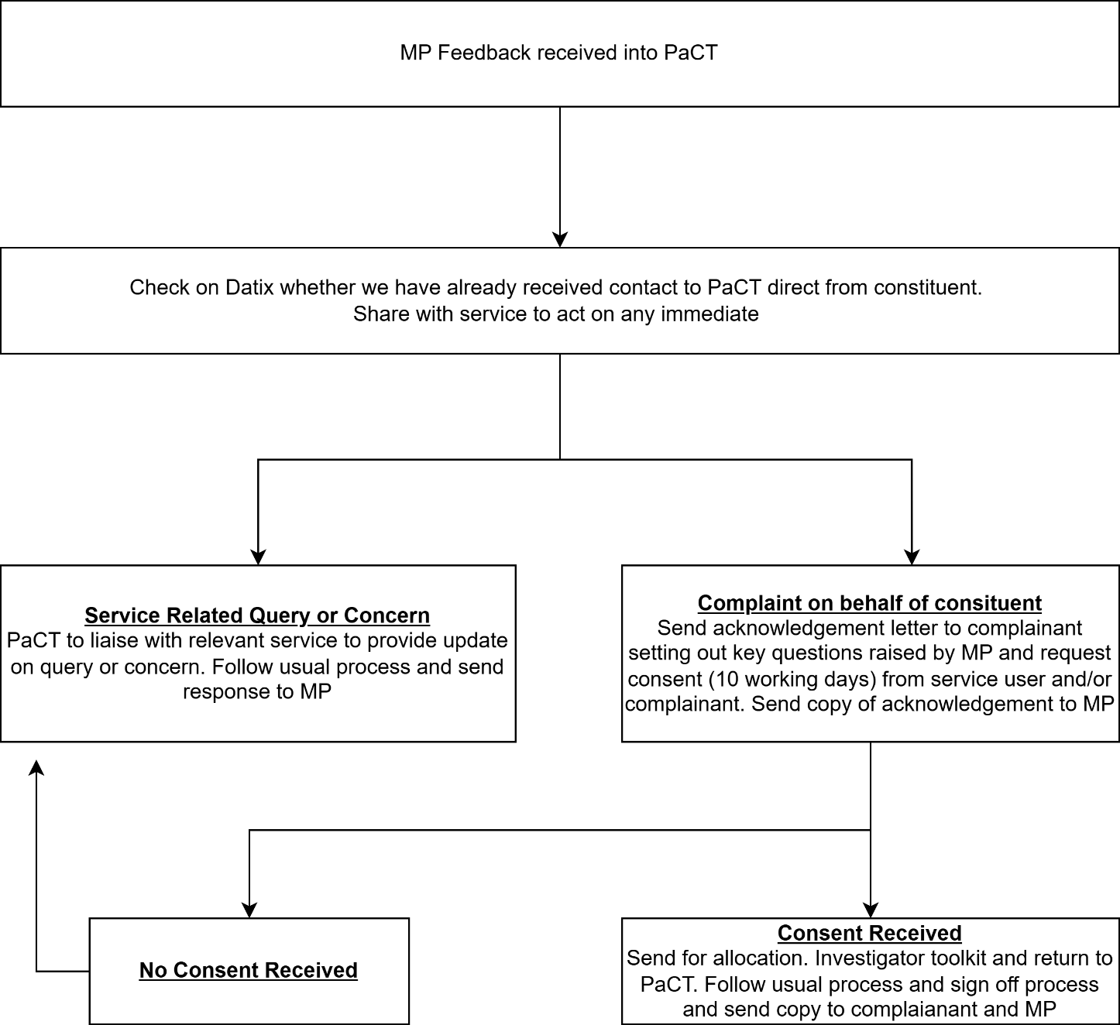

Appendix H – Reactivated complaints

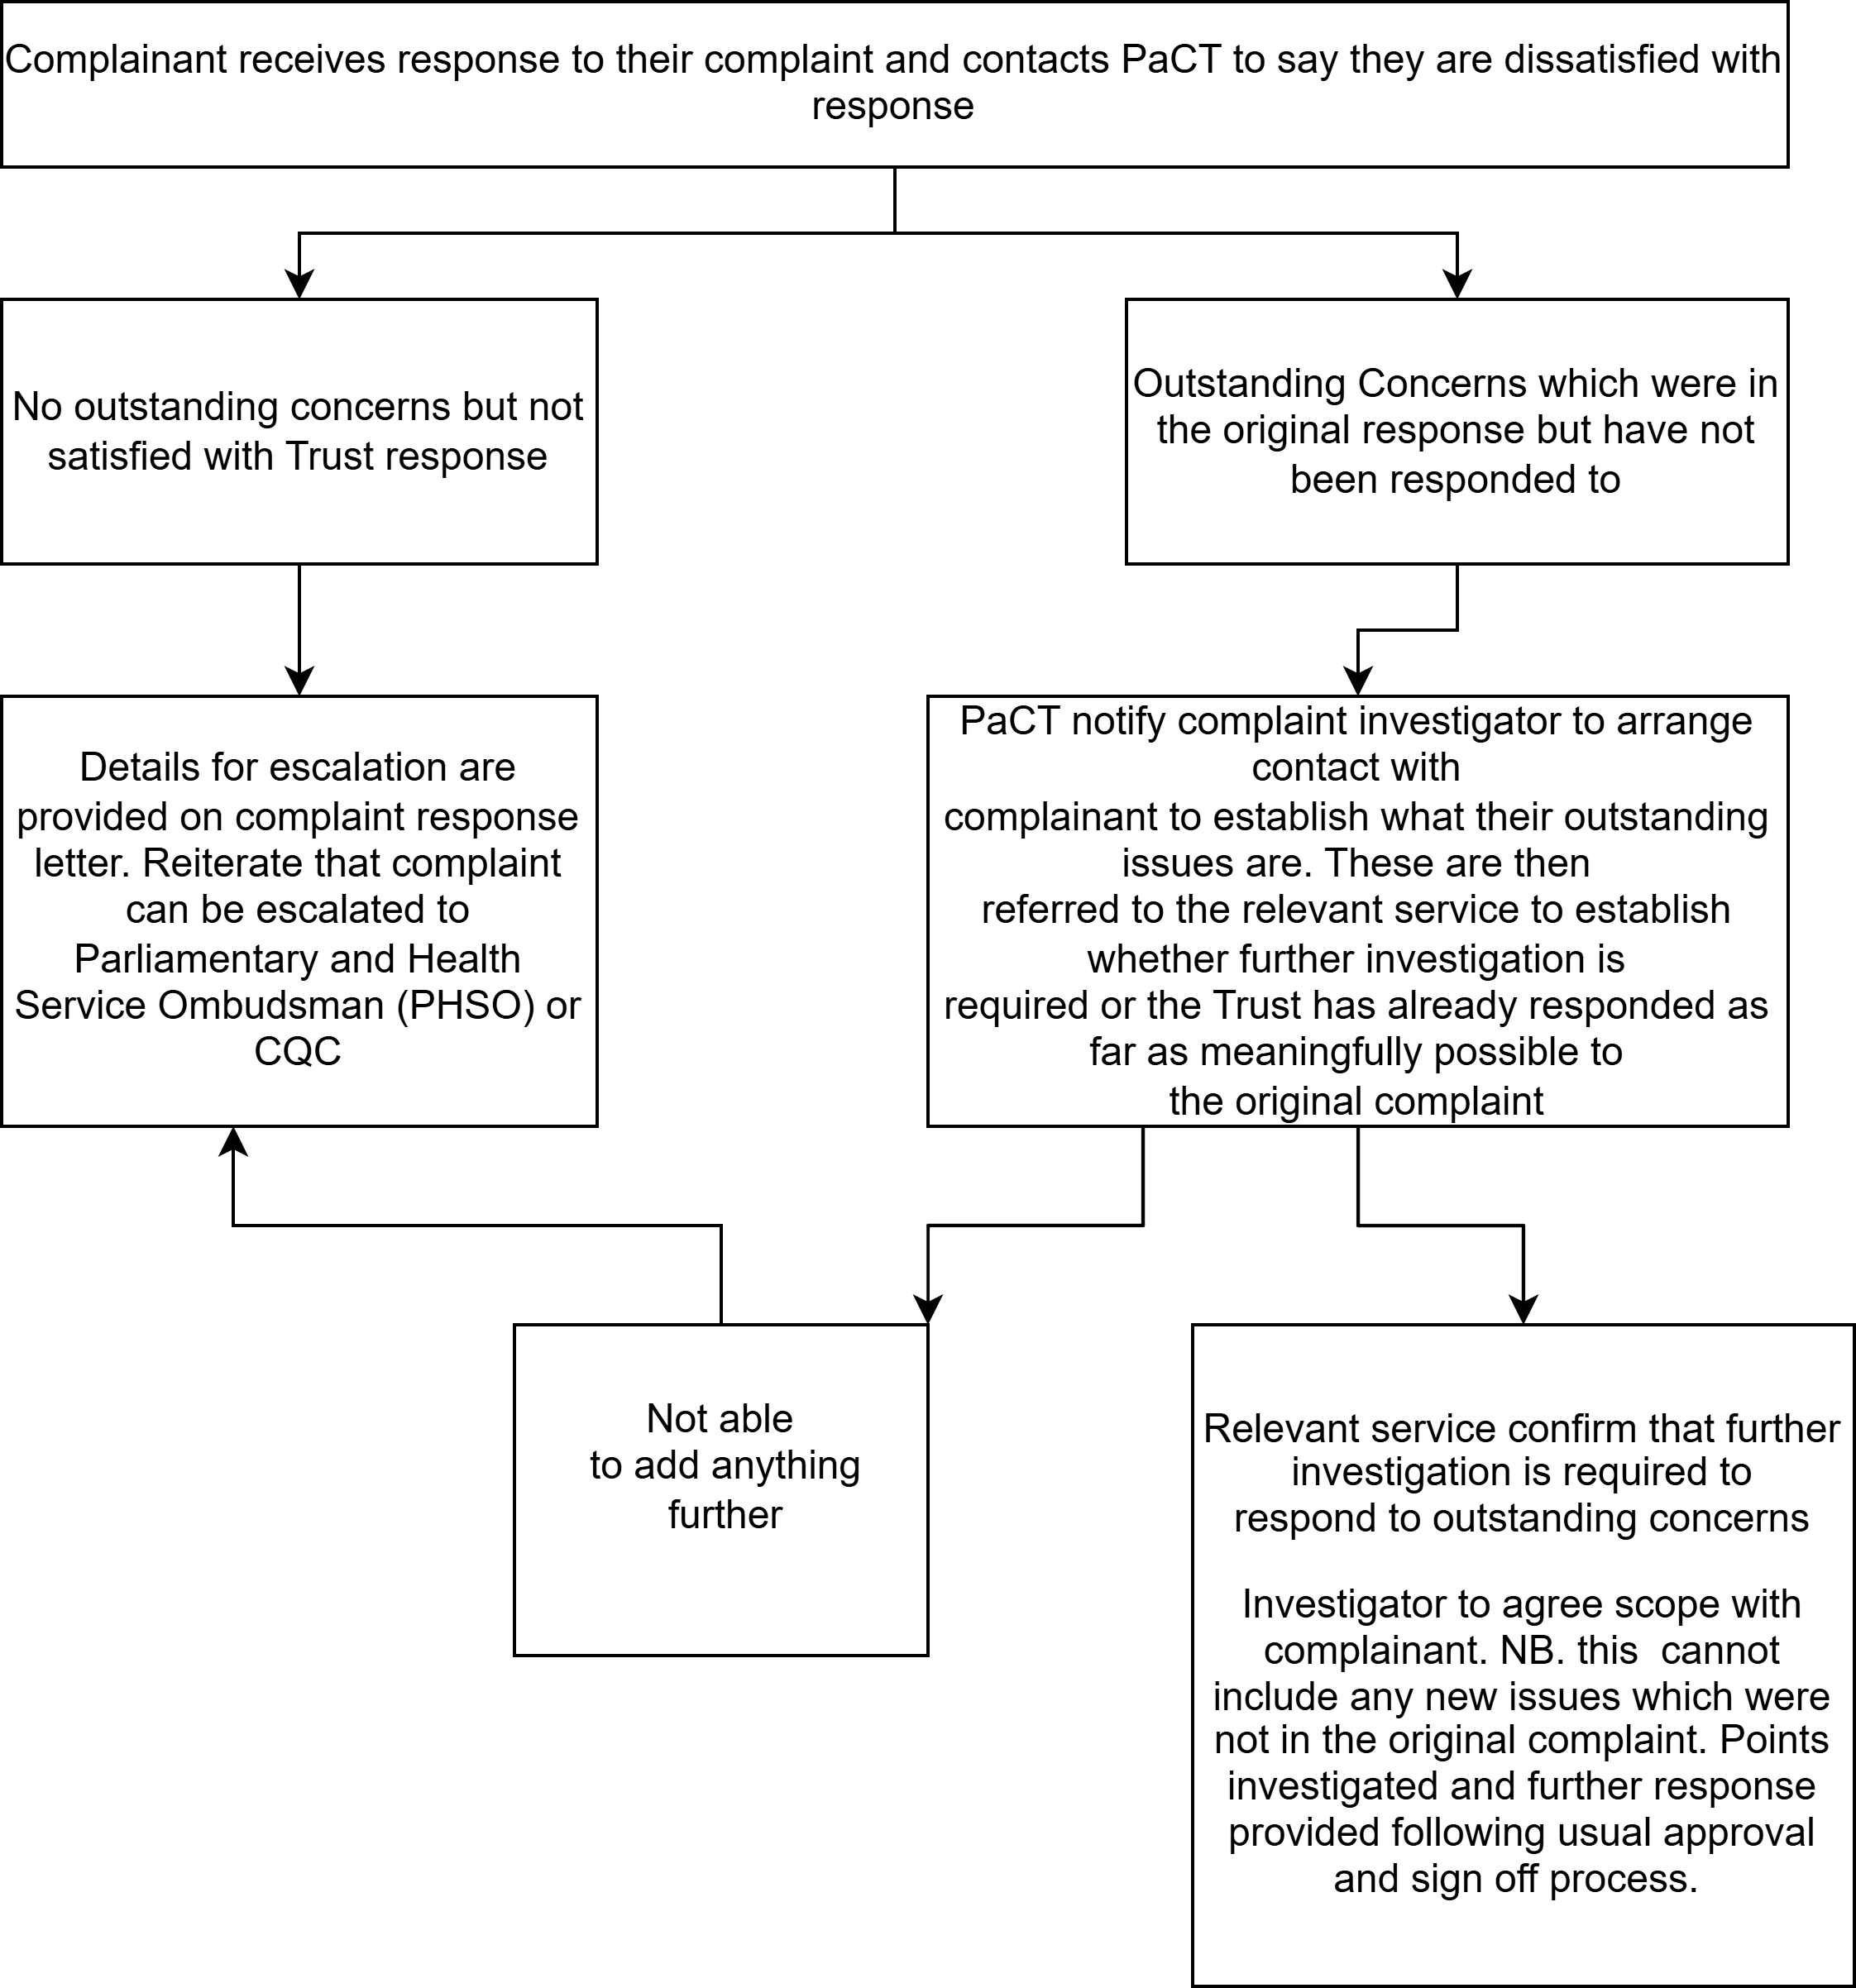

Appendix I – CQC Complaints Process
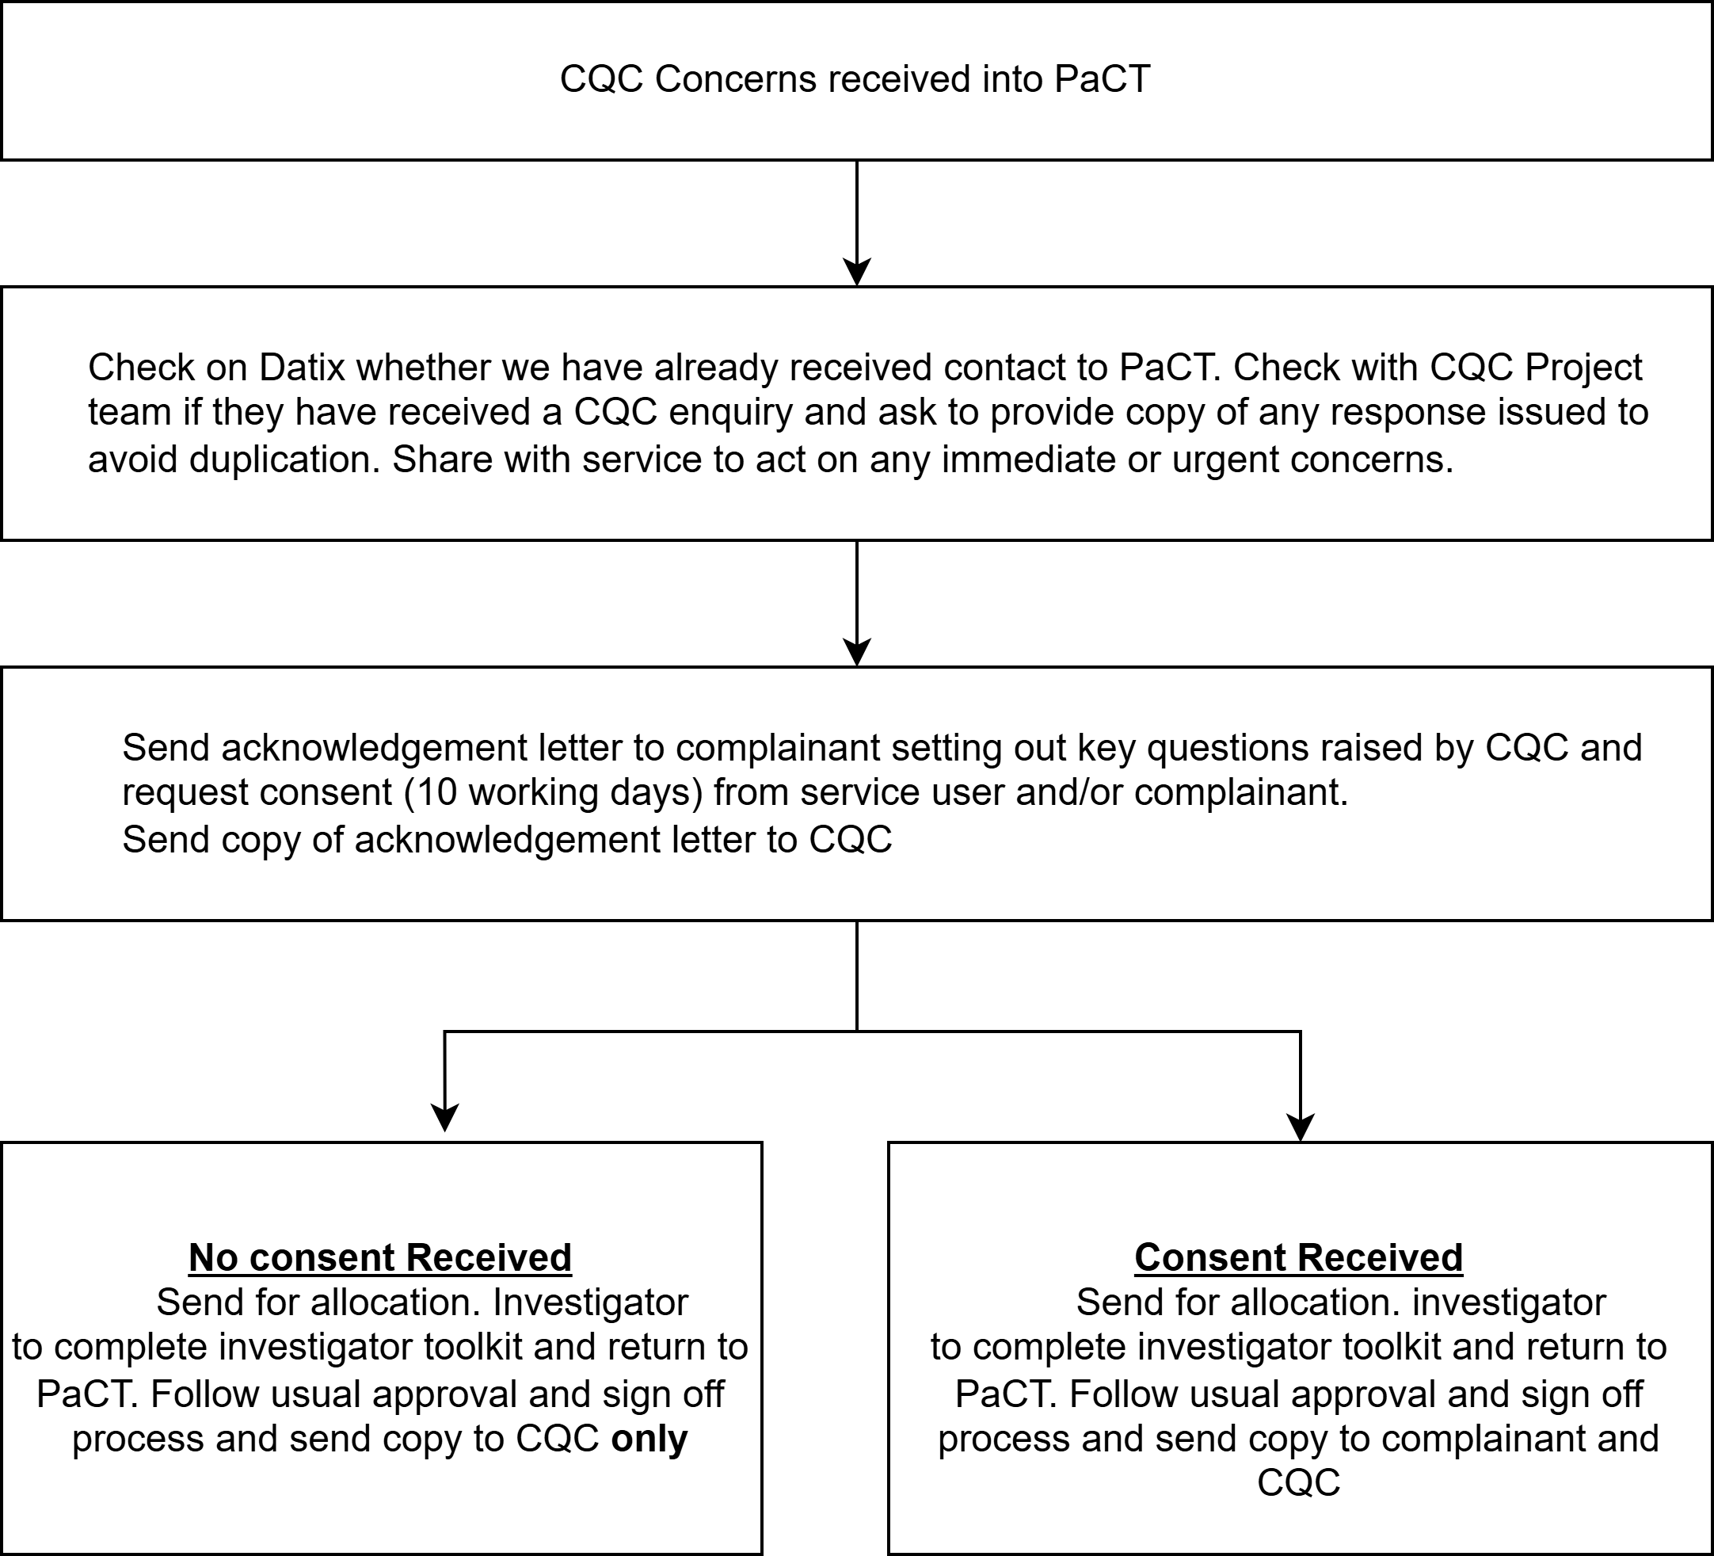

Appendix J - Common Principles for a Child Friendly Complaints Process

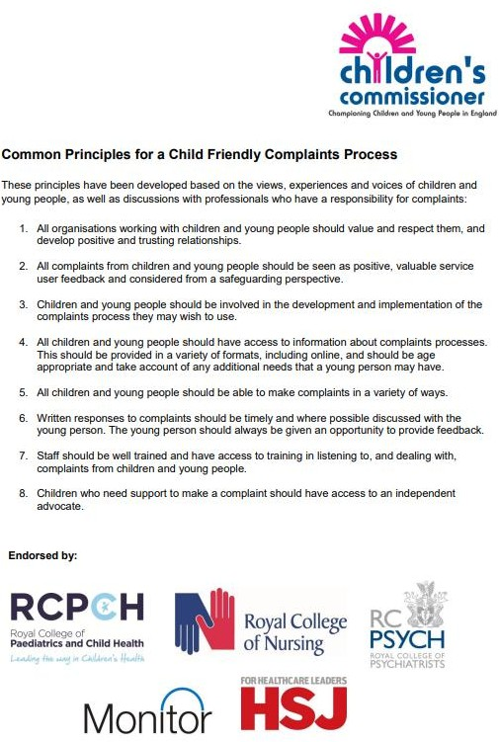

Appendix K
Monitoring Form
Date:
Person raising the concern: Click or tap here to enter text. Contact details:Click or tap here to enter text.
Person dealing with the concern: Click or tap here to enter text. Contact details: Click or tap here to enter text.

Concern and action requested | How resolved | Improving services
Set out the main issues, how they have affected the person and what the person is looking for as a good outcome or resolution. | Set out what you have done to look into the matter, what you found and what action you took to resolve the concern. | Set out any learning you have identified and how you have shared it with colleagues, other teams, the PALS & Complaints team and others..

I have shared (or offered to share) this form with [name of the person raising the complaint]. They have confirmed that they are happy with [insert details of how matter has been resolved (explanation, apology, action etc)].
I confirm that I have passed this form to the PALS & Complaints Team to enter on DATIX.

Date | Click or tap to enter a date.
Signature | Click or tap here to enter text.

SECTION 3 IDENTIFICATION OF STAKEHOLDERS
Key Individuals / groups consulted in development of the document:

Stakeholder  (job title or group name) | Date Sent | Date  Response Received | Modification suggested?  Y/N | Modification made?  Y/N
Director of Nursing and Professions | 04/02/2026 | 13/02/2026 | Y | Y
Deputy Director of Nursing and Professions | 04/02/2026 | 13/02/2026 | Y | Y
Head of Clinical Governance | Check with Sam | 04/02/2026 | Y | Y
Medical Director | 19/02/2026 | 20/03/2026 | N | N
Chief Operating Officer | 19/02/2026 | 20/03/2026 | N | N
Clinical Directors | 19/02/2026 | 20/03/2026 | N | N
Staff-side | 19/02/2026 | 20/03/2026 | N | N
Nursing & Professions Council | 19/02/2026 | 20/03/2026 | Y | Y
Unified Clinical Governance | 19/02/2026 | 20/03/2026 | Y | Y
Trustwide Clinical Governance | 19/02/2026 | 20/03/2026 | Y | Y
Head of Mental Health Legislation | 19/02/2026 | 20/03/2026 | N | N
Health and Safety Committee | 19/02/2026 | 20/03/2026 | N | N
Head of Human Resources | 19/02/2026 | 20/03/2026 | N | N
Head of Information Governance | 19/02/2026 | 20/02/2026 | Y | Y
Head of Operational Governance | 19/02/2026 | 20/03/2026 | N | N
Director, Visible (Trauma Informed expert) | 19/02/2026 | 20/03/2026 | Y | Y
Heads of Operations via Operational Briefing Group | 19/02/2026 | 20/03/2026 | Y | Y

SECTION 4 REFERENCES, EVIDENCE BASE

- NHS Complaint Standards and Model Complaint Handling Procedure – Parliamentary and Health Service Ombudsman (PHSO)
- Local Authority Social Services and NHS Complaints (England) Regulations 2009
- NHS England Complaints Policy (updated 18 September 2024)

SECTION 5 ASSOCIATED DOCUMENTATION (if relevant)
Patient Safety Incident Response Framework (PSIRF) Safeguarding
Data Protection Information Governance Duty of Candour Incident Management

SECTION 6. EQUALITY IMPACT
The Trust has a duty under the Equality Act 2010 to have due regard to the need to eliminate unlawful discrimination, advance equality of opportunity and foster good relations between people from different groups. Consideration must be given to any potential impacts that the application of this policy/procedure might have on these requirements and on the nine protected groups identified by the Act (age, disability, gender reassignment, marriage and civil partnership, pregnancy and maternity, race, religion and belief, gender and sexual orientation).
Declaration: The potential impacts on the application of this policy/procedure have been fully considered for all nine protected groups. Through this process I have/have not* identified any potential negative impacts for any of the nine protected groups.
Print name: Samantha Marshall

Job title: Head of Patient Experience, Complaints & Legal Services Date: 25/03/2026
If any potential negative impacts are identified the Diversity Team must be contacted for advice and guidance: email; diversity.lypft@nhs.net.



CHECKLIST
To be completed and attached to any draft version of a procedural document when submitted to the appropriate group/committee to support its consideration and approval/ratification of the procedural document.
This checklist is part of the working papers.

 | Title of document being newly created / reviewed: | Yes / No/
1. | Title
 | Is the title clear and unambiguous? | Y
 | Is the procedural document in the correct format and style? | Y
2. | Development Process
 | Is there evidence of reasonable attempts to ensure relevant expertise has been used? | Y
3. | Content
 | Is the Purpose of the document clear? | Y
5. | Approval
 | Does the document identify which committee/group will approve it? | Y
6. | Equality Impact Assessment
 | Has the declaration been completed? | Y
7. | Review Date
 | Is the review date identified? | Y
 | Is the frequency of review identified and acceptable? | Y
8. | Overall Responsibility for the Document
 | Is it clear who will be responsible for co-ordinating the dissemination, implementation and review of the document? | Y

Name of the Chair of the Committee / Group approving
If you are assured this document meets requirements and that it will provide an essential element in ensuring a safe and effective workforce, please sign and date below and forward to the chair of the committee/group where it will be ratified.
Name | Nichola Sanderson | Date | 2 April 2026
Name of the chair of the Group/Committee ratifying
If you are assured that the group or committee approving this procedural document have fulfilled its obligation, please sign and date it and return to the procedural document author who will ensure the document is disseminated and uploaded onto Staffnet.
Name | Clare Edwards | Date | 28 April 2026

