It’s your information, but it’s our responsibility

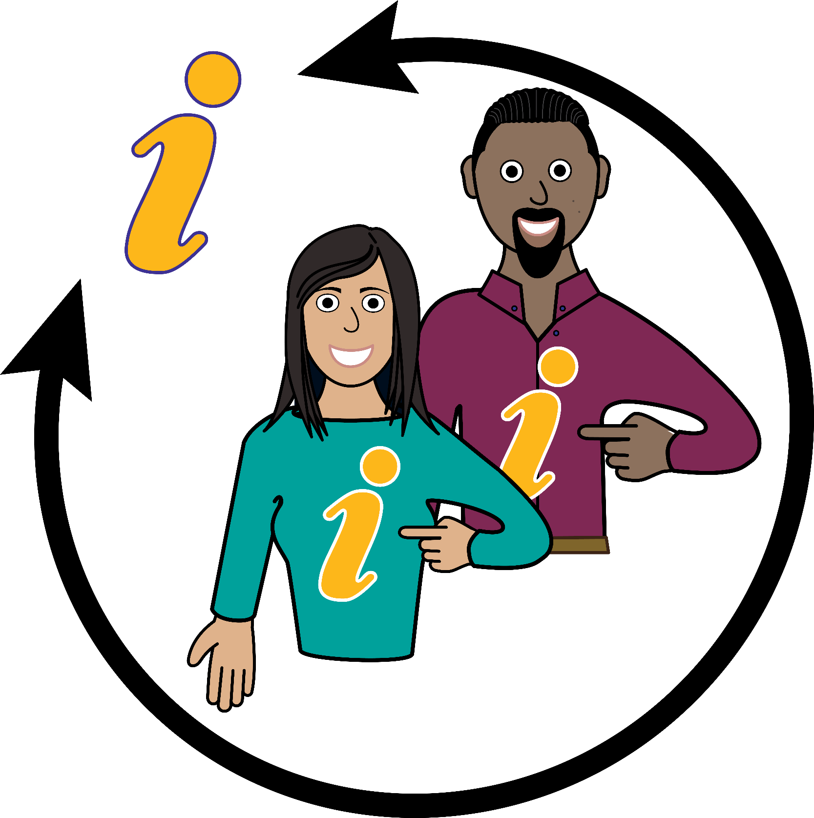

Why we keep information about you

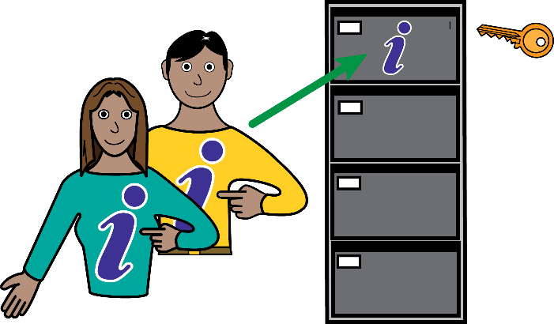 | - Care professionals keep records about your health and the treatment you get. This helps us to give you the best care.  - These records are private and only used for your care, unless the law says that we must tell others.

Information we keep about you

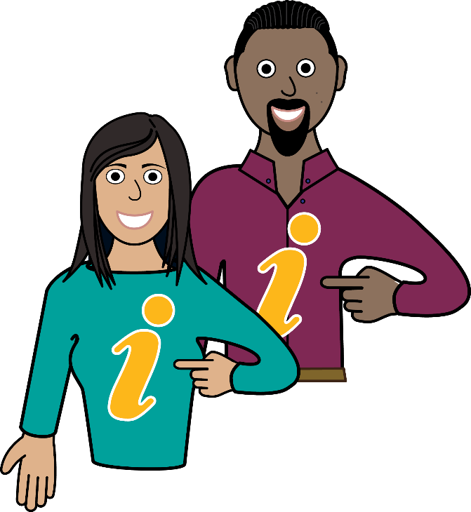 | - Information we keep about you includes:  - Things like your name, address, date of birth and NHS number  - The times we have been in touch with you  - Notes and reports about your health and the care you need  - Details and records about the treatment and care you receive.

How does this help you

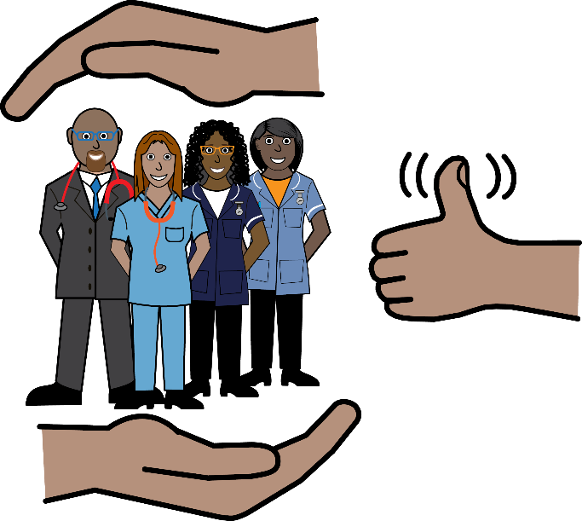 | - Care workers will have information to help see what care you need now and in the future  - Information is already there if you need to see someone new  - So we can check the care that you get

How your records are used to help the NHS

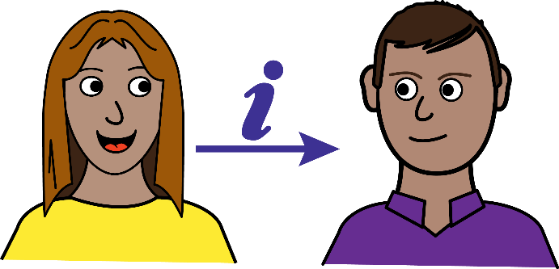  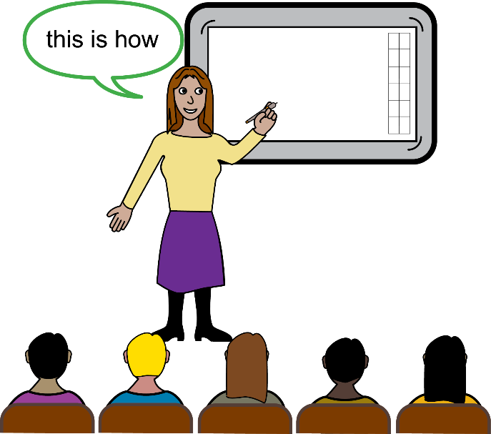 | - Your information can help us:  - Look after the health of everybody  - Check that the care we give is good  - Make sure our services do what people need  - Help us train our staff  - Help us find out what keeps people well  - Check problems and complaints  - See how well the NHS is doing  - Usually your information will only be seen by people giving your care.  - If your information is used to help the NHS, we will make sure that no one can tell it is about you.  - We will ask before doing any research.

Sharing your information

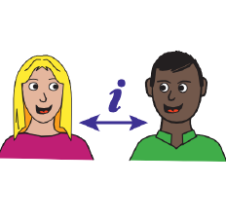 | - Your information will be used by our care teams to help you.  - Sometimes we may need to share your information with other people caring for you.  - If we have to share your information it will always be done confidentially and safely.

The people we work with are

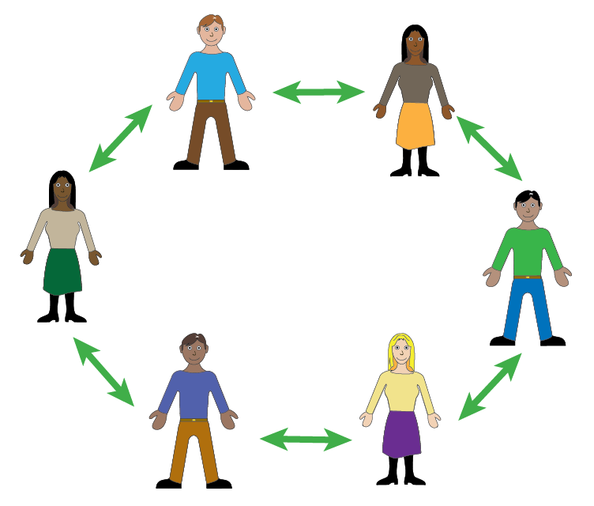 | - We work with:  - Hospitals  - Your doctor  - Social services and the council  - Voluntary organisations  - NHS Commissioning organisations. These are the people who choose which NHS services we should provide

Your information, your rights and the law

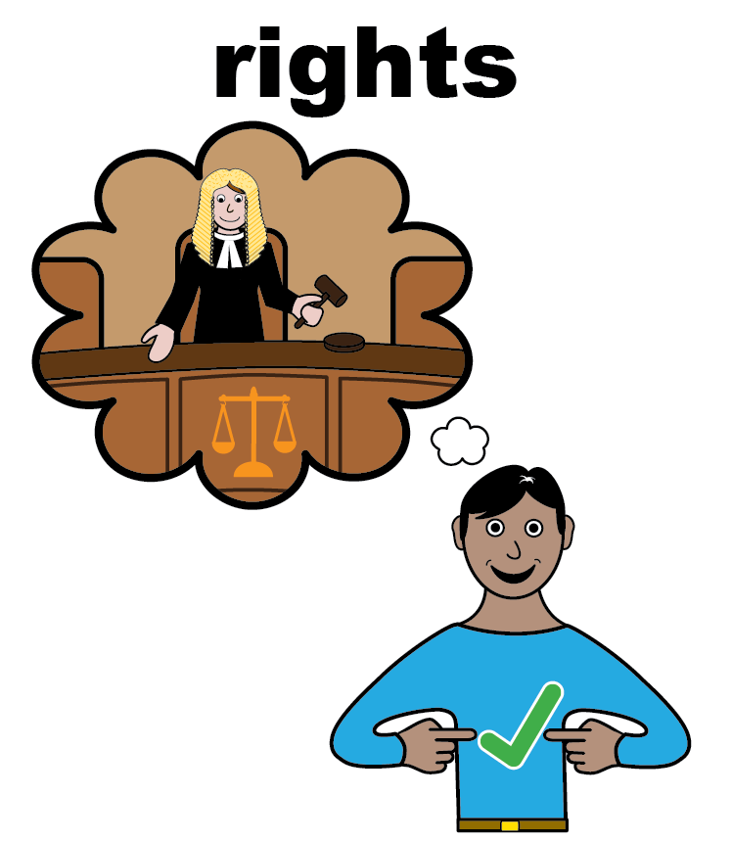 | - The laws says how we must protect and use your information. It also give you rights. You can:  - ask for a copy of your information  - have mistakes corrected  - find out what we do with your information.  - You can find more about this on our website, or by contacting our Data Protection Officer.

How do we ensure your information is accurate?

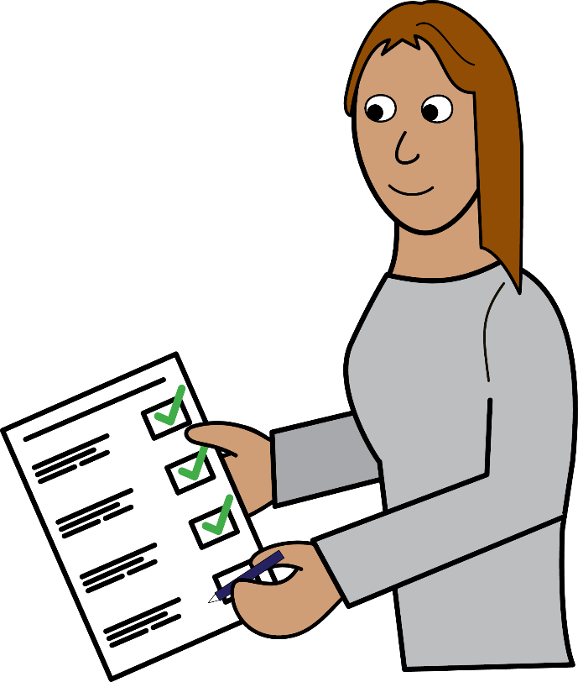 | - We check your information is right.  - Our staff will sometimes ask you things we already know or you have told us before as part of that checking.  - We also check this with other information that is about you.  - You can help us by telling us if you think any information about you is wrong. Let us and your doctor know if things change. This might be moving house, changing your name or your phone number.

Keeping it confidential

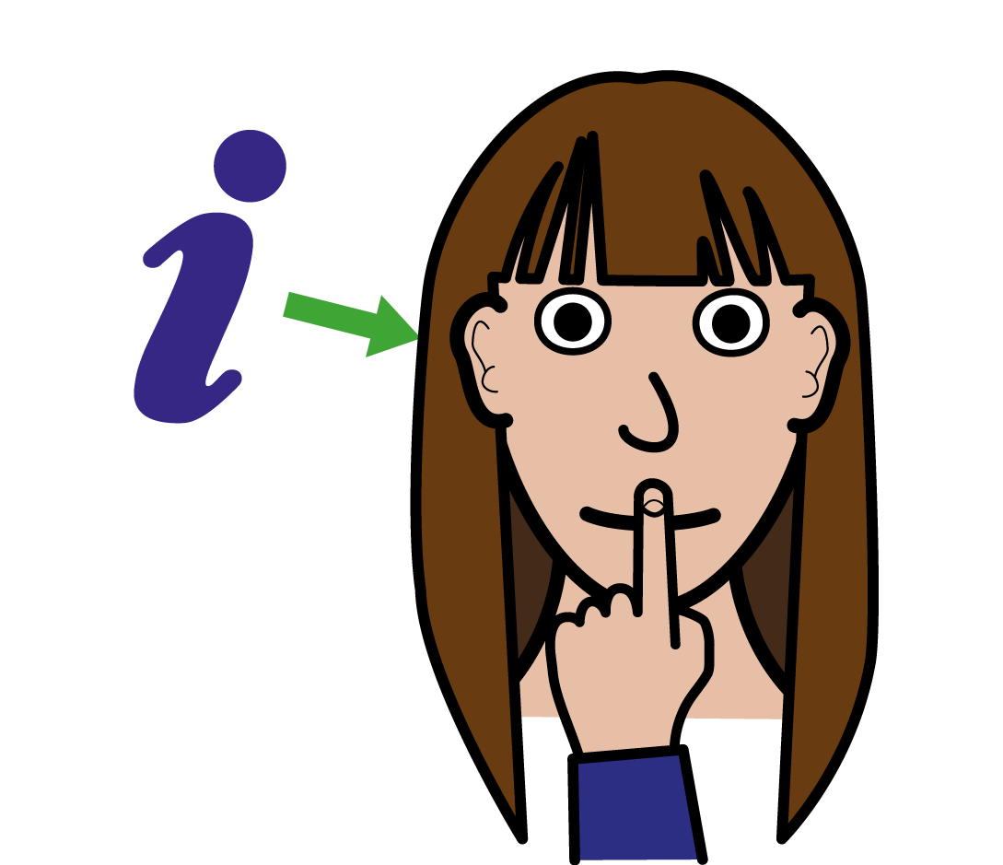 | - All our staff have to keep information about you confidential and safe.  - Every year our staff take courses to help them do this. It is one of the rules of their job and part of the way they must behave to do their job.

Consent

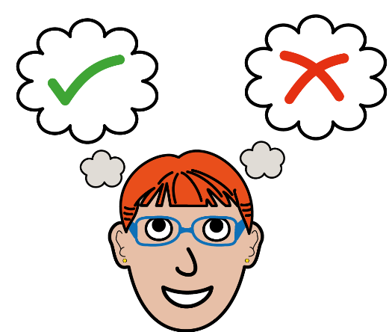 | - If we want to use your information for anything else we will ask you first.  - We will only ever pass on your information without you saying it is ok if:  - it is an emergency  - it is in the public interest  - you are a danger to yourself or other  - if required by the law

Want to know more
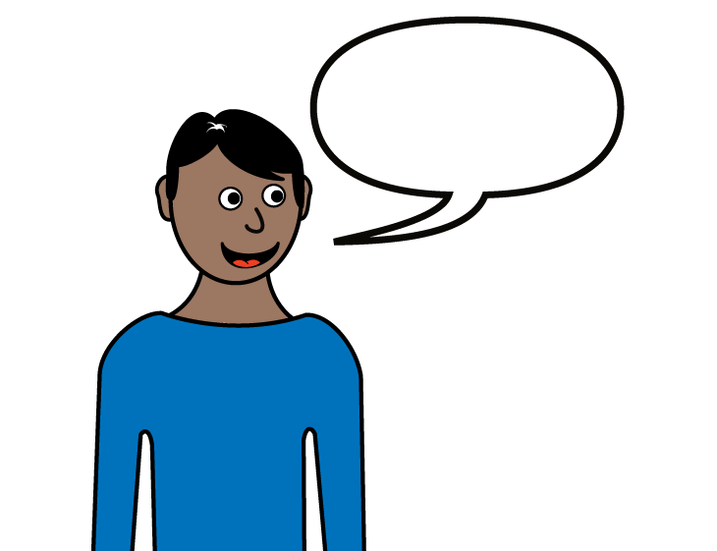 | - If you would like to know more please speak to our staff who are concerned with your care.
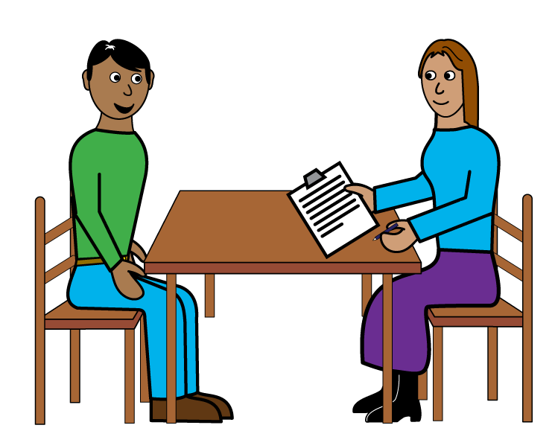 | - Patient Advice and Liaison Service (PALS)  - Telephone: 0800 0525 790  - Email PALS (pals.lypft@nhs.net)  - PALS website
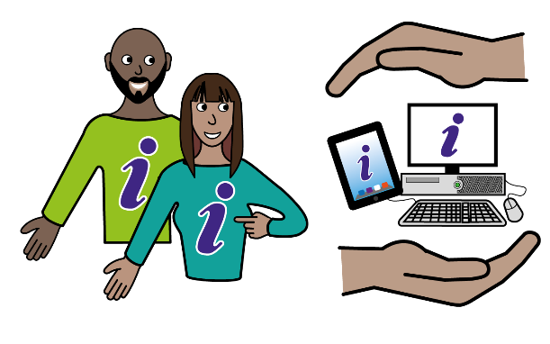 | - Data Protection Officer  - Email Information Governance (informationgovernance.lypft@nhs.net)  - If you would like to speak to our Data Protection Officer, please arrange this via our PALS team.

