The Accessible Information Standard poster

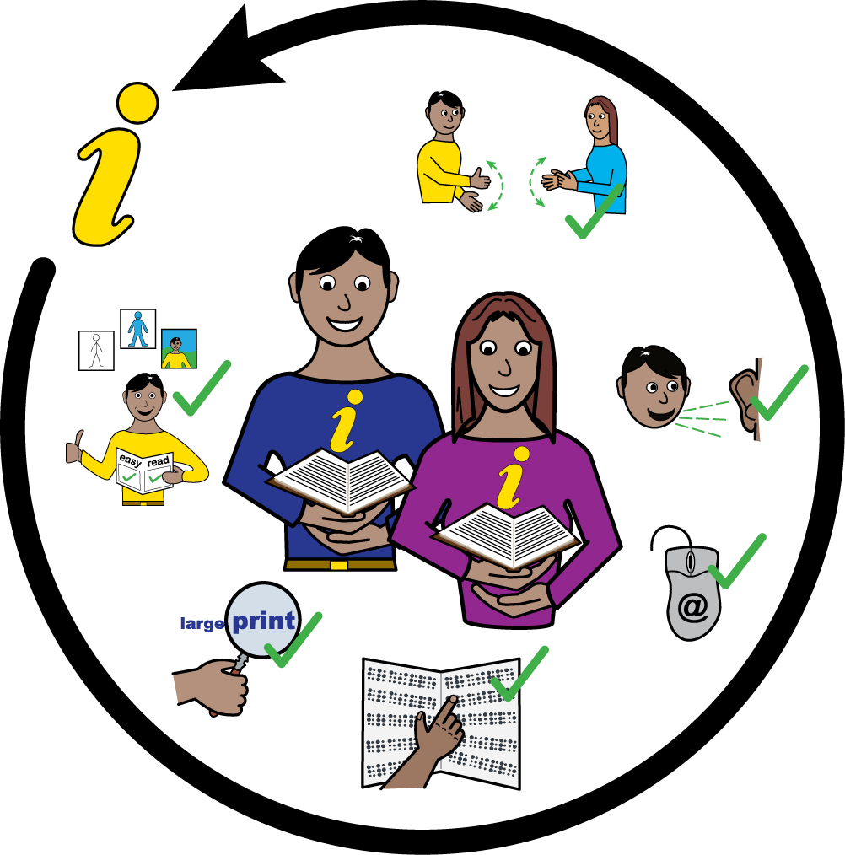

The Accessible Information Standard
The Accessible Information Standard is a law to make sure that people who have a disability, impairment or sensory loss are given information they can easily read or understand.

The Accessible Information Standard tells NHS and adult social care organisations they must make sure people get information in different formats such as:

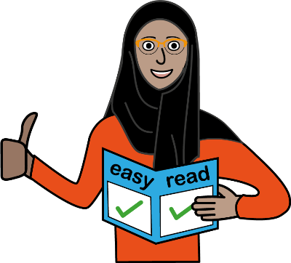 | - Easy read
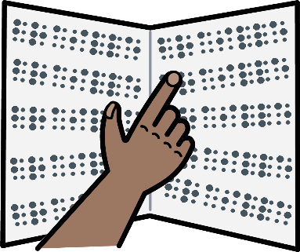 | - Braille
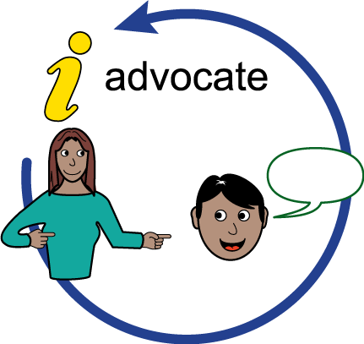 | - Advocate
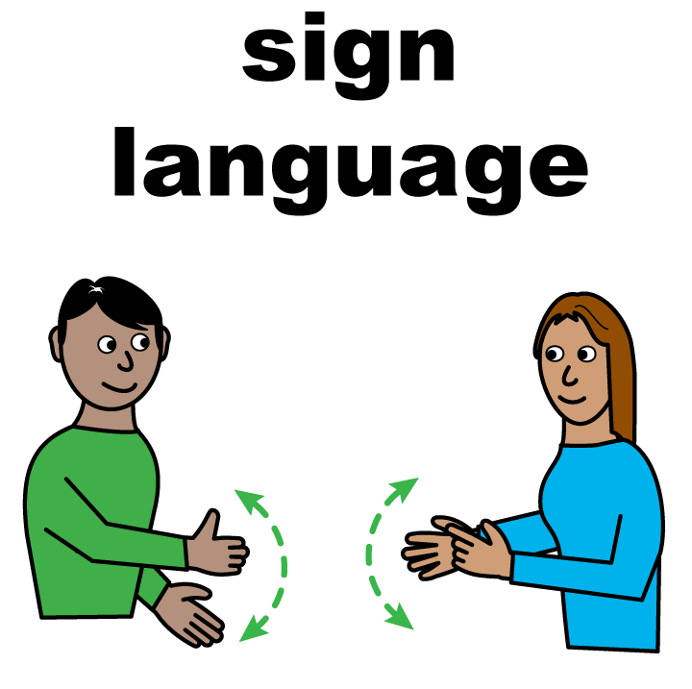 | - British Sign Language (BSL)
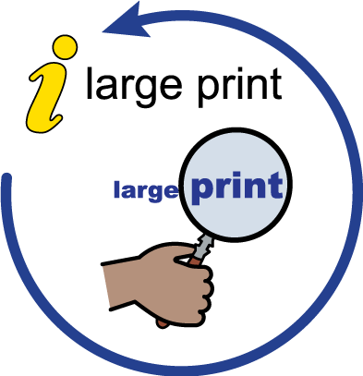 | - Large print
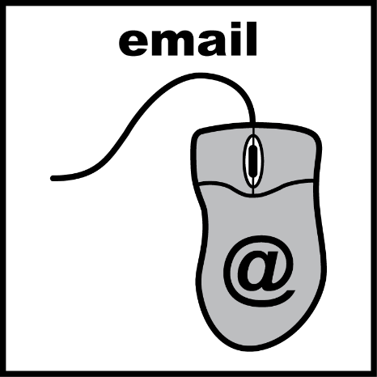 | - Email

The standard required our Trust to do five things:
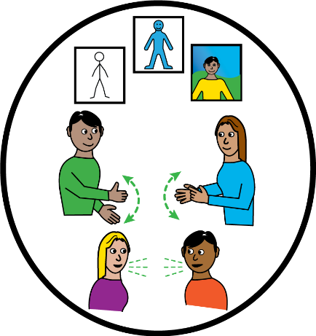 | - Ask people if they have any information  - or communication needs and how we can meet these.
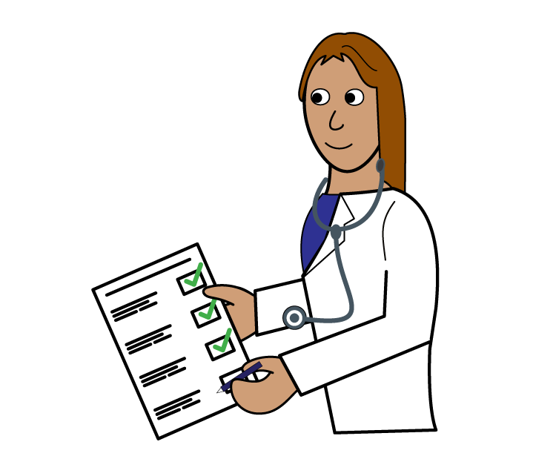 | - Record those needs clearly and in a set way.
 | - Highlight or flag the person’s file or notes so it is clear they have communication needs and how to meet these needs.
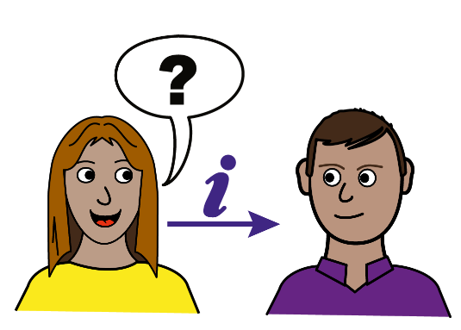 | - Share our knowledge of a person’s information or  - communication needs with other providers of NHS and adult social care services when we have  - consent or permission to do so.
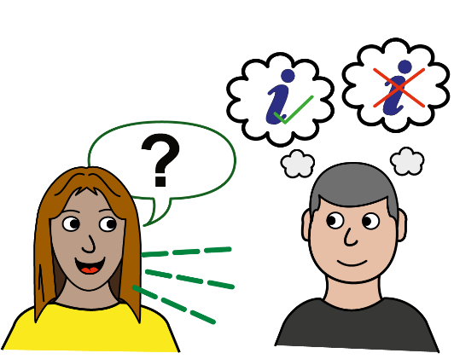 | - Take steps to make sure people receive information that they can access and understand and that they are given communication  - support if they need it.

Further information

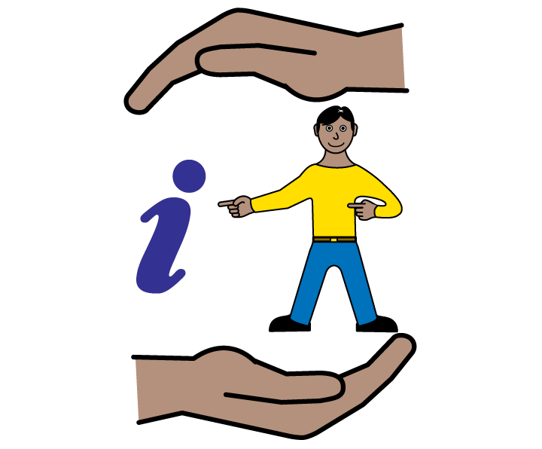 | - Please tell a member of staff if you have any communication support needs. You can help us make sure we get things right for you
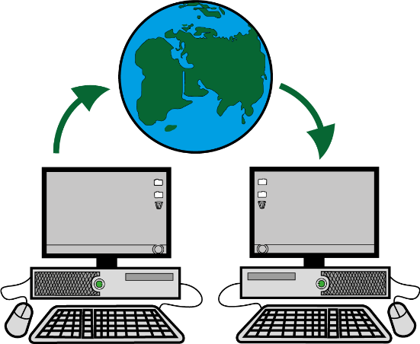 | - You can find more information about the Accessible Information Standard on the NHS England website.

