How we look after your information

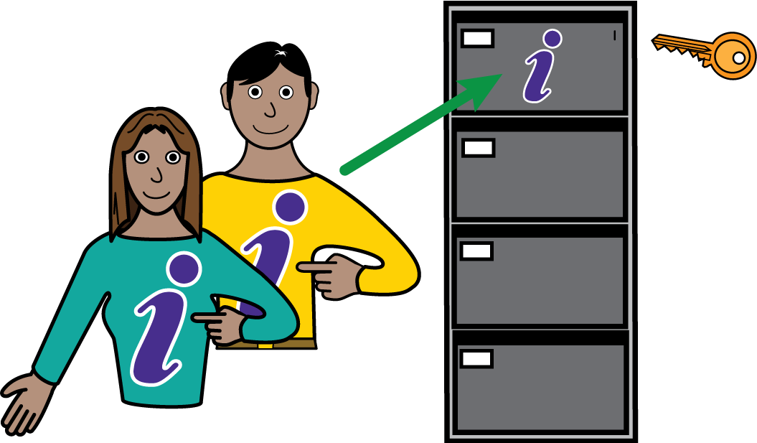

How we look after your information

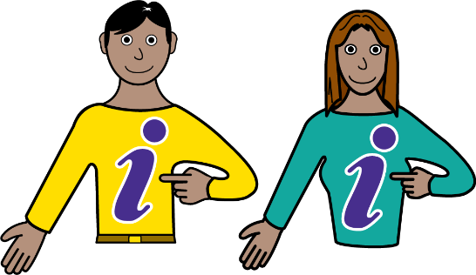 | - So that we can give you good care we need to know about your health and needs.  - We also have to follow the rules of the law about how we look after that information and keep it safe.  - We will keep your information while we are looking after you, and for a time after you leave our care, according to NHS rules.  - We may share information about you with other people who help us look after you.  - The law also makes it clear that you have rights. These rights are:-
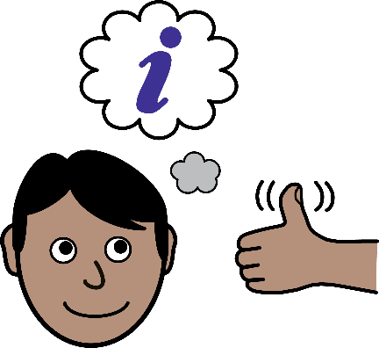 | - The right to be informed  - You have a right to know how your information is looked after and used by us.
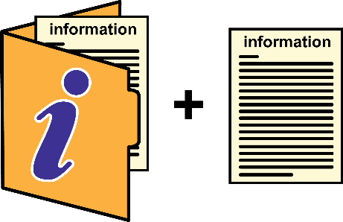 | - The right of access  - You have a right to ask and get a copy of your information.  - However we have to check the information before, to make sure that information likely to cause harm or upset to you or anyone else is removed.
 | - The right to rectification  - If mistakes are found and agreed, these will be put right.
 | - The right to erasure  - You can ask for your information to be erased. However this does not apply to records about your health.
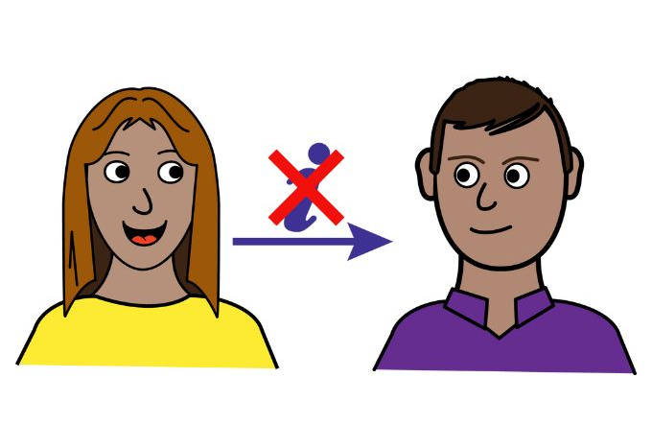 | - The right to restrict processing  - The Trust will not share your information with people you don’t want us to, for example family members. However we will share important information with other health and social care workers involved in your care, or when the law tells us we must.
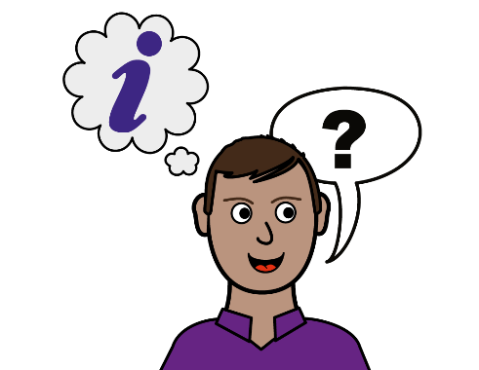 | - The right to data portability  - We will provide any information you ask for in the way you choose when it is reasonable for us to do so.
 | - The right to object  - We will not use information about you for planning and research if you ask us not to.
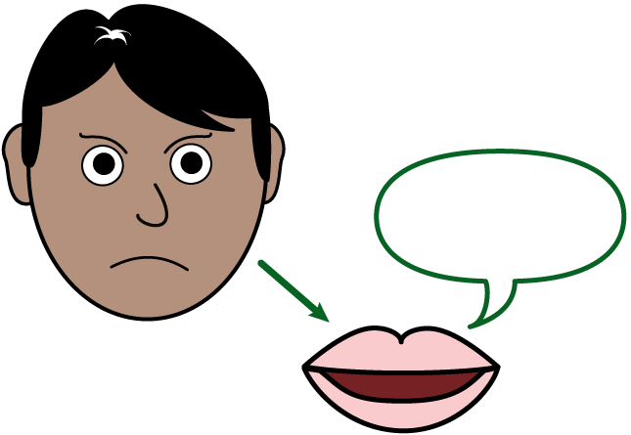 | - The right to complain  - If you think we have not looked after your information properly you can complain to the Information Commissioner’s Office.

Contacting the Information Commissioner’s Office

 | - They can be contacted at:  Information Commissioner’s Office  Wycliffe House  Water Lane  Wilmslow  Cheshire SK9 5AF  Telephone: 0303 123 1113  Website: Information Commissioner’s Officer – handling concerns.

Contacting Leeds and York Partnership NHS Foundation Trust

 | - You do not have to tell us your information, but we do need your information so that we can give you good care.  - Leeds and York Partnership NHS Foundation Trust must look after the information we hold.
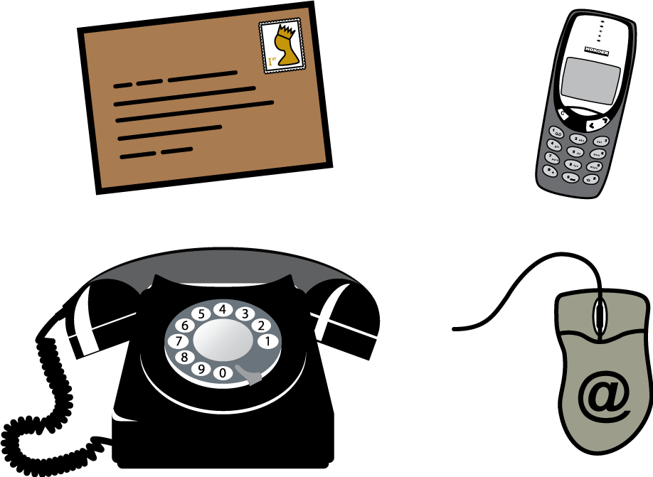 | - Contact us:  - Email Information Governance.  - If you would like to speak to our Data Protection Officer, please arrange this via our Patient Advice and Liaison Service (PALS).

