How we look after your information when you use Patient Hub

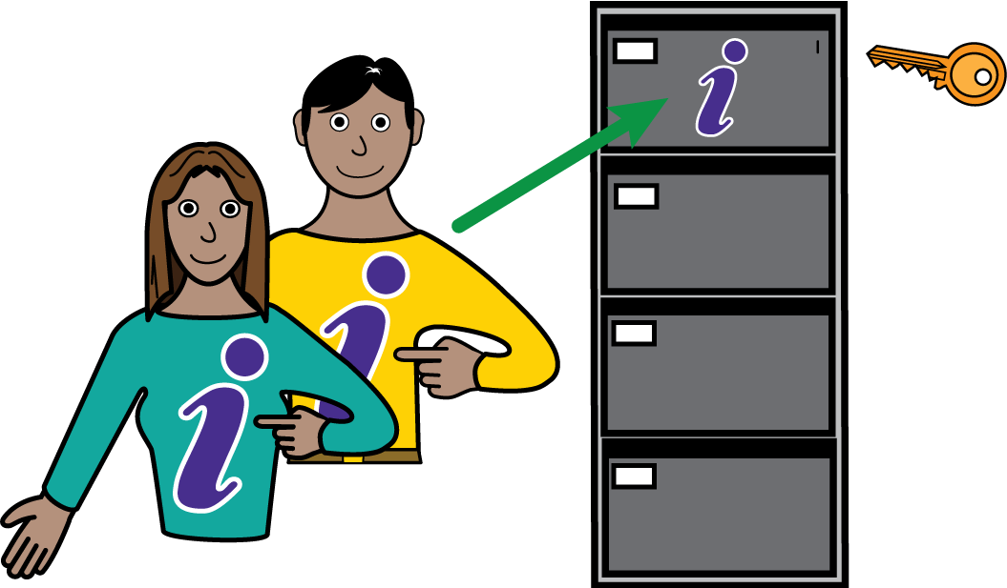

Why we need your information

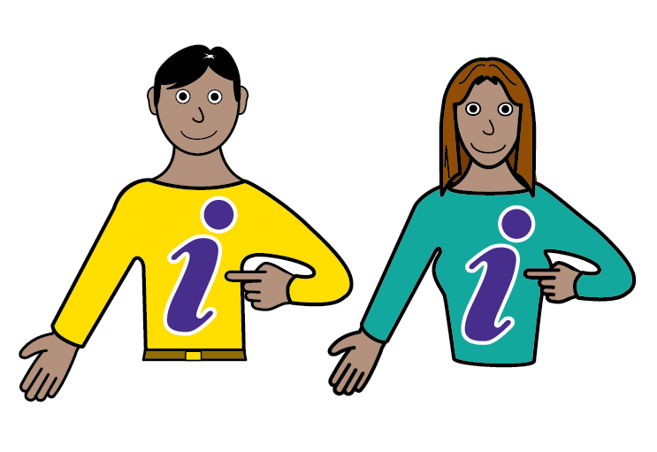 | - We need some information about you so we can give you good care and let you use Patient Hub.  - Patient Hub is a secure online tool that helps you:  - See your appointment details  - Get messages and reminders  - Fill in forms and health questionnaires  - Read helpful health information

Who looks after your information

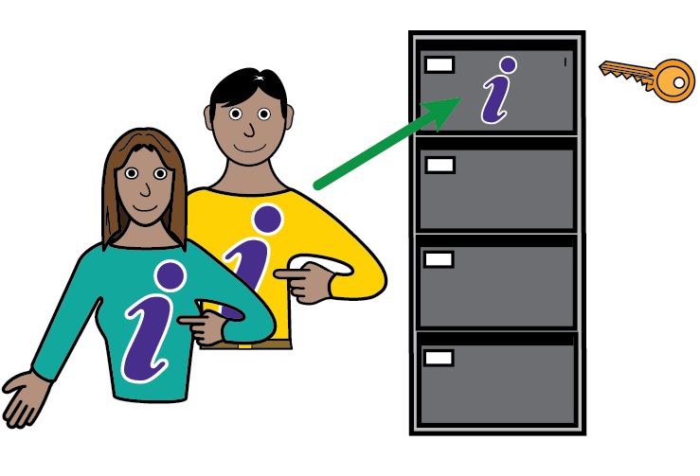 | - Leeds and York Partnership NHS Foundation Trust looks after your information.  - We follow the law called UK GDPR and the Data Protection Act 2018.  - Netcall helps us run Patient Hub. They only use your information for this purpose.

What information we collect

 | - We collect your personal details:  - your name,  - date of birth,  - NHS number,  - address,  - phone number,  - email,  - next of kin
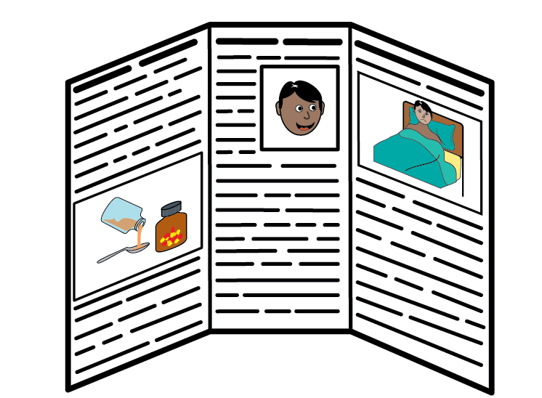 | - We collect your health details:  - your medical history,  - treatment, medicines,  - allergies,  - test results,  - appointment letters
 | - We collect information about your device:  - the type of phone or computer you use,  - browser type,  - how you use Patient Hub

How we use your information
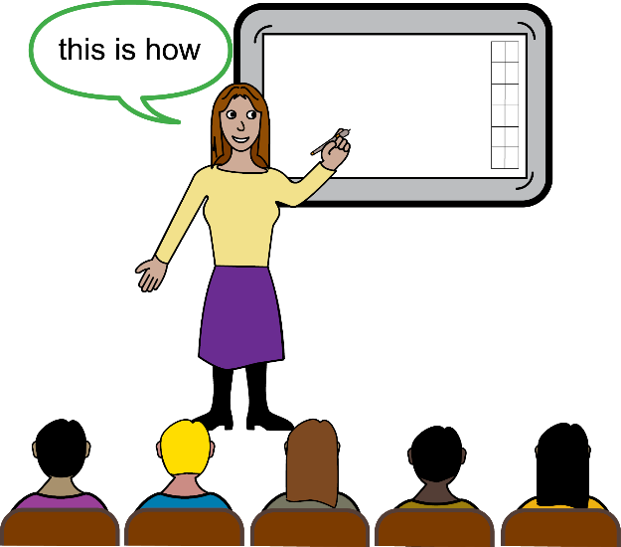 | - We use your information:  - to give you secure access to your health records  - to show your appointment details  - to send you messages and reminders

How we keep your information safe

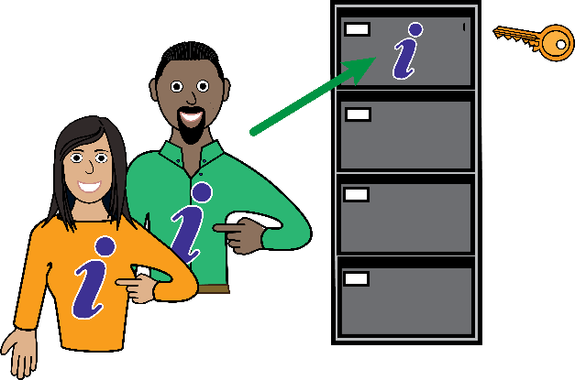 | - Your information is kept safe using encryption and strict security rules.  - Only staff involved in your care can see your records.  - Your information is stored in the UK following NHS security standards.

How long we keep your information

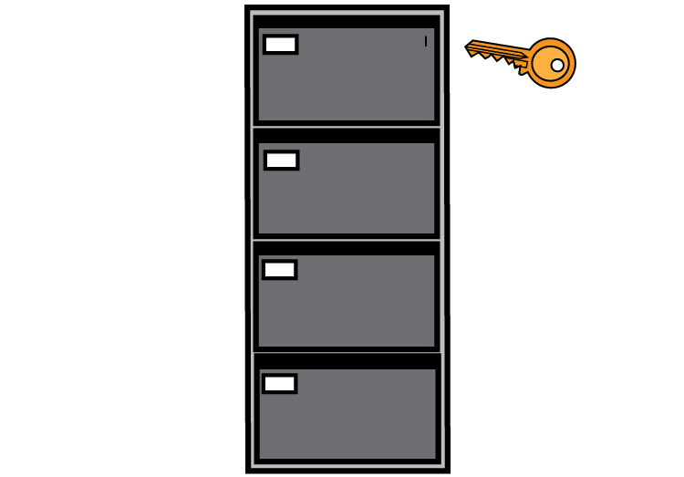 | - We keep your records as the NHS rules say:  - Usually for 20 years after you leave our care  - Or 10 years after death  - Sometimes longer if there is an official inquiry.

Your rights

 | - You have rights about your information. You can also opt out of research and planning by using the National Data Opt-Out.
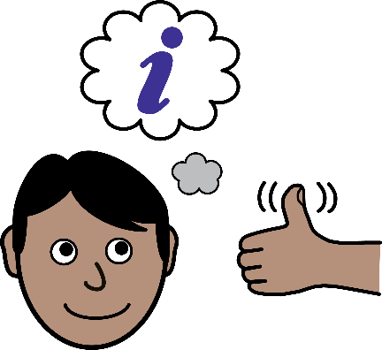 | - The right to be informed  - You have a right to know how your information is looked after and used by us.
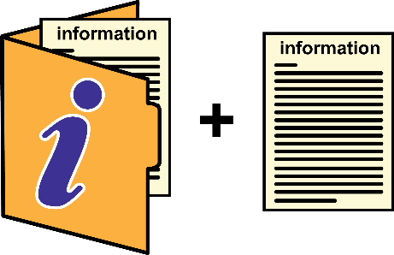 | - The right of access  - You have a right to ask and get a copy of your information.  - However, we have to check the information before, to make sure that information likely to cause harm or upset to you or anyone else is removed.
 | - The right to rectification  - If mistakes are found and agreed, these will be put right.
 | - The right to erasure  - You can ask for your information to be erased. However this does not apply to records about your health.
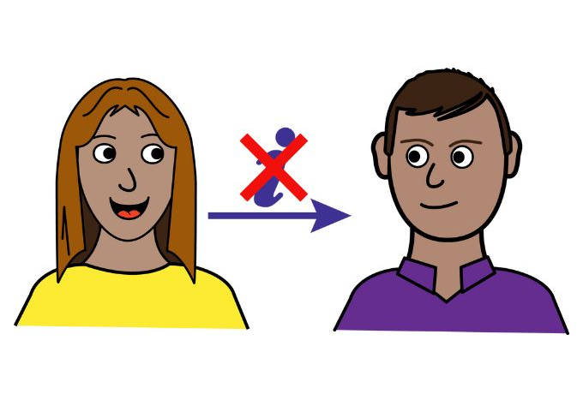 | - The right to restrict processing  - The Trust will not share your information with people you don’t want us to, for example family members. However, we will share important information with other health and social care workers involved in your care, or when the law tells us we must.
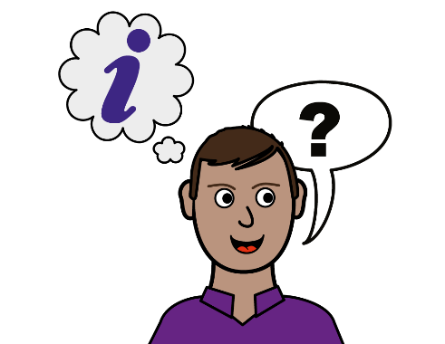 | - The right to data portability  - We will provide any information you ask for in the way you choose when it is reasonable for us to do so.
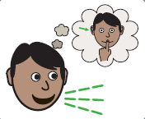 | - The right to object  - We will not use information about you for planning and research if you ask us not to.
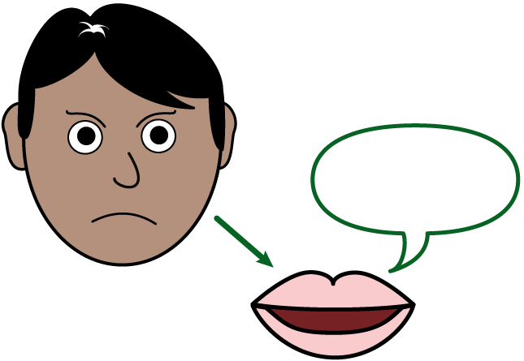 | - The right to complain  - If you think we have not looked after your information properly you can complain to the Information Commissioner’s Office.

Sharing your information

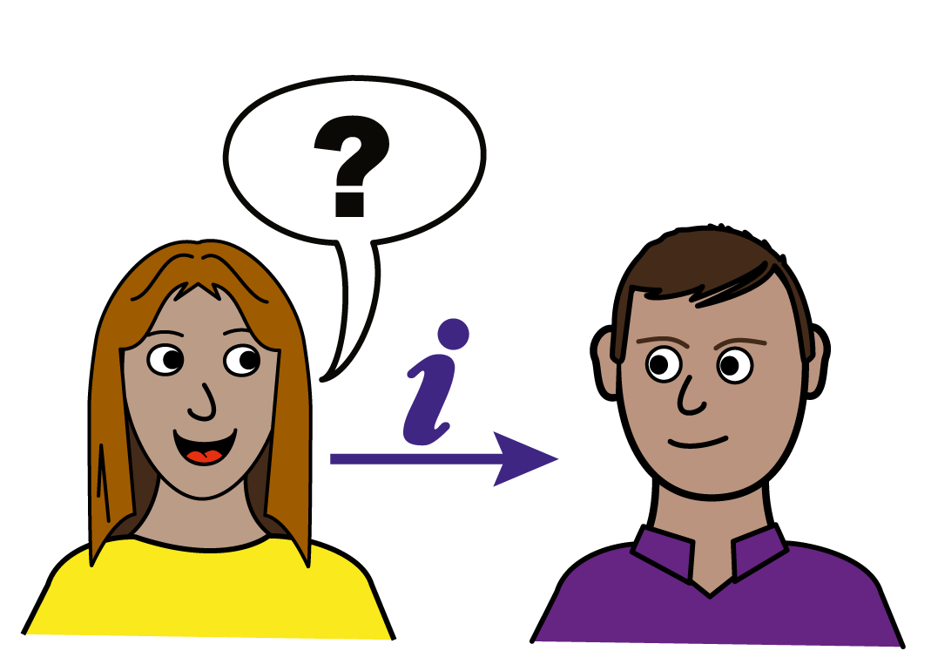 | - We only share your information with:  - Other NHS services involved in your care  - Legal authorities if the law says we must

Do you have to use Patient Hub?

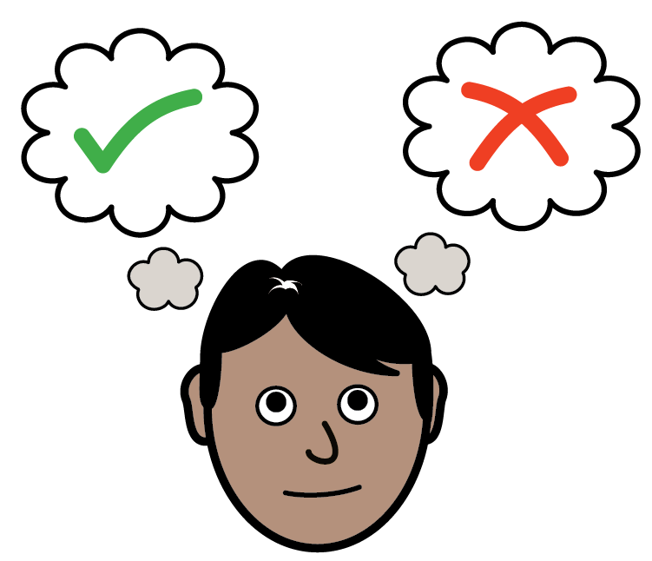 | - No. Using Patient Hub is your choice.  - If you do not want to use it, we will give you the same information in other ways.

If you have questions or want to complain

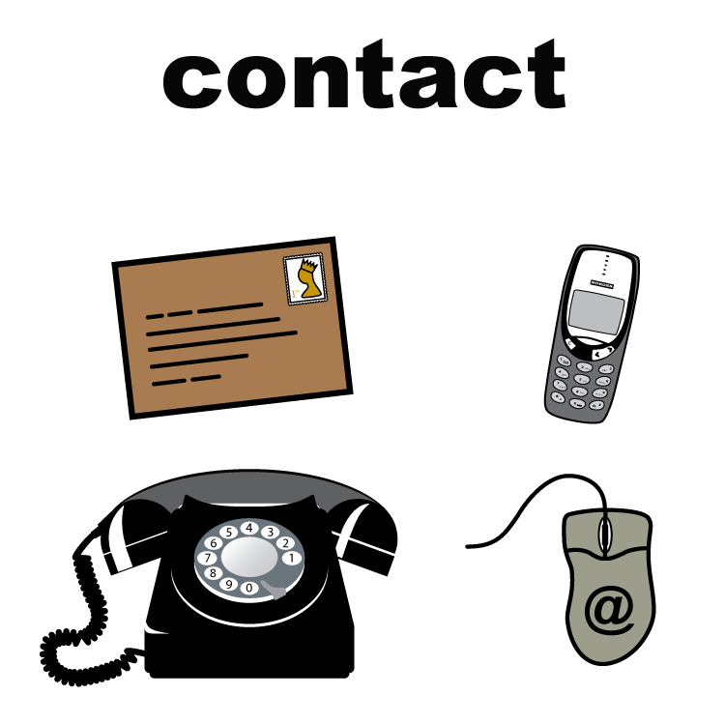 | - Contact our Data Protection Officer:  - Email Information Governance.  - If you would like to speak to our Data Protection Officer, please arrange this via our Patient Advice and Liaison Service (PALS).
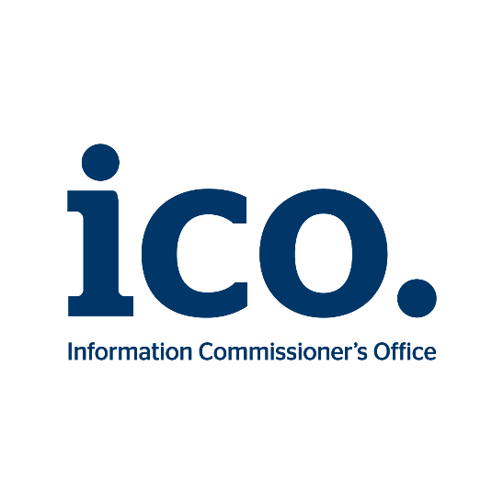 | - Or you can make a complaint to the Information Commissioner’s Office  - Address: Wycliffe House, Water Lane, Wilmslow, Cheshire, SK9 5AF  - Telephone: 0303 123 1113  - Website: Information Commissioner’s Officer – handling concerns.

