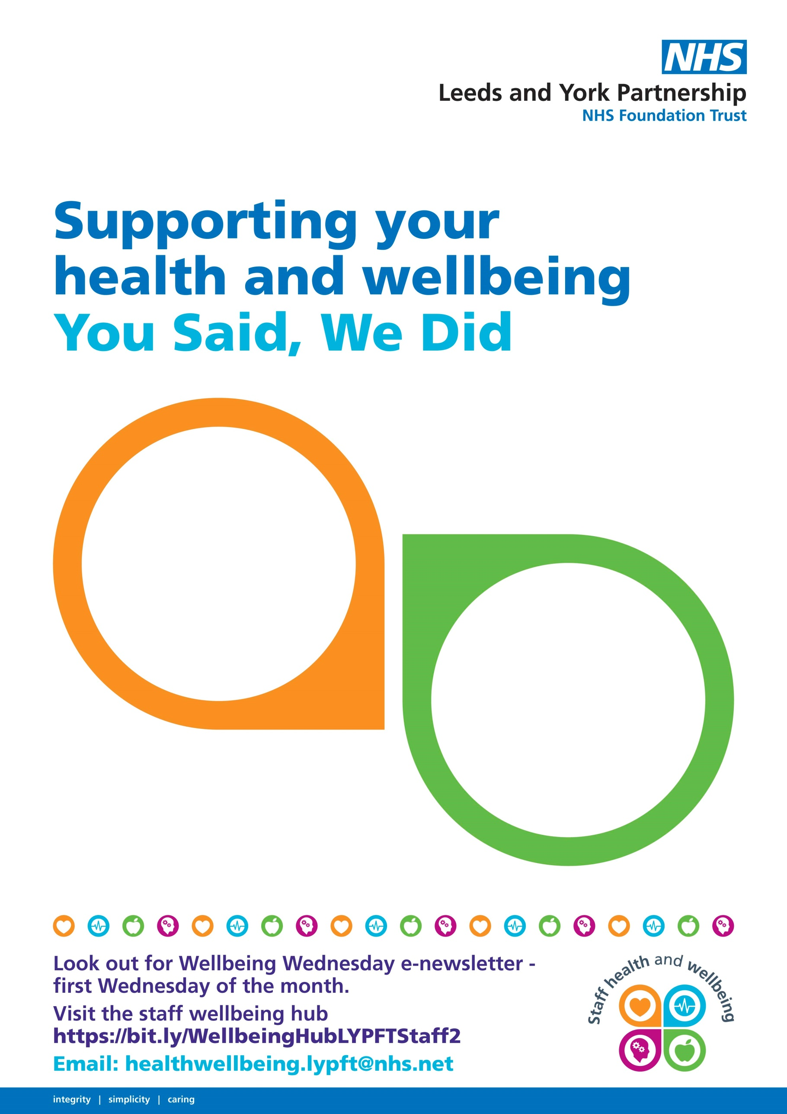

**July 2021**

**You Said**we need better staff facilities at our sites

**We Did**we are now visiting sites and scoping out upgrades to staff rooms and other wellbeing spaces

**You Said**we need an easier   
way of keeping up to date with the staff wellbeing offer

**We Did**new dedicated   
wellbeing newsletter