

Use of Eye Protection and FFP3 Masks

# Eye protection

In line with national guidance, eye protection is to be used during all patient contact. The eye protection supplied is reusable*, and is available in 2 different forms; glasses and face visors. Eyewear is worn on a sessional basis i.e. one item per shift.

1. **Glasses**

The eye protection supplied by the Trust has recently been updated to include anti-fog eyewear with the aim of improving vision and comfort.

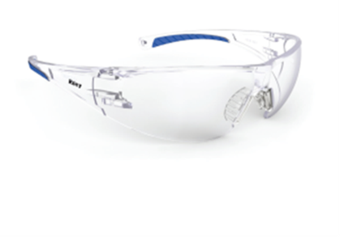

**Riley Kosma** will become our standard anti-fog eyewear and can be reused for an indefinite period*

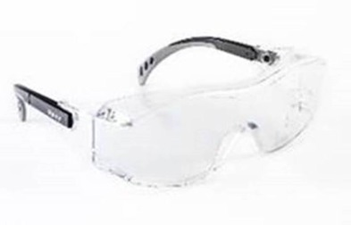

**Riley Tilla** (overglasses) anti-fog eye wear for use over the top of prescription glasses and can be reused for an indefinite period*

1. **Face visors**

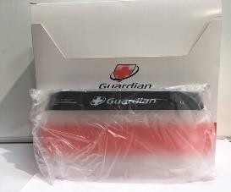Face visors continue to be available for staff preferring these to the eye wear above

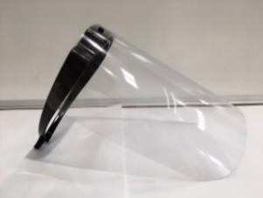

## *subject to suitable cleaning

## Reuse of equipment

This is currently recommended in the UK Infection Prevention and Control guidance, where the eye protection is not labelled as single use only and includes the eyewear pictured above.

## Cleaning of NON single use eyewear

1. Each staff member to be allocated their own glasses/visor – named with permanent marker and stored appropriately away from contamination when off duty (e.g. in locker after cleaning).
2. Hands must be cleaned and a new pair of gloves must be worn for cleaning activities
3. Clean using a Clinell Disposable Universal (Green) Wipe as directed below

**Glasses**

* Wipe all surfaces with disinfectant wipes – use enough wipes to wet each surface
* Place on a clean surface and allow to air dry

**Visor**

* Clean the headband first with one wipe; foam/elastic parts cannot be cleaned. If the foam or elastic band are visibly soiled the visor must be disposed of
* Using a second wipe clean the inside surface in an ‘S’ shaped motion from top to bottom - contact time is 60 seconds – air dry
* Using a third wipe, clean the outside surface in an ‘S’ shaped motion from top to bottom as above.

All eyewear must be disposed of if damage or deterioration is noticed.

# FFP3 Masks

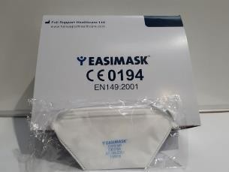FFP3 masks are required only for staff conducting aerosol generating procedures during direct patient care. This includes staff involved in responding to cardio-respiratory arrest in inpatient areas. The majority of staff in relevant roles have been FIT tested to the FFP3 DUCK BILL Mask, and this type FFP3 mask has been placed in the RESUS GRAB BAGS for use in the event of an emergency.

Staff who have been fitted to wear an alternative FFP3 mask have been issued their own supply of their specific masks.