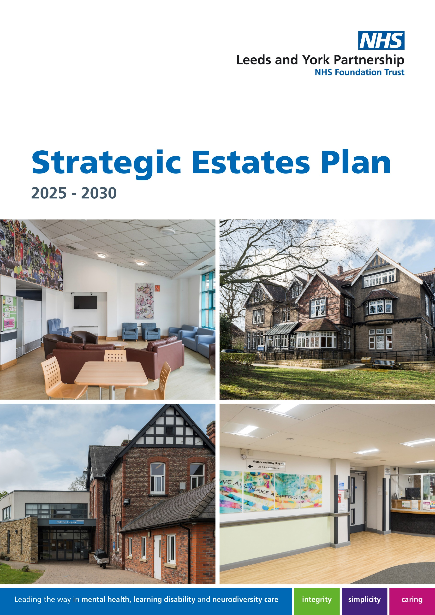

Contents

Foreword 3
Executive summary 4
Our vision 6
Case for Change 8
Where are we now: Estate Overview 9
How we are quality assuring and enabling a fit for purpose estate 12
Our progress since 2018 17
Where do we want to be: Our Estate Delivery Principles 19
Estate Delivery Principle 1: Consolidation and Rationalisation 19
Estate Delivery Principle 2: Optimise Partner Estate 20
Estate Delivery Principle 3: Optimise Technology 20
Estate Delivery Principle 4: Optimise Building Design and Layout 21
Estate Delivery Principle 5: Achieve carbon net zero 22
How we will measure our success 22
How will we get there: Our future aspirations for our estate 23
Our short-term plans 2025/26 – 2026/27 25
Our medium-term plans 2027/28 – 2028/29 25
Our long-term aspirational plans 2029/30 - beyond 26
Financial challenges we might face with the delivery of our aspirational plans 28
Conclusion 29
Appendix A: Clinical Service Portfolio 30
Appendix B: Estate Characteristics – Functionality, Space Utilisation and Condition 32

Foreword

Welcome to the Leeds and York Partnership Foundation Trust (LYPFT) Strategic Estates Plan (SEP), where our refreshed plan highlights the scale of our ongoing ambition to enhance our estate. Every year we provide services to over 811,000 people, with our estate making an enormous difference to the experience and quality of care for people who use our services, their families, carers and our workforce. Our Strategic Estate Objectives and Estate Delivery Principles set out how we will strive to achieve a modern, fit for purpose, sustainable/green and efficient estate, which is better utilised and significantly upgraded. It will support and enable modern digital infrastructure and flexible ways of working.

At LYPFT we provide specialist mental health, learning disability and neurodiversity services in Leeds, some specialist services across West Yorkshire, Humber and North Yorkshire and highly specialised services across the North of England. Our estate reach spans 24 primary sites and multiple other assets across the vast geography of our services and includes our inpatient buildings and locality-based community hubs.

In preparing this refreshed plan within the Trust we have received capital to further boost our Perinatal Services and our High Support Rehabilitation facilities which will be available for both the people of Leeds and across our region. The NHS landscape is ever changing, and it has never been more important to demonstrate that our ambitions/aspirations have a clear evidence-base. For the Trust to realise its ambitions we would require further investment to ensure our services users experience best in class in relation to the estate.

Our vision is: to optimally utilise only the highest quality, modern, fit for purpose estate whilst being aligned with the One Public Estate (OPE). Over the next five years, we will:

- Ensure our estate offers a therapeutic environment for our service users, is compliant with safety regulations, and is secure.
- Ensure our estate is efficient and effective for our workforce and supports modern flexible and agile working.
- Develop our estate to be digitally enabled.
- Work towards achieving our net zero targets across all categories and strive to become a Green Trust.
- Work closely with our partners to plan and deliver estate solutions across Leeds.
- Secure the future of our Private Finance Initiative (PFI) buildings by acquiring some of them, or potentially all of them, depending on clinical needs, to bring them into our ownership and direct control in 2028.


Dawn Hanwell
Chief Financial Officer and Deputy Chief Executive

Executive summary

Our Strategic Estates Plan is one of five strategic plans which underpin and support the delivery of our overall Trust strategy and vision: ‘to lead the way in mental health, learning disability and neurodiversity care so the communities we serve can live healthy and fulfilling lives, our people can achieve their personal and professional goals, and everyone can live their lives free from stigma and discrimination’. In addition, it aligns to our three core strategic objectives that will enable the Trust to deliver on its ambitions:

- We deliver great care that is high quality and improves lives
- We provide a rewarding and supportive place to work and train
- We deliver effective and sustainable services

We are the main provider of specialist mental health and learning disability services in Leeds. We also provide adult neurodiversity service in Leeds and specialist services across North Yorkshire, West Yorkshire and the Humber. In addition, we provide some highly specialised services across the North of England.

Our caring and respectful staff use their expertise to deliver a wide range of specialist and innovative services to all the communities we serve. From community support to crisis treatment, our care is people centred. This means we actively involve the person using our services so they are empowered to achieve their personal goals and can enjoy a fulfilling life.

The Trust has a duty to deliver high quality care whilst providing value for the taxpayer’s pound. We are allocated around £2.5m capital per year (exc. PFI estate) to ensure our estate is statutory compliant, remains economic, efficient and effective to run and provides the right environments where great care can be delivered. Our Strategic Estates Plan provides the principles for how our decisions on the future of our estate is shaped. Significant investment beyond our annual allocation requires us to bid nationally for funds. This requires a comprehensive business case for each investment scheme under consideration and is an essential precursor to the allocation of such capital.

Changes in the delivery of health services which are already known and those yet to be developed will impact on the estate. The range of services to be delivered across our estate will change significantly over the next 10 years as more services are delivered in primary care settings and others combine with neighbouring NHS healthcare providers or relocate to community healthcare hubs. Hospitals are likely to focus on delivering more complex activity which cannot be delivered in a community setting, caring for people detained under the Mental Health Act or where the level of activity and the degree of specialisation would result in those services being inappropriate to deliver in a primary care or community setting.

Our Strategic Estates Plan sets out our vision, values, strategic objectives, and priorities for the next five years. We have a good record of service improvement, however we know that things are becoming increasingly challenging. We also recognise that delivering our plan will require making tough decisions about our priorities and where we will be able to invest in the future. We know we cannot deliver our plans alone and it is dependent on partners to collaborate with us for the shared purpose of improving the health and lives of the communities we serve. We will continue to review our plan to ensure that it remains up to date in response to changes in the operating models, new policy directions, and local need.

Our refreshed plan is aligned with all our core organisational strategic plans (care services, people, digital and quality). We engaged with stakeholders to gain an understanding of service and estate needs and reaffirmed that our vision, objectives, and delivery principles are still the right direction of travel for our estate.

In developing our Strategic Estates Plan we have set out the aspirational schemes that should we have the valuable capital funding available, aspire to achieve. These aspirations are important factors in how we might deliver our care services in future, support strategic decision-making and alignment with our organisational goals.

Our vision

Our overarching vision for our estate is to optimally utilise only the highest quality, modern, fit for purpose estate whilst being aligned with the One Public Estate (OPE).

Our refreshed Strategic Estates Plan focuses on the period 2025 – 2030. The plan takes into account the local, regional and national direction of travel for estate across the NHS. Specifically, within West Yorkshire as a key partner we have been integral in the production of the 10-year West Yorkshire Infrastructure Plan which sets out the significant capital requirements for our Trust.

The overall estate, based on external benchmarks, performs within recommended parameters. However, new ways of working and changing care models all require a different, more flexible estate model. Whilst the target is to reduce the recurring revenue cost and risk, the primary objective is delivering an estate that is fit for purpose, focusing on service user and staff experience and supports the delivery of high-quality care.

By 2029 we will have concluded our PFI concession and the assets we require to deliver high quality care for our service users, their families and their carers will have been acquired by the Trust. We will continue to consolidate and rationalise our estate with a focus on ensuring space is appropriately optimised, safe, suitable, fully utilised, not under occupied or overprovided, and utilising our office hotelling data to monitor our performance. Our estate will support and enable digital technology integration and work towards achieving carbon net zero and making sustainability at the heart of all that we do.

Our strategic estate objectives are:

Figure 1. Estate strategic objectives

These six strategic objectives mean:

- Service Led: we will ensure that service requirements are the driver in all that we need to achieve and always put our service users at the centre of all that we do.
- Statutory Compliant: we will continue to achieve and deliver statutory compliance on our entire estate, ensuring our buildings are safe.
- Economic, Efficient, Effective: we will ensure that our estate is used efficiently, effectively and economically making sure that every pound we spend on our buildings is spent wisely.
- Supports New Ways of Working: we will focus on being flexible and innovative to ensure that we achieve value for money and occupy estate only where required.
- Supports Being Green: we will put sustainability at the core of all that we do and monitor delivery against our Green Plan ambitions.
- One Public Estate: we will work both independently and with external partners to ensure that we achieve estate optimisation and make the best use of resources which supports services across our shared geographical footprint.

Our vision is clear that we only want to occupy high-quality, modern and fit for purpose estate and, where feasible, align with the City of Leeds OPE principles. To achieve our vision, we have a set of core delivery principles which underpin our implementation plan. Our delivery principles provide a framework that we use to test all decisions for our estate.

To help guide and deliver our strategic objectives, we have identified key Delivery Principles which will influence our decision-making which are:

- Consolidation and rationalisation
- Optimise One Public Estate
- Optimise technology
- Optimise building design and layout
- Achieve carbon net zero

Case for Change

Our case for change is driven by the need to create a more efficient, therapeutic, and sustainable environment that supports high-quality patient-centred care. We do not want our estate to limit our ability to deliver flexible and responsive mental health, learning disability and adult neurodiversity services. By optimising the estate, we can:

- Deliver great care that is high quality and improves lives
- Provide a rewarding and supportive place to work and train; and
- Deliver effective and sustainable services

Transforming our estate will not only reduce operational costs but also support our long-term goals of expanding access, improving health outcomes, and achieving financial sustainability.

We recognise that there is a clear case for change and a need to:

Optimally utilise only the best, modern, fit for purpose estate

Be aligned with One Public Estate (OPE)

Tackle health inequalities.
Address the growing liability of backlog maintenance.
Embrace digital technology.
Improve performance against national and regional targets.
Utilise inpatient sites for inpatient services.
Upgrade existing site infrastructure.
Tackle the challenges around PFI Expiry
Upgrade clinical space to meet modern health care requirements.
Embrace modern ways of working.
Address the issue that more money is being spent than is received from government.
Address the ageing Trust estate.
Improve working environments for staff.
Address the needs of a growing local population.
Improve space utilisation.
Improve service user and carer experience.
Address the needs of an ageing local population.
Improve capacity.
Achieve value for money.
Figure 3. LYPFT Case for Change

Optimally utilise only the best, modern, fit for purpose estate.
Be aligned with One Public Estate (OPE).

Figure 3. LYPFT Case for change:

- Tackle health.
- Improve performance against national and regional targets.
- Tackle the challenges around PFI Expiry.
- Address the issue that more money is being spent than is received from government.
- Address the needs of a growing local population.
- Address the needs of an ageing local population.
- Address the growing liability of backlog maintenance.
- Utilise inpatient sites for inpatient services.
- Upgrade clinical space to meet modern health care requirements.
- Address the ageing Trust estate.
- Improve space utilisation.
- Improve capacity.
- Embrace digital technology.
- Upgrade existing site infrastructure.
- Embrace modern ways of working.
- Improve working environments for staff.
- Achieve value for money.

Where are we now: Estate Overview

Our current estate is complex and comprises of a range of assets which are under different management, operational, and tenure arrangements:

Owned Estate Assets
This is estate that is fully owned and controlled by the Trust, and which is operationally managed by an “in house” Estates and Facilities Team, with specialist external contracts for key elements of skilled maintenance which cannot be provided internally. Decisions on change of use for our owned estate is wholly within the control of the Trust. We operate out of 4 primary sites of which there are 15 buildings, which have a total Gross Internal Area of 21,183 and we have 32 inpatient beds plus a Section 136 facility (Children and Young People).

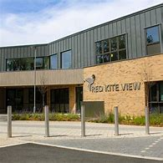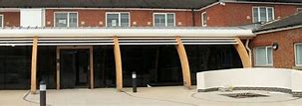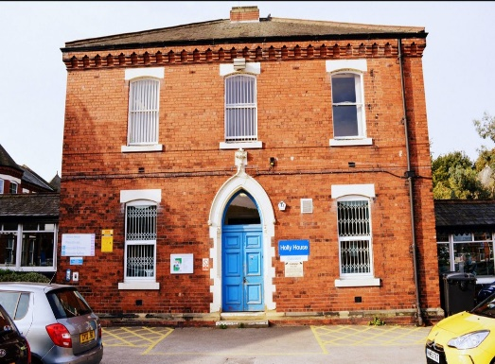
Image: Some of our owned estate Red Kite View, Aire Court and St Mary’s Hospital (Holly House)

PFI Assets
This estate is under a PFI Project Agreement contract managed through a Special Purpose Vehicle (SPV). The Hard and Soft Facilities Management (FM) is sub-contracted as part of this tenure arrangement. There is no contractual right to ownership of these assets at the end of the concession (2028), and the PFI has inflexible contractual conditions which make service change / improvements more difficult and expensive to deliver. The Project Agreement includes 7 PFI Assets and we currently operate out of 5 of these sites which has a total Gross Internal Area of 24,954m2 and 308 inpatient beds.

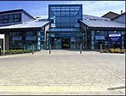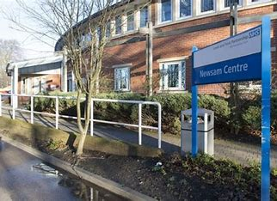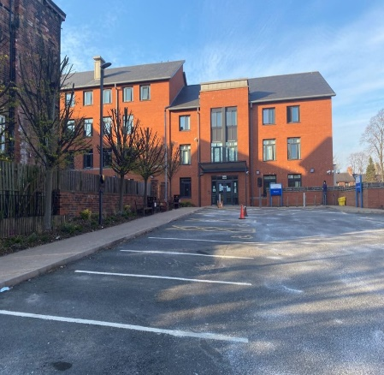
Image: Some of our PFI Estate, Becklin Centre, Newsam Centre and The Mount

NHS Property Services Assets
York based assets are under the ownership and control of NHS Property Services which is a national wholly owned company of the Department of Health. This also has complex and inflexible service level arrangements, and a third-party facilities contract that is managed also by NHS Property Services. The Trust’s Estates and Facilities Team deliver Soft FM services directly to the York sites. Limited access to NHS central capital investment for improvements/change is a key constraint for this estate. We operate out of 2 sites which has a total Gross Internal Area of 5,469m2 and has 42 inpatient beds which are Forensic Services and Children and Young People.

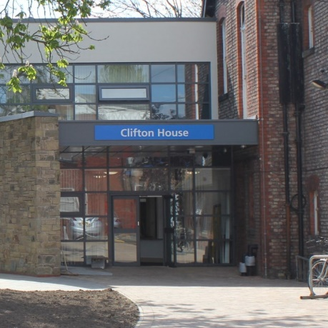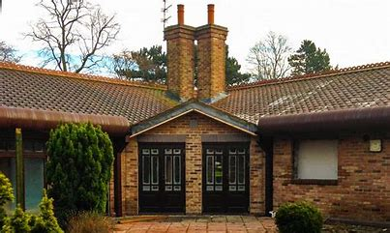
Image: Clifton House and Mill Lodge, our York properties owned by NHS Property Services

Service Level Agreements /Public Partner Arrangements /Commercial Leased (other lease estate)
The Trust occupies some other public sector partner estate which is managed through inter-provider service level arrangements, this includes our 8 inpatient beds for our NICPM service at Brotherton Wing. There are also several ad-hoc rooms used based on minimal/ no charge. The Trust also operates a range of commercial property leases with varying terms and lengths of concession. These are largely used as office based / non-clinical accommodation and not directly patient facing.

A summary of the existing characteristics of our estate can be found below in Table A:

 | PFI Estate | NHS PS Estate | Owned Estate | Other Leased Estate
Total number of inpatient beds | 308  (79%) | 42  (10%) | 32  (8%) | 8  (3%)
Number of buildings | 7 | 2 | 15 | 40+
Total Gross Internal Area m2 | 24,954m2  (40.5%) | 5,469m2  (8.8%) | 21,183m2  (34.4%) | 10,000m2  (16.3%)
Annual Running Cost of Estate  (Exc. Capital) | £12.6m  (61.4%) | £2.4m  (11.7%) | £4.2  (20.5%) | £1.3m  (6.4%)
Total Net Book Value | £70m | £4.2m | £44.1m | £0.7m
Table A. Trust wide estate characteristics

The existing estate comprises of 24 primary building assets and 390 inpatient beds. Whilst we operate non-inpatient services out of many more buildings that are embedded in the One Public Estate, under ownership of strategic partners or privately owned with approximately 40.5% of the estate by gross floor area is within the PFI and over 90% by net floor area is located in Leeds.

The total annual cost of the PFI, Trust-owned and NHSPS and leased and rented properties within the Estate is c.£20.5m (including the PFI unitary charge) giving a cost of c£332.76 per square metre of estate.

How we are quality assuring and enabling a fit for purpose estate

The delivery of our services is changing with new integrated approaches between physical and mental health services, moving towards more care being delivered within the community and improving inpatient care. To support this, we recognise that our estate needs to change and be flexible to meet future requirements. We quality assure our estate against the following factors:

- Quality
- Meeting broader clinical needs
- Service User feedback (Patient Led Assessment of the Care Environment)
- Service User and asset security
- Environmental safety
- Accessibility to our estate
- Backlog Maintenance (including statutory compliance)
- Health Building Notes (HBNs) - Technical Guidance and Standards
- PFI Assets
- Functional suitability
- Restricted outdoor space for inpatient settings
- Space Optimisation

Quality
Aligned to the standard ‘quality’ metrics of amenity / comfort engineering / design, we ensure we are fully appraised of our quality position through several routes. The annual Patient Led Assessment of the Care Environment (PLACE) assessment provides indicative service user perceptions, we obtain information through surveys such as 6 Facet and clinical environmental reports to capture the requirements of change in our Estate. We include principles of co-production where able, and work with clinical and operational teams to gather as much information as possible to improve our estate and ensure that challenges and issues relating to quality are captured and acted on.

Meeting broader clinical needs
Our service users and some of our staff have additional needs of the Estate to ensure that they have a positive experience when on our sites. We are committed to creating an inclusive and supportive environment for people who use our services and our workforce. Consideration is given for the broader requirements in relation to all of our clinical diverse needs as well as being as therapeutic as possible. We aim to ensure that when planning and designing we adhere to principles for broader clinical requirements and not just those of our core services. An additional key factor in considering clinical needs and creating positive experiences, the requirements of the Health Equity should be considered as part of our decision making. These requirements should be captured through our trust wide audits and will be managed through our governance groups relating to Clinical Services and the Estate.

Service User Feedback (PLACE)
The Trust takes feedback from our service users and their families seriously and acts upon the feedback and comments as a priority. The Trust currently has multiple forums in which service users can contribute and provide their views on how they perceive our services, including their opinions of our estate. The most notable, and mandated mechanism to receive feedback is via the Patient Led Assessment of the Care Environment (PLACE). Our service users have stated the following about our Estate:

- The Wards feel safe and reassuring - Signage needs to be updated
- More plants and greenery would be nice - Corridors feel dark and unwelcoming
- There is lots of natural light - Some areas are not bright enough
- My ward makes me feel calm - Toilet area's need to be upgraded
- I wish I had my own shower room - The ward can cater for many different cultural needs
Figure 4. PLACE feedback from 2023 and 2024, how our service users and families perceive our estate

The feedback from service users is clear in that we must continue to strive to invest in our environments. Not only do we use service user feedback as a driver to improve the quality of our estate, but we also work collaboratively with specialist internal colleagues such as the Dietetic Teams to ensure that we provide an excellent quality of food, menu offering and wider catering experience within our estate. We have recently undertaken investment around improving our service user feedback and we ensure that appropriate governance is in place to support the PLACE assessments.

Service user and asset security
We carry out periodic risk assessments across our entire estate and we monitor the actions and development of action plans through Trust governance. We have recently committed to investing in our security provisions across our estate to ensure compliance and to move towards more technological solutions.

Environmental Safety
There are various environmental risks that need a multi-faceted approach to provide assurance that our estate is safely managed, and any risks are mitigated where possible. To achieve the required levels of assurance, Estates and Facilities work with key stakeholders such as our clinical teams and Infection Control to ensure that both the static and non-static elements of the estate are managed accordingly and that they minimise the risk of any self-harm or ligature event. Multiple periodic inspections and audits across our estate linked to statutory compliance and service user safety, enable us to proactively ensure our estate is safe. Our inspections and audits allow us to prioritise capital investment where there is an identified risk and the scope of the audits captures environmental components such as anchor points, furniture, window, doors, flooring, lighting curtains, sanitary ware.

In addition to the safety of our service users, the safety and wellbeing of our workforce will continue to be a key factor in our consideration, design and investment given that they are front and centre of all care provision especially in our in-patient estate where we regularly experience incidents in relation to violence and aggression.

Accessibility to our Estate
Despite ongoing works regarding accessibility, the Trust does have some areas of challenge, and we will look to address this but change in this regard would require capital investment. Non-Capital investment will see the Trust continually commit to working with partners both internal to the Trust through the Disability at Work Network (DaWN) and external partners such as the AccessAble initiative. Further accessibility will be continually reviewed and reported through the annual PLACE Assessments that are completed and give us a good benchmark to work with for improvements.

Backlog Maintenance (including statutory compliance)
Backlog Maintenance is the cost to improve the estate to a defined standard for physical condition, functionality, and safety, this can also include impending backlog which is the assessment of upcoming works that will fall into backlog maintenance within the next five years.

We will continue to prioritise our requirement to invest in backlog maintenance, and key drivers will include safety, statutory compliance, business continuity and sustainability. We will refer to our 6 Facet Survey to inform of our requirements and our investment needs. (Estate characteristics from our 6 Facet Survey information can be found in Appendix B).

Our PFI Estate is also regularly reviewed by both the Trust and the SPV to ensure that lifecycle plans are delivered to ensure this Estate is maintained at a safe and acceptable condition. We also review our NHS Property Services Estate through condition surveys, risk assessments and regular collaboration to ensure that our environments remain safe and fit for purpose. Table B highlights the Trust’s approach to backlog maintenance and explains our current position.

 | Year Constructed | Year Of Survey | GIA (sqm) | Backlog Maintenance | Impending Backlog | Total | Cost Per Sqm
Owned Estate | 1955-2004 | 2022 | 21,183 | £2,743,018 | £5,584,559 | £8,327,577 | £393.13
PFI Estate | Approx. 2000 | 2023 | 24,954 | Backlog Maintenance is a contractual obligation on the PFI Estate and is managed by the Estates and Facilities Department to ensure the Estate is Condition B ahead of the 2028 PFI Concession
NHS PS Estate | Various | 2022 | 5,469 | Backlog Maintenance is regularly reviewed through condition surveys and risk assessments to ensure that our Estate is safe and fit for purpose and is done so through collaboration
Table B. Backlog Maintenance profile for Leeds and York Partnership NHS FT Estate (Source: Base Data has been utilised using the Estate Returns Information Collection (ERIC) 2023/24, Site Data)
We also continue to monitor the condition of our leased estate. We work collaboratively with other public sector host organisations and private landlords to ensure that our environments remain effective and ensure the buildings perform as they are intended.
Backlog maintenance will continue to be assessed using national NHS guidance and reported as part of the Trust’s annual Estates Returns Information Collection (ERIC) which is compiled annually. In addition, the Trust’s performance against its peers will be assessed against the NHS Model Health System, a data-driven improvement tool which includes data from ERIC returns. We will prioritise backlog reduction in areas which will most affect clinical care and reduce critical infrastructure risk.

Health Building Notes (HBNs) - Technical Guidance and Standards
Health Building Notes were published after our inpatient sites were constructed. Several of our inpatient ward bedrooms do not have ensuite facilities. Across our Leeds inpatient services (PFI) out of a total of 308 bedrooms, 42 bedrooms have ensuite facilities and within York inpatient service (NHSPS) out of a total of 42 bedrooms we have 10 bedrooms with ensuite facilities. However, across our owned/leased estate out of a total of 41 bedrooms we have 23 bedrooms with ensuite facilities.

PFI assets
PFI assets can come with complexities in relation to legal and contractual requirements which has a subsequent impact on cost and time. However, we have demonstrated that we will continue to invest in our PFI Estate ahead of expiry in 2028 with significant projects, and we continue to regularly monitor the
annual lifecycle improvements work which is funded separately via our unitary charge and is separate from Trust capital. We will continue to work collaboratively with our SPV to ensure that PFI lifecycle plans are monitored through our Clinical Environments Group to ensure they are aligned with the requirements of our services and are in the required condition to ensure our estate is safe.

Building constraints
Planning permissions, building architecture and building location add to further complexities and factors when considering environmental improvements. Within most of our existing footprint, we are restricted by location and architecture to expand or extend. Most of our estate is not very flexible, and any major changes will need significant capital investment, re-location or require a decant facility to carry out necessary improvement.

Functional suitability
Functional suitability is the assessment of three elements; internal space relationships, support facilities and location and Appendix B highlights the previous Functional Assessment. Overall, our estate scores ‘B - satisfactory but minor changes are needed’. We do have two outliers; Red Kite View is rated ‘A - very satisfactory, no change needed’ which correlates to the recent and significant investment and stakeholder engagement to ensure the building was fit for purpose upon construction. The other outlier is Woodland Square which scores ‘C- Non-Satisfactory, major change needed’.

Space Optimisation
In line with our Delivery Principles, we have consolidated and rationalised the estate since the last Strategic Estates Plan (2018-2021). However, we need to achieve more if we are to demonstrate our work towards sustainable estate delivery. To ensure we are optimising and utilising the correct estate, we should follow the principles as outlined in Estate Delivery Ambition 4: Optimise Building Design and Layout.

The analysis of void space across our estate reveals a low level of vacancy. The negligible void space reflects a strong commitment to optimising the available infrastructure, ensuring that facilities are primarily dedicated to patient care and operational needs. Key sites, such as Trust Headquarters, The Mount and Becklin Centre, report zero void space, signifying their full occupancy.

Our Estate where our inpatient beds is provided, should prioritise the needs of inpatient care. Currently a significant proportion of our inpatient buildings is dedicated to off-ward space, primarily used for office accommodation, meeting/training space and facilities management. To meet our aspiration of providing all bedrooms with ensuite facilities and enhancing our therapy provision, we recognise the need to reduce the amount of non-ward space.

Summary of quality assurance regarding our estate
We will continue to ensure that our estate remains statutorily compliant under routine, day to day operation of maintaining our assets. However, we will also continue to try our upmost in capturing the unique requirements from all our aspects of our Trust to optimise the estate in ensuring it is fit for purpose. Where we are unable to capture all requirements, we will carry out Impact Assessments so we can evidence our decision-making process within the operating limits in which we are assigned and make sure that we are well governed during these processes.

Our progress since 2018

In our previous Strategic Estate Plan 2018 – 2021 we provided a baseline assessment of our estate as a basis for informing the planning process. An assessment of each part of the estate against several criteria and key performance indicators was undertaken. The measurement criteria and key performance indicators utilised the Carter and Naylor Report recommendations, and a six-facet overview. The review was completed internally and is a self-assessment of estate performance, building on the previous information from external surveys.

We have made significant progress against the outcomes we set ourselves back in 2018. We have reduced our leased accommodation, demolished some of our owned old buildings that were no longer fit for purpose and reduced the financial burden. A summary of the progress made since 2018 against each of our Estate Delivery Principles is outlined below:

Delivery principle | Progress to date
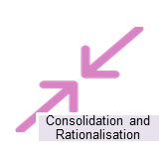 | - We have vacated 10 private building leases totalling 3,273m² and saving £1.1m enabling greater utilisation of our owned estate.  - We have demolished 9 buildings across our owned estate totalling 4,418m².  - Although we have reduced our not fit for purpose estate, we have replaced this with our new owned inpatient facility Red Kite View.  - Our 3 community locality hub buildings are open 7 days per week.
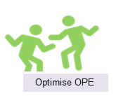 | - We have built strong relationships with our partners across Leeds and York and utilise office space and therapy rooms within primary care, third sector and Local Authority buildings. We also utilise flexible workspace providers to expand our reach of estate across the region and the North East and North West of England.  - We are a key partner as part of the Citywide Strategic Estates Board who are responsible for estates planning. The Board’s objective is to rationalise our overall estate footprint, improve quality and utilisation of our estate and promote integrated shared estate solutions – our ‘One Public Estate’.
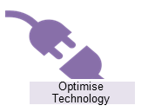 | - We have adopted an office hotelling solution to enable meeting rooms, offices, therapy rooms, clinic rooms and group therapy rooms to be booked across all of our buildings. For some of our sites we also provide desk booking. This enables a greater understanding of the utilisation of our estate 7 days per week, 365 days per year.  - The Trust has adopted modern methods of working where practical and utilises online resources such as Microsoft Teams to reduce the burden and requirement of physical estate.  - There has been investment in the development of the Computer Aided Facilities Management System which continues to provide improved customer service and improved data capture to inform estate decision making.
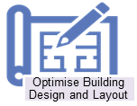 | - We have made significant investments in our estate since 2018. We have:  - Opened Red Kite View which is the new West Yorkshire inpatient facility for children and young people.  - Redeveloped our owned estate to create flexible working and touch down collaboration spaces  - Created new clinic facilities across two of our locality hubs  - Created Health and Wellbeing facilities for our workforce  - Maintaining our inpatient ward environments by replacing flooring, lighting, bedroom and bathroom renovations  - Created a new statutory compliant seclusion facility within the Newsam Centre  - We have created an eating disorder day facility for children and young people at Mill Lodge  - We have renovated our Section 136 facility and improved the external areas to allow service users secure access to outside space  - Improving privacy and dignity and prioritising ensuite facilities are key priorities of all new schemes.
 | - Created improved Governance and Board level reporting from our Sustainability Steering Group.  - Installed electrical infrastructure for EV Car Charging.  - Installed the electrical infrastructure and carried out backlog maintenance in preparation for Solar Panel installation on the estate in 2025.  - Have moved towards a 100% LED estate working with partners across the owned, PFI and NHS PS estate.
Table C. Our successes since the last Strategic Estates Plan – and where these are aligned with our delivery principles

Where do we want to be: Our Estate Delivery Principles

The estate is our vital asset in supporting services within the Trust to create the conditions to provide safe, reliable and effective care. The quality of our estate is critical to the care we provide, as well as the experiences of service users and carers, and the wellbeing and productivity of our workforce.

Our vision is:

‘To make best use of our most modern fit for purpose estate in line with the One Public Estate principle, ensuring the needs of our care services and service user leads our estate strategy.’

The relationships between our vision and our objectives working to our delivery principles is summarised below:

Vision | Objectives | Delivery Principles
To optimally utilise only the best modern fit for purpose estate, in line with One Public Estate | - Service led  - Statutory compliant  - Economic, efficient and effective estate  - Supports new ways of working  - Supports being green  - One public estate | - Consolidation / Rationalisation of the estate  - Optimise partner Estate (One Public Estate)  - Optimise technology  - Optimise building design and layout  - Achieve carbon net zero
Table D. Relationships between our vision, objectives and delivery principles

Estate Delivery Principle 1: Consolidation and Rationalisation

Effective consolidation and rationalisation programmes offer potential to change user behavior and drive forward a more collaborative working style. Since 2018 we have vacated ten commercially leased premises across Leeds, West Yorkshire and regionally. This continues to be a key ambition as we strive to continuously review our estate so that it remains fit for purpose and aligns with our future vision and service delivery models, whilst ensuring that the estate is efficiently and effectively utilised to generate system-wide savings and recycling value.

On average we see over 25,000 new service users each year in one of our community locality hubs, inpatient units, or partner estate across Leeds. It is vital that we know how efficiently, effectively, and economically our buildings are being utilised. Using our office hoteling solution, we know how often rooms are used, for how long and by whom. This enables us to maximise our accommodation to support our clinical pathways and ensure our services operate from buildings appropriate for their use i.e., inpatient sites for inpatient services.

The underpinning delivery principles for how we will consolidate and rationalise our estate are:
- We will continuously review all existing leases, to determine appropriate utility and on-going suitability, identifying earliest breakage points.
- We will continuously review and rebase our occupancy levels and requirements to validate scale of under/over occupancy to support and challenge services to use space differently and by so doing harness and support new ways of working.
- We will continuously review financial and operational backlog maintenance risk and reduce these where appropriate by rationalising unsuitable and inflexible accommodation.

Estate Delivery Principle 2: Optimise Partner Estate

We will continue to take a strategic view on disposals, lease exits and release property where appropriate and right to do so whilst ensuring that the locations of our care services are accessible and enable the co-production and co-delivery of care with service users.

We want to ensure that our workforce can meet with colleagues from partner organisations in shared space to collaborate, build relationships and share knowledge.

We will do this by working closely with our partners, principally through the Leeds Strategic Estate Board (SEB) and by sharing our plans with partners to ensure full visibility of the collective estate. This will allow us to review the use of the wider footprint across Leeds, West Yorkshire and regionally and explore the potential for co-located services in shared estate where appropriate and relevant to service needs. This approach will ensure that any utilisation of the partner estate meets the collective vision and objectives of the Leeds Strategic Estates Board and or a provider collaborative. Our core estate and co-working sites need to be accessible, easy to book, and have fit-for-purpose accommodation aligned to our agile working principles.

- We will work closely with partners principally through the Leeds SEB to plan and deliver estate synergies. With the aim to co-locate services in shared estate, relevant to service need, ensuring any utilisation of partner estate meets our vision and objectives.
- We will share our estate plans with partners to ensure full visibility of the collective estate and enable a collective approach to planning investment and change of use in estate across a wider footprint.
- We will participate in the Mental Health Collaborative workstreams to review use of the wider estate footprint across West Yorkshire.
- We will ensure that all the estate is accessible, easy to book, have fit for purpose accommodation (LYPFT and wider), and is aligned with our agile working principles.

Estate Delivery Principle 3: Optimise Technology

The recent challenges of the pandemic have exacerbated the issues around infection control and the design of health facilities but have also illustrated the benefits that technology can bring. Video conferencing facilities to support more effective meetings within our Trust have been adopted rapidly, and video consultations (where appropriate) in outpatients have been deployed effectively. The pandemic has shown that we can stand up and adopt innovative technologies at pace and scale when the circumstances demand it. This has provided an opportunity to learn lessons and build upon the solid foundations in place.

We have adopted an office hoteling solution across our estate so we can understand how our estate is being used 7 days per week, 365 days a year. This is an essential tool in identifying how our meeting rooms, offices, desks, consultation/ therapy rooms are used. We are transitioning to all office spaces (clinical and administration) being flexible and bookable, so no individual has their own room. What is paramount to this is ensuring rooms are booked to undertake clinical appointments (virtual or face to face), recording data and information from a service users’ consultation.

Our delivery principles include:

- Ensuring our Strategic Estates Plan is aligned to our digital plans including mobile technologies, remote access, public Wi-Fi, procurement of a new electronic patient record management system.
- Ensuring the necessary technology infrastructure is available to facilitate estate co-location across both our estate, and wider partner estate.
- Harnessing technology as a conduit to increased utilisation and reduced footprint by the enablement and monitoring of agile working principles.
- Monitoring room and desk utilisation across our entire estate – adopting the principle that all rooms are bookable with no individual offices.

Estate Delivery Principle 4: Optimise Building Design and Layout

Patients and staff should perceive the built environment as a supportive and welcoming space. Aligned with our aspirations and available options, we recognised the importance of personal space, a homely welcoming atmosphere, a supportive environment, thoughtful physical design, access to outdoor areas and provision of facilities for both recreation and leisure. Additionally, we aim to create an environment that promotes health and wellbeing for our service users, their carers, staff and visitors alike.

To protect our service users’ privacy and dignity, our ambition is to prioritise ensuite facilities, allowing service users to have private amenities, thereby enhancing comfort, privacy, and overall experience by eliminating the need for shared facilities. We are also committed to enhancing staff wellbeing by providing facilities that foster a positive and healthy workplace for staff. This can be achieved by relocating services (where right and appropriate) to improved accommodation that is more conducive with the delivery of modern healthcare should improvements to their existing demise be unachievable or overly limited. We are committed to:

- Delivering clear functional specifications that can be used in the design of capital schemes (new and refurbishment schemes) as this is core to delivering fit for purpose estate​.
- Ensuring designs are service led (clinical and non-clinical), are co-produced, and fully consider service specific requirements such as dementia, gender, autism and all protected characteristics.
- Providing care settings that are safe, inclusive, accessible, and therapeutic which are conducive to recovery and the provision of high-quality care.
- Care services that are located with appropriate clinical adjacencies to facilitate safe and efficient transfers of care and/or flexible access to trained staff.
- Ensuring our inpatient facilities are for inpatient services, reducing the amount of office accommodation.
- Building flexibility into the estate to meet changes to care service requirements.​

Estate Delivery Principle 5: Achieve carbon net zero

The NHS ambition to be the first Net Zero Healthcare System in the world and the target, as legislated in the Health and Care Act 2022, to meet Net Zero by 2045 at the latest, has provided greater focus on sustainability. Closer targets include NHS Estates to reduce direct emissions (energy use) by 80% by 2032 which is also supported by all of our new Estate to achieve ‘BREEAM Excellent’. NHS England have also published the ‘NHS Net Zero Building Standard’ which is applicable to all new buildings and upgrades of existing facilities.

Our ambition is to work towards achieving our net zero targets across all categories and strive to become a Green Trust. We have already incorporated sustainability in many aspects of our activities however, we also recognise that more can be done. This ambition does come with challenges and will have a significant financial impact as we work towards becoming a green organisation with much of our estate requiring offsets to achieve net zero even with additional investment.

To put that into context, the estimated cost of a typical new build increases by 30% to 35% to achieve net zero. A recent assessment of the requirements to decarbonise the estate estimates a £14.8m investment is required. In addition, the Strategic Outline Case for the future of our PFI estate estimates that £32m would be required to ensure those buildings are as near as possible to net zero but will likely not achieve net zero in isolation.

Moreover, to go some way in meeting our green targets, we will need to ensure that all operational and capital expenditure not only addresses the purpose that it is to be used for, but also enables the implementation of measures that support carbon emission reductions and decarbonisation of the estate. In alignment to the NHS Net Zero 4-step plan, planned backlog maintenance, upgrading building fabric plant replacement and installing renewables, offers opportunities to deliver energy efficiency improvements and reduce emissions by specifying carbon reduction as part of the programme. Efforts to reduce backlog maintenance can also drive co-benefits for carbon emission reduction, without the need for new additional capital.

How we will measure our success

We have set ourselves some significant strategic delivery principles within our Strategic Estates Plan for where we would, should the necessary funding be available, strive to achieve. How we will measure and track our success:

- We will monitor our performance with our peers against the NHS Model Health System, a data-driven improvement tool which includes data from ERIC returns as part of the Trust’s annual ERIC returns.
- We will use our office hotelling solution, to analyse the room booking and occupation data to understand how efficient and effective our buildings are being utilised.
- We will strive to be in the top quartile for critical backlog maintenance in percentage terms when assessed against a targeted group of similar mental health Trusts outside of London.
- We will capture, monitor and validate annually our carbon position and report on our progress.
- We will assess BREEAM standards, where applicable, at a project level.
- We will continually strive to achieve year on year improvements during our Patient Led Assessments of the Care Environment

How will we get there: Our future aspirations for our estate

We operate within the West Yorkshire system with our local ‘place’ Leeds being largely where we provide the majority of our services, with our allocated capital envelope being designated for our West Yorkshire based estate. Our York services operate within the Humber and North Yorkshire system. We are also act as the lead or partner within a number of provider collaboratives across the two systems we operate across.

Working alongside our care services we have developed the aspirational plans for the future of our estate. These aspirations will require further feasibility testing, prioritisation and evaluation linked with our objectives and delivery principles, organisational priorities and work programmes. These aspirations are set in the backdrop of the demise of our Private Finance Initiative (PFI) concession in 2028 and our short and medium-term capital investments we will need to make to ensure we complete essential backlog maintenance and remain statutorily compliant.

The key themes that emerged from developing our aspirations are:

Co-location: some of our services are not appropriately co-located to ensure we deliver great care that is high quality. This particularly impacts upon our adult acute service which is separated across two sites.

Privacy and dignity: some of our services operates mixed sex environments making service user privacy and dignity requirements difficult to accommodate. This particularly impacts upon our Psychiatric Intensive Care Service (PICU).

Sub-optimal environment: some of our accommodation is not as accessible as we would like it to be and not designed in line with national standards i.e. 81% of our inpatient ward bedrooms do not have ensuite facilities, are not dementia/neurodivergent friendly, do not have adequate seclusion facilities, and have limited access to outside space and not fully robust in relation to the acuity of our service users.

Community services: there are pressures on space to hold large team meetings or teams to collaborate in large numbers, although much of our estate is only intensively used for parts of the week.

Inpatient services: our inpatient sites are significant assets, and it is vitally important that they are used for the purpose of supporting high quality inpatient care. They must be able to respond efficiently and effectively to changes in service delivery models, changing service user needs and also requirements around provision of access to outside. Ultimately, our inpatient sites should just be for inpatient services and the wraparound care they require. The table below provides a summary of how the space is utilised across our inpatient sites.

 | Footprint GIA m2 | Asket Croft | Asket House | Becklin Centre | Clifton House | LGI | Little Woodhouse Hall | Mill Lodge | Newsam Centre | Parkside Lodge | Red Kite View | The Mount | Woodland Square | Inpatient Total
Ward Area | Single Bedroom | 0 | 0 | 1,156 | 393 | 177 | 0 | 156 | 1,181 | 88 | 0 | 1,186 | 148 | 4,486
 | Single Bedroom Ensuite | 438 | 300 | 11 | 144 | 0 | 0 | 26 | 9 | 128 | 423 | 119 | 0 | 1,600
 | Other Ward Areas | 740 | 868 | 3,378 | 2,054 | 582 | 0 | 1,011 | 4,150 | 420 | 1,276 | 4,004 | 574 | 19,057
 | Vacant Space | 0 | 0 | 0 | 922 | 0 | 1,900 | 0 | 945 | 0 | 0 | 0 | 0 | 3,766
 | Subtotal | 1,179 | 1,168 | 4,545 | 3,513 | 759 | 1,900 | 1,194 | 6,284 | 636 | 1,699 | 5,309 | 722 | 28,909
Off Ward | Corridor, Reception Etc. Circulation Space | 350 | 0 | 1,963 | 427 | 0 | 0 | 0 | 1,172 | 151 | 323 | 650 | 0 | 5,035
 | Meeting / Training Space | 20 | 0 | 110 | 104 | 0 | 0 | 0 | 89 | 45 | 75 | 57 | 0 | 500
 | Off Ward Therapy Space1 | 0 | 0 | 243 | 0 | 0 | 0 | 0 | 93 | 0 | 363 | 107 | 0 | 806
 | Office Accommodation | 373 | 0 | 779 | 246 | 0 | 0 | 0 | 1,012 | 164 | 183 | 548 | 0 | 3,306
 | Outpatients2 | 35 | 0 | 224 | 0 | 0 | 0 | 62 | 164 | 57 | 0 | 0 | 0 | 541
 | Pharmacy | 0 | 0 | 179 | 0 | 0 | 0 | 0 | 36 | 0 | 0 | 75 | 0 | 290
 | Plant / Mitie Space and Other | 59 | 0 | 252 | 26 | 0 | 0 | 0 | 374 | 175 | 513 | 505 | 0 | 1,905
 | Subtotal | 836 | 0 | 3,751 | 804 | 0 | 0 | 62 | 2,940 | 592 | 1,457 | 1,942 | 0 | 12,383
 | SITE TOTAL | 2,015 | 1,168 | 8,296 | 4,317 | 759 | 1,900 | 1,256 | 9,224 | 1,228 | 3,156 | 7,251 | 722 | 41,292

Table E. Space occupancy for Wards and Non Wards, site by site.

Our short-term plans 2025/26 – 2026/27

We have initiated the governance processes to prepare the organisation for the demise of our PFI concession in 2028. As part of our preparedness, we will continue to monitor the PFI Contract in line with the Project Agreement. This will include ongoing assurance regarding statutory maintenance and ensuring delivery of the PFI Lifecycle Plan and to adopt a risk-based approach to capital investment. We will also continue to prioritise any safety risks associated with our estate i.e. ligature.

Across our owned and lease buildings (including NHS Property Services estate), we will continue to monitor our own facilities management service through the CAFM System and use of Independent Audits. The backlog maintenance plan will be informed by the outcome of an updated 6 Facet Survey to be carried out in 2024/25 and will help determine how we might spend our capital envelope.

During 2025/26 we will see the opening of the expanded perinatal inpatient facility for the Yorkshire and Humber geography and, the opening of Parkside Lodge as the redeveloped facility to accommodate a Level 2 High Intensity Rehabilitation inpatient service. This service will transfer from the existing provision at ward 5, Newsam Centre but under new level 2 criteria. Both schemes will enable our overall number of ensuite facilities to increase (expanded Perinatal inpatient ward includes an additional 6 beds with x4 ensuite). Parkside Lodge will be fully ensuite (x18 beds) upon completion of the renovation. This will increase our PFI ensuite facilities to 20%.

Within this time period we will see the mobilisation of the community transformation model across Leeds. In partnership with the other Leeds NHS anchor institutions, Leeds City Council and voluntary sector, we have collaboratively redesigned our community model of mental health care to reinforce and enhance integration. For our estate the three locality hubs across the city will become team ‘anchor’ spaces for teams to connect and collaborate. Outpatient clinics, group therapy and physical health clinics will take place across the hubs, however the connectivity with ‘One Public Estate’ will enable our reach to be expanded across Leeds partner estate.

The administration of our clinical and corporate services is the bedrock of the day to day running of our organisation. We are transitioning all offices to being flexible workspaces, supporting the agile approach to working our teams have adopted and aligned with the use of digital technologies.

Our medium-term plans 2027/28 – 2028/29

Our estate footprint is made up of predominantly PFI assets, with the concession ceasing in June 2028. In March 2023 we submitted our initial Strategic Outline Case (SOC) to the Department of Health and Social Care (DHSC) to secure a new future for our estate. Regrettably, the SOC is currently on hold due to national capital funding considerations. We are however well on with our plans to secure the future of our PFI including the how we might manage catering, maintenance, security and cleaning. As part of our medium-term plans, we will be refreshing our SOC to seek agreement from the DHSC to look to how we can acquire some or all of our PFI buildings in 2028 which will bring them within our control.

Our long-term aspirational plans 2029/30 - beyond

It is our aspiration to address our estate key themes making sure our buildings are flexible to respond to changing service user needs and higher acuity, ensuring we always deliver great care that is high quality and improves lives. We aspire to protect our service users’ privacy and dignity by prioritising ensuite facilities, eliminating mixed-sex environments, providing facilities with access to outside space and reducing the amount of non-ward office accommodation. Our inpatient sites are largely PFI assets which we will acquire in 2028 therefore the scope to renovate is constrained to our existing footprints. We have initiated modelling each aspiration to determine the feasibility of each and to understand what steps we could take towards making some of them a reality as part of our short/medium term plans. All our aspirations are predicated on having the availability of valuable capital resource to achieve any. Our aspirations for the future and the challenges in achieving these are set out in the table below.

Service line | Aspirations
Adult acute services | We aspire to:  - Transform our existing 12 bed Psychiatric Intensive Care Unit (PICU) ward to have swing space to allow for separate male/female space and facilities,  - Transform our adult acute wards to have 16-18 beds with single room ensuite facilities,  - Transform one single site to accommodate all adult acute and PICU beds.  Our challenges:  - Sufficient footprint across our existing buildings to achieve this aspiration.  - Link with forensic services aspirations of a single site low secure facility.  - Workforce and revenue availability to operationalise this scheme.
Older adult services | We aspire to:  - Transform our dementia wards to be ground floor located with access to outside space and explore reprovision in partnership,  - Transform our older adult functional wards to be ground floor located with access to outside space and focus on developing a therapeutic environment.  Our challenges:  - Alignment with the future aspirations of our acute trust partners.  - Sufficient ground floor footprint across our existing buildings to achieve this aspiration.
Forensic services | We aspire to:  - Transform Clifton House to ensure our male ward has a statutorily compliant seclusion facility,  - Transform one single site to be our locked low secure facility.  Our challenges:  - See adult acute challenge.  - Further challenge includes the availability of capital resource (internal and external – Provider Collaborative/Humber and North Yorkshire ICB) to achieve this aspiration.
ED/Rehab/ Gender services | We aspire to:  - Explore realigning our inpatient eating disorders service with gastro services.  - Linked with the future rehab community model, potential to reprovide Asket House as a residential service managed by the Trust.  - Co-locate community and level 1 Low Intensity Mental Health Rehabilitation Inpatient services at the Asket Centre (Asket House and Croft)  - To ensure our Gender Identity Service is not located on a mental health trust site.  Our challenges:  - Alignment with the future aspirations of our acute trust partners.
CYP services | We aspire to:  - Transform part of Red Kite View to have day space provision.
Liaison and perinatal services | We aspire to:  - Explore alternative models of provision for the NICPM service i.e. intensive community and inpatient service). Co-location on an acute Trust site is the requirement.  Our challenges:  - Alignment with the future aspirations of our acute trust partners across West Yorkshire.
LD services | We aspire to:  - Reconsider the future of Woodland Square following city-wide partner agreement on the future of planned respite to ensure the respite model is accommodated in optimum building.  Our challenges:  - To meet long term maintenance and statutory compliance of the Woodland Square buildings.
Community services at place and regionally | We aspire to:  - Continue the work already underway as part of community transformation and setting the foundations of the neighbourhood health model, work closely with our partners to plan and deliver estate solutions across Leeds.  - We will continue to review how we provide accommodation for our regional services, to ensure it meets our needs.
Pharmacy | We aspire to:  - Move from the current two pharmacy dispensaries to a single larger pharmacy dispensary for the supply of medicines across the Trust.  Our challenges:  - Determining a location across our sites that would accommodate the size of footprint required for a single site solution.
Table F. Our Service Aspirations derived from engagement workshops with care services and other key functions in LYPFT

Financial challenges we might face with the delivery of our aspirational plans

The delivery of our Strategic Estates Plan aspirations is predicated on the capital funding being available to meet all requirements. In the current financial climate and complex financial regime, restrictions on capital funding are likely to limit the extent and/or speed that we can deliver our short-, medium- and long-term plans. There are two main sources of capital funding:

- Capital Envelopes: known as CDEL (capital delegated expenditure limits) is a ceiling-based limit per annum where individual organisations (in partnership at system level) can use to develop their internal capital plan. This allocation is currently determined on an annual basis and must include expenditure on leases (new or existing extended leases) as well as investment in our assets.

- Public Dividend Capital (PDC): schemes that are part of national programmes and are nationally funded. These normally include cash but may be provided without cash (CDEL cover only). Access to this capital requires rigorous business cases to evidence the requirement and gain approval.

All capital expenditure has revenue expenditure consequences, and these consequences need to be factored into all business cases and investment decisions.

Conclusion

Our Strategic Estates Plan is framed within the changing strategic and business environment in which we operate. It recognises that to deliver high quality effective care, attention to the quality of the estate for our service users and workforce is essential.

Our plan aligns with the national, regional, and local transformation and strategy initiatives and with our own internal strategic plans and other functional plans. Whilst the plan focuses on the period 2025 - 2030, it is cognisant of the longer-term impacts and further strategic horizon, driven primarily by the end of the PFI concession in 2028.

The estate, based on external benchmarks, performs within recommended parameters, however, new ways of working and changing care models all require a different, more flexible estate model. Whilst the target is to reduce the recurring revenue cost and risk, the primary objective is delivering an estate that is the high quality, fit for purpose, focusing on the service user and staff experience, to support high quality care. Our focus will be on facility management ensuring space is appropriate, safe, suitable, fully utilised, not under occupied or overprovided, and equipped with systems to monitor our performance.

We also recognise that delivering the plan will require making tough decisions about our priorities and where we will be able to invest in the future. We know we cannot deliver it alone and we are dependent on partners to collaborate with us for the shared purpose of improving health and wellbeing. We will continue to review our priorities to ensure that they remain up to date in response to changes in the operating model, new policy directions, and clinical needs.

We are committed to delivering the highest quality healthcare services for our service users across our portfolio and have established a strong position to do so. We will remain critical of our performance and measure ourselves on a continual basis. We will continue to form strong relationships with our partners to ensure the same high level of service standards are reached, working collaboratively to achieve our objectives. Throughout, one central focus remains, to make the best use of our modern fit for purpose estate in line with the One Public Estate principle, ensuring the needs of our care services both now and long into the future.

Appendix A: Clinical Service Portfolio

We are the main provider of specialist mental health and learning disability services in Leeds. We also provide adult neurodiversity service in Leeds; we provide some specialist services across West Yorkshire and Humber and North Yorkshire, and we provide some highly specialised services across the North of England. Our service portfolio is shown in the table below:

Occupancy | Site | GIA (m²) | Services Operating from the Site
PFI | Asket Croft | 2,015 | Rehab and Recovery Inpatient and Community, Assertive Outreach, Community Learning Disabilities, Safeguarding, Infection Control
PFI | Asket House | 1,168 | Rehab and Recovery Inpatient
PFI | Little Woodhouse Hall | 1,900 | Vacant
PFI | Parkside Lodge | 1,228 | Vacant but with plans to move High Intensity Rehab in to the building
PFI | Becklin Centre | 8,297 | Adult Acute Services, Crisis Services, Liaison, Mental Health Legislation, PALS, Pharmacy
PFI | The Mount | 7,723 | Older Peoples Inpatient, Older Peoples Intensive Home Treatment Team, Library Service, Clinical Audit and Continuous Improvement, Perinatal inpatients and community, Pharmacy
PFI | Newsam Centre | 9,224 | Forensic Inpatient Services, Adult Acute Inpatient, Eating Disorders Service, Complex Rehab Enhanced Support Team (CREST), Chronic Fatigue, Gender Identity, Pharmacy
NHS Property Services | Clifton House | 4,317 | Forensic Inpatient Services
NHS Property Services | Mill Lodge | 1,256 | York Children and Young People Inpatient Service
Trust Owned Premises | Aire Court | 1,700 | Working Age Adult Community Mental Health Team, Older People's Community Mental Health Team, Leeds Autism Diagnostic Service, Community Learning Disability Team, ADHD
Trust Owned Premises | Millfield House | 380 | Older Peoples Community Mental Health Team, Working Age Adult Community Mental Health Team
Trust Owned Premises | St Mary’s Hospital | 4,916 | Working Age Adult Community Mental Health Team, Older People's Community Mental Health Team, Community Learning Disability Team, Estates, Training Services, Human Resources, Recruitment, Leeds Community Healthcare, Emerge, Medical Education, Care Homes, Pharmacy
Trust Owned Premises | St Mary’s House | 3,222 | Working Age Adult Community Mental Health Team, Older People's Community Mental Health Team, IT and Health Informatics, Research and Development, Practice Learning and Development, Psychotherapy, Trust HQ, Pharmacy
Trust Owned Premises | Woodland Square | 1,577 | Learning Disability Respite Services, Ventures, Learning Disability Intensive Support Team, Supported Living Services Team Base
Trust Owned Premises | Red Kite View | 3,156 | Children and Young People Inpatient Service
Lease | Don Valley House | 498 | North of England Commercial Procurement Collaborative (NOECPC)
Lease | Lea House | 377 | Veterans Services
Lease | LGI | 987 | NICPM and Liaison
Lease | Roseville Road | 1,914 | Procurement, Logistics and EDRM Project Team
Lease | York CVS – The Priory Street Centre |  | Research and Development – COMIC Team
Lease | York Science Park | 81 | Northen Deaf Children and Young People Service
One Public Estate and Embedded Services | Kippax HC | 157 | Older peoples and Working Age Adult Community Mental Health Team / Outpatient Clinics
One Public Estate and Embedded Services | St James Hospital | - | Liaison Psychiatry
One Public Estate and Embedded Services | Merrion House | - | Gambling Service
One Public Estate and Embedded Services | Manchester | - | Northen Deaf Service
One Public Estate and Embedded Services | Newcastle | - | Northen Deaf Service

Appendix B: Estate Characteristics – Functionality, Space Utilisation and Condition

These scores have derived from our 2024/25 Six Facet Survey. The scope of the data includes the Owned and Leased Estate as the PFI Estate should be contractually maintained to Condition B.

Occupancy | Site | Functionality | Space Utilisation | Condition
NHS Property Services | Clifton House | B | U | C
NHS Property Services | Mill Lodge | B | F | B
Trust Owned Premises | Aire Court | B | F | B
Trust Owned Premises | Millfield House | B | U | B
Trust Owned Premises | St Mary’s Hospital | B | F | C
Trust Owned Premises | St Mary’s Main House | A | F | B
Trust Owned Premises | St Mary’s South Wing | B | F | C
Trust Owned Premises | St Mary’s North Wing | B | F | B
Trust Owned Premises | Woodland Square | C | U | C
Trust Owned Premises | Red Kite View | A | F | A
Leased Premises | Roseville Road | B | O | C
Leased Premises | LGI | B | F | C

Key
Functionality:
A = Very Satisfactory, no change needed
B = Satisfactory, minor change needed
C = Non-satisfactory, major change needed
D = Unacceptable in its current condition
Space Utilisation:
F = Fully used – a satisfactory level of utilisation
E = Empty – empty or grossly under used at all times (excluding temporary closure)
U = Under used – generally under-used, utilisation could be significantly increased
O = Overcrowded – overcrowded or overloaded and facilities are generally overstretched
Quality:
A = Facility of excellent quality
B = A facility requiring general maintenance investment only
C = A less than acceptable facility requiring capital investment
D = A very poor facility requiring significant capital investment or replacement
X = Supplementary rating to a C or D to indicate that nothing but a total rebuild or relocation will suffice (that is, improvements are either impractical or too expensive to be tenable)
** = Score driven by clinical requirements and not the necessarily the condition of the facility i.e. ligature risks, non-compliances with HBNs such as no ensuite facility

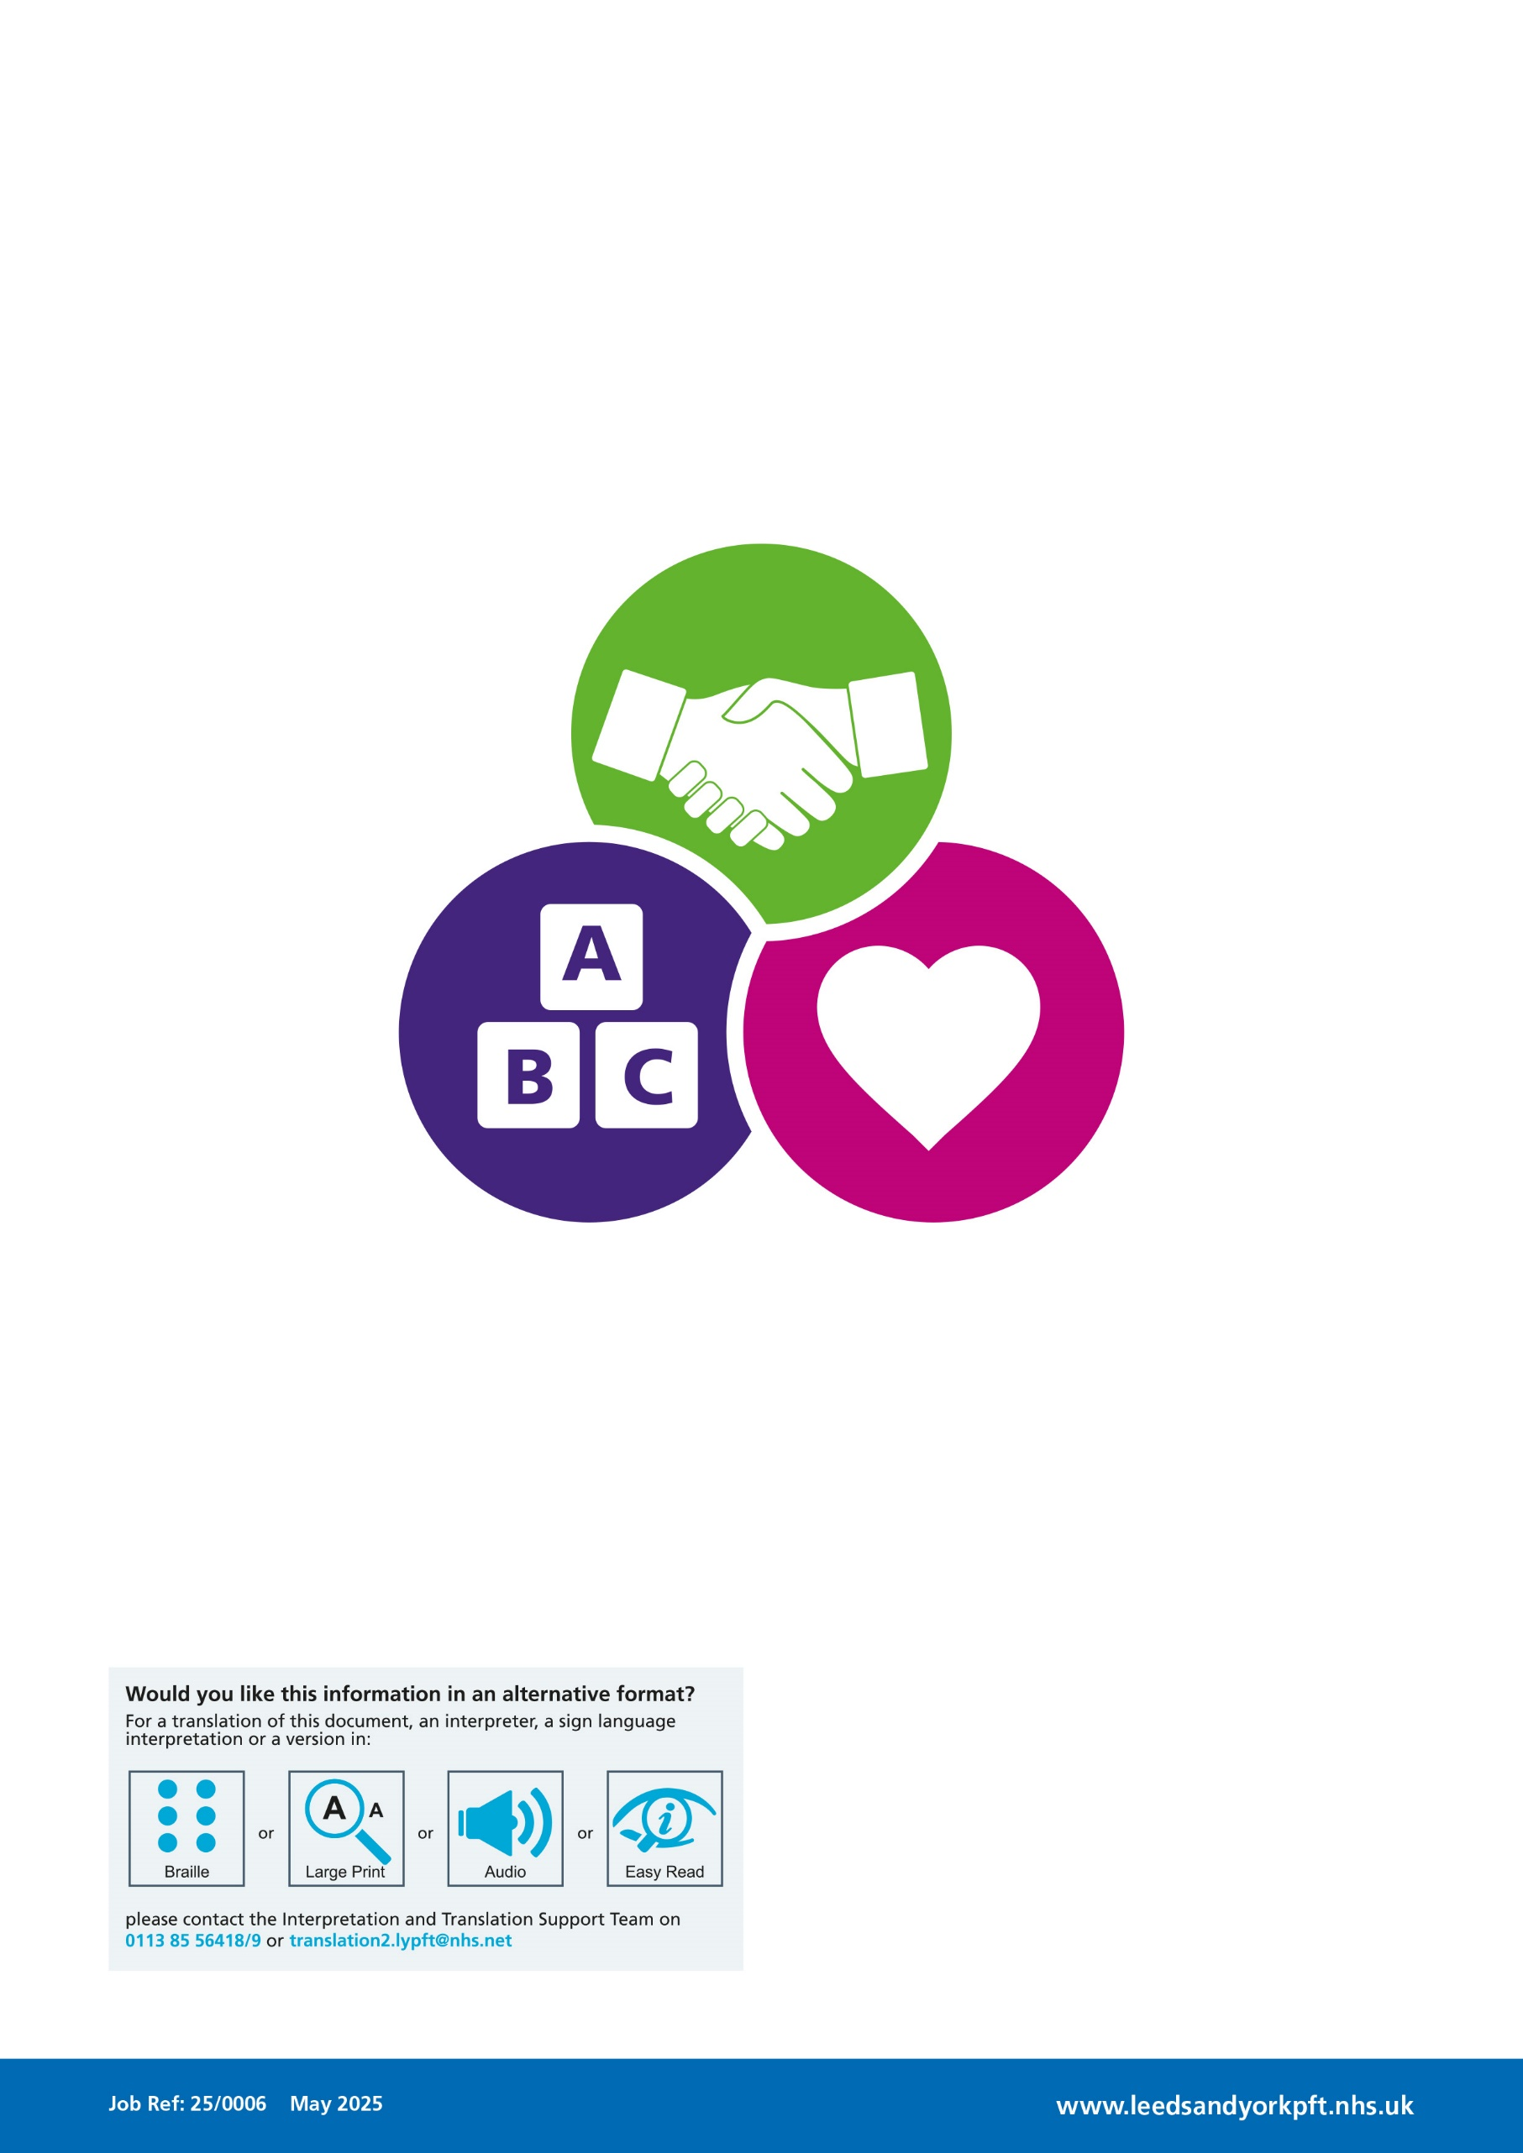

14% of bedrooms have ensuite facilities across our Leeds PFI buildings
24% of bedrooms have ensuite facilities across our York NHS Property Services buildings
56% of bedrooms have ensuite facilities across our owned (RKV, Woodland Square) and leased (NICPM)
The number of ensuite facilities will increase upon the opening of the expanded Perinatal inpatient ward (opening 6 beds with x4 ensuite). Parkside Lodge will be fully ensuite (x18 beds) upon completion of the renovation. This increases our ensuite provision across the PFI estate to 20%.

