Learning Disability Services
Our plan on a page for 2022/23
April 2023
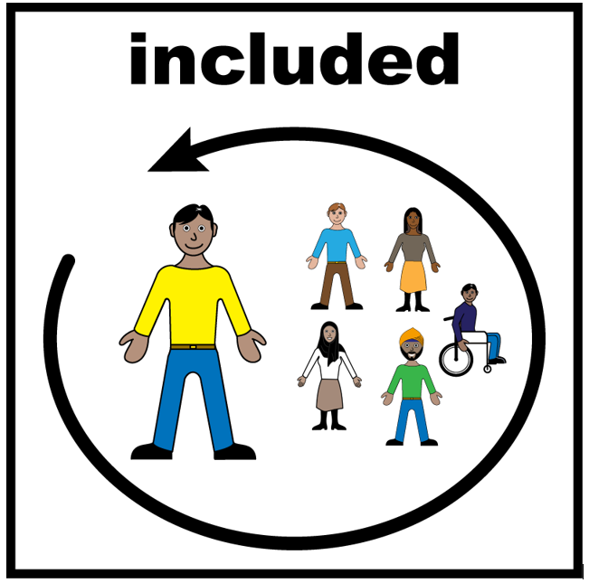 | 6. How will we reduce health inequalities.  How will we improve the support for everyone from every community to be included in their health care.
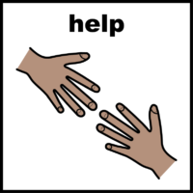 | We will continue to make Reasonable Adjustments for people with a learning disability so that they can access our services.
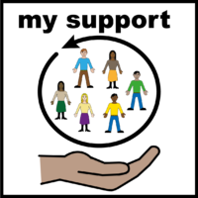 | Work with other health and care staff in other services to make it better for people with a learning disability to be supported and included in their health care.
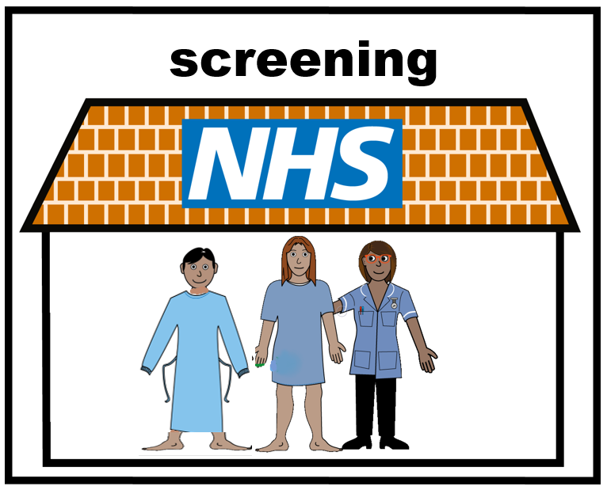 | Support service users to have the right screening.
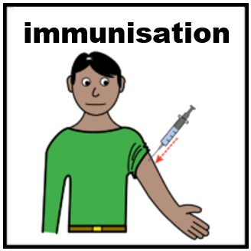 | Support service users to have the right immunisations.
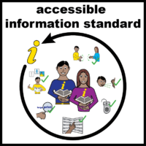 | We will continue to champion the NHS Accessible Information Standard.  We will continue to make health information accessible for people with a learning disability.
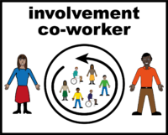 | We will make sure that people with lived experience are represented in our staff team.  We will make sure that people with lived experience are represented in our interview panels when we are choosing new staff.

