Learning Disability Services
Our plan on a page for 2022/23
April 2023
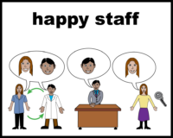 | 5. How we will improve for staff working here
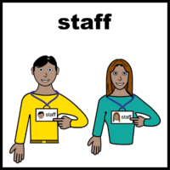 | We want to improve the wellbeing of all the staff who work for us.
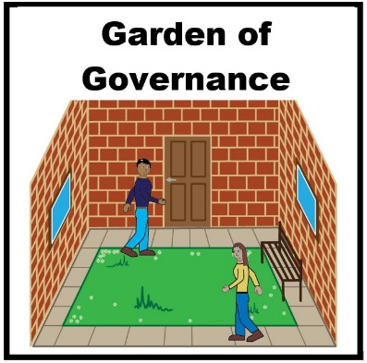 | We want to make our “Garden of Governance and Wellbeing” better.
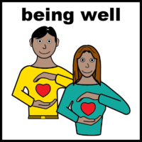 | Support staff when something serious has happened.  Help them to recover and learn lessons.
 | Have more fun events for staff.

