Learning Disability Services
Our plan on a page for 2022/23
April 2023
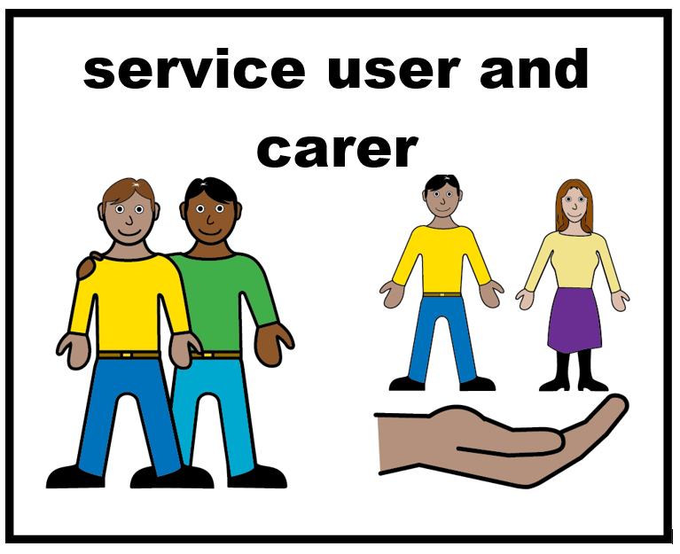 | 4. How will improve service user and carer experience
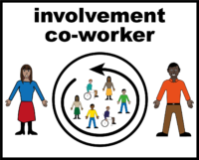 | Invest in our user involvement team.  Employ more people with lived experience in the trust.
 | Develop the three “have your say” questions to help you tell us what you think about our service.
 | Have more fun events like our Jubilee Party.

