Learning Disability Services
Our plan on a page for 2022/23
April 2023
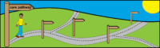 | 3. How we are going to get there
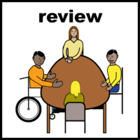 | Review our referral and assessment team.  Make sure they are working well.
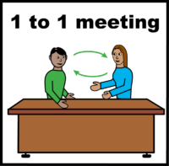 | Have more face-to-face appointments
 | Use technology that you like to use to help staff and service users have more choice about how they talk to us.
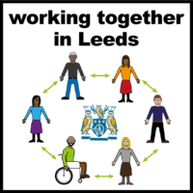 | We want to work together with others to make sure we have the right supported living and respite services in Leeds.
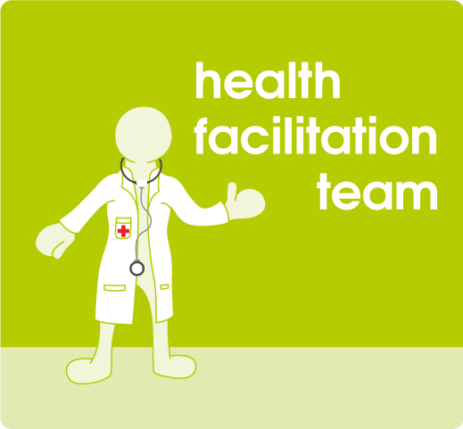 | We want to look at the Health Facilitation Team to make sure they are giving the best outcomes.

