Learning Disability Services
Our plan on a page for 2022/23
April 2023
 | 2. Where do we want to be in 12 months to 18 months time?
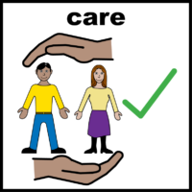 | We want to manage our ability for our staff to work with people
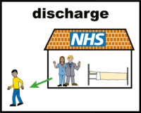 | We want to get our discharges right so that people can live well in their communities
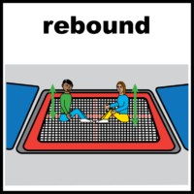 | We want to open our rebound service again
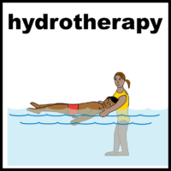 | We want to open our hydrotherapy service again
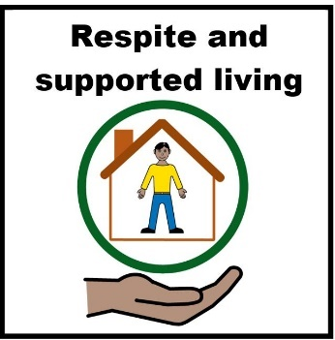 | We want to make sure our supported living and respite services are working well

