Learning Disability Services
Our plan on a page for 2022/23
April 2023
 | - Where are we now?
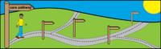 | We are getting back to normal after the pandemic.
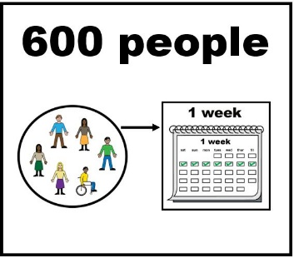 | We are seeing people.  About 600 people are seen each week.
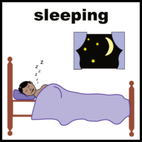 | Some of those people stay overnight in our care.
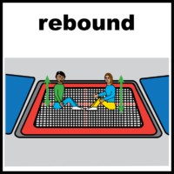 | We have not opened our rebound service yet.
 | We have not opened our hydrotherapy service yet.
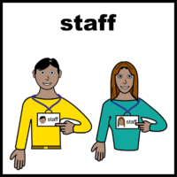 | Finding new staff is our biggest worry.

