Workforce Race  Equality Report | 2022  2022

Workforce Representation

The first WRES indicator 1 looks at the composition of our workforce (excluding bank) by banding compared with the overall workforce. The tables below show the changes in the overall number of ethnic minority staff in each Agenda for Change pay band and the medical workforce over the last two financial years.

Table 1- Non-Clinical staff breakdown for 2020/21 and 2021 to 2022

Non-Clinical
Band | 2020/21 |  |  | 2021/22
 | White | BAME | Unknown | White | BAME | Unknown | % BME in band
Band 1 | 4 | 0 | 0 | 2 | 0 | 0 | 0%
Band 2 | 105 | 23 | 4 | 103 | 23 | 10 | 16.9%
Band 3 | 131 | 28 | 5 | 158 | 32 | 2 | 16.6%
Band 4 | 93 | 11 | 1 | 98 | 16 | 1 | 13.9%
Band 5 | 57 | 9 | 2 | 56 | 9 | 1 | 13.6%
Band 6 | 64 | 9 | 2 | 60 | 12 | 1 | 16.4%
Band 7 | 57 | 8 | 5 | 56 | 10 | 4 | 14.2%
Band 8a  Band 8b  Band 8c | 39  14  11 | 7  1  1 | 4  1  1 | 48  16  15 | 8  1  1 | 7  1  2 | 12.6%  5.5%  5.5%
Band 8d | 8 | 0 | 0 | 8 | 0 | 2 | 0%
Band 9 | 0 | 0 | 0 | 2 | 0 | 0 | 0%
VSM | 6 | 0 | 2 | 11 | 1 | 8 | 5.2%

Table 2- Clinical staff breakdown for 2020/21 and 2021 to 2022

Clinical
 | 2020/21 |  |  | 2021/22
Band | White | BME | Unknown | White | BME | Unknown | BME in band
Band 1 | 0 | 0 | 0 | 0 | 0 | 0 | 0%
Band 2 | 15 | 4 | 0 | 17 | 5 | 9 | 16.1%
Band 3 | 413 | 145 | 8 | 401 | 206 | 16 | 33.0%
Band 4 | 76 | 10 | 2 | 97 | 13 | 3 | 11.5%
Band 5 | 271 | 72 | 16 | 223 | 72 | 19 | 22.9%
Band 6 | 422 | 53 | 7 | 452 | 75 | 8 | 14.0%
Band 7 | 165 | 15 | 3 | 203 | 22 | 1 | 9.7%
Band 8a  Band 8b  Band 8c  Band 8d | 96  27  23  5 | 5  4  3  1 | 1  0  1  0 | 100  27  28  3 | 15  3  4  1 | 6  1  1  0 | 12.3%  9.6%  12.1%  25.0%
Band 9 | 1 | 0 | 0 | 1 | 0 | 0 | 0%
VSM | 5 | 0 | 0 | 1 | 0 | 0 | 0%
Of which are Medical & Dental
Consultants | 43 | 32 | 0 | 47 | 30 | 1 | 38.4%
of which senior medical manager | 0 | 0 | 0 | 0 | 0 | 0 | 0%
Non-consultant career grade  Trainee grades | 23  31 | 15  28 | 0  14 | 25  29 | 13  29 | 2  20 | 32.5%  37.1%

Key Findings.

- The percentage of ethnic minority staff employed at LYPFT has increased from 17.5% last year to 20% this year.
- The number of people in non-clinical roles in Bands 6, 7, 8a and VSM show slight growth. However, the number of people in Bands 8b, 8c, 8d and 9 has remained static.
- There has been the largest growth in the number of ethnic minority staff in senior clinical roles at Band 8a from 5 in 2020/21 to 15 in 2021/22.This equates to a 7.4% increase in representation at Band 8a.

Table 3- Representative ethnicity growth by staff group over 5 years

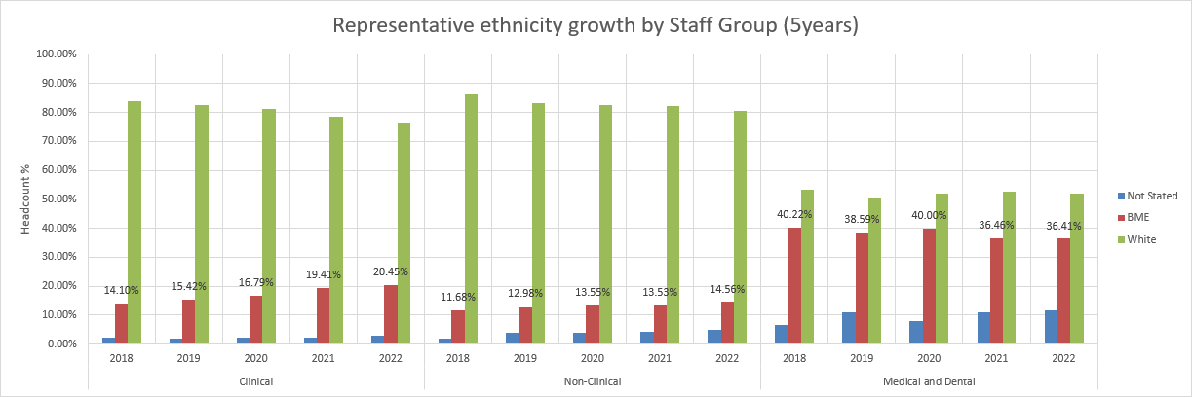

WRES metrics 2 to 9

The table below details the WRES data over a two- year period, details of key findings and available benchmark data. It should be noted that for WRES metrics 2 to 4 the national benchmark data used was published in 2021. Further benchmark data will be published by the national team in early 2023. Further detailed benchmarking will be undertaken as part of ongoing analysis.

WRES theme/Question |  | Staff Group | Reporting Period-2021 |  | Reporting Period- 2022 | Benchmark  2021 | Key Findings
2.Relative likelihood of white applicants being appointed from shortlisting across all posts compared to BAME staff. |  | White/BAME | 1.41 |  | 2.12 | 1.61 | Negatively indicates that white staff are over twice as likely to be appointed from shortlisting and this is higher than the currently available benchmark (for 2021) of 1.61.
3.Relative likelihood of BAME staff entering the formal disciplinary process compared to White staff. |  | White/BAME | 1.19 |  | 0.33 | 1.14 | Positive reduction which indicates that BAME staff are less likely to enter the formal disciplinary process. This is lower than the currently available benchmark (for 2021) of 1.14. In 2021/22 there was a total of 26 formal disciplinary cases and 2 involved BAME staff.
4.Relative likelihood of white staff accessing non-mandatory training and continuous professional development (CPD) compared to BAME staff. |  | White/BAME | 0.65 |  | 0.83 | 1.14 | During 2021/22, 51% of BAME staff accessed training or CPD. Compared to 42% of white staff. The probability indicator is in the range of no adverse effect.
WRES Theme /Question |  | Staff Group | Staff Survey  2020 |  | Staff Survey  2021 | Benchmark | Key Findings
5. Percentage of staff experiencing harassment, bullying or abuse from patients, relatives, or the public in last 12 months. |  | White | 25% |  | 26% | 26% | Ethnic minority staff reported a +12% negative experience than our white colleagues, with incidences unfavourably increased by +6% in 2021.  Bullying, harassment, and abuse (B&H) by service users, their families, or the public towards our BAME staff is a significant area of concern.
 |  | BAME | 32% |  | 38% | 32%
6.Percentage of staff experiencing harassment, bullying or abuse from staff in last 12 months. |  | White | 17% |  | 17% | 18% | Unfavourable increase in ethnic minority staff reporting experiencing bullying and harassment from staff via the staff survey of 4%. This equates to the benchmark.
 |  | BAME | 19% |  | 23% | 23%
7.Percentage of staff believing that trust provides equal opportunities for career progression or promotion. |  | White | 61% |  | 59% | 61% | 43% of ethnic minority staff reported a less positive experience of career progression or promotion, in comparison to white colleagues at 59%. Whilst the results have increased, they are significantly lower than that of white staff and remain below the national average.
 |  | BAME | 42% |  | 43% | 47%
8.Percentage of staff experienced discrimination at work from manager / team leader or other colleagues in last 12 months. |  | White | 5% |  | 6% | 6% | Whilst there has been no reported change over the last year, 14% of our BAME colleagues are experiencing more than double the level of discrimination from managers, compared to our white colleagues. This is an 8% negative gap when comparing responses from ethnic minority and white colleagues.
 |  | BAME | 14% |  | 14% | 14%
WRES Theme/Question | Reporting Period-  2021 |  |  | Reporting Period-2022 |  | Key findings
9.Percentage difference between the organisations Board voting membership and its overall workforce. | -9.8% |  |  | -12.5% |  | Trusts are required to look at the percentage difference between the organisations Board membership and its overall workforce. The data is disaggregated, by:  - voting membership of the Board  - executive membership of the Board.  Percentage of ethnic minority Board members as of 31st March 2021 was 9.8. This percentage increased to 12.5% as of 31 March 2022.  The percentage of BME voting Board members was 0% and Executive Board members 0%.

